Project Documentation: RAG Document Q&A Web App

Problem Statement
In the era of information overload, manually searching through large documents to find specific information is time-consuming and inefficient. There is a need for an intelligent system that can ingest documents in various formats (PDF, DOCX, TXT) and allow users to query them using natural language. This project aims to provide an end-to-end Retrieval-Augmented Generation (RAG) web application that solves this problem by combining semantic search with generative AI to deliver accurate, context-aware answers from uploaded documents.

System Architecture
The system follows a standard Retrieval-Augmented Generation (RAG) pipeline:
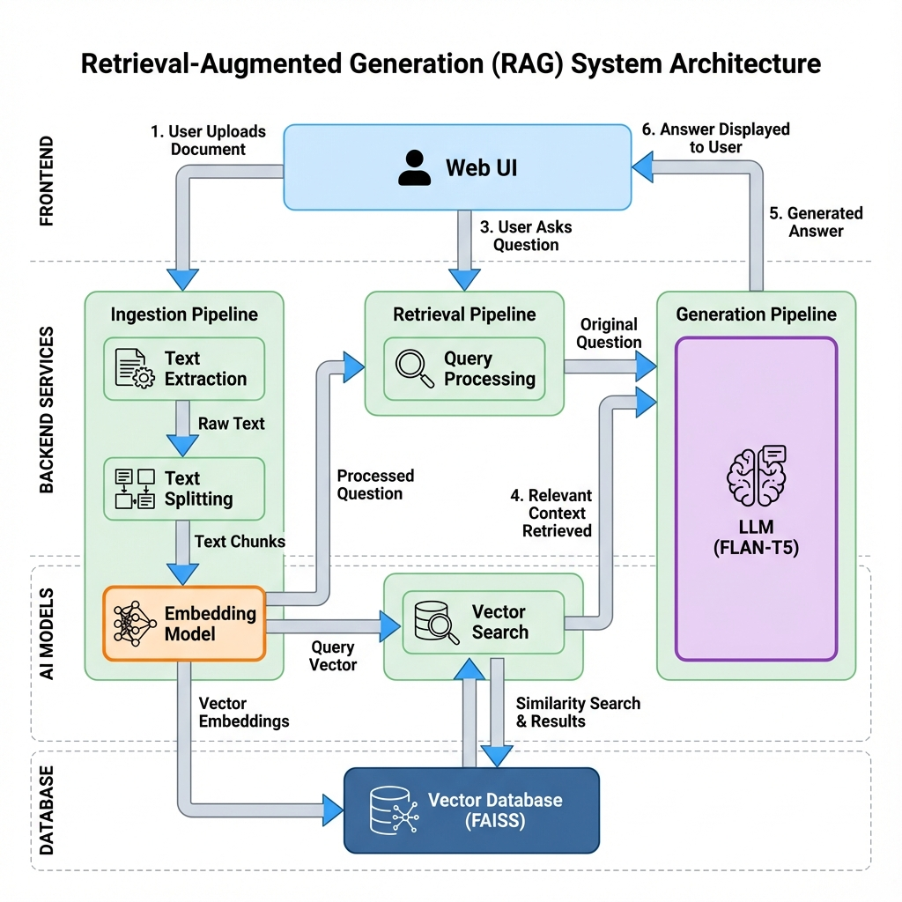
Figure 1: High-level System Architecture
- 1. Document Ingestion: User uploads a file (PDF, DOCX, or TXT) via the Web UI.
- 2. Text Extraction: The backend extracts raw text using PyPDF2 or python-docx.
- 3. Chunking: Text is split into smaller, manageable chunks (e.g., 200 characters) to fit model context windows.
- 4. Embedding Generation: Each chunk is converted into a numerical vector using the SentenceTransformer model.
- 5. Vector Indexing: Vectors are stored in a FAISS (Facebook AI Similarity Search) index for efficient similarity search.
- 6. Query Processing: When a user asks a question, it is converted into a vector.
- 7. Retrieval: The system searches the FAISS index for the most relevant text chunks (context) based on the query vector.
- 8. Answer Generation: The retrieved context and the user's question are passed to the Generative LLM (FLAN-T5) to produce a natural language answer.

Tech Stack

Frontend:
- HTML5, CSS3, JavaScript

Backend:
- Flask (Python)

AI & NLP:
- LangChain (Framework for LLM apps)
- SentenceTransformers (for Embeddings)
- FAISS (Vector Database)
- Hugging Face Transformers (Text Generation)
- PyTorch (Deep Learning framework)

Document Parsing:
- PyPDF2 (PDFs)
- python-docx (DOCX)

Models Used

Embedding Model:
- Model: all-MiniLM-L6-v2
- Role: Converts text into 384-dimensional vectors. Optimized for speed and performance.

Generative Model:
- Model: google/flan-t5-base
- Role: Sequence-to-sequence model capable of following instructions and generating coherent answers from context.

Result
The project successfully delivers a responsive, local-first web application. Users can upload documents and receive accurate, context-based answers in real-time without needing external API keys or heavy GPU resources.

Future Improvements
- Improved Accuracy:
Implementing advanced retrieval techniques like Hybrid Search (Keyword + Vector) and re-ranking retrieved results to ensure the most relevant context is used.
- Advanced Models:
Integration with larger, more powerful models such as Llama-3, Mistral-7B, or GPT-4 (via API) to handle more complex reasoning and larger context windows.
- Persistent Storage:
Saving the FAISS index to disk (or using a DB like Chroma/Pinecone) so users don’t have to re-upload documents every time the server restarts.
- Multi-Document Support:
Allowing users to query across multiple uploaded documents simultaneously.
- UI/UX Enhancements:
Adding chat history, citation highlighting (showing which part of the document the answer came from), and a dark mode toggle.

