1. Sample response without the date parameters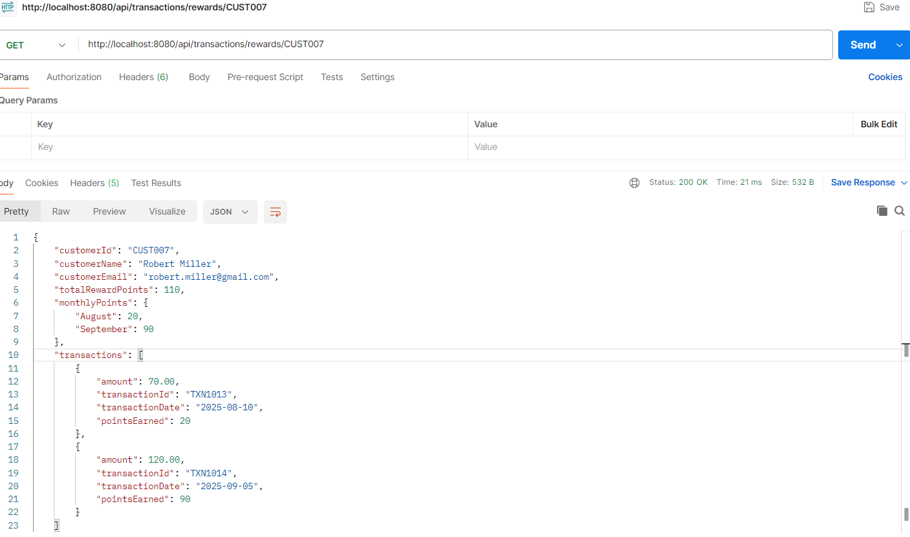

2.Sample Response with date parameters
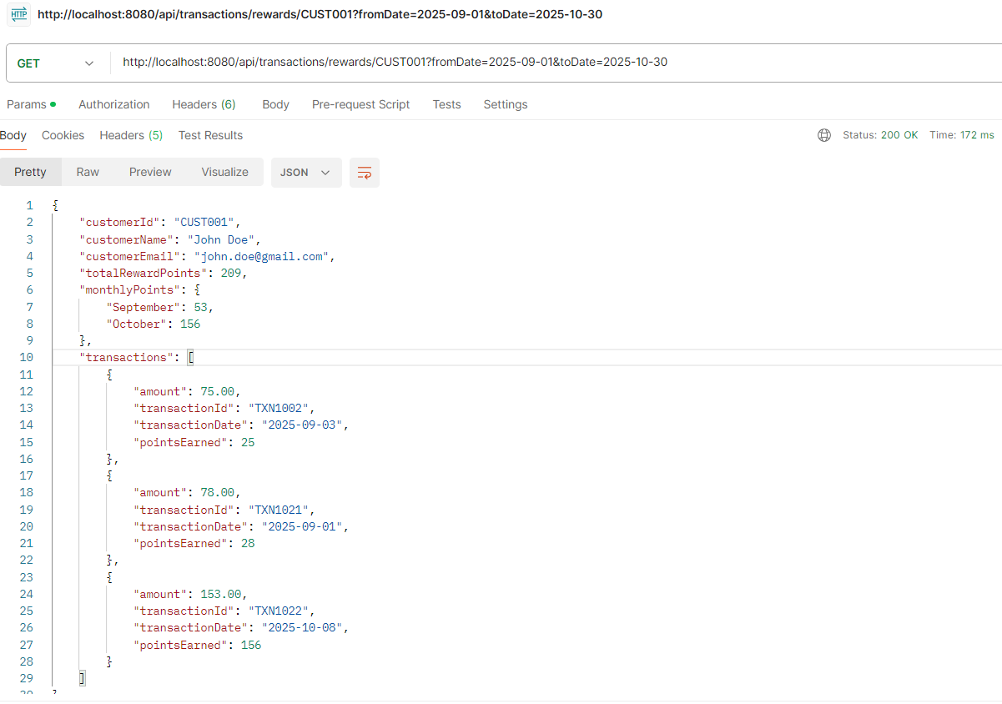

3.ToDate is after today or fromDate cannot exceed more than 90 days
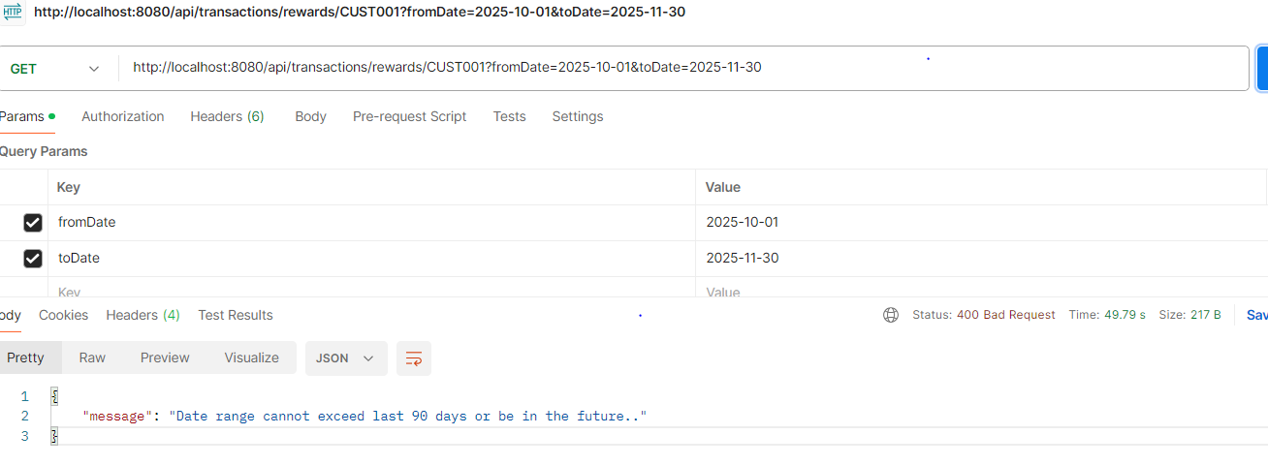
4.Customer doesn’t have any transactions for the given period
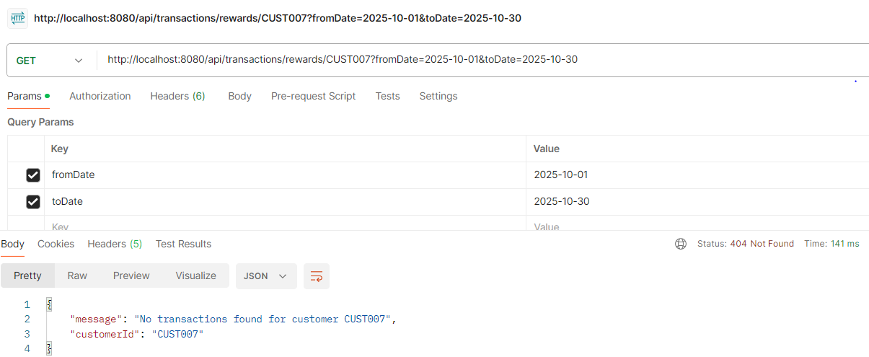

5. Customer Not found exception
