**Exercises:. Nikhil Kumar**

**4AL19CS400**

**4th sem B sec**

**1.Java program to calculate Compound Interest.**

public class CompoundInterest

{

public static void main(String args[])

{

double amount=0,principle=100,rate=10,time=3,ci;

System.out.println("principle= "+principle);

System.out.println("rate="+rate);

System.out.println("time="+time);

amount=principle*((1+rate/100)*(1+rate/100)*(1+rate/100));

System.out.println("amount="+amount);

ci=amount-principle;

System.out.println("compound interest="+ci);

}

}

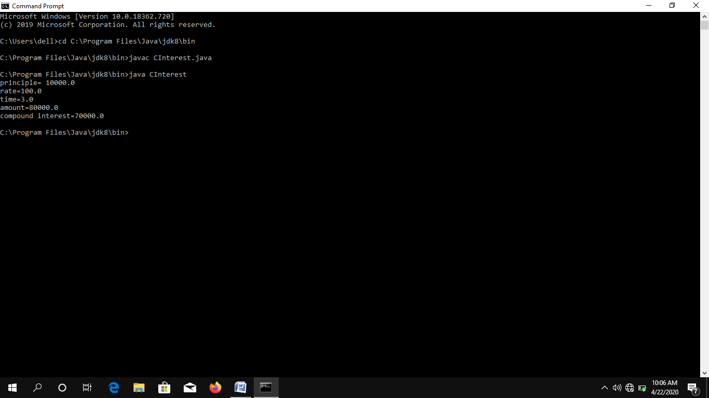

**2.Java program to convert decimal to binary number**.

public class DecimalBinary

{

public static void main(String a[]){

System.out.println("Binary representation of 120: ");

System.out.println(Integer.toBinaryString(120));

}

}

Output:

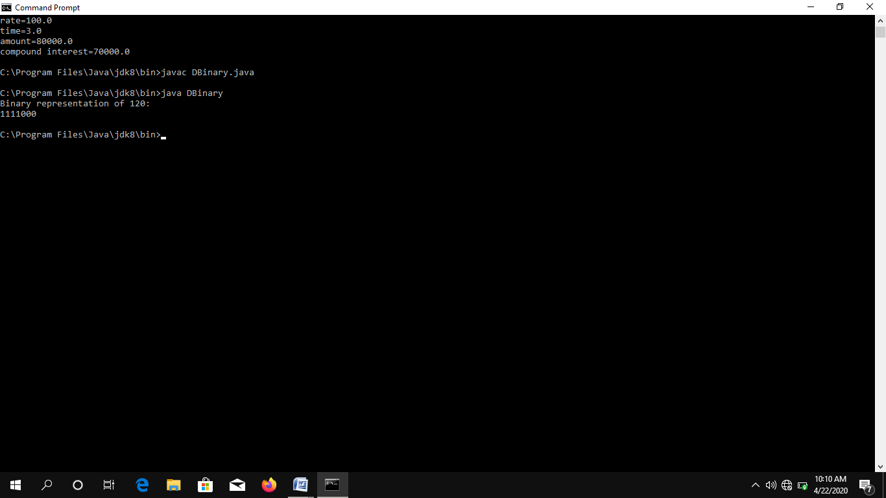

**3. Java program to check whether given number is Armstrong number**.

public class Armstrong

{

public static void main(String[] args)

{

int number = 371, originalNumber, remainder, result = 0;

originalNumber = number;

while (originalNumber != 0)

{

remainder = originalNumber % 10;

result += Math.pow(remainder, 3);

originalNumber /= 10;

}

if(result == number)

System.out.println(number + " is an Armstrong number.");

else

System.out.println(number + " is not an Armstrong number.");

}

}

Output:

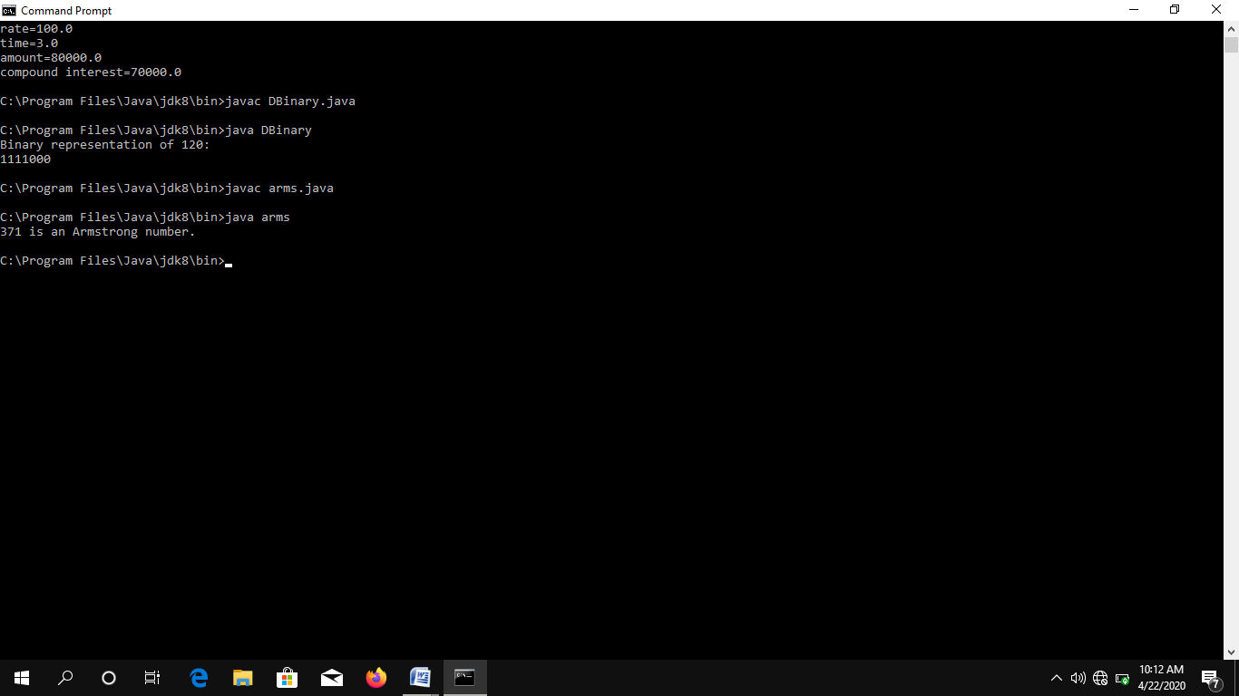

**4. Java program to demonstrate ArrayIndexOutOfBounds Exception.**

public class ArrayException {

static void printArrayValue(){

try{

String[] array = new String[]{"one","two","three","four","five"};

String value = array[10];

}catch(Exception e){

System.err.println("Exception is : "+e.toString());

}

}

public static void main(String[] args) {

printArrayValue();

}

}

Output:

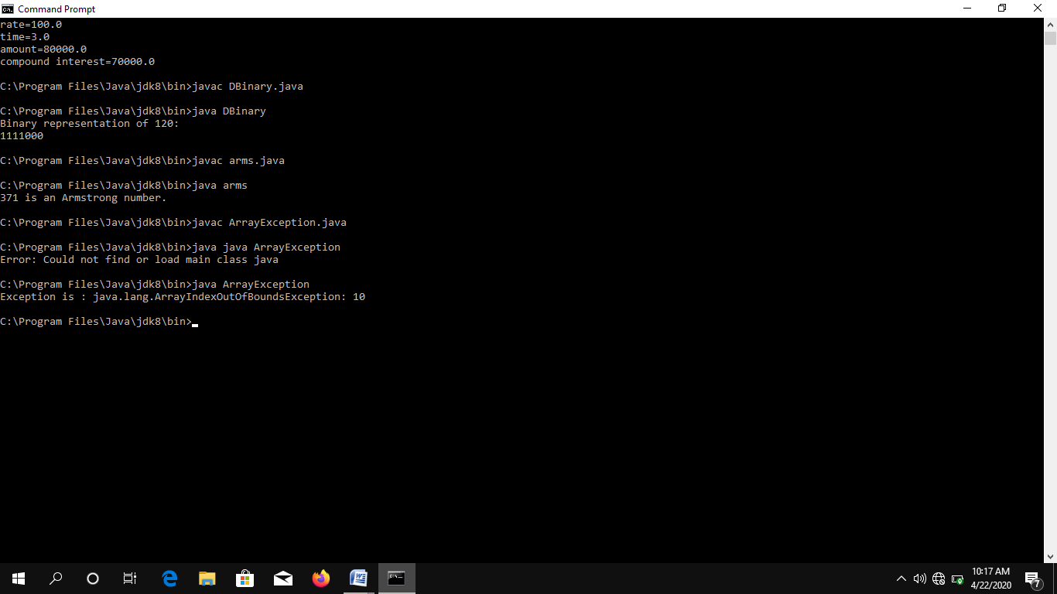

public class DeadLockBetweenTwoThreads

{

String strone = "HAI";

String strtwo = "HELLO";

Thread t1 = new Thread("Thread One"){

public void run(){

while(true){

synchronized(strone){

synchronized(strtwo){

System.out.println(strone + strtwo);

}

}

}

}

};

Thread t2 = new Thread("Thread Two"){

public void run(){

while(true){

synchronized(strtwo){

synchronized(strone){

System.out.println(strtwo + strone);

}

}

}

}

}

public static void main(String a[]){

DeadLockBetweenTwoThreads obj = new DeadLockBetweenTwoThreads();

obj.t1.start();

obj.t2.start();

}

}

Output:

