**Assignment 1**: DAX Functions in Power BI

Data Analysis Expressions (DAX) is a formula language used in Power BI to perform calculations and queries on data models. It is known as a *function language*, where all logic is written inside functions.

DAX supports two main data types:

* Numeric → integers, currency, decimals
* Other → strings and binary objects

For this assignment, I used the StudentPerformanceFactors dataset to demonstrate various DAX functions.

1. Total Students Count

Counts the total number of students in the dataset.

TotalStudents = COUNTROWS(StudentPerformanceFactors)

2. Average Exam Score

Calculates the average exam score across all students.

AverageExamScore = AVERAGE(StudentPerformanceFactors[Exam_Score])

3. Pass Rate

Calculates the percentage of students who passed, assuming a passing score threshold of 50.

PassRate =

DIVIDE(

CALCULATE(COUNT(StudentPerformanceFactors[Exam_Score]), StudentPerformanceFactors[Exam_Score] >= 50),

[TotalStudents],

0

)

4. Top 10% Score Threshold

Finds the score threshold for the top 10% of students.

Top10PercentScore = PERCENTILE.EXC(StudentPerformanceFactors[Exam_Score], 0.9)

5. Average Exam Score by Gender

Calculates the average exam score segmented by gender.

AverageScoreByGender =

CALCULATE(

AVERAGE(StudentPerformanceFactors[Exam_Score]),

ALLEXCEPT(StudentPerformanceFactors, StudentPerformanceFactors[Gender])

)

6. Score Improvement from Previous Scores

Calculates the difference between the current exam score and the previous score to measure improvement.

ScoreImprovement =

StudentPerformanceFactors[Exam_Score] - StudentPerformanceFactors[Previous_Scores]

7. Total Male Students

Counts the number of male students in the dataset.

TotalMaleStudents =

CALCULATE(

COUNT(StudentPerformanceFactors[Gender]),

StudentPerformanceFactors[Gender] = "Male"

)

Here are columns created by using DAX Function:

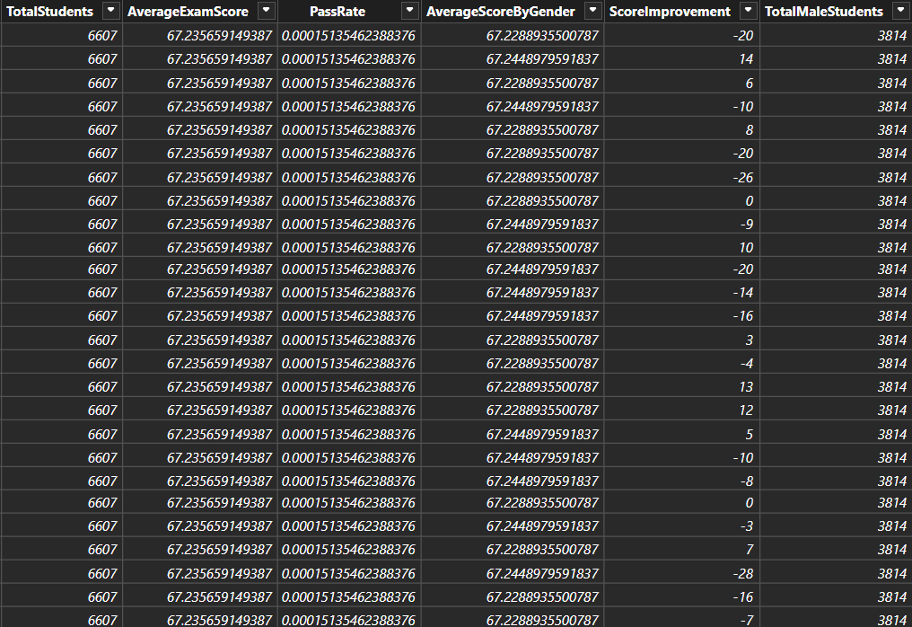

Here is report created by using DAX Function:

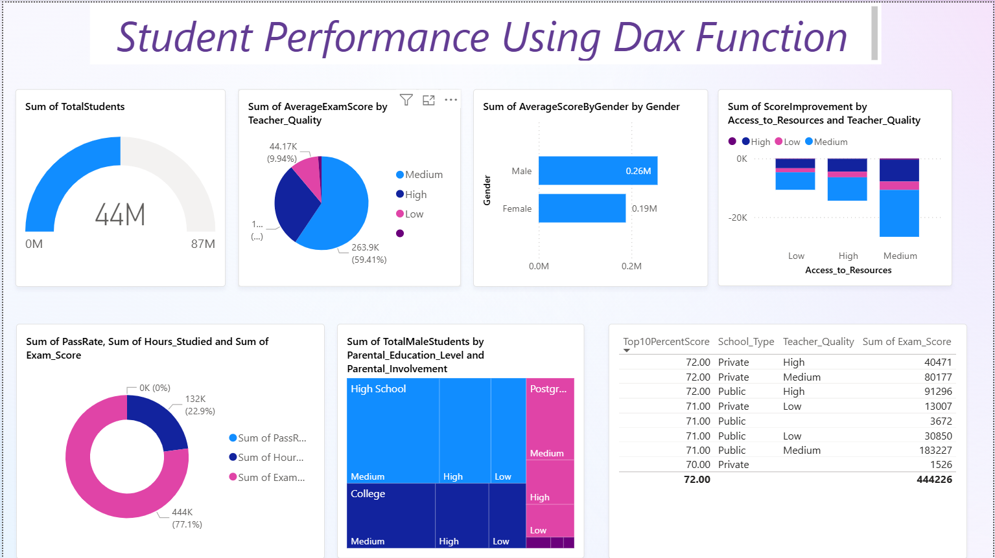

**Conclusion**:- Through these DAX functions, we can analyze student performance more effectively. We can calculate important metrics such as total students, average exam scores, pass rate, top performers, and even improvements over time. Additionally, segmentation by gender and other categories helps in deriving deeper insights from the dataset.