**JOINS**

Used to combine fields from two tables by using values common to each.

Types

1. Inner join
2. Left join
3. Right join
4. Full join
5. Natural join
6. Cross join

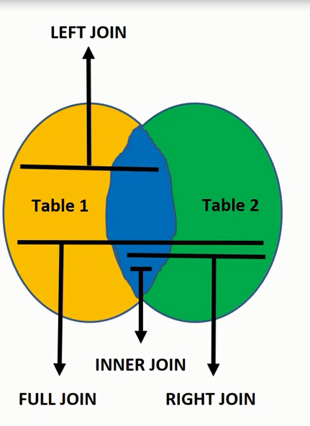

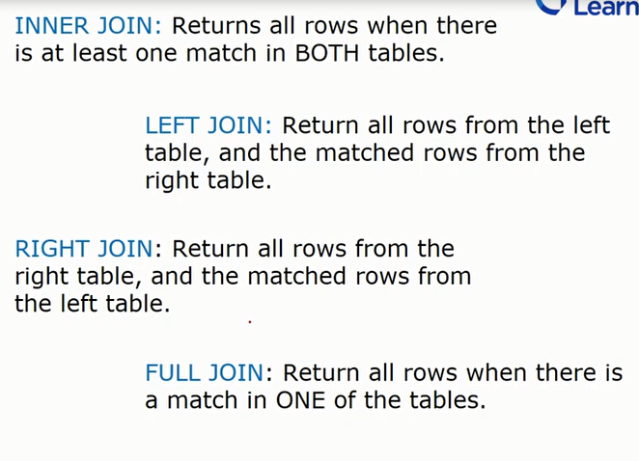

create table emp (EMP_ID NUMBER(4) PRIMARY KEY, NAME VARCHAR2(20),GENDER VARCHAR2(20),AGE NUMBER(2),SALARY NUMBER(5));

create table EMP_DEPT(DEPT_ID NUMBER(4) PRIMARY KEY, EMP_ID NUMBER(4),DEPARTMENT VARCHAR2(20), CITY VARCHAR2(20),PINCODE NUMBER(6));

DESC EMP;

DESC emp_dept;

INSERT INTO EMP_DEPT VALUES(21,206,'DEVELOPER','DELHI',258988);

INSERT INTO EMP_DEPT VALUES(22,202,'SALES','hYDERABAD',546656);

INSERT INTO EMP_DEPT VALUES(23,205,'DEVELOPER','AMRAWATI',444901);

INSERT INTO EMP_DEPT VALUES(24,203,'HR','NAGPUR',111222);

INSERT INTO EMP_DEPT VALUES(25,201,'MBA','MORSHI',444905);

INSERT INTO EMP VALUES(201,'NIKHIL','MALE',25,2500);

INSERT INTO EMP VALUES(202,'ADITYA','MALE',55,2585);

INSERT INTO EMP VALUES(203,'POOJA','FEMALE',24,5555);

INSERT INTO EMP VALUES(204,'ANAND','MALE',41,557);

INSERT INTO EMP VALUES(205,'DHANU','FEMALE',26,455);

INSERT INTO EMP VALUES(206,'GANESH','MALE',25,8988);

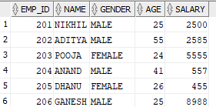

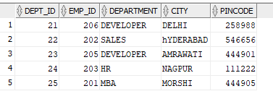

WHICH JOIN WE SHOULD USE IS BASED UPON WHOSE COMMON DETAILS WE HAVE TO SHOW.

HERE TABLE1/LEFT TABLE = EMP, TABLE2/RIGHT TABLE =EMP_DEPT

JISKE COMMON DETAILS, WO JON USE KARO

1. **INNER JOIN/ JOIN**

**Returns all rows when there is at least one match in both tables**

**Drawback**

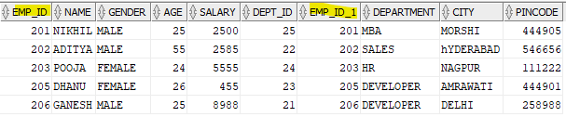

1. **Left join/left outer join**

**Here we will get all details of table1 and common details of table 2**

--WRITE A QUERY TO DISPLAY COMMON DETALS FROM DEPT AND ALL DETAILS FROM EMP BY USING LEFT JOIN

select * from emp e left join emp_dept d on e.emp_id = d.emp_id;

--OR

select * from emp e left outer join emp_dept d on e.emp_id = d.emp_id;

1. **Right join/ right outer join**

**Here we will common details of table1 and all details of table 2**

WRITE A QUERY TO DISPLAY COMMON DETALS FROM EMP AND ALL DETAILS FROM DEPT BY USING RIGHT JOIN

select * from emp e right join emp_dept d on e.emp_id = d.emp_id;

**--NOTE**

**--table name written on left side of RIGHT JOIN => show matched common data**

**--table name written on right side of RIGHT JOIN => show all data**

--SHOWS MATCHED DATA OF DEPT AND ALL DATA OF EMPLOYEE

select * from emp_dept d right join emp e on e.emp_id = d.emp_id;

1. **Natural join**

* **It is same as inner join. Only we don’t write a condition here (ON condition)**
* **A NATURAL JOIN is a join operation that creates an implicit join clause for you based on common columns in two tables being join.(seems like inner join)**
* **A natural join can be inner join, left join, right join.**

**--write a query to display all data from employee and department table where where values of**

**empIf of employee = department table usng natural join.**

**select * from emp natural join emp_dept;**

**difference between natural join and inner join**

1. no need to write ON condition
2. duplicate columns (emp_d) wont show

* **natural left join act sas left join**

select * from emp natural left join emp_dept;

* **natural right join act sas right join**

select * from emp natural right join emp_dept;

1. **Cross join**

* **Cross join/ Cartesian join returns the "Cartesian product" of sets of records from two or more joined tables.**
* **What is Cartesian product? => multiplying each row of table1 to each and every row of table 2**

1. **Self join**

* **IT IS USED TO JOIN A TABLE WITH ITSELF AS IF THE TABLES WERE TWO TABLES.**
* **TO JOIN THE TABLES MEANS THAT EACH ROW OF THE TABLE IS COMBINED WITH IT=ITSELF AND WITH EVERY OTHER ROW OF THE TABLE.**

**Syntax**

select a.col_nme,b.col_name

from table1 a, table2 b

where a.common_field=b.common_field;

**here we are join one table with itself.**