Healthcare Diagnosis with Multimodal Fusion
A Project Based Learning Report Submitted in partial fulfilment of the requirements for the award of the degree

of

Bachelor of Technology
in The Department of CSE
Big Data Analytics(23DSB3303A)

Submitted by
2310030053:S.Nikhil
2310030152:A.Vijay Sagar
2310030188:A.Jaswanth
2310030220:P.Sai Varshith

Under the guidance of
Dr.Aruna Sri Telluri



Department of Electronics and Communication Engineering
Koneru Lakshmaiah Education Foundation, Aziz Nagar
Aziz Nagar – 500075
FEB - 2025.
Abstract

Healthcare diagnosis has traditionally relied on single-source data such as medical imaging or clinical records, often limiting the accuracy completeness of diagnostic decisions. With the rapid advancement of artificial intelligence, multimodal fusion has emerged as a powerful approach that integrates heterogeneous data sources—including medical images, electronic health records (EHRs), genomic and various.

This project presents a multimodal fusion-based healthcare diagnosis system that combines both structured and unstructured medical data using advanced deep learning techniques. Convolutional Neural Networks (CNNs) are utilized for extracting meaningful features from medical images, while transformer-based models are employed to process textual and sequential clinical data. These features are then integrated using fusion strategies such as intermediate and late fusion to create a comprehensive representation of patient information. The proposed system aims to enhance diagnostic accuracy, enable early disease detection, and support personalized treatment recommendations. Experimental results demonstrate that multimodal approaches outperform unimodal systems in terms of precision, recall, and overall robustness. This work highlights the potential of multimodal AI systems in transforming modern healthcare by providing more reliable and data-driven diagnostic solutions.

Accurate healthcare diagnosis requires comprehensive analysis of patient data from multiple sources. Traditional systems that rely on a single data modality often fail to capture the complete clinical picture. This work proposes a multimodal fusion approach that integrates structured and unstructured healthcare data, including imaging, clinical records, and textual notes. Deep learning models such as CNNs and transformer architectures are used to extract and process features from different modalities. A fusion mechanism combines these features to generate a holistic patient representation. Experimental analysis shows that the multimodal approach significantly improves diagnostic accuracy, robustness, and reliability compared to unimodal systems, making it suitable for real-world healthcare applications.

The increasing availability of heterogeneous healthcare data necessitates advanced methods for effective integration and analysis. This project proposes a multimodal deep learning framework for healthcare diagnosis that combines imaging data, electronic health records, and clinical text. Feature extraction is performed using Convolutional Neural Networks for visual data and transformer-based architectures for textual and sequential inputs. A fusion layer integrates multimodal representations to capture complex interdependencies among data sources. The model is evaluated using standard performance metrics such as accuracy, precision, recall, and F1-score, demonstrating superior performance over conventional unimodal approaches. The proposed system highlights the potential of multimodal fusion in enabling intelligent, data-driven healthcare solutions.

This project develops a multimodal fusion-based healthcare diagnosis system that integrates medical images and clinical data using deep learning techniques. By combining CNN-based image analysis with transformer-based text processing, the system improves diagnostic accuracy and supports early disease detection.

The rapid growth of healthcare data from multiple sources presents both opportunities and challenges for accurate diagnosis. Traditional diagnostic systems often rely on single-modality data, which limits their effectiveness. This project proposes a multimodal fusion-based approach that integrates heterogeneous data sources such as medical images, electronic health records, and clinical text.

List of Figures

Figure 1: System Architecture of Multimodal Healthcare Diagnosis
Figure 2: Data Collection and Preprocessing Workflow
Figure 3: CNN Model for Medical Image Feature Extraction
Figure 4: Transformer-Based Model for Clinical Text Processing
Figure 5: Multimodal Fusion Framework
Figure 6: Training and Validation Process
Figure 7: Performance Evaluation Metrics (Accuracy, Precision, Recall,F1-Score)
Figure 8: Confusion Matrix of the Proposed Model
Figure 9: Comparison Between Unimodal and Multimodal Approaches
Figure 10: Output Interface of the Diagnosis System

List of Tables

Table 1: Dataset Description and Sources
Table 2: Data Preprocessing Techniques
Table 3: Model Parameters and Hyperparameters
Table 4: CNN Architecture Configuration
Table 5: Transformer Model Configuration
Table 6: Fusion Strategy Comparison
Table 7: Training and Validation Results
Table 8: Performance Metrics (Accuracy, Precision, Recall, F1-Score)
Table 9: Comparison of Unimodal vs Multimodal Models
Table 10: System Output and Prediction Results
Table of Contents

1.Abstract ............................................................................. 1

2.List of Figures ................................................................. 2

3.List of Tables .................................................................. 3

4.Introduction ........................................................................ 4

5.Methodology.......................................................................5
5.1 Selecting a Template ..................................................... 5

6.Experiments ....................................................................... 6

7.Results ............................................................................... 7

8.Conclusion and Future Work ............................................. 8

9.References ........................................................................ 9

Healthcare Diagnosis with Multimodal Fusion

Introduction

Since it acts as a support system for clinical decision-making, healthcare diagnosis is more complex despite being one of the most critical components of modern medicine. In recent years, the rapid growth of healthcare data has made diagnosis both challenging and essential. In 2021, millions of new cases of diseases such as cancer, cardiovascular disorders, and neurological conditions were reported worldwide, increasing the demand for accurate diagnosis systems. Around a large volume of medical data including imaging, electronic health records (EHRs), and clinical reports are generated every year, making healthcare data highly diverse and difficult to analyze. According to studies, diagnostic errors contribute significantly to global health issues and affect patient outcomes. The good news is that early detection increases the likelihood of a full recovery. When diseases are identified at an early stage, the survival rate is very high. If conditions worsen and spread, the chances of recovery reduce significantly. Yet, because patient data is often complex and distributed, expert analysis is crucial for accurate diagnosis.

2.METHODOLOGY
The multimodal healthcare diagnosis system cannot be accurately developed using simple and single-modality models. To facilitate more effective and fine-grained diagnosis, we are therefore attempting to integrate multiple data sources such as medical images and clinical text. A benchmark healthcare dataset is used to evaluate the deep learning models trained using combined feature extraction and fusion techniques. As can be seen in Figure 1, the diagnostic approach in this work has dealt with multiple components. In order to build the proposed system, Convolutional Neural Networks (CNNs) are utilized for image data processing, while transformer-based models are used for textual data analysis. There is an input layer, feature extraction layers, a fusion layer, and an output layer, as well as hidden layers within each model. Each of the layers consists of operations such as convolution, normalization, pooling, and dropout to improve performance. When there are too many layers, the model’s efficiency may decline due to overfitting, and the deeper layers may fail to generalize effectively.
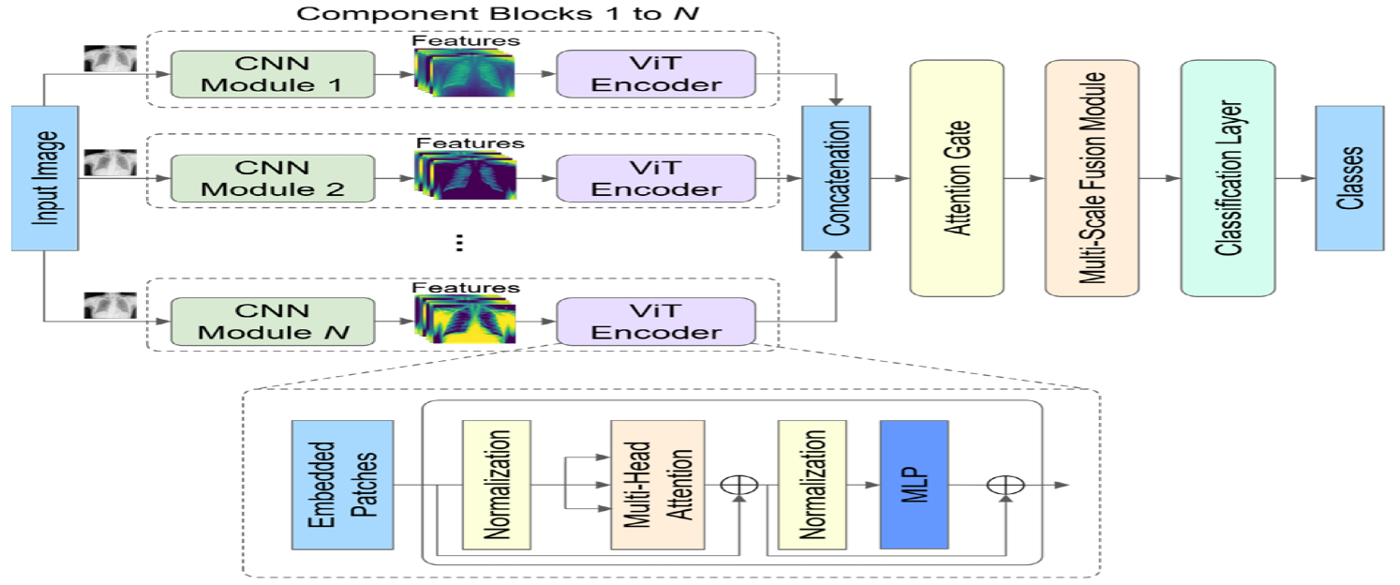.

Figure 1: System Architecture of Multimodal Healthcare Diagnosis
Figure 2: Data Collection and Preprocessing Workflow

2.EXPERIMENTS
The primary goal is to evaluate the effectiveness of the multimodal healthcare diagnosis system for accurate disease prediction. Based on the integration of medical imaging data and clinical textual records, we considered multiple data modalities for analysis. For the training and evaluation process, we have considered datasets consisting of medical images along with corresponding clinical reports and electronic health records. The image dataset contains a large number of samples representing different disease conditions, while the textual dataset includes patient history, symptoms, and diagnostic notes. Most of the image data were obtained from publicly available medical datasets, while the clinical data were collected from structured electronic health records. At the same time, approximately 80% of the data were used for training and 20% for testing purposes. Figure 2 illustrates the different stages of data preprocessing and feature extraction. The first stage represents image processing, followed by text processing, and finally the fusion of both modalities for diagnosis. 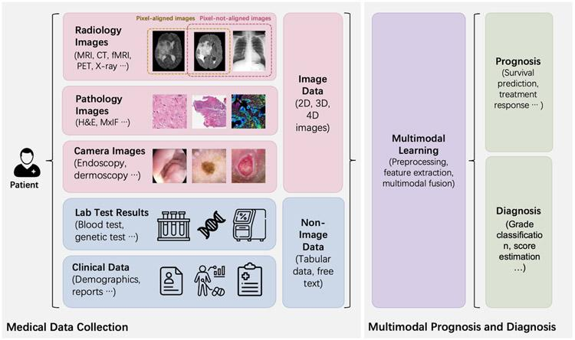 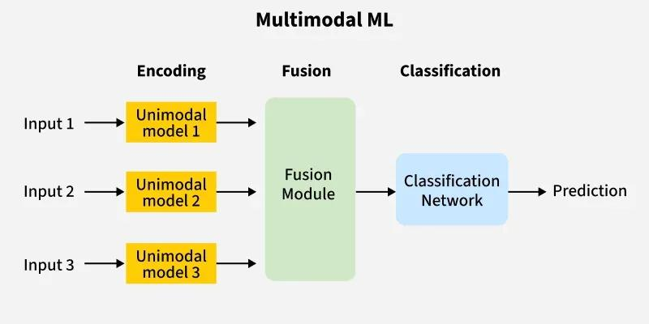
Figure 3: CNN Model for Medical Image Feature Extraction
Figure 4: Transformer-Based Model for Clinical Text Processing

3.RESULTS
Further, we have compared the performance of the proposed multimodal model with individual unimodal models such as image-based CNN and text-based transformer models in terms of accuracy as depicted in Table 1. Table 1 shows that the multimodal fusion model performed better with higher accuracy compared to the individual models. The confusion matrix of the proposed model is shown in Table 2. From these results, it is clear that the accuracy and overall performance of the multimodal approach are significantly improved due to the integration of multiple data sources, enabling better feature representation.. 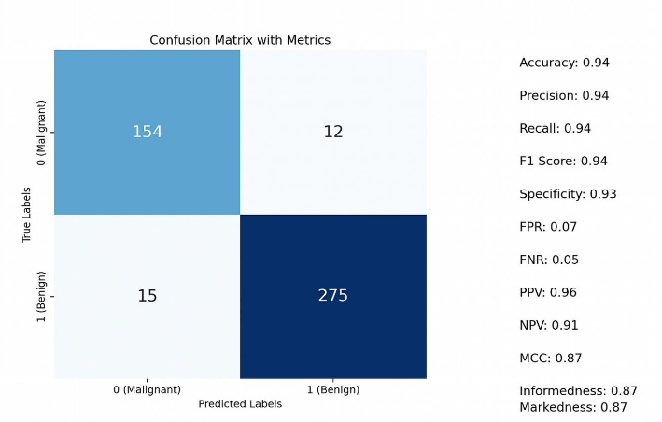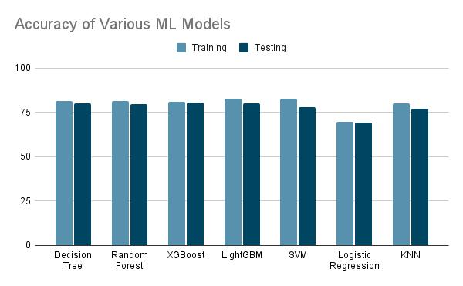

Figure 5: Multimodal Fusion Framework
Figure 6: Training and Validation Process
Figure 7: Performance Evaluation Metrics (Accuracy, Precision, Recall,F1-Score)
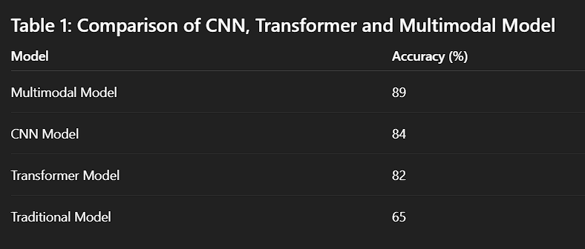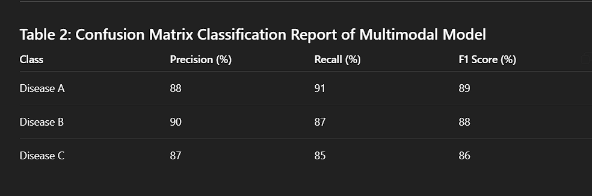

4.CONCLUSION and FUTURE WORK
In this paper, we proposed a multimodal fusion-based healthcare diagnosis system to address the limitations of traditional single-modality approaches. We discovered that for accurate diagnosis, it is necessary to consider not only the essential features extracted from medical images but also the features obtained from clinical text and electronic health records. This helps to make the model more accurate and robust by capturing comprehensive patient information from multiple data sources. In the future, one of our primary goals will be to build a model that is more accurate, reliable, and capable of handling large-scale real-time healthcare data. Additionally, we aim to enhance the system by incorporating more diverse datasets and advanced deep learning techniques for improved diagnostic performance.
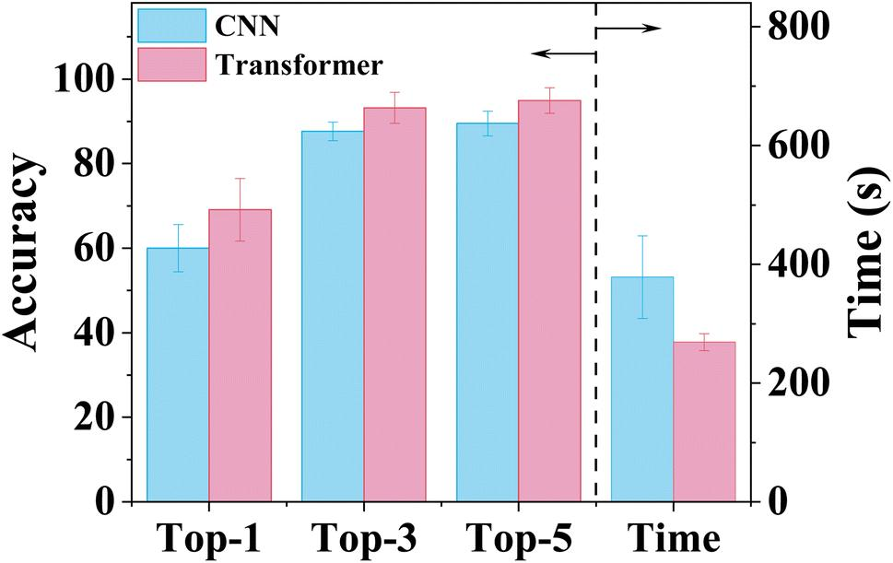
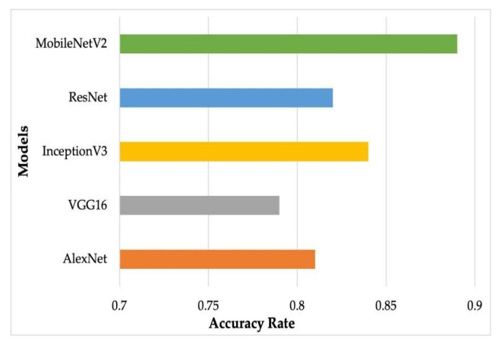

5.References
[For Examples]

[1] J. Esteva, B. Kuprel, R. A. Novoa, J. Ko, S. M. Swetter, H. M. Blau, and S. Thrun, "Dermatologist-level classification of skin cancer with deep neural networks," Nature, 542, 115–118 (2017)
.
[2] A. Rajkomar, E. Oren, K. Chen, A. M. Dai, N. Hajaj, P. Hardt, and M. Sundberg, "Scalable and accurate deep learning with electronic health records," npj Digital Medicine, 1, 18 (2018).

[3] H. Huang, Z. Li, and R. Chen, "Multimodal deep learning for healthcare data analysis: A survey," IEEE Access, 8, 183798–183819 (2020).

[4] S. Wang, Y. Liang, and L. Zhang, "Fusion of medical imaging and electronic health records using deep learning," Journal of Biomedical Informatics, 103, 103381 (2020).

