

Darshan University

A Project Report on

**“Furniture Management System”**

Under the subject

**Software Engineering (2305CS202)**

MCA, Semester – II

Department of Computer Application

|  |  |
| --- | --- |
| Submitted By | |
| Student Name: Nikhil Rathod | Enrolment No.: 24030501039 |
| Academic Year  (2024-2025) | |
| Internal Guide  Prof. Devangi L. Kotak  Darshan University | Dean-DIET  Dr. Gopi Sanghani  Darshan University |

|  |  |
| --- | --- |
|  | **Department of Computer Application**  **Darshan University** |

**DECLARATION**

We hereby declare that the SRS, submitted along with the **Software Engineering** **(2305CS202)** for entitled **“Furniture Management System”** submitted in partial fulfilment for the Semester-2 of **Master of Computer Application (MCA)** in **Department of Computer Application (DoCA)** Departmentto Darshan University, Rajkot, is a record of the work carried out at **Darshan University, Rajkot** under the supervision of  **Prof. Devangi L. Kotak** and that no part of any of report has been directly copied from any students’ reports, without providing due reference.

Nikhil Rathod

Student’s Signature

Date: 02/04/2025

|  |  |
| --- | --- |
|  | **Department of Computer Application**  **Darshan University** |

**CERTIFICATE**

This is to certify that the SRS on **“Furniture Management System” has** been satisfactorily prepared by **Nikhil Rathod (24030501039)** under my guidance in the fulfillment of the course **Software Engineering (2305CS202)** work during the academic year 2024-2025.

|  |  |  |
| --- | --- | --- |
| Internal Guide  Prof. Devangi L. Kotak  Darshan University |  | Dean-DIET  Dr. Gopi Sanghani  Darshan University |

**Acknowledgement**

I wish to express my sincere gratitude to my project guide Prof. **Devangi L. Kotak** and all the faculty members for helping me through my project by giving me the necessary suggestions and advices along with their valuable co- ordination in completing this work.

I also thank my parents, friends and all the members of the family for their precious support and encouragement which they had provided in completion of my work. In addition to that, I would also like to mention the Darshan University personals who gave me the permission to use and experience the valuable resources required for the project from the University premises.

Thus, in conclusion to the above said, I once again thank the faculties and members of **Darshan University** for their valuable support in completion of the project.

Thanking You

**Nikhil Rathod**

**ABSTRACT**

The Furniture Management System is an all-inclusive solution designed for managing custom furniture manufacturing and selling ready-made furniture. This system helps in the management of the furniture business as it offers an easy-to-use digital platform for customer orders, inventory, and production processes.

The system includes modules specifically for the making of custom furniture. Customers can place orders for such customized furniture by specifying their requirements, dimensions, materials, and design preferences, which the admin can manage and track to achieve production and delivery on time.

For customers purchasing readymade furniture, the system presents a catalog of the available furniture items that can be browsed through, view details of a product, and make a direct purchase. It is also possible to track an order status and follow updates from the customer side. The admin module also encompasses inventory management, production tracking of custom orders, sales data management, and producing reports on sales, production, inventory, and activity from customers.

# List of Figures

|  |  |  |
| --- | --- | --- |
| **Fig. No.** | **Name** | **Pg.no.** |
| Fig. 2.1.1 | Use case diagram for Furniture management system | 3 |
| Fig. 2.2.1 | Activity diagram for Furniture management system | 4 |
| Fig. 2.2.2 | Swimlane diagram for Furniture management system | 5 |
| Fig. 2.3.1 | Sequence diagram for Furniture management system | 6 |
| Fig. 2.4.1 | State diagram of Furniture | 7 |
| Fig. 2.5.1 | Class diagram for Furniture management system | 8 |
| Fig. 2.6.1 | Context diagram for Furniture management system | 9 |
| Fig. 2.6.2 | DFD level-1 for Furniture management system | 10 |
| Fig. 2.6.3 | DFD level-2 for Furniture management system | 11 |
| Fig. 3.1.1 | Screen-1: Admin Add product | 12 |
| Fig. 3.1.2 | Screen-2: View Orders | 13 |
| Fig. 3.1.3 | Screen-3: Admin Report Generation | 14 |

# List of Tables

|  |  |  |
| --- | --- | --- |
| **Table no.** | **Name** | **Pg.no.** |
| Table 3.1-1 | Screen element of Admin Add product | 12 |
| Table 3.1-2 | Screen element of View Orders | 13 |
| Table 3.1-3 | Screen element of Admin Report Generation | 14 |
| Table 4.1-1 | Table: Customer | 15 |
| Table 4.1-2 | Table: Category | 15 |
| Table 4.1-3 | Table: Product | 15 |
| Table 4.1-4 | Table: Order | 16 |
| Table 4.1-5 | Table: Payment | 16 |
| Table 4.1-6 | Table: SalesReport | 16 |

**TABLE OF CONTENT**

|  |  |  |  |
| --- | --- | --- | --- |
| **Chapter No** | **Chapter Title** | | **Page No** |
|  | Acknowledgement | | iv |
|  | Abstract | | v |
|  | List of Figure | | Vi |
|  | List of Table | | vii |
|  | Table of Contents | | viii |
| **Chapter 1** | **INTRODUCTION** | | 1 |
|  | 1.1 | Product perspective | 1 |
|  | 1.2 | Product features | 1 |
|  | 1.3 | Functional requirements | 1 |
|  | 1.4 | Non-functional requirements | 2 |
| **Chapter 2** | **DESIGN AND IMPLEMENTATION CONSTRAINTS** | | 3 |
|  | 2.1 | Use case diagram | 3 |
|  | 2.2 | Activity diagram and Swimlane diagram | 4 |
|  | 2.3 | Sequence diagram | 6 |
|  | 2.4 | State diagram | 7 |
|  | 2.5 | Class diagram | 8 |
|  | 2.6 | Data flow diagram | 9 |
|  |  | 2.6.1 Context diagram (level-0) | 9 |
|  |  | 2.6.2 DFD Level-1 | 10 |
|  |  | 2.6.3 DFD Level-2 | 11 |
| **Chapter 3** | **EXTERNAL INTERFACE REQUIREMENT (SCREENS)** | | 12 |
|  | 3.1 | Screen-1: Admin Add product | 12 |
|  |  | Screen-2: View Orders | 13 |
|  |  | Screen-3: Admin Report Generation | 14 |
| **Chapter 4** | **DATABASE DESIGN** | | 15 |
|  | 4.1 | List of tables | 15 |
|  | **REFERENCES** | | 17 |

# Introduction

## Product perspective

The Furniture Management System is a digital solution designed to modernize traditional furniture business processes by providing an internet-based platform for managing both custom-made and ready-made furniture operations. It offers customers a seamless experience to browse, order, and track furniture, while administrators can efficiently manage inventory, orders, and production schedules. Supporting multi-user features, the software contains all such basic operations necessary for inventory, custom order tracking, sales processing, and report generation.

## Product features

### There are three different users who will be using this product:

* **Admin**, who acts as the system manager
* **Customer**, who can purchase ready-made furniture or request custom furniture.

### Features for Admin:

* Manage the inventory of ready-made furniture, including adding, updating, and deleting furniture details.
* Handle custom furniture requests by reviewing customer specifications and tracking the production process.
* Monitor and update the status of customer orders (both custom and ready-made).

### Features for Customers:

* Browse the catalog of ready-made furniture by categories and view product details.
* Place orders for ready-made furniture and track order status.
* Submit custom furniture requests by specifying dimensions, materials, and design preferences.

## Functional Requirement

### **Admin Requirement**

* **Add Furniture:** New entries must be entered in the database with category, dimensions, material, price, and availability.
* **Update Furniture:** Modify details of existing furniture, including price, stock, and specifications.
* **Delete Furniture:** Remove incorrect or obsolete furniture entries from the inventory.
* **Order Management:** Manage and track customer orders, approve/reject custom requests, and update order statuses.
* **Customer Management:** Maintain a detailed database of customers with contact details and order history.
* **Barcode scanning:** To read the barcode easily using RFID sensors. The database is automatically updated when books are scanned while issuing or returning.
* **Inventory Management:** Track and manage stock levels for furniture and raw materials.
* **Search Functionality:** Search furniture by category, attributes, or keywords.
* **Check In article:** After receiving any article system will renter article by Checking
* **Permission Management:** Set user permissions to restrict or enable access to functionalities.
* **Report Generation:** Generate detailed reports on sales, inventory, production, and customer activity.

### **Customer Requirement**

* **Authentication:** Customers must securely log in before accessing the system
* **Browse Furniture:** View a categorized catalog of ready-made furniture with details and images.
* **Custom Furniture Requests:** Submit requests specifying dimensions, materials, and design preferences.
* **Order Tracking:** Track the status of both ready-made and custom orders.
* **Search Functionality:** Search furniture by category, price range, materials, or other attributes.
* **Request New Designs:** Suggest new furniture designs or request unavailable items.
* **Account Management:** View and manage personal account details, purchase history, and order statuses.

## Non-Functional Requirement

### **Accuracy:**

* The data stored about the books and the fines calculated should be correct, consistent, and reliable.

### **Availability:**

* The System should be available for the duration when the library operates and must be recovered within an hour or less if it fails. The system should respond to the requests within two seconds or less.

### **Maintainability:**

* The software should be easily maintainable and adding new features and making changes to the software must be as simple as possible. In addition to this, the software must also be portable.

# Design and Implementation Constraints

## Use case diagram

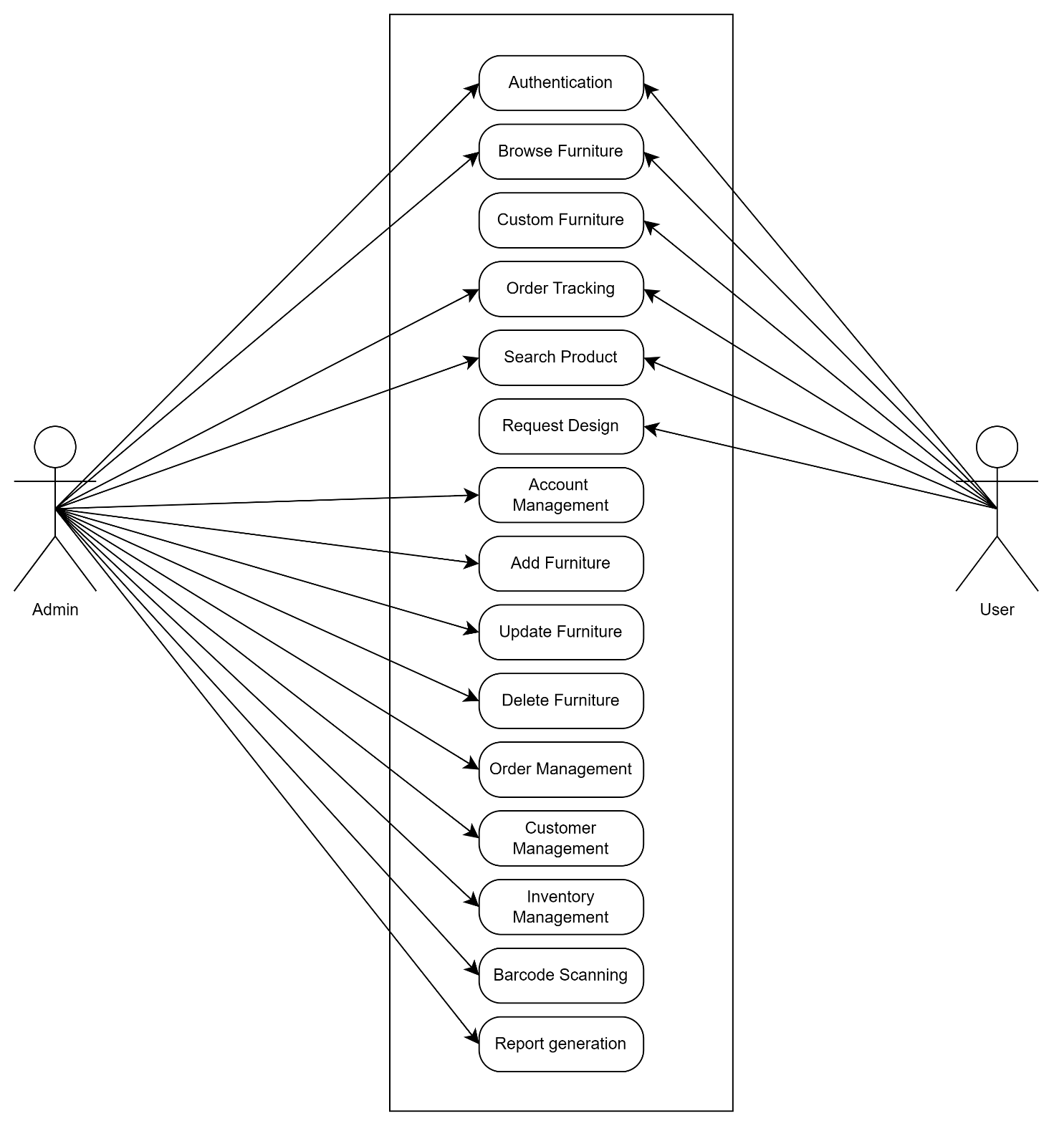

Figure ‑ Use case diagram for furniture management system

## Activity diagram and Swimlane diagram

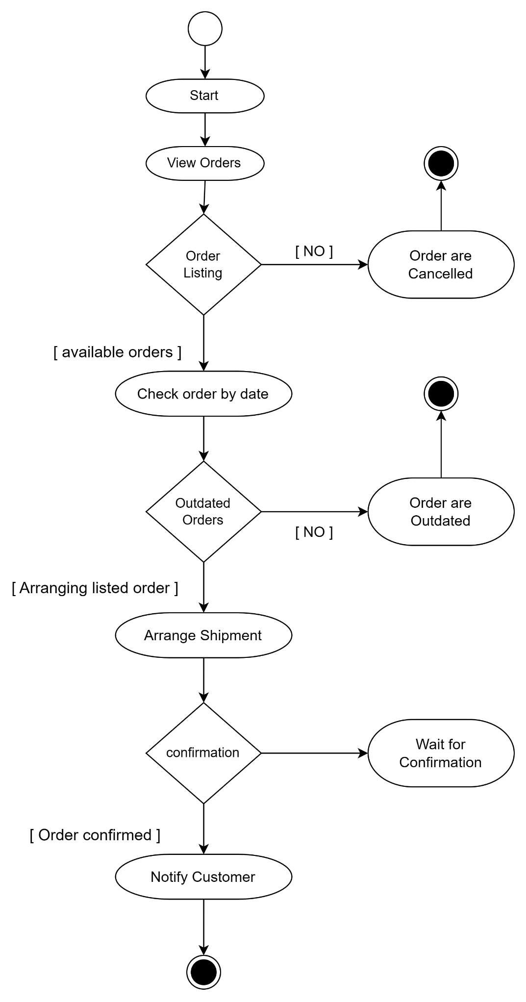

Figure 2.2‑1 Activity diagram for Manage Order

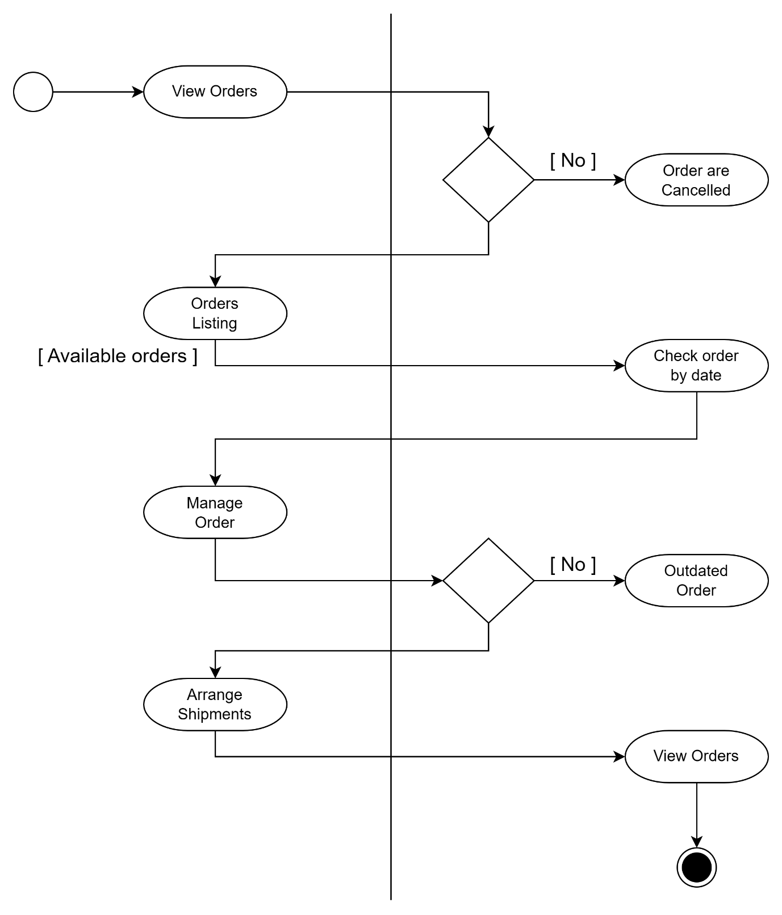

Figure 2.2‑2 Swimlane diagram for User Order

## Sequence diagram

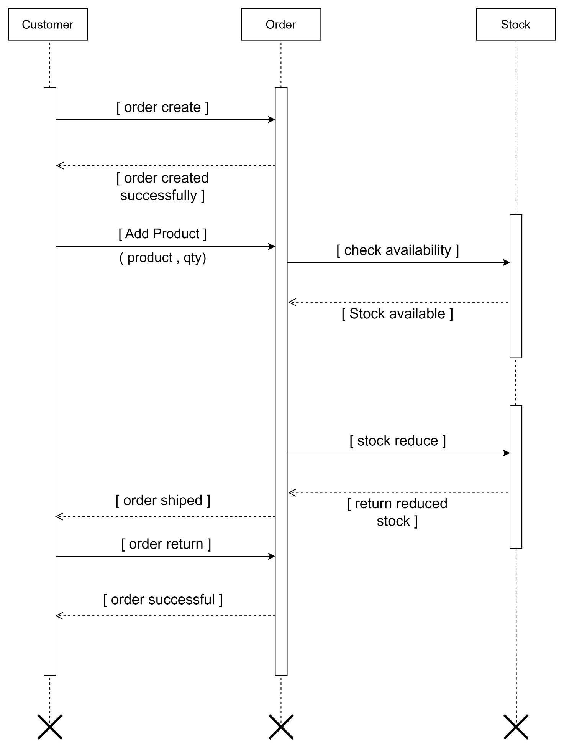

Figure ‑ Sequence diagram for User Order

## State diagram

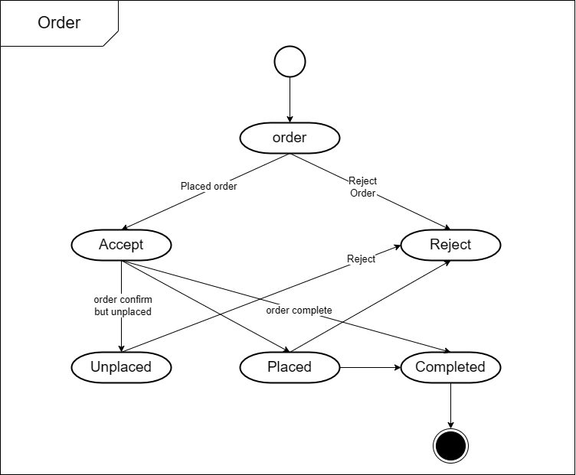

Figure 2.4‑1 State diagram of Order

## Class diagram

Figure 2.5‑1 Class diagram for Furniture management system

## 2.6 Data flow diagram

### Context diagram (level-0)

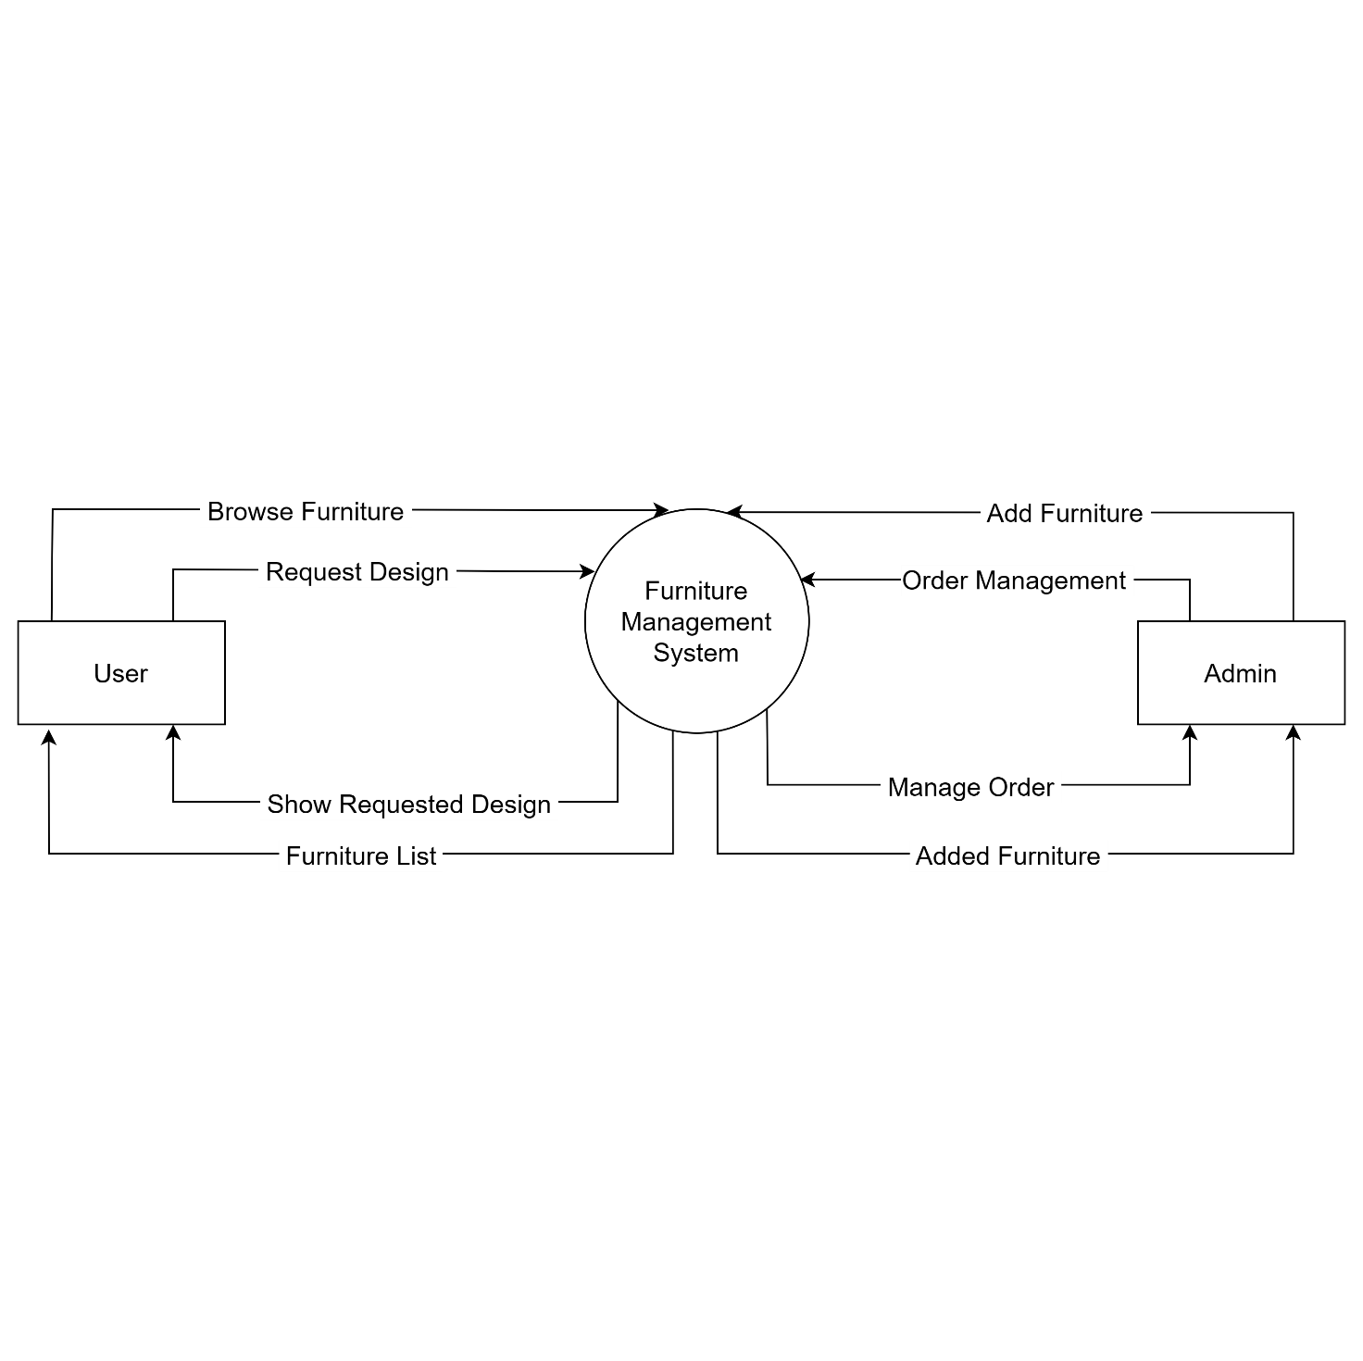

Figure ‑ Context diagram for furniture management system

### DFD Level-1

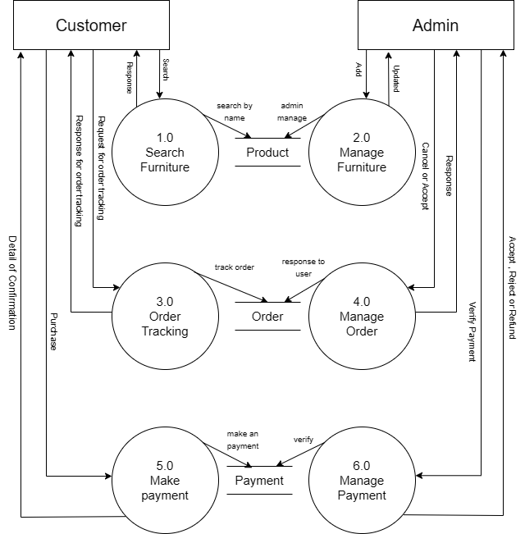

Figure ‑ DFD level-1 for Furniture Management system

### DFD Level-2

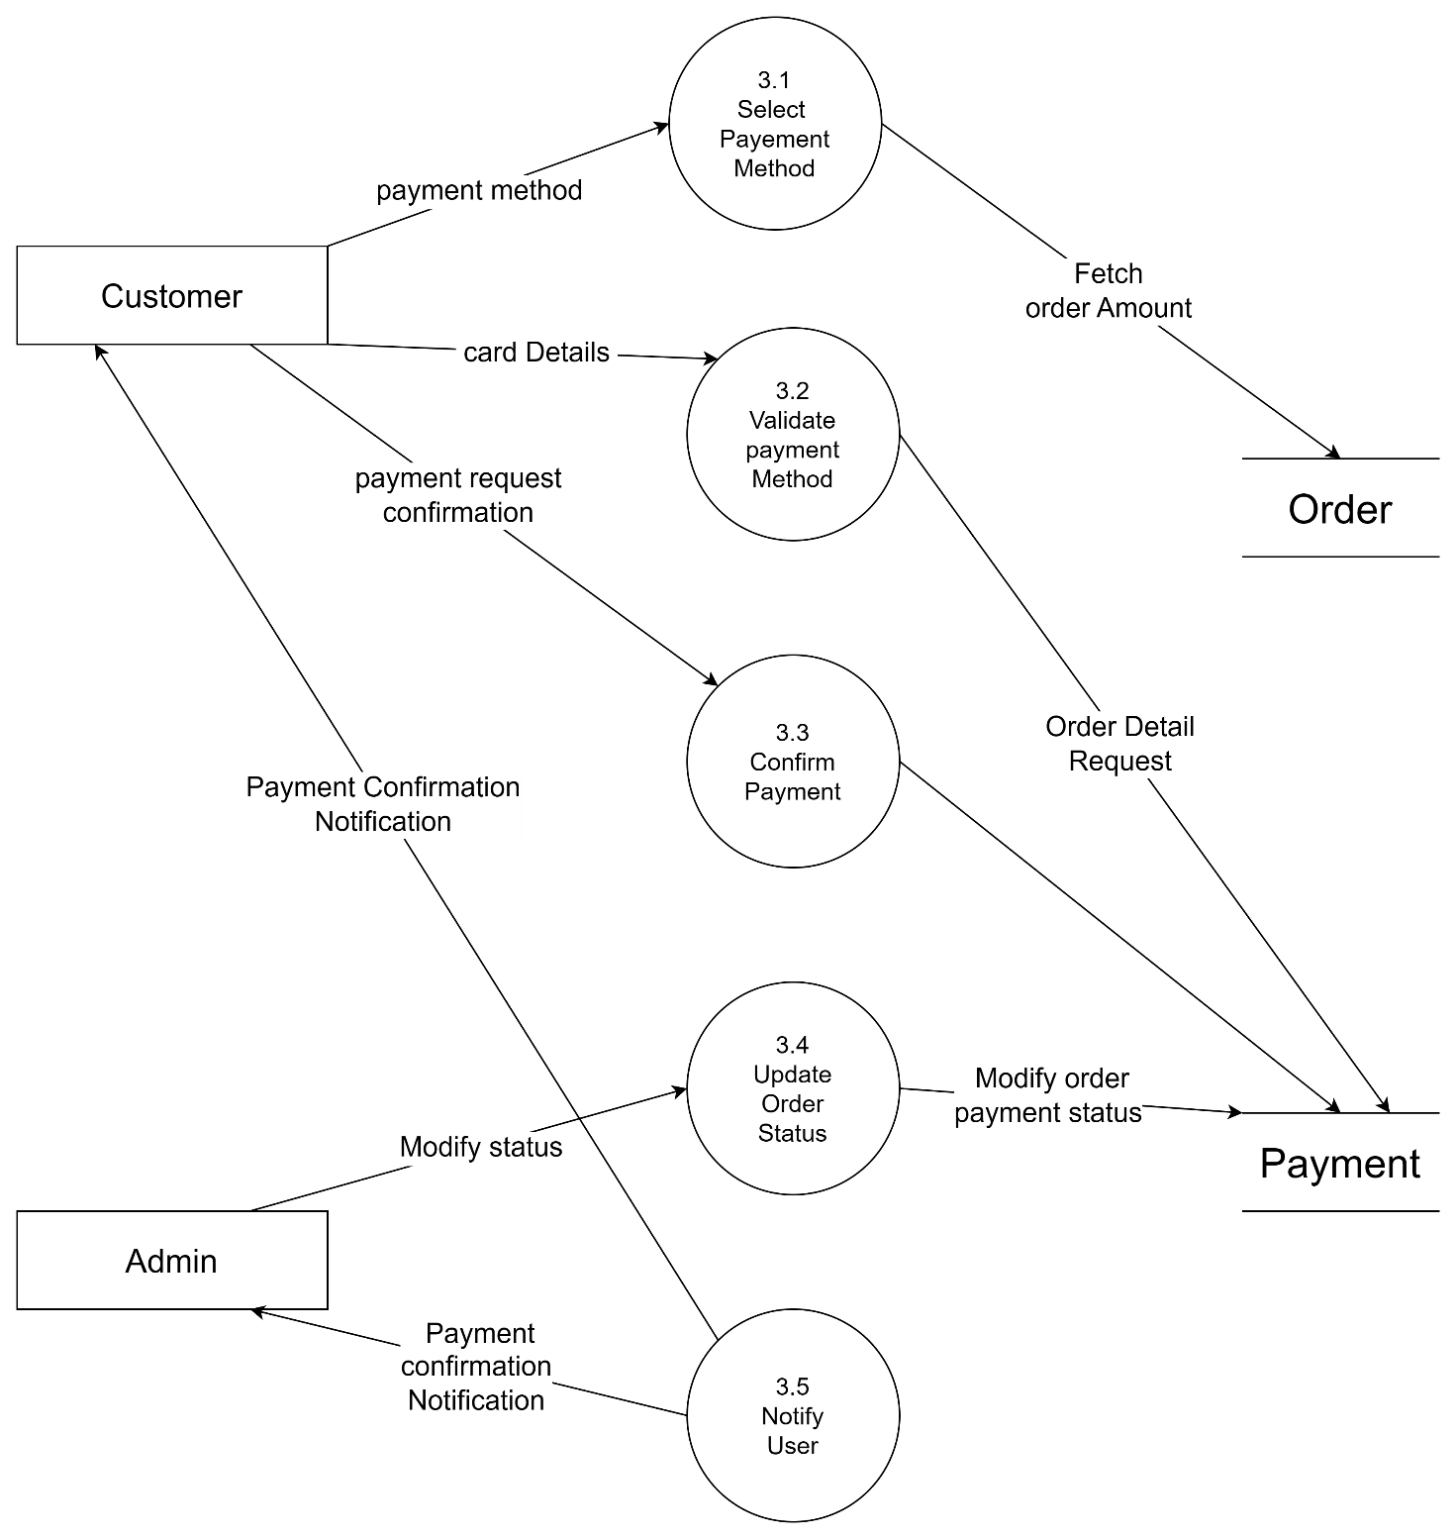

Figure ‑ DFD level-2 for Manage Payment

# External interface requirement (Screens)

## Screen-1: Admin Add Product

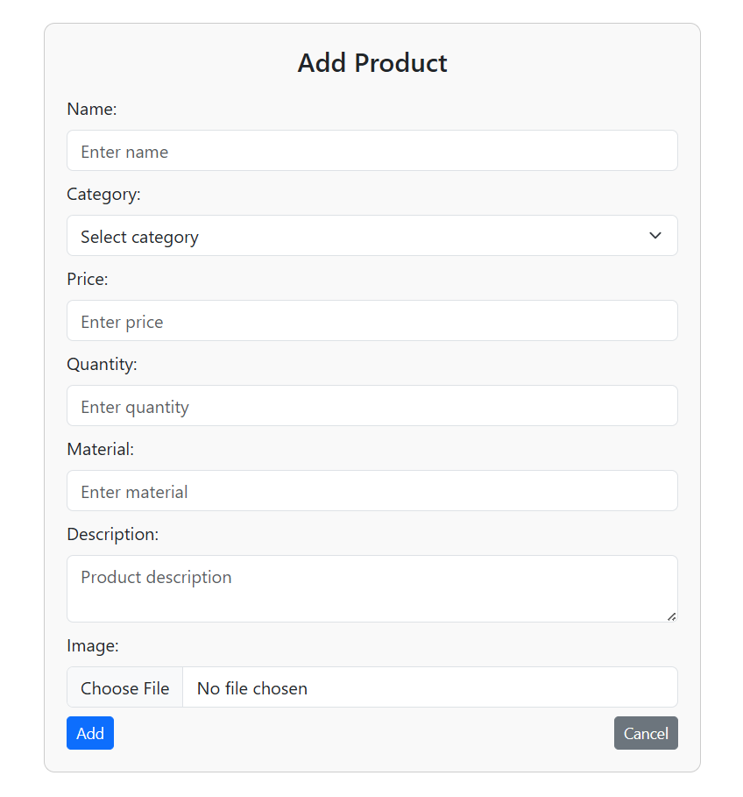

Figure ‑ Screen-1: Add Product

**Purpose:** The **Add Product** feature helps the admin add new furniture items with details to manage the inventory easily.

Table ‑ Screen element of Add Product

|  |  |  |  |
| --- | --- | --- | --- |
| Sr. | Screen Element | Input Type | Description |
| 1 | Form Title | Label | “Add Product” Indicates the purpose of form. |
| 2 | Product Name | Textbox | A text input field for entering the name of product. |
| 3 | Select Category | Dropdown | A dropdown menu for selection the product category. |
| 4 | Product Price | Textbox | Input for product price. |
| 5 | Product Quanty | Textbox | Input for product quantity. |
| 6 | Material | Textbox | A text input for entering the material of product. |
| 7 | Description | Textbox | A multiline text area for details of product. |
| 8 | Product Image | Choose File | A file upload option. |
| 9 | Sybmit | Button | “Add Product” to save the product details. |

## Screen-2: View Orders

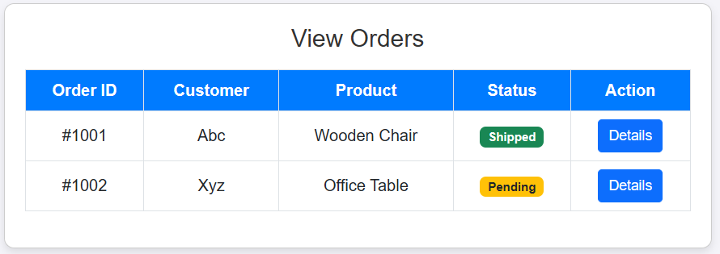

Figure 3.1‑2 Screen-2: View Order

**Purpose:** The **View Orders** feature allows the admin to see all customer orders in one place. It helps in tracking order status and managing shipments easily.

Table 01‑2 Screen element of View Order

|  |  |  |  |
| --- | --- | --- | --- |
| Sr. | Screen Element | Input Type | Description |
| 1 | Form Title | Label | “View Order” Indicates the purpose of form. |
| 2 | Order Id | Table | Shows the all orders id. |
| 3 | Customer Name | Table | Shows the all orders customers name. |
| 4 | Product Name | Table | Shows the all orders customers product name |
| 5 | Status | Table | Label show the status is shipped or pending. |
| 6 | Action | Button | Login button navigates to model and show the product details. |

## Screen-3: Admin Report Generation

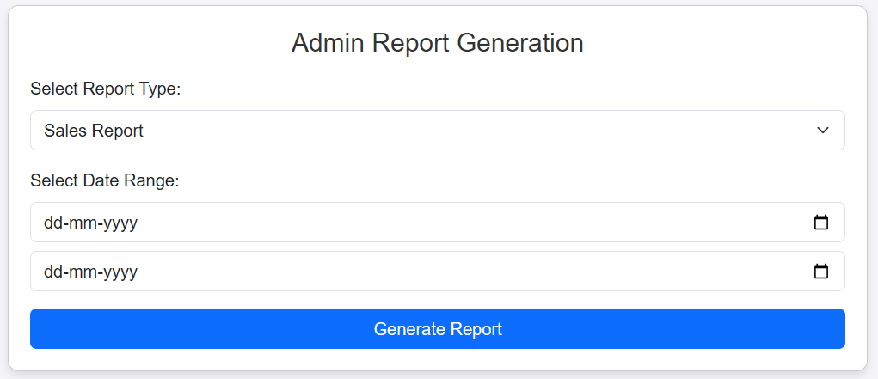

Figure 3.1‑3 Screen-3: Admin Report Generation

**Purpose:** Admin report generation is to organize and present important data clearly for better decision-making. It helps track progress, spot issues, and improve efficiency.

Table 3.1-3 Screen element of Admin Report Generation

|  |  |  |  |
| --- | --- | --- | --- |
| Sr. | Screen Element | Input Type | Description |
| 1 | Form Title | Tabel | “Admin Report generation” Indicates the purpose of form. |
| 2 | Select Report type | Label | Indicates the Select Report Type. |
| 3 | Sales Report | Dropdown | Select Report Type dropdown to select report type. |
| 4 | Select Date Range | Label | Indicates the Select date range.. |
| 5 | Start Date | Date picker | Choose the start date to want report. |
| 6 | End date | Date picker | Choose the end date to want report.. |
| 7 | Generate Report | Button | Submit is a button for store the entered data into database. |

# Database design

## List of Tables

* Customer
* Category
* Product
* Order
* Payment
* SalesReport

Table 4.1‑1 Table: Customer

|  |  |  |  |  |
| --- | --- | --- | --- | --- |
| Column | Data Type | Null | Keys & Constrains | Default Value & Description |
| customerID | int | NN | PK (Auto Increment) | Unique identifier for each customer |
| name | varchar(100) | NN |  | Customer's full name |
| address | Text | NN |  | Customer's physical address |
| email | varchar(100) | AN | UNIQUE | Customer's email address |
| phoneNumber | varchar(50) | NN |  | Customer's contact number |

Table 4.1‑2 Table: Category

|  |  |  |  |  |
| --- | --- | --- | --- | --- |
| Column | Data Type | Null | Keys & Constrains | Default Value Description |
| categoryID | int | NN | PK (Auto Increment) | Unique identifier for each category |
| categoryName | varchar(100) | NN | UNIQUE | Name of the furniture category |

Table 4.1‑3 Table: Product

|  |  |  |  |  |
| --- | --- | --- | --- | --- |
| Column | Data Type | Null | Keys & Constrains | Default Value & Description |
| productID | int | NN | PK (Auto Increment) | Unique identifier for each furniture |
| name | varchar(100) | NN |  | Name of the furniture item |
| description | text | AN |  | Detailed description of the item |
| categoryID | int | AN | FK(References Category) | Category this furniture belongs to |
| price | decimal(10,2) | NN |  | Current price of the item |
| quantityInStock | int | NN |  | Available quantity in inventory |
| material | varchar(50) | AN |  | Primary material of the furniture |

Table 4.1‑4 Table: Order

|  |  |  |  |  |
| --- | --- | --- | --- | --- |
| Column | Data Type | Null | Keys & Constrains | Default Value & Description |
| orderID | int | NN | PK (Auto Increment) | Unique order identifier |
| customerID | varchar(100) | NN | FK(References Customer) | Customer who placed the order |
| orderDate | varchar(100) | NN |  | Date when order was placed |
| status | DateTime | NN | CHECK (Pending/Shipped/Delivered) | Current status of the order |
| totalPrice | varchar(100) | NN |  | Calculated total price of order |

|  |  |  |  |  |
| --- | --- | --- | --- | --- |
| Column | Data Type | Null | Keys & Constrains | Default Value & Description |
| orderID | int | NN | PK (Auto Increment) | Unique order identifier |
| customerID | int | NN | FK(References Customer) | Customer who placed the order |
| orderDate | date | NN |  | Date when order was placed |
| status | varchar(50) | NN | CHECK (Pending/Shipped/Delivered) | Current status of the order |
| totalPrice | decimal(10,2) | NN |  | Calculated total price of order |

Table 4.1‑5 Table: Order

|  |  |  |  |  |
| --- | --- | --- | --- | --- |
| Column | Data Type | Null | Keys & Constrains | Default Value & Description |
| paymentID | int | NN | PK (Auto Increment) | Unique order identifier |
| orderID | int | NN | FK(References Customer) | Associated order |
| paymentDate | date | NN |  | Date when payment was made |
| paymentAmount | decimal(10,2) | NN |  | Amount paid |
| paymentMethod | varchar(50) | NN | CHECK (Credit/Debit/Cash/etc.) | How payment was made |
| paymentStatus | varchar(50) | NN | CHECK (Completed/Pending/etc.) | Current status of payment |

Table 4.1‑6 Table: Payment

|  |  |  |  |  |
| --- | --- | --- | --- | --- |
| Column | Data Type | Null | Keys & Constrains | Default Value & Description |
| reportID | int | NN | PK (Auto Increment) | Unique report identifier |
| startDate | date | NN |  | Start date of reporting period |
| endDate | date | NN |  | End date of reporting period |
| totalSales | decimal(10,2) | NN |  | Total sales in the period |
| totalOrders | int | NN |  | Number of orders in the period |
| generatedDate | timestamp | AN | DEFAULT CURRENT_TIMESTAMP | When the report was generated |

Table 4.1‑7 Table: SalesReport

# References

* https://developer.ibm.com/articles/the-class-diagram/
* https://www.tutorialspoint.com/management_concepts/project_activity_diagram.htm
* https://help.bizzdesign.com/articles/#!horizzon-help/Modeling-a-UML-use-case-diagram