**Lab Practical #01:**

Study of basic networking commands and IP configuration.

**Practical Assignment #01:**

1. Perform and explain various networking commands listed below:
   1. ipconfig
   2. ping
   3. getmac
   4. systeminfo
   5. traceroute / tracert
   6. netstat
   7. nslookup
   8. hostname
   9. pathping
   10. arp

## ipconfig

### Description:

|  |  |  |
| --- | --- | --- |
| No. | Option | Description |
| 1 | ipconfig | Displays basic IP configuration for all adapters. |
| 2 | ipconfig /all | Shows detailed IP settings, including MAC address and DHCP info. |
| 3 | ipconfig /release | Releases current IP address from DHCP server. |
| 4 | ipconfig /renew | Renews the IP address from DHCP server. |
| 5 | ipconfig /flushdns | Clears DNS cache on your system. |

### Implementation:

1ipconfig

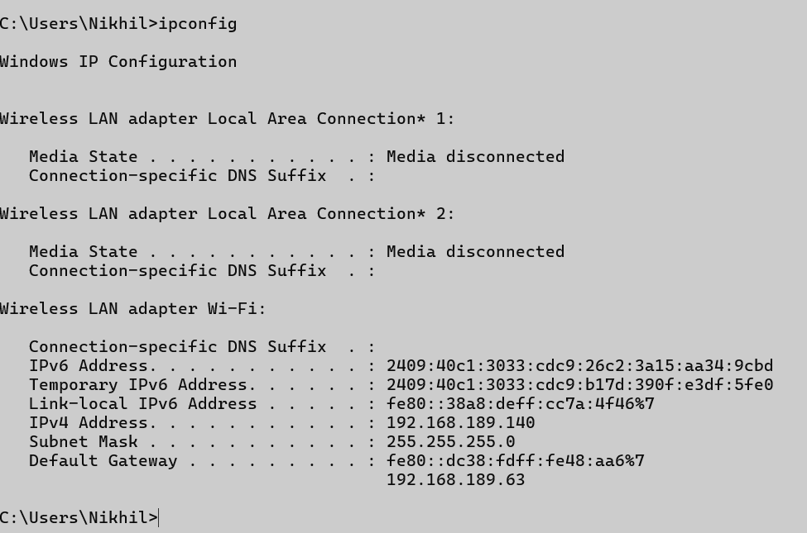

2 ipconfig /all

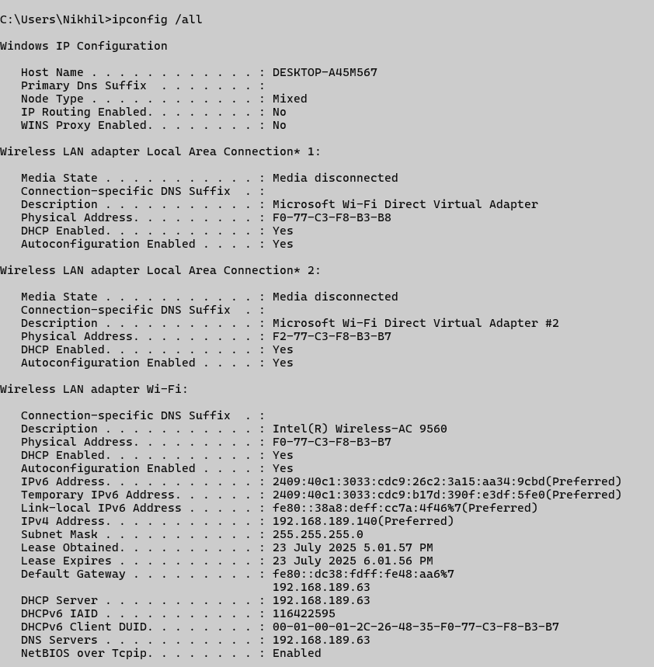

3 ipconfig /releasell

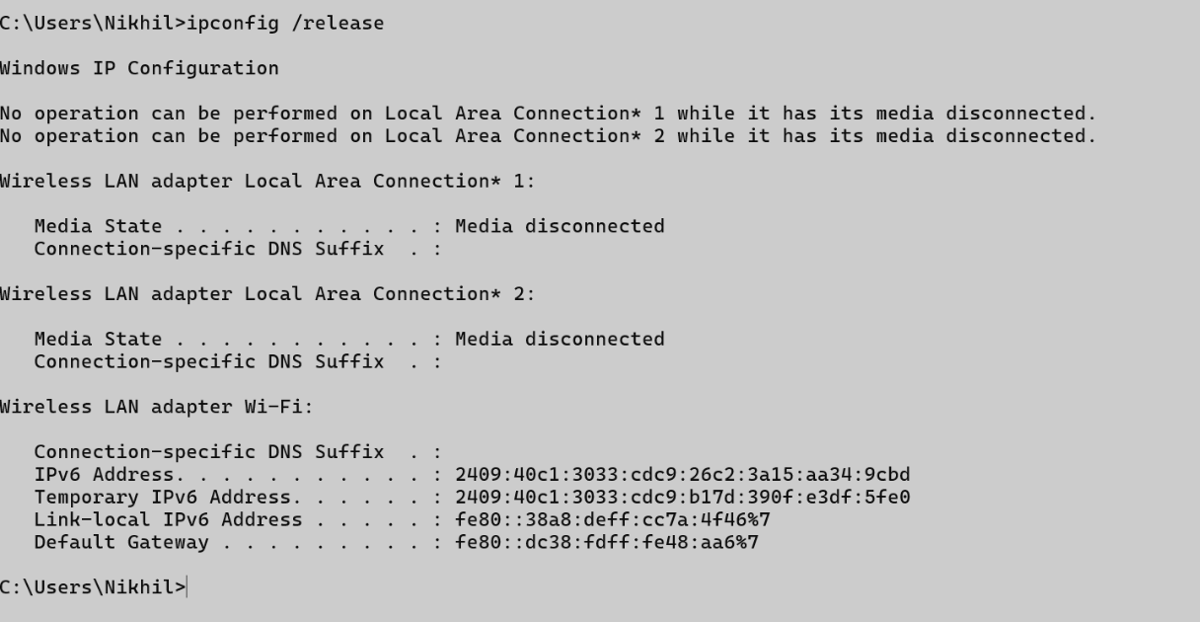

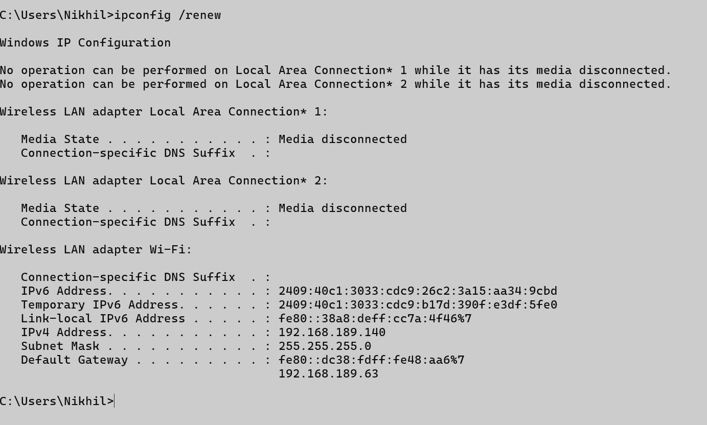4 ipconfig /renew

5. ipconfig /flushdns



## ping

### Description:

|  |  |  |
| --- | --- | --- |
| No. | Option | Description |
| 1 | ping | Sends ICMP Echo Request to test connectivity. |
| 2 | ping [hostname] | Checks reachability of a host (e.g., ping google.com). |
| 3 | ping [IP] | Tests a specific IP (e.g., ping 8.8.8.8). |
| 4 | ping -n [count] | Sends a specific number of echo requests (e.g., ping -n 5 google.com) |
| 5 | ping -t [host] | Pings the target continuously until stopped. |

### Implementation:

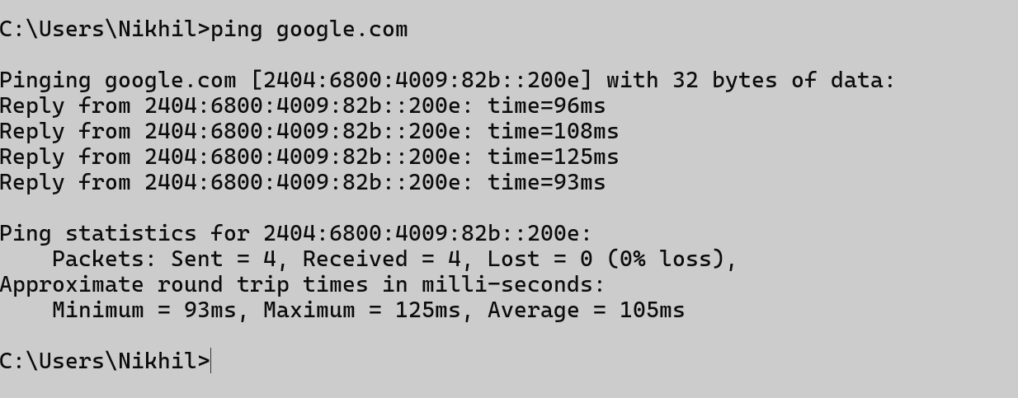1. ping google.com

2. ping 8.8.8.8

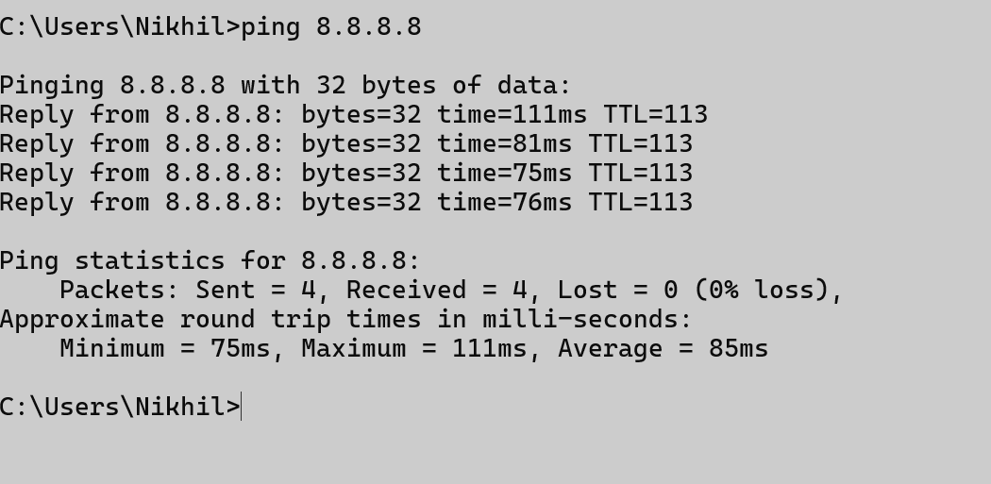

3. ping -n 5 google.com

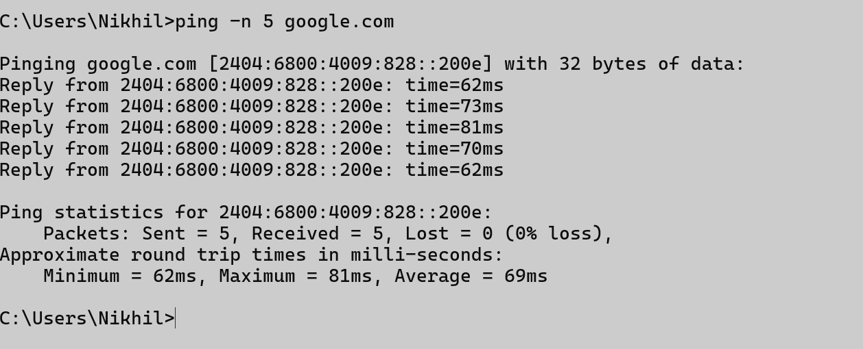

4. ping -t 8.8.8.8

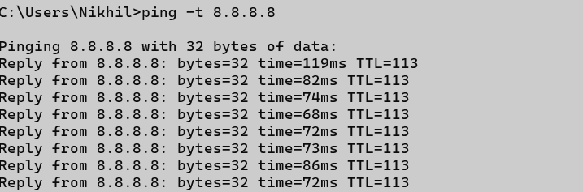

## getmac

### Description:

|  |  |  |
| --- | --- | --- |
| No. | Option | Description |
| 1 | getmac | Displays MAC address of the computer. |
| 2 | getmac /v | Shows detailed output with connection names. |
| 3 | getmac /fo list | Outputs MAC in list format. |

### Implementation:

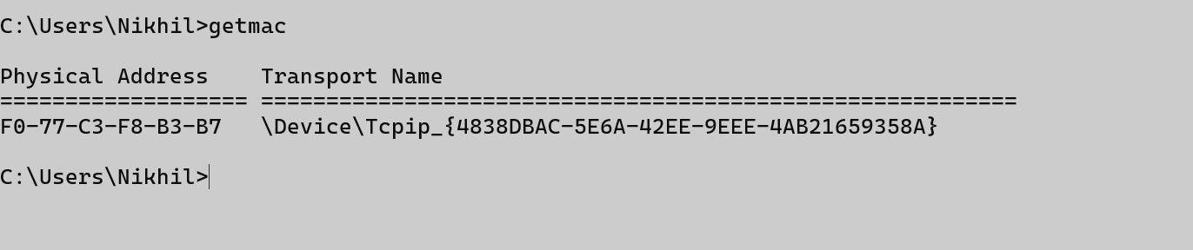1. getmac

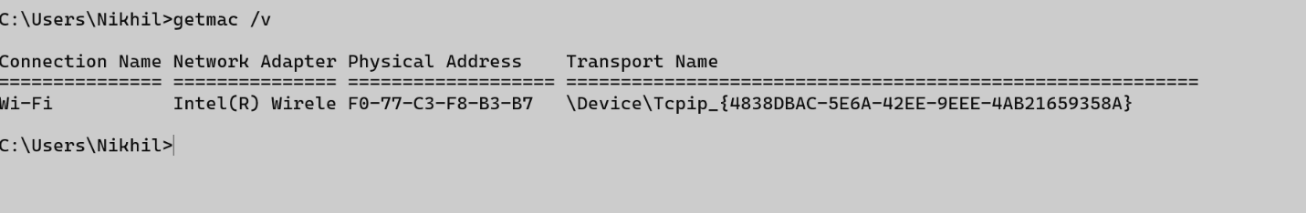2. getmac /v

3. getmac /fo list



## systeminfo

### Description:

|  |  |  |
| --- | --- | --- |
| No. | Option | Description |
| 1 | Systeminfo | Displays detailed system configuration. |
| 2 | `systeminfo “Host“ | findstr "Host"` |
| 3 | `systeminfo “OS“ | findstr "OS"` |

### Implementation:

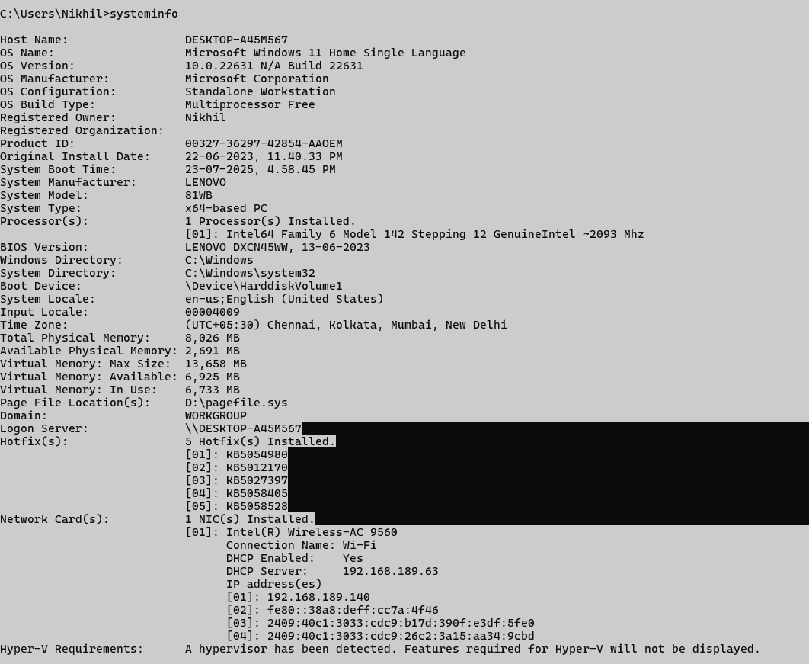1. systeminfo

2 /3 .

systeminfo | findstr "Host"

systeminfo | findstr "OS"

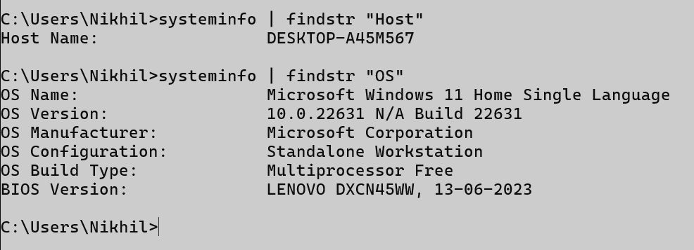

## traceroute / tracert

### Description:

|  |  |  |
| --- | --- | --- |
| No. | Option | Description |
| 1 | tracert google.com | Shows route taken to reach google.com. |
| 2 | tracert -d | Doesn't resolve hostnames (shows IPs only). |
| 3 | tracert -h 5 | Limits max number of hops to 5. |

### Implementation:

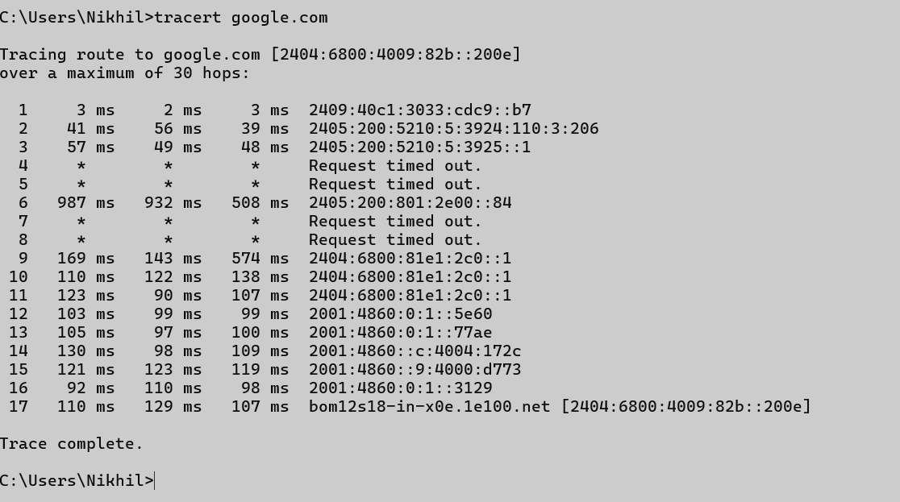1. tracert google.com

2. tracert -d google.com

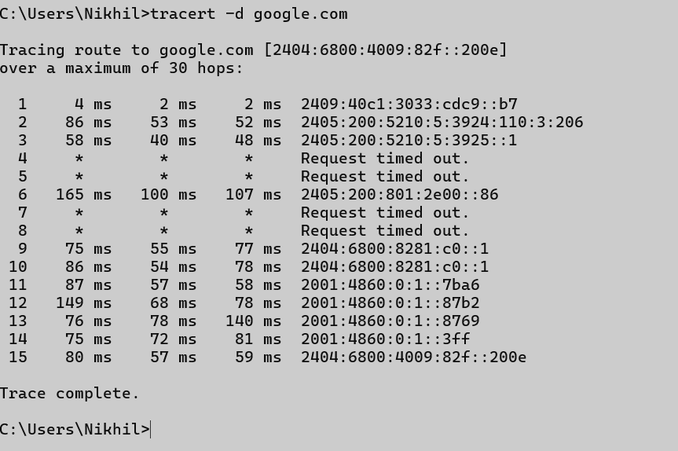

3. tracert -d google.com

## 

## netstat

### Description:

|  |  |  |
| --- | --- | --- |
| No. | Option | Description |
| 1 | netstat | Shows route taken to reach google.com. |
| 2 | netstat -a | Doesn't resolve hostnames (shows IPs only). |
| 3 | netstat -n | Limits max number of hops to 5. |

### Implementation:

1. netstat

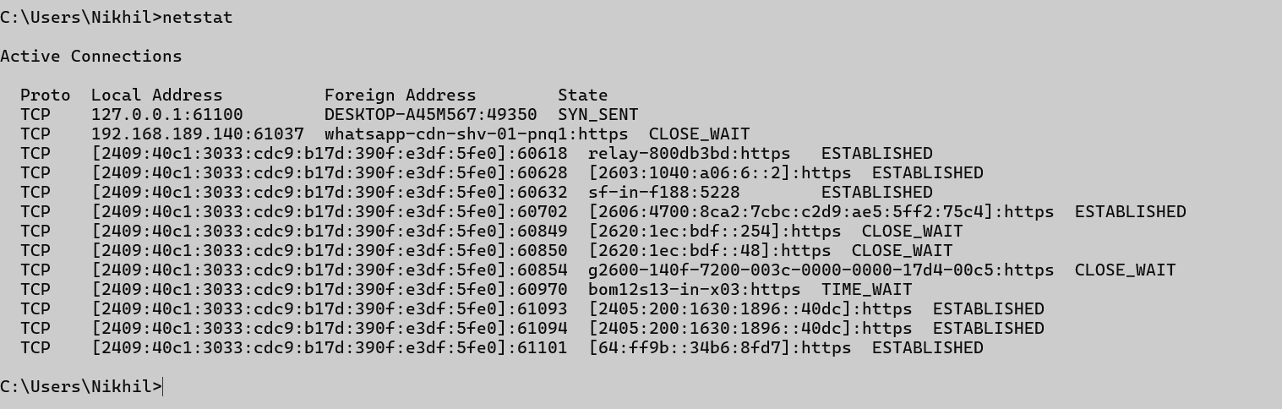

2. netstat -a

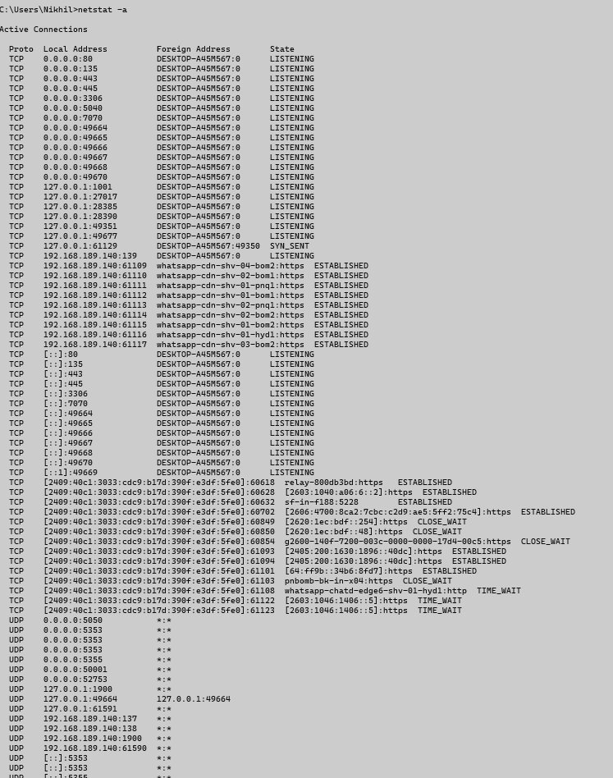

3. netstat -n

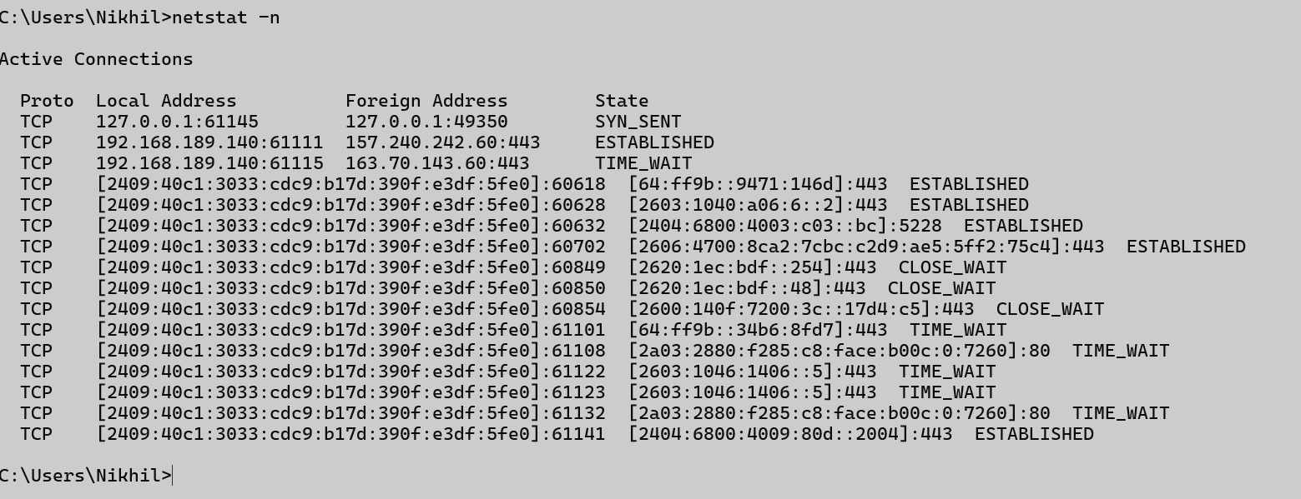

## 7. nslookup

### Description:

|  |  |  |
| --- | --- | --- |
| No. | Option | Description |
| 1 | nslookup | Starts interactive mode for DNS queries.. |
| 2 | nslookup google.com | Queries DNS for IP of google.com. |
| 3 | nslookup -type=MX gmail.com | Queries mail servers of gmail.com. |

### Implementation:

1. nslookup



2. nslookup



3. nslookup -type=MX gmail.com

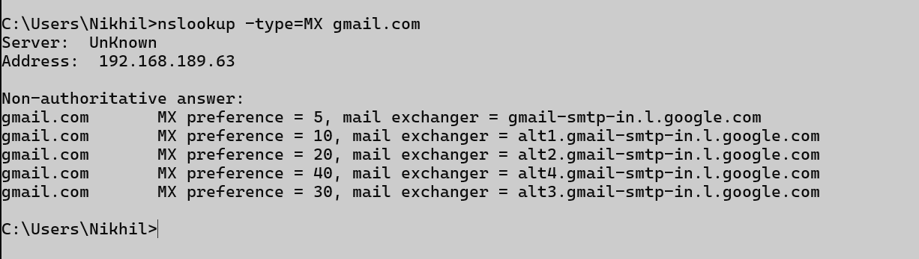

## 8. hostname

### Description:

|  |  |  |
| --- | --- | --- |
| No. | Option | Description |
| 1 | hostname | Combines ping and tracert with packet loss statistics. |

### Implementation:

1. hostname



## 9. pathping

### Description:

|  |  |  |
| --- | --- | --- |
| No. | Option | Description |
| 1 | pathping google.com | Combines ping and tracert with packet loss statistics. |

### Implementation:

1. pathping google.com

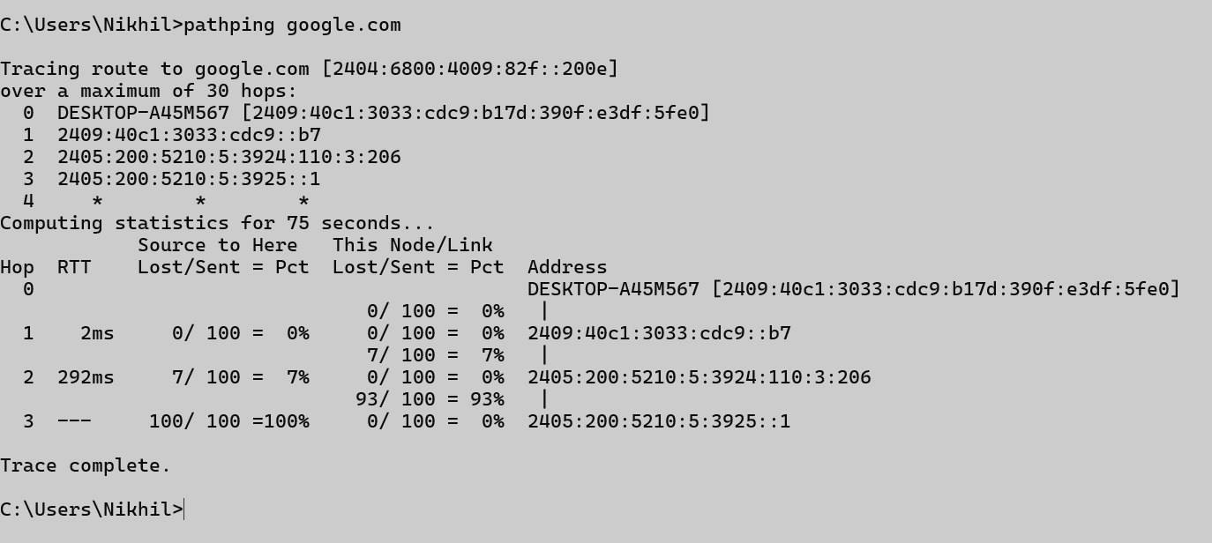

## 10. arp

### Description:

|  |  |  |
| --- | --- | --- |
| No. | Option | Description |
| 1 | arp -a | Combines ping and tracert with packet loss statistics. |
| 2 | arp -d * | Deletes all ARP entries. |
| 3 | arp -s <IP> <MAC> | Adds a static entry (requires Admin privileges). |

### Implementation:

1. arp -a

