**Lab Practical #10:**

Study Packet capture and header analysis by Wireshark (HTTP, ICMP, DNS, TCP, UDP etc.)

**Practical Assignment #10:**

1. **Explain usage of Wireshark tool.**
2. **Packet capture and header analysis by Wireshark (HTTP, ICMP, DNS, TCP, UDP etc.)**

**Wireshark**

Wireshark is an open-source network protocol analyser.

It captures live packet data from a network interface and allows detailed inspection of protocols.

Supports hundreds of protocols (HTTP, ICMP, DNS, TCP, UDP, etc.).

**Protocols Studied**

**HTTP (Hyper Text Transfer Protocol):** Used for web communication.

**ICMP (Internet Control Message Protocol):** Used for error messages and diagnostics (e.g., ping).

**DNS (Domain Name System):** Resolves domain names to IP addresses.

**TCP (Transmission Control Protocol):** Connection-oriented protocol for reliable communication.

**UDP (User Datagram Protocol):** Connectionless protocol for fast but unreliable communication.

1. 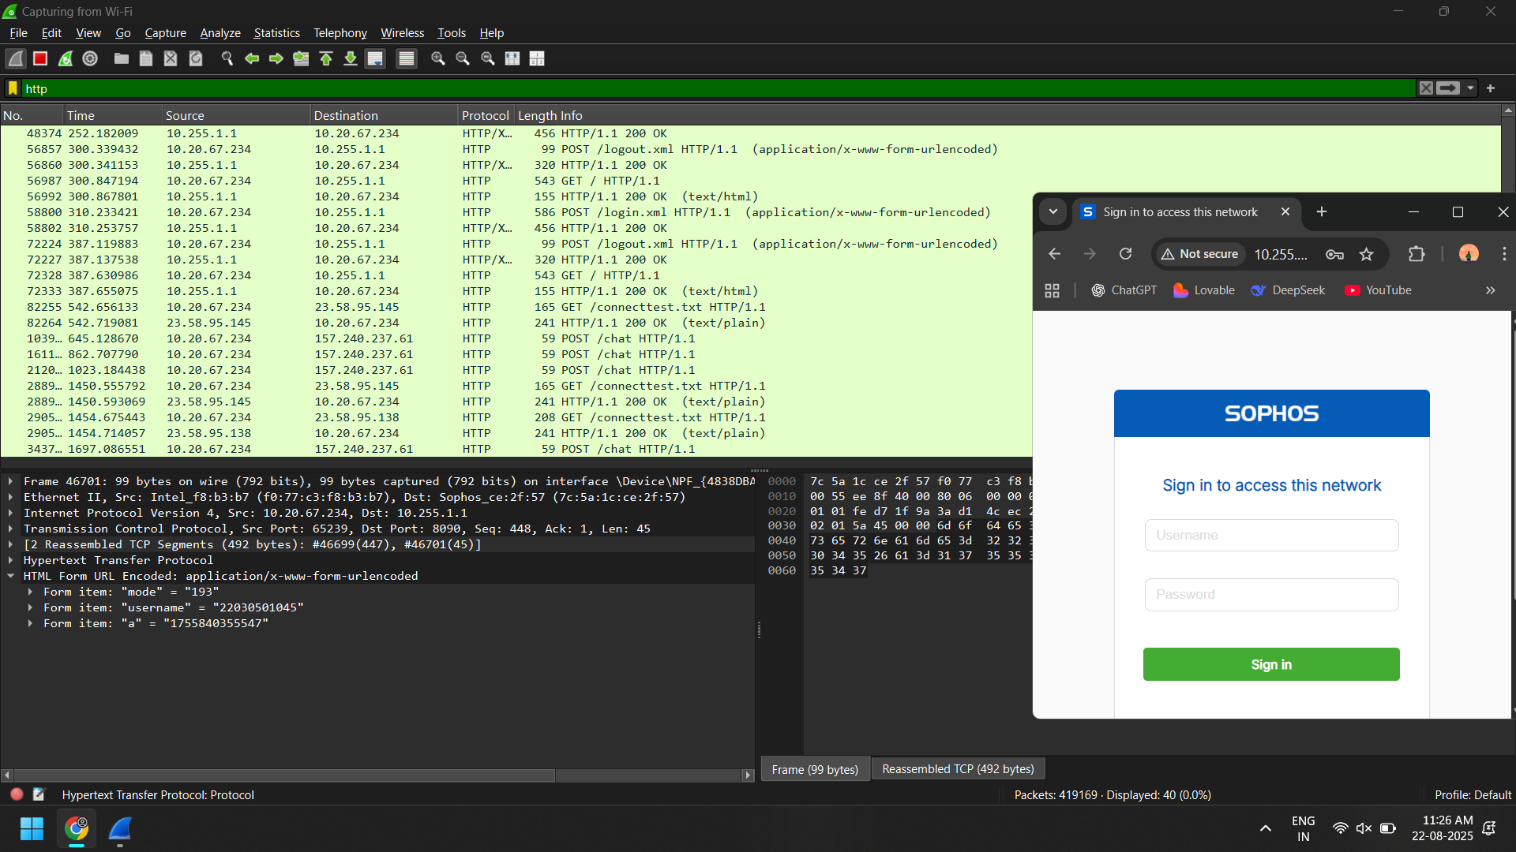**HTTP**

1. 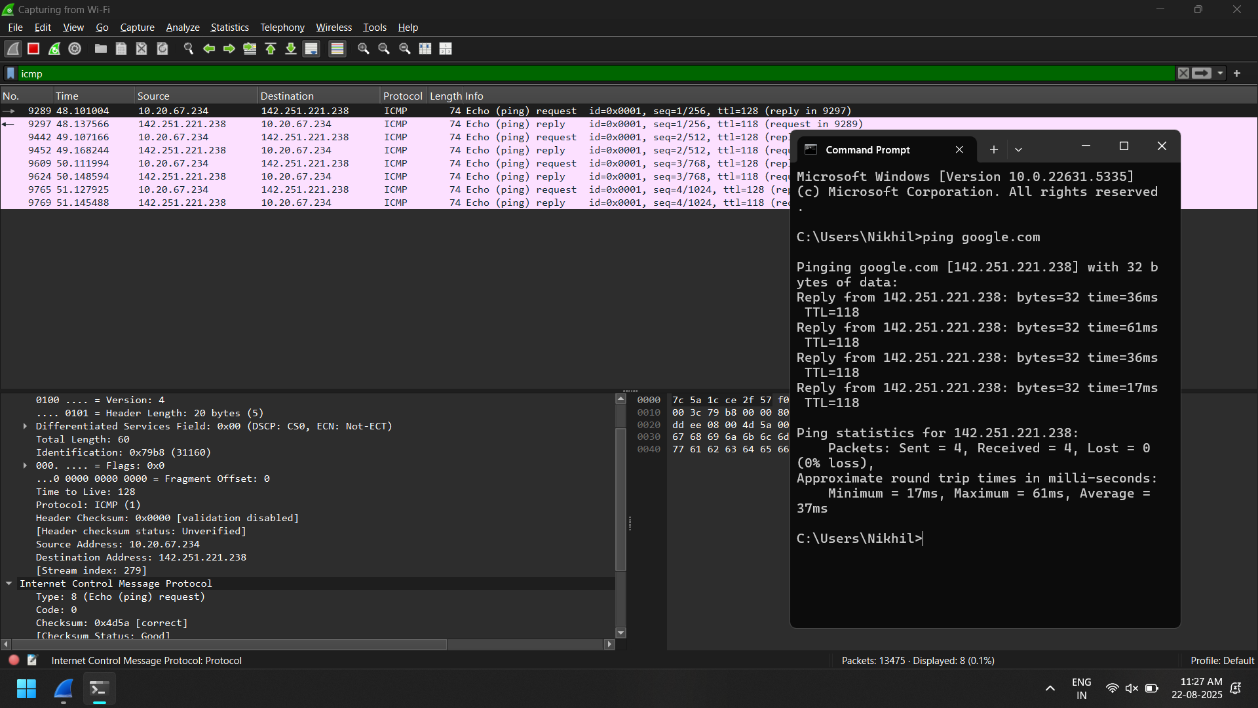**ICMP**
2. **DNS**

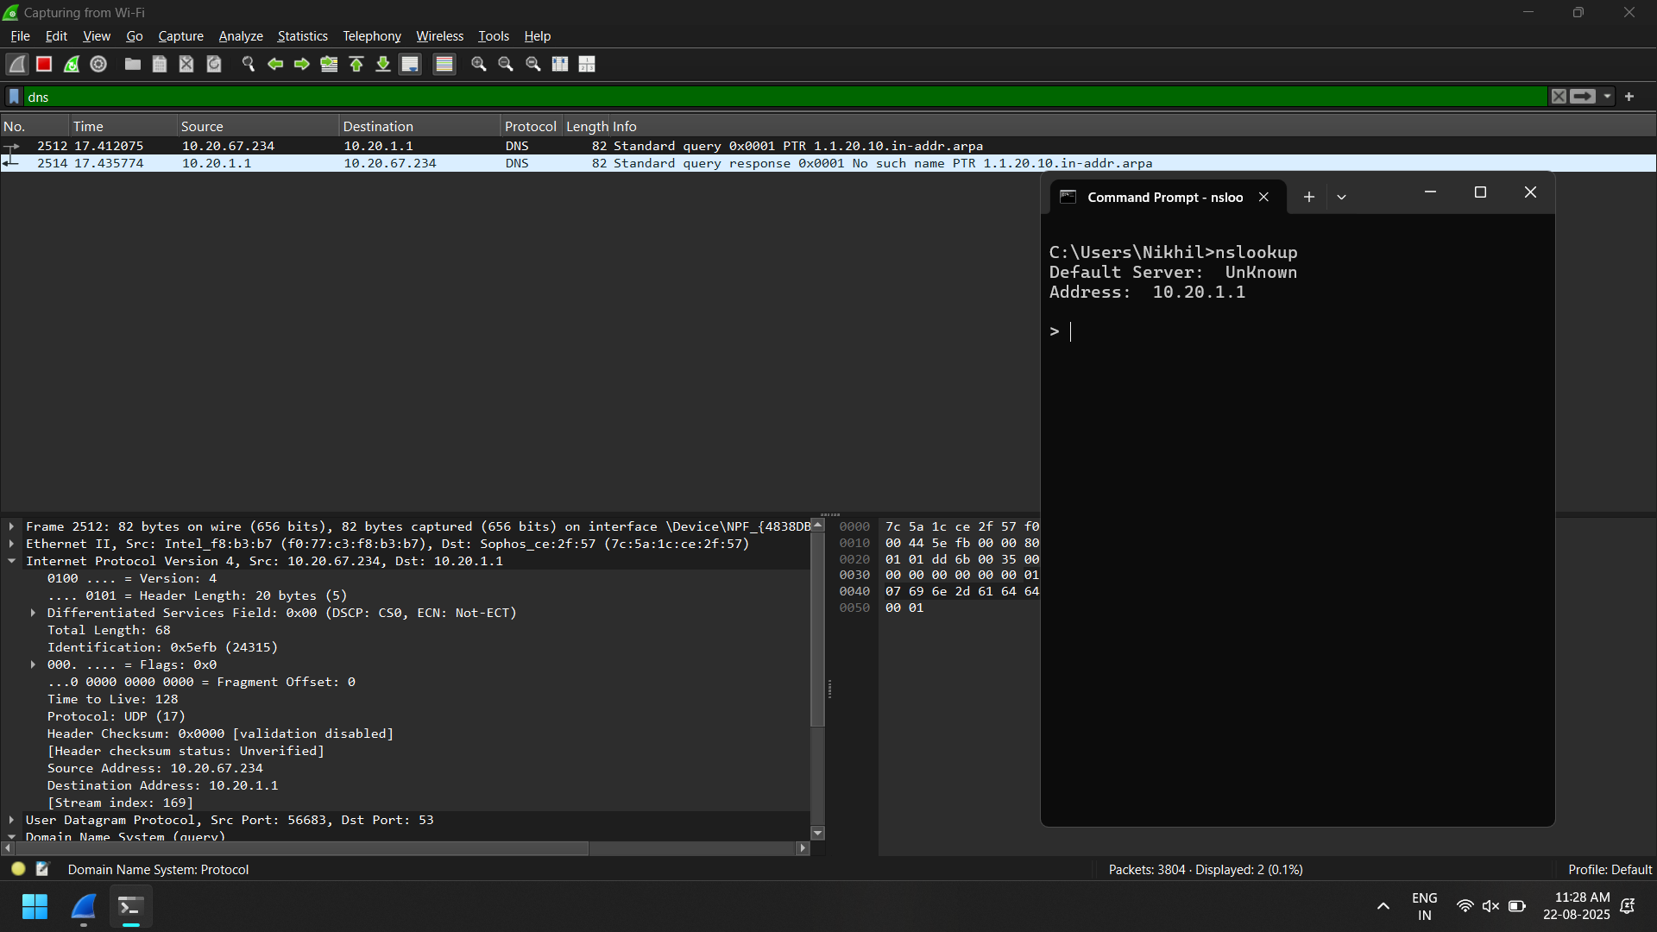

1. 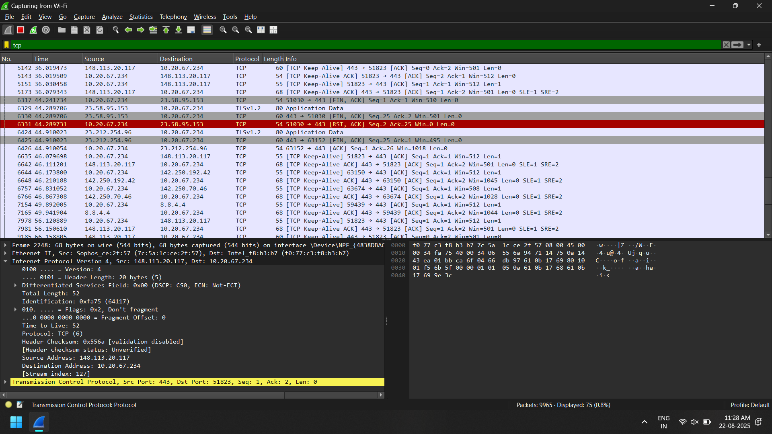**TCP**