**Lab Practical #12:**

Study the concept of routing using packet tracer. (Dynamic Routing)

**Practical Assignment #12:**

1. Connect the two different networks based on the calculated IP addresses and subnet using a packet tracer.
2. Connect the three different networks based on the calculated IP addresses and subnet using a packet tracer.

**1. Connect the two different networks based on the calculated IP addresses and subnet using a packet tracer.**

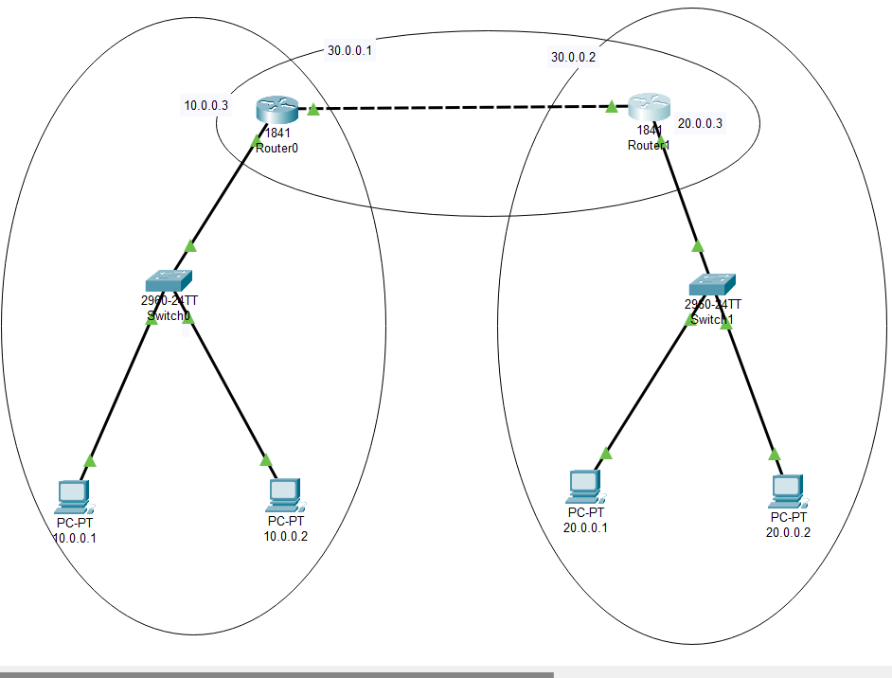

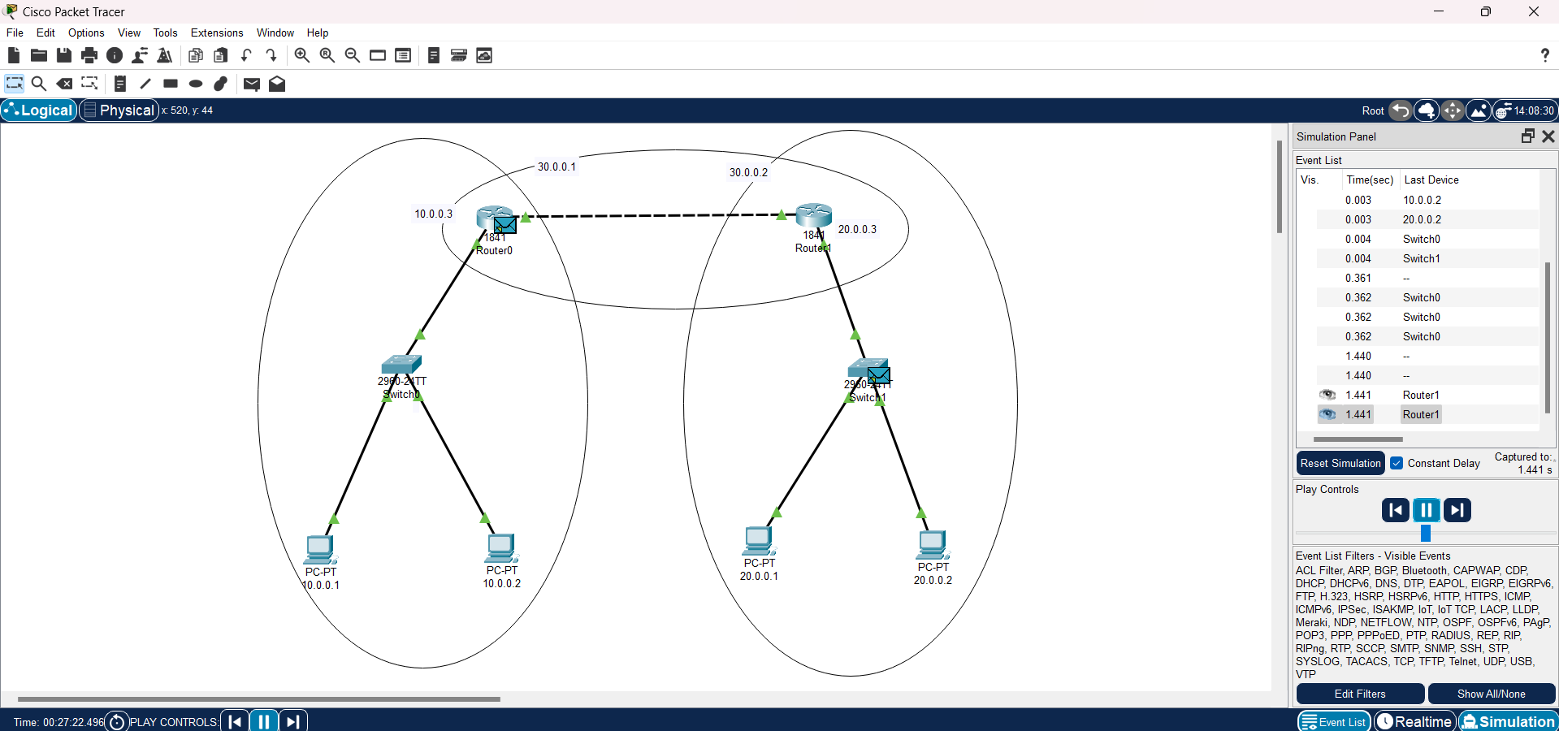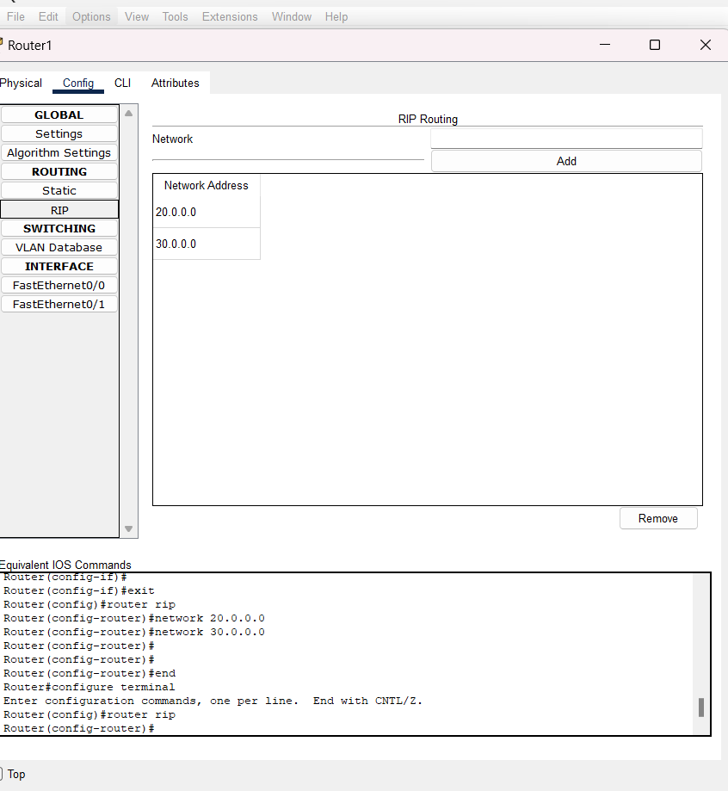

1. **Connect the three different networks based on the calculated IP addresses and subnet using a packet tracer.**

