**Lab Practical #03:**

Study of different types of network cables & connectors and crimping a LAN.

**Practical Assignment #03:**

1. List various networks cable. Also, write short description.
2. Difference between guided and unguided media.
3. Give cross-wired cable and straight through cable diagram (Color Code wise).

## List various networks cable and connectors. Also, write short description.

a) **Twisted Pair Cable**

* **Description**: Twisted pair cables consist of pairs of insulated copper wires twisted together to reduce electromagnetic interference. They are commonly used in Ethernet networks. There are two types:
  + Unshielded Twisted Pair (UTP): Lacks shielding, cheaper, and widely used in home and office networks.
  + Shielded Twisted Pair (STP): Includes shielding to reduce interference, used in environments with high interference.
* **Diagram**:

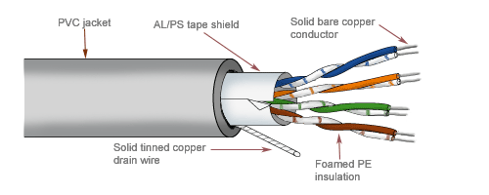

b) **Coaxial Cable**

* **Description**: Coaxial cables have a central conductor surrounded by insulation, a metallic shield, and an outer cover. They are used for cable TV, internet (DOCSIS), and older Ethernet networks.
* **Diagram**:



c) **Fiber Optic Cable**

* **Description**: Fiber optic cables use glass or plastic fibres to transmit data as light pulses. They offer high bandwidth, low attenuation, and immunity to electromagnetic interference. Used in high-speed internet and long-distance communication.
* **Diagram**:

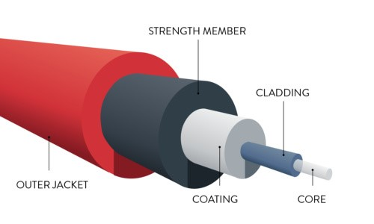

1. **Difference between guided and unguided media.**

|  |  |  |
| --- | --- | --- |
| No. | Guided Media | Unguided Media |
| 1 | Uses physical cables to transmit data | Uses wireless signals (e.g., radio waves). |
| 2 | Examples: Twisted pair, coaxial, fiber | Examples: Wi-Fi, Bluetooth, satellite’s |
| 3 | Secure and reliable. | Prone to interference and less secure. |
| 4 | Limited by cable length. | No physical limitations, but range varies. |

## Give cross-wired cable and straight through cable diagram (Color Code wise).

1. Cross-wired Cable Diagram (Color Code) PC to PC

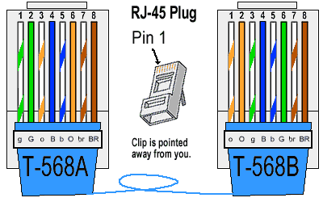

1. Straight Through Cable Diagram (Color Code) PC to Switch

