Lab Practical #09:

Study & Survey of Institute organization network infrastructure.

**Practical Assignment #09:**

1. **Identify type of network in your institute. Draw a design of network in your institute (Any Lab/Floor/Building).**
2. **List how many network devices and types of cable used and give its details.**

**Type of network:**

**LAN (Local Area Network):** For departments, labs, faculty rooms, and administrative offices within the campus buildings.

**VLANs (Virtual LANs):** Logical segmentation for separating student labs, faculty, administration, and guest Wi‑Fi traffic on the same physical switches.

**WLAN (Wireless LAN):** Campus-wide Wi‑Fi for students, faculty and guests via multiple Access Points (APs).

**Chosen Area for Design:**

**Area:** Computer Lab — 3rd Floor, CSE Department

**Requirements & assumptions:**

* 40 student workstations
* 2 faculty machines
* 1 lab server (file/print/authentication)
* 2 network printers
* 1 networked projector
* 2 IP cameras
* Wi‑Fi APs to cover the floor

**Network Design:**

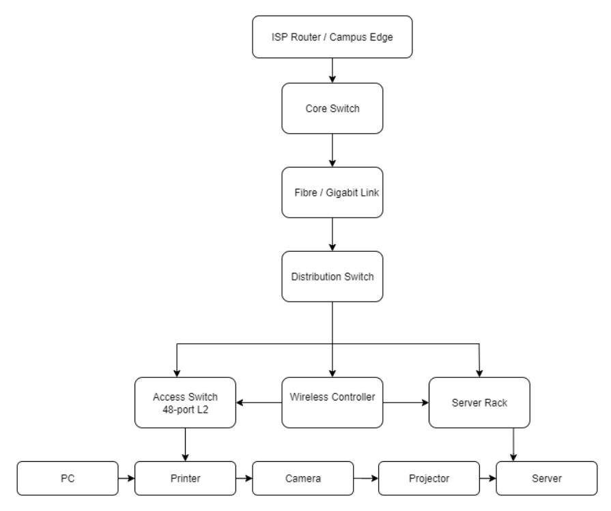

**Cable types:**

**Single-mode / Multi-mode Fibber (OM3/OM4):** Used for building-to-building and core-to-distribution backbone (10 Gbps link).

**Cat6 UTP (Unshielded Twisted Pair):** For workstation to access switch (1 Gbps). Cat6A for 10 Gbps where needed.

**Cat5e:** Older labs may still have Cat5e (1 Gbps reliable short-run), but recommended to upgrade to Cat6.

**Coaxial (if CCTV uses analog):** Not relevant if IP cameras used (then use Ethernet).

## Network Devices Details (for the lab / floor):

* Core Switch
* Distribution Switch
* Access Switch
* Wireless AP
* Router/Firewall
* Server
* Network Printer
* IP Camera