LOOPS

Assignment Questions

Assignment Questions

**Q1. Write a Java program to calculate the sum of natural numbers up to a given positive integer 'n'.**

**package Loops.LoopAssig;**

**import java.util.Scanner;**

**//Write a Java program to calculate the sum of natural numbers up to a given positive integer 'n'.**

**public class SumNatural**

**{**

**public static void main(String[] args)**

**{**

**Scanner sc=new Scanner(System.in);**

**System.out.println("Enter a number : ");**

**int n=sc.nextInt();**

**int sum=0;**

**for (int i=0; i<=n;i++)**

**{**

**sum+=i;**

**}**

**System.out.println("Sum : "+sum);**

**}**

**}**

* **OUTPUT :**

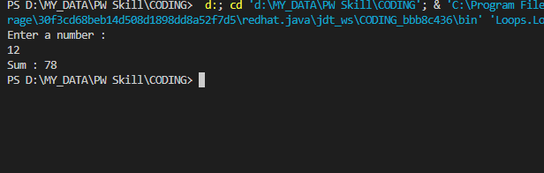

**Q2. Write a Java program to print a multiplication table for a given number 'n'.**

**package Loops.LoopAssig;**

**/\***

**\* Write a Java program to print a multiplication table for a given number 'n'.**

**\*/**

**import java.util.Scanner;**

**public class MulOfTable**

**{**

**public static void main(String[] args)**

**{**

**Scanner sc=new Scanner(System.in);**

**System.out.print("Enter number : ");**

**int n=sc.nextInt();**

**for(int i=1;i<=10;i++)**

**{**

**System.out.println(n+" * "+i+" = "+(i*n));**

**}**

**}**

**}**

* **OUTPUT:**

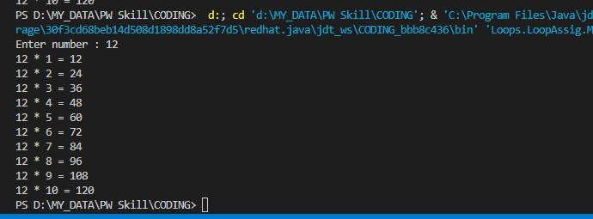

Q3. **Write a Java program to find the GCD (Greatest Common Divisor) of two numbers using a loop.**

**package Loops.LoopAssig;**

**import java.util.Scanner;**

**/\***

**\* Write a Java program to find the GCD (Greatest Common Divisor) of two numbers using a loop.**

**\*/**

**public class GCD {**

**public static void main(String[] args)**

**{**

**Scanner sc=new Scanner(System.in);**

**System.out.print("Enter two number : ");**

**int a=sc.nextInt();**

**int b=sc.nextInt();**

**int min;**

**if(a>b)**

**min=b;**

**else**

**min=a;**

**while (min > 0)**

**{**

**if (a%min == 0 && b%min == 0)**

**{**

**break;**

**}**

**min--;**

**}**

**System.out.println("Greatest common multiple : "+min);**

**}**

**}**

* **OUTPUT:**

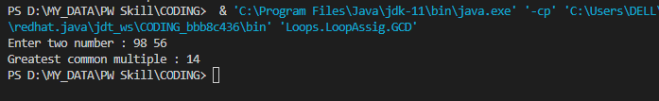

Q4. **Write a Java program to check if a given string is a palindrome or not using a loop.**

**package Loops.LoopAssig;**

**import java.util.Scanner;**

**// Q4. Write a Java program to check if a given string is a palindrome or not using a loop.**

**public class PalindromStr**

**{**

**public static void main(String[] args)**

**{**

**Scanner sc=new Scanner(System.in);**

**System.out.println("Enter a string : "); //nitin**

**String name=sc.next();**

**boolean flag=true;**

**int start=0, end;**

**end=name.length() -1;**

**while (start != end)**

**{**

**char s=name.charAt(start);**

**if (s != name.charAt(end))**

**{**

**flag=false;**

**break;**

**}**

**start++;**

**end--;**

**}**

**if (flag)**

**System.out.println("Palindrone name");**

**else**

**System.out.println("Not Palindrone name");**

**}**

**}**

* **OUTPUT:**

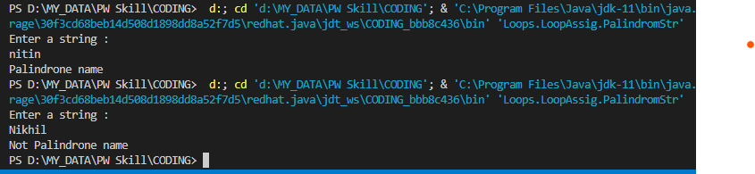

**Q5. Write a Java program to generate and print the first 'n' terms of the Fibonacci series.**

**package Loops.LoopAssig;**

**import java.util.Scanner;**

**/\***

**\* Q5. Write a Java program to generate and print the first 'n' terms of the Fibonacci series.**

**\*/**

**public class fibonaccisSeries**

**{**

**public static void main(String[] args)**

**{**

**Scanner sc=new Scanner(System.in);**

**System.out.print("Enter n term : ");**

**int n=sc.nextInt();**

**int a=0,b=1;**

**System.out.print(a+" "+b);**

**int sum=a+b;**

**// 0 1 1 2 3 5**

**for(int i=2;i<=n;i++)**

**{**

**sum=a+b;**

**System.out.print(" "+sum);**

**a=b;b=sum;**

**}**

**}**

**}**

* **OUTPUT:**

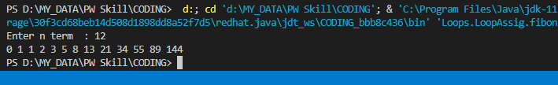

Java + DSA

THANK YOU !