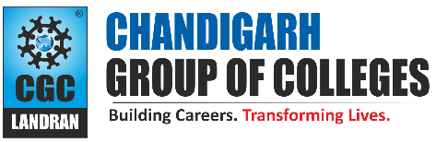

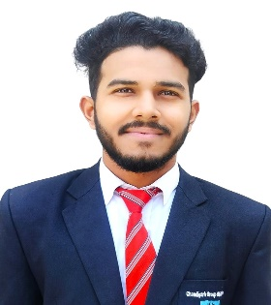

Navuday Kumar Ray

[Nayagaon, Sonepur, Bihar -841217] [+919508978794]

[[2](mailto:2101725.cse.cec@cgc.edu.in)1[01725.cse.cec@cgc.edu.in](mailto:2101725.cse.cec@cgc.edu.in)]

# **PROFESSIONAL SUMMARY**

An undergraduate Engineering student ,

a logical Thinker with excellence Problem solving skills and ability to perform well

in team ,Adept at finding Innovative solutions

I bring a diverse range of Technical

knowledge to the table and have passion about

Software development.

# **TECHNICAL COMPETENCIES**

**Languages:** C | C++ | HTML | CSS | Python

**Databases:** MySQL

**Technical Skills:** Oops, DBMS, Operating System, Web development with Django

# **INTERPERSONAL SKILLS**

Versatile | quick Learner | Patience

| Team Player | Collaboration | Decision Making & Problem Solving | Resilience.

# **INTERESTS & HOBBIES**

Listening to Podcast | Meditation | Outdoor Sports | Traveling

# **LANGUAGES KNOWN**

English | Hindi

# **PERSONAL DETAILS**

Mother’s Name: Sunita Devi

Father’s Name: Lakshman Prasad Ray D.O.B: 25/01/2003

# **EDUCATION**

Bachelors of Technology in Computer Science Engineering | Chandigarh Group of Colleges, Landran

Session: 2021-2025 | Score: 7.8 CGPA

Intermediate (CBSE) | Delhi Public School, Vidyanagar Session: 2019 -2020 | Percentage: 70%

Matriculation (CBSE) | Kendriya Vidyalaya, ShaktiNagar Session:2017-2018 | Percentage:83.4%

# **TRAINING & PROJECTS**

# **Helping Hand Hub| Developer**

Duration: 2 Months

Environment: Windows, V S Code Languages/Database: Python, HTML, CSS | MySQL

Team Size: Individual

* Explore Helping Hands Hub, a Django-driven project promoting social impact. This platform seamlessly connects donors and volunteers. Admins efficiently manage operations, Leveraging Django and HTML, CSS ensuring a user-friendly experience.

**Virtual Assistant | Developer**

Duration: 1 Month

Environment: Windows, VS Code

.Languages/Database: Python Team Size: Individual

* Virtual Assistant is a Python based project which help you ease your day to day tasks, such as opening videos, searching and opening websites, playing music and even more..

# **ACADEMIC ACHIEVEMENTS**

* Got selected in Super Achiever batch made by college after giving AMCAT exam.
* Secured 7th rank at Coding competition consists of two round organized by college (Mind Hack Coder) out of 180 students.

# **CERTIFICATIONS**

* An Elite Certificate in DBMS by NPTEL issued by *IIT, Kharagpur.*
* Cloud Architecting Certificate by AWS Academy
* Machine Learning Certificate by Great Learning

# **EXTRA CURRICULAR & CO-CURRICULAR ACHIEVEMENTS**

* Participated in Football Tournament
* Organized event in Parivartan fest of our college 2022.