**PROJECTS**

* **Electric Go-kart (3kW 48V DC Motor)**  *Duration: Sep 2019- Mar 2020*

Project Type: Hindustan Formula Karting Championship 2020

This aims to design and development of working model of cost effective electric go-kart. Main objective behind designing and fabricating the electric go -kart is to make it available in cheap price, making it simple in working for even nonprofessional drivers, increasing is strength so that it can sustain more weight and providing it with all the best available facilities in lower cost . The project mainly focuses on the material selection and designing of cheaper electric system compared to other electric go-karts manufactured, calculations required for designing the kart, basic required analysis.

Complete design, reports, manufacturing and testing for competition purpose. Role played as Documentation Head.

Role played as Documentation Head.

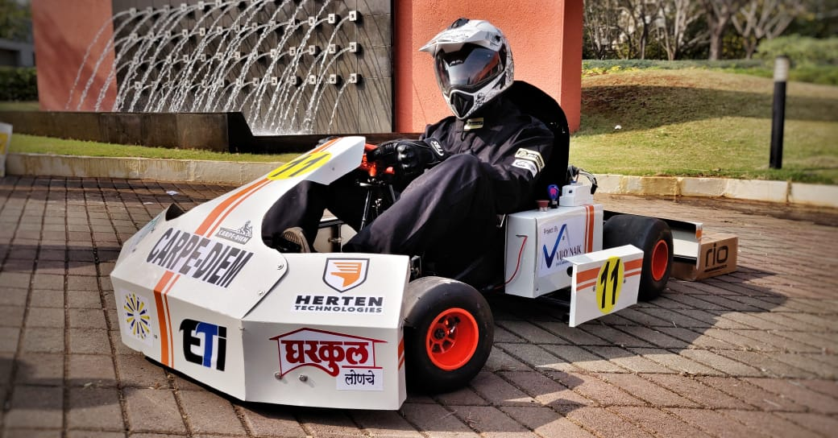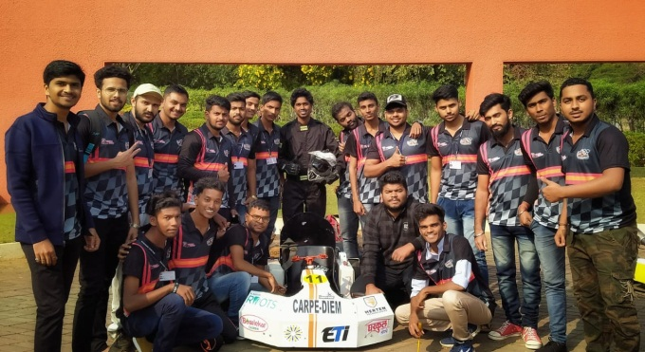

* **Highway Vertical Axis Wind Turbine** *Duration: Aug 2019- Nov 2019*

Project Type: AAKRUTI 2019 Design contest by Dassault Systèmes

Design on a theme of “Smart Energy”  
Complete CAD model was done in Solidworks.  
Analysis of force and complete animation with costing and DIY Report.

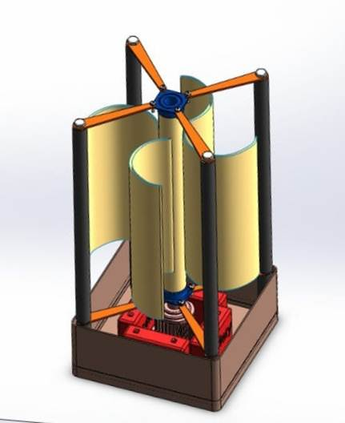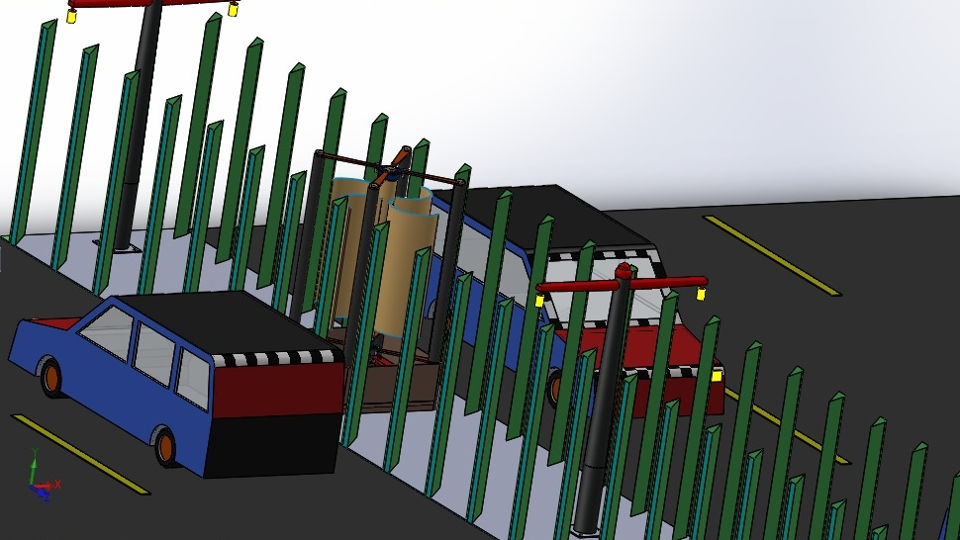

* **Go-kart (135cc 4 Stroke SI Engine)** *Duration: Sep 2018- Mar 2019*

Project Type: International Go-kart Championship 2019

A go kart is a small four wheeled vehicle basically used for traditional kart racing and amusement purpose. Go-kart is designed and fabricated for participation at the international go kart event. To best optimize this balance the use of solid modeling and design on Solidworks & AutoCAD software is extremely useful in addition to conventional analysis.

Role played as Design Head.

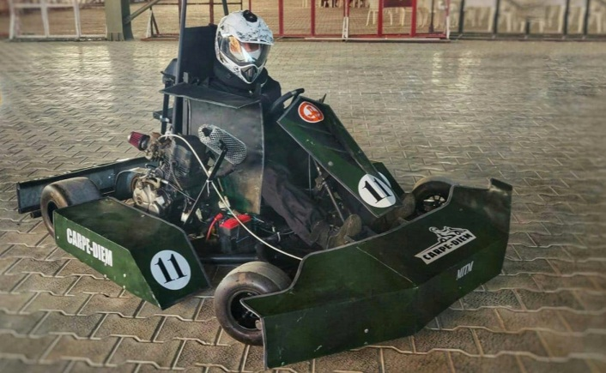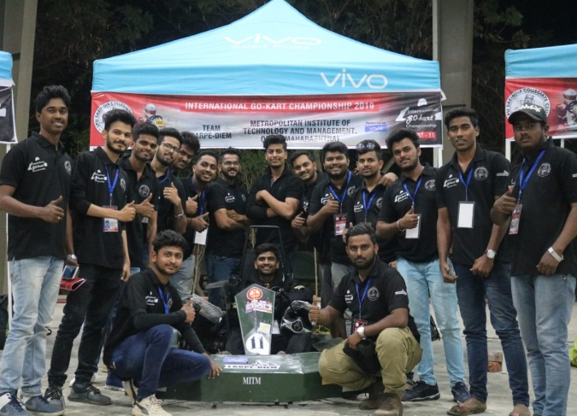

**ACHIEVEMENTS**