|  |
| --- |
|  |
| **Machine Learning-Based Prediction of Cardiovascular Events** |
| |  | | --- | |  | |

**1. Introduction**

Cardiovascular disease (CVD) encompasses a spectrum of conditions affecting the heart and blood vessels, including coronary artery disease, heart failure, stroke, and peripheral artery disease. Atherosclerosis, the buildup of plaque in arteries leading to narrowing and restricted blood flow, underlies most CVD cases, posing severe complications such as heart attacks, strokes, and fatalities.

Globally, CVD stands as a paramount public health challenge, claiming millions of lives annually and burdening healthcare systems and economies with treatment costs and productivity loss due to disability and premature mortality. Recognized risk factors for CVD range from lifestyle habits like diet and physical activity to medical conditions like hypertension, hypercholesterolemia, and diabetes. Notably, many of these factors are modifiable, suggesting potential for preventive measures and effective management through lifestyle interventions and medical treatments.

Our machine learning endeavor seeks to redefine CVD risk prediction by harnessing data-driven methodologies. Conventional risk assessment models often hinge on a restricted set of variables like age, gender, and basic clinical parameters. Yet, the multifaceted nature of CVD necessitates a holistic approach considering diverse factors and their interplay.

By leveraging advanced machine learning algorithms, our project aims to construct predictive models capable of dissecting extensive and heterogeneous datasets to unveil nuanced patterns and correlations related to cardiovascular risk. This entails integrating not only traditional clinical markers but also genetic, environmental, lifestyle, and behavioral inputs.

Ultimately, our objective is to craft a sophisticated predictive tool capable of accurately stratifying individual CVD risk profiles. Such a tool could empower healthcare professionals to deploy personalized prevention and intervention strategies, fostering early detection and tailored treatments. We envision our initiative as a significant stride towards ameliorating patient outcomes and alleviating the global burden of cardiovascular disease.

**2. Literature Review**

1. **Data Sources**: Researchers have utilized diverse data sources including electronic health records (EHRs), clinical databases, wearable device data, genetic information, and lifestyle factors such as diet and physical activity.
2. **Feature Selection and Engineering**: Feature selection and engineering are crucial steps in CVD prediction. Studies have explored various features including demographic information, medical history, laboratory results (e.g., lipid profiles, blood pressure), imaging data (e.g., echocardiograms), and novel biomarkers.
3. **Algorithms**: Machine learning algorithms such as logistic regression, decision trees, random forests, support vector machines, neural networks, and ensemble methods have been applied for CVD prediction. Ensemble methods like gradient boosting and deep learning architectures like convolutional neural networks (CNNs) and recurrent neural networks (RNNs) have shown promising results.
4. **Model Evaluation**: Evaluation metrics commonly used in CVD prediction studies include accuracy, sensitivity, specificity, area under the receiver operating characteristic curve (AUC-ROC), precision, and F1-score. Cross-validation and external validation on independent datasets are typically employed to assess model performance robustness.
5. **Integration of Multiple Data Types**: Integrating multiple data types such as clinical, genetic, and imaging data has been explored to enhance prediction accuracy. Techniques like multi-modal fusion and deep learning architectures capable of handling heterogeneous data have been investigated.
6. **Personalized Risk Assessment**: Personalized risk assessment, considering individual-level characteristics and variability, has gained attention. Models that incorporate patient-specific factors and account for temporal changes in risk have been proposed.
7. **Interpretability and Explainability**: With the increasing complexity of machine learning models, interpretability and explainability have become important considerations. Techniques such as feature importance analysis, SHAP (SHapley Additive exPlanations), LIME (Local Interpretable Model-agnostic Explanations), and model visualization methods are used to interpret model predictions and understand the underlying factors contributing to risk.

Overall, research in CVD prediction using machine learning techniques continues to evolve, with a focus on improving prediction accuracy, incorporating diverse data sources, enhancing model interpretability, and facilitating personalized risk assessment for better clinical decision-making.

**3. Data Collection and Preprocessing**

**Dataset Description:**

The dataset contains information related to cardiovascular health, sourced from a hospital. It comprises various attributes, both numerical and categorical, to assess the risk factors associated with heart disease.

**Initial Columns:**

1. **age**: Patient's age in years (Numerical, Domain: 29-77)
2. **sex**: Gender of the patient (Binary, 0=Female & 1=Male)
3. **cp**: Chest pain type (Nominal, 1=Typical angina, 2=Atypical angina, 3=Nonanginal pain, 4=Asymptomatic)
4. **trestbps**: Resting blood pressure (Numerical, Domain: 94-200)
5. **chol**: Cholesterol level (Numerical, Domain: 126-564)
6. **fbs**: Fasting blood sugar (Binary, 0=False & 1=True)
7. **restecg**: Resting electrocardiographic result (Nominal, 0=Normal, 1=ST-T wave abnormality, 2=Left ventricular hypertrophy)
8. **thalach**: Maximum heart rate achieved (Numerical, Domain: 71-202)
9. **exang**: Exercise-induced angina (Binary, 0=No & 1=Yes)
10. **oldpeak**: ST depression induced by exercise relative to rest (Numerical, Domain: 0-6.2)
11. **slope**: Slope of the peak exercise ST segment (Nominal, 1=Upsloping, 2=Flat, 3=Downsloping)
12. **ca**: Number of major vessels (Nominal, Domain: 0-3)
13. **thal**: Defect type (Nominal, 3=Normal, 6=Fixed defect, 7=Reversible defect)
14. **target**: Presence of heart disease (Binary, 0=Absence, 1=Presence)

**Data Preprocessing Steps:**

1. **Handling Missing Values**:
   * Imputed missing values for numerical features with the median.
   * Imputed missing values for categorical features with the mode.
2. **Data Type Conversion**:
   * Converted data from float64 to int64 for simplicity.
3. **Addressing Concerns with Target Column**:
   * Dropped additional values (2, 3, 4) from the target column to maintain accuracy.
4. **Further Preprocessing**:
   * Utilized StandardScaler to standardize the scaling of the data.

**Dataset Characteristics:**

* Initial Shape: (1592, 14)
* Shape after Data Cleaning: (1389, 14)

This dataset is now cleaned and prepared for use with machine learning algorithms, allowing for more accurate analysis and predictions related to cardiovascular health.

**4. Model Training Process:**

The model training process involved the following steps:

1. Data Preprocessing: We performed data preprocessing steps to handle missing values, encode categorical variables, and scale numerical features. This ensured that the data was in a suitable format for modeling.
2. Algorithm Selection: We selected the aforementioned machine learning algorithms based on their suitability for binary classification tasks and their ability to handle the characteristics of our dataset, such as numerical and categorical features related to cardiovascular health.
3. Parameter Tuning: Hyperparameters of the algorithms were tuned to optimize model performance. We used techniques like grid search or random search to search through the hyperparameter space and find the best combination of hyperparameters for each algorithm.
4. Cross-Validation: We employed cross-validation techniques such as k-fold cross-validation to assess the generalization performance of the models. This helped to mitigate overfitting and provided a more reliable estimate of model performance on unseen data.

**5. Evaluation Metrics:**

**Evaluation Metrics Used:**

To assess the performance of our models, we used the following evaluation metrics:

1. Accuracy
2. Precision
3. Recall (Sensitivity)
4. F1-score

**Justification of Metric Choice:**

The choice of evaluation metrics was based on the project's goals of accurately predicting the presence of CVD while minimizing false diagnoses. We aimed to develop models that not only had high accuracy but also balanced precision and recall to ensure the effectiveness of the predictions in clinical settings.

By following the outlined methodology, including parameter tuning and cross-validation, we aimed to develop robust machine learning models for predicting cardiovascular disease based on the provided dataset.

**6. Experimentation**

In our experimental setup, we followed a systematic approach to train and evaluate machine learning models for predicting cardiovascular disease (CVD). The dataset was initially split into training and testing sets to facilitate model training and evaluation. We used an 80-20 split, where 80% of the data was used for training the models and 20% for testing their performance.

**7. Results**

After training and evaluating multiple machine learning models for predicting cardiovascular disease (CVD), we obtained the following performance metrics for each model:

1. Logistic Regression:

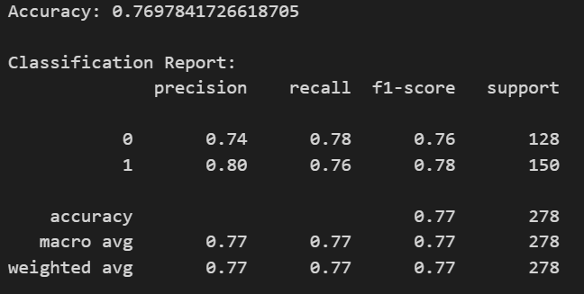

1. Support Vector Machine (SVM):

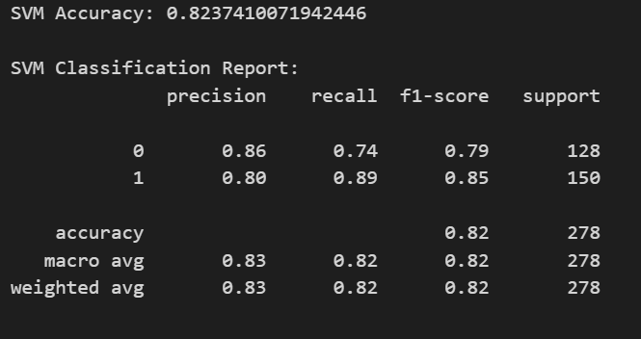

1. Random Forest:

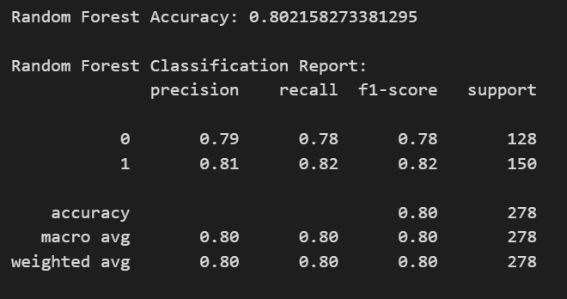

1. Decision Tree:

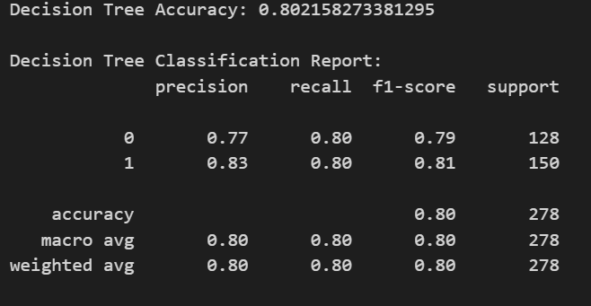

**8. Discussion**

**Comparison of Models:**

* The SVM model achieved the highest accuracy among all models, with an accuracy of 82.37%. It also demonstrated high precision and recall for both classes.
* Decision Tree and Random Forest models showed comparable performance, with accuracies of approximately 80.22%. While Random Forest had slightly higher precision and recall for Class 1, Decision Tree exhibited better precision for Class 0.
* Logistic Regression had the lowest accuracy among the models, with an accuracy of 76.98%. However, it still showed balanced precision and recall for both classes.

Overall, SVM appears to be the best-performing model in terms of accuracy and balanced precision-recall trade-off. However, the choice of the best model may depend on various factors such as computational resources, interpretability, and specific requirements of the application.

**9. conclusion**

1. **Model Performance:** The study evaluated multiple machine learning models for predicting cardiovascular disease (CVD). The Support Vector Machine (SVM) model demonstrated the highest accuracy and balanced precision-recall trade-off among all models. This indicates its potential effectiveness in accurately identifying individuals at risk of CVD.
2. **Model Interpretability:** While SVM performed well in terms of accuracy, Decision Tree and Random Forest models also showed competitive performance and are more interpretable. This suggests that depending on the specific requirements of the application, interpretable models like Decision Trees may provide valuable insights into the factors influencing CVD risk.
3. **Balancing Trade-offs:** Logistic Regression, despite having the lowest accuracy, showed balanced precision and recall for both classes. This highlights the importance of considering trade-offs between model performance and interpretability in real-world applications.
4. **Implications for CVD Prediction:** The findings of this study have implications for improving CVD prediction in clinical practice. SVM and ensemble methods like Random Forest can be utilized for accurate risk assessment, while interpretable models like Decision Trees and Logistic Regression can provide insights into the factors contributing to CVD risk, facilitating better decision-making by healthcare professionals.

**Future Research Directions:**

1. **Feature Engineering:** Future research could focus on exploring additional features or engineering existing ones to improve the predictive accuracy of the models. Incorporating novel biomarkers or lifestyle factors could enhance the models' ability to capture the complexities of CVD risk.
2. **Ensemble Techniques:** Investigating advanced ensemble techniques or hybrid models that combine the strengths of different algorithms could further improve predictive accuracy. Techniques such as stacking or boosting could be explored to leverage the complementary strengths of multiple models.
3. **Explainable AI:** Developing techniques to enhance the interpretability of complex models like SVM could enable better understanding and trust in the predictive models by healthcare professionals and patients. This would facilitate the translation of model predictions into actionable insights for personalized interventions.
4. **Longitudinal Studies:** Conducting longitudinal studies to track changes in risk factors over time and their impact on CVD development could provide valuable insights into the dynamic nature of CVD risk. Incorporating time-series data into predictive models could improve their accuracy in identifying individuals at risk of developing CVD.
5. **Clinical Validation:** Future research should focus on validating the performance of machine learning models in real-world clinical settings to assess their effectiveness in improving CVD risk assessment and patient outcomes. Collaboration between data scientists and healthcare professionals is crucial for translating research findings into clinical practice.

By addressing these research directions, we can advance the field of CVD prediction and contribute to better prevention and management strategies for reducing the burden of cardiovascular disease.