**BrainDead**

**“Report on Analyze Placement data”**

**Team (The avengers)**

Members (1. Nikhil S ,2. Pritam M)

**Department of Computer Science and Technology, IIEST Shibpur.**

**Abstract**

So, our focus will be to analyze the placement records of the students at an MBA college. We are here not only to analyze the placement record of students but also to analyze the requirements needed to attend placement drive as well as get the job and even the other factors such as percentage requirements from 10th,12th, Under graduation with specialization, and finally the Mba percentage and many more.

**Declaration**

I Nikhil S and Pritam M students of 2nd year B Tech Computer Science Engineering from CMR University, Bangalore hereby declare that the project work entitled “Analyze placement data” has been carried out by us. This report is submitted in partial fulfillment of the requirement for the event. We declare that the report submitted is to the best of our knowledge.

Place: Bangalore

Date:

**Index**

|  |  |  |
| --- | --- | --- |
| Serial No. | Topics | Page No. |
| 1. | Introduction | 5 |
| 2. | Libraries used | 6 |
| 3. | Analysis | 8 |
| 4. | Conclusion | 10 |
| 5. | Annexure | 12 |

**Introduction**

In the present times, we can see that even after completing the degree with good marks it’s not sure whether he/she will get placed in the job interview. So we tried to analyze the main reason behind it so that we can achieve the change in the number of a student placed in the placement drive.

We are keeping many factors in mind starting from your 10th percent, 12th percent, gender, Under graduation course with specialization, then higher education in the following field, work experience, Employability test percentage, Status of placement, MBA percentage and what is the salary a candidate can expect if he or she gets placed in the placement drive.

We slowly going analyzed every factor with the help of libraries and collab, which we used in our project to analyze with the help of code which is also provided further.

**Libraries used**

1. **Pandas-profiling**

Describe the () function, that is so handy, pandas-profiling delivers an extended analysis of a DataFrame while allowing the data analysis to be exported in different formats such as HTML and JSON. The package outputs a simple and digested analysis of a dataset, including time series and text. The pandas-profiling library in Python includes a method named ProfileReport(), which generates a basic report on the input DataFrame. The report consists of the following:

* DataFrame overview,
* Each attribute on which DataFrame is defined,
* Correlations between attributes (Pearson Correlation and Spearman Correlation), and
* A sample of DataFrame.

**2. MATLAB**

Matlab is a programming platform designed specifically for engineers and scientists to analyze and design systems and products that transform our world. The heart of MATLAB is the MATLAB language, a matrix-based language allowing the most natural expression of computational mathematics. Matlab is a programming language. It was originally made for numerical analysis (especially numerical linear algebra). But today, it is used in many areas such as:

* Data analysis
* Deep learning
* Machine learning
* Neural network
* Numerical analysis
* Numerical methods for ordinary differential equations
* Numerical methods for partial differential equations
* Finite element method
* Optimization
* Signal processing
* Statistics

**3. Google colab**

Colaboratory(“Colab” for short) is a data analysis and machine learning tool that allows you to combine executable Python code and rich text along with charts, images, HTML, LaTeX, and more into a single document stored in Google Drive. Colab allows anybody to write and execute arbitrary python code through the browser and is especially well suited to machine learning, data analysis, and education.

Advantages of Colab,

* Sharing
* Versioning
* Code snippets
* Price

**Analysis**

So, our analysis begins with 215 people of which 139 are males and 76 are females. We started analysis from the 10th(named the column sss_p), where the min percentage is 40.89% and has the highest percentage of 89.4%. Considering the board of education, a column is added namely ssc_b.

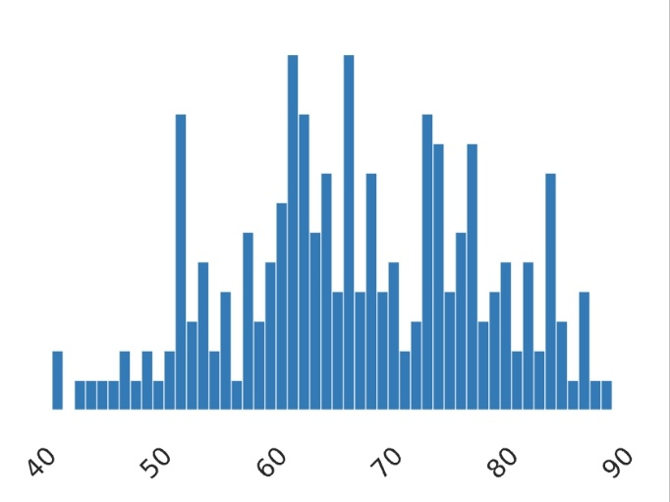

The average percentage obtained by the students varies between 67.30%, which can be considered a bare minimum.

From there we go into 12th (named the column as hsc_p), where the min percent obtained is 37% and the highest percentage of 97.7%. The average somewhere lies between 66.33%. Under the board of education, a column is added namely hsc_b

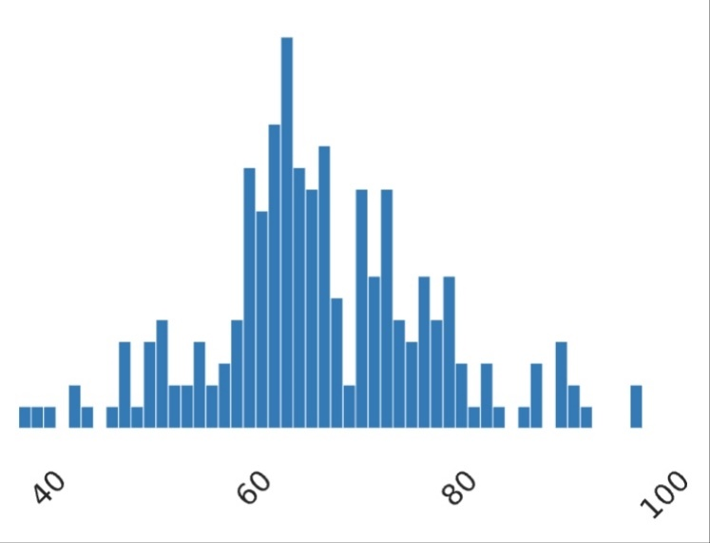

After 12th, students undergo UG’s courses with specializations varying upon the field of degree. Commonly, other courses even this one has exams and tests in them. The min percentage obtained is 50% and the highest percentage is 91% with an average lying between 66.6%. The degree percentage column is named degree_p.

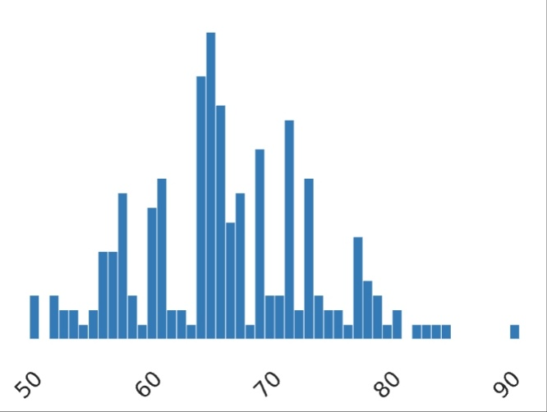

So once UG’s courses are done, the post-graduation course MBA has to be done, that column would be named specialization with the MBA percentage column named as mba_p. After the completion of the PG course, there will be a test named

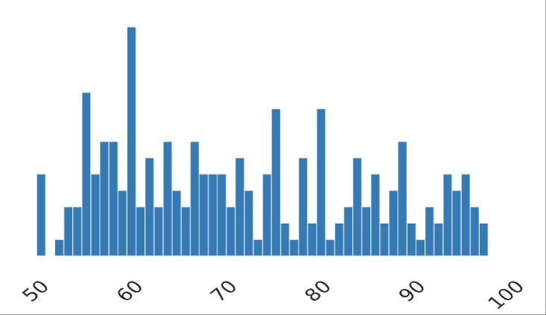

as estest_p(this test is basically for Employability test percentage which is conducted by the college.

The min percent obtained in this test was 50% and the max percent was 98% with an average of 72.10%.

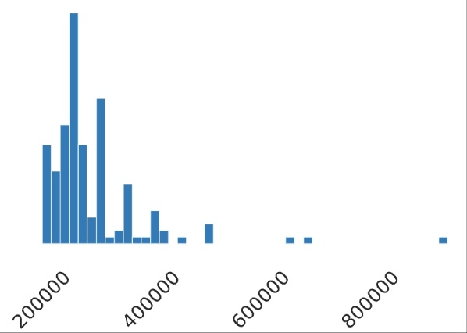

Once the candidate is done with this test, then he/she will be eligible for a placement drive. On average, 148 people out of 215 are placed and the remaining 67 people aren't placed. The ones who have got placed can expect their base salary to start from 200000 LPA which can go up to 94 LPA.

Factors affecting the placement of a student

* Work experience
* Entrance examination score
* Grades he/she achieved
* Internship
* Rating on extra-curricular activities

Degree specialization which is in high demand

* Marketing
* Leadership and strategy
* Operations and supply chain
* Applied Finance
* Digital marketing

Does MBA percentage matter in placement

* However, the academic records do not contribute more than 5-10% to the recruiter's decision. If you have managed to maintain a healthy 65-75% average in your school and college years, you should find it easy to match the basic eligibility criterion for most MBA jobs.

**Conclusion**

According to our analysis, we saw that if a person pays a little more attention to his academic growth along with technical skills, extra circular activities, and more. It's proved that MBA percentage matters up to some extent only, what mainly matters is your personal skills, try to maintain a little more marks than then average marks, that would be enough and most importantly the way you talk and confidence levels also matters especially in the field of digital marketing and marketing.

**References**

1. <https://www.google.com/>
2. <https://www.youtube.com/>
3. https://citrusbug.com/blog/python-libraries-for-machine-learning

Annexure

import pandas as pd

from pandas_profiling import ProfileReport

df =pd.read_csv("/content/Placement_Data_Full_Class.csv")

profile = ProfileReport(df)

profile.to_file(output_file="/content/Placement_Data_Full_Class.html"