StudyMate - Hackathon Project Document

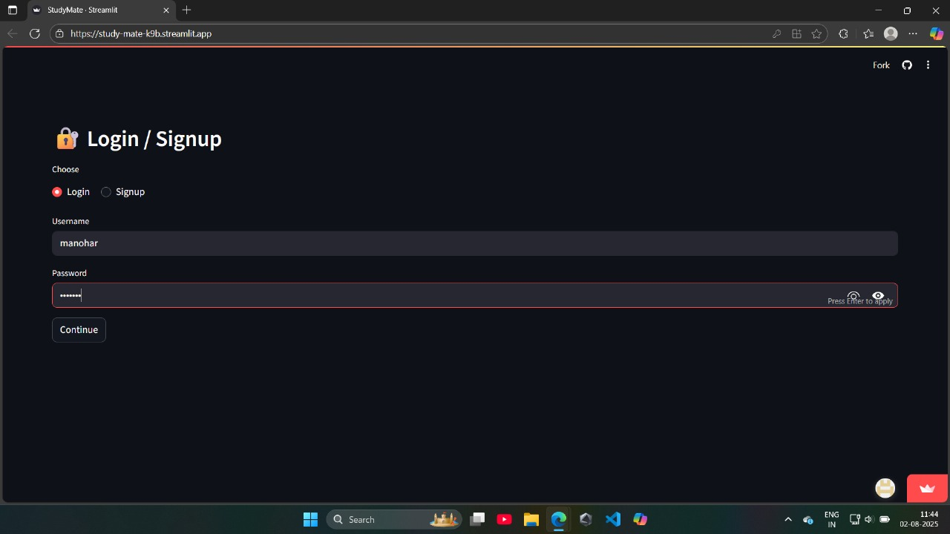

Project Link:

https://study-mate-k9b.streamlit.app/

**1. Project Title**

StudyMate

**2. Theme**

Education and Artificial Intelligence

**3. Team Information**

Team Size: 3 Members  
  
Roles:  
  
Backend Developer: API, Database, and Authentication Integration.  
  
Frontend Developer: Streamlit UI, User Experience.  
  
AI/ML Developer: AI Answer Extraction using Gemini API.

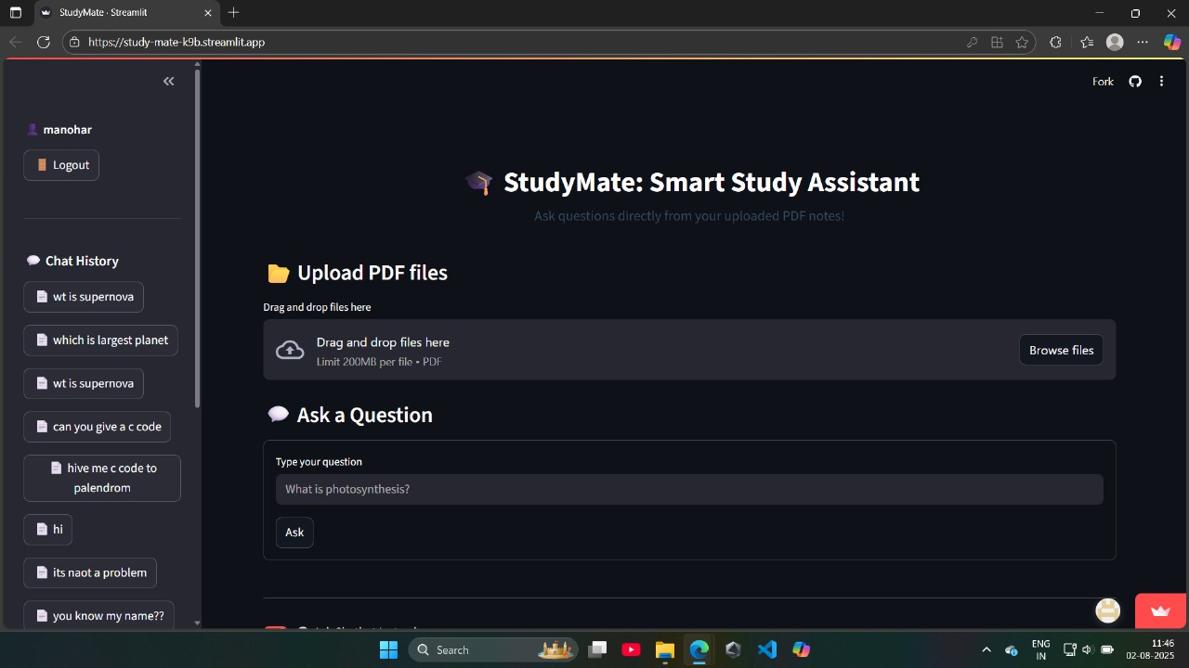

**4. Problem Statement**

Modern students depend heavily on PDF notes, research papers, and e-learning materials. During exams, they spend a lot of time manually searching through hundreds of pages to find specific answers. This leads to:  
  
- Wasted preparation time.  
- Inconsistent learning due to irrelevant results from general search engines.  
- Increased stress levels before exams.  
  
Current solutions like Google and ChatGPT fail to focus only on the student's own study material, which makes personalized learning difficult. There is a clear need for a tool that connects AI power with personal academic content.

**5. Objective**

To create a personalized AI learning assistant that allows students to:  
  
- Interact with their own PDF study materials.  
- Ask questions naturally and receive precise, context-based answers only from their uploaded PDFs.  
- Reduce search time and enhance exam preparation efficiency.

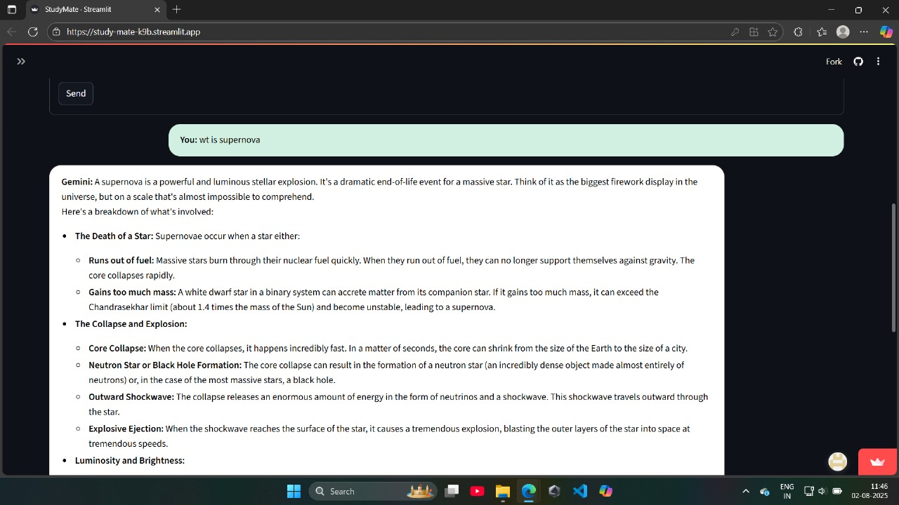

**6. Proposed Solution**

StudyMate is a web-based AI-powered tool designed to make studying faster and smarter.  
  
✅ Students can upload lecture PDFs or research papers.  
✅ An AI engine (Gemini API) scans the document and understands the context.  
✅ Students ask natural language questions and get accurate answers extracted only from their PDF.  
✅ Recently asked questions are saved as a quick revision bank.  
✅ Includes an AI chatbot for general study-related queries.  
✅ A secure login system ensures each user’s data and Q&A history is private.  
  
Core Idea: Combine Education + AI + Personalized Study Materials into one seamless platform.

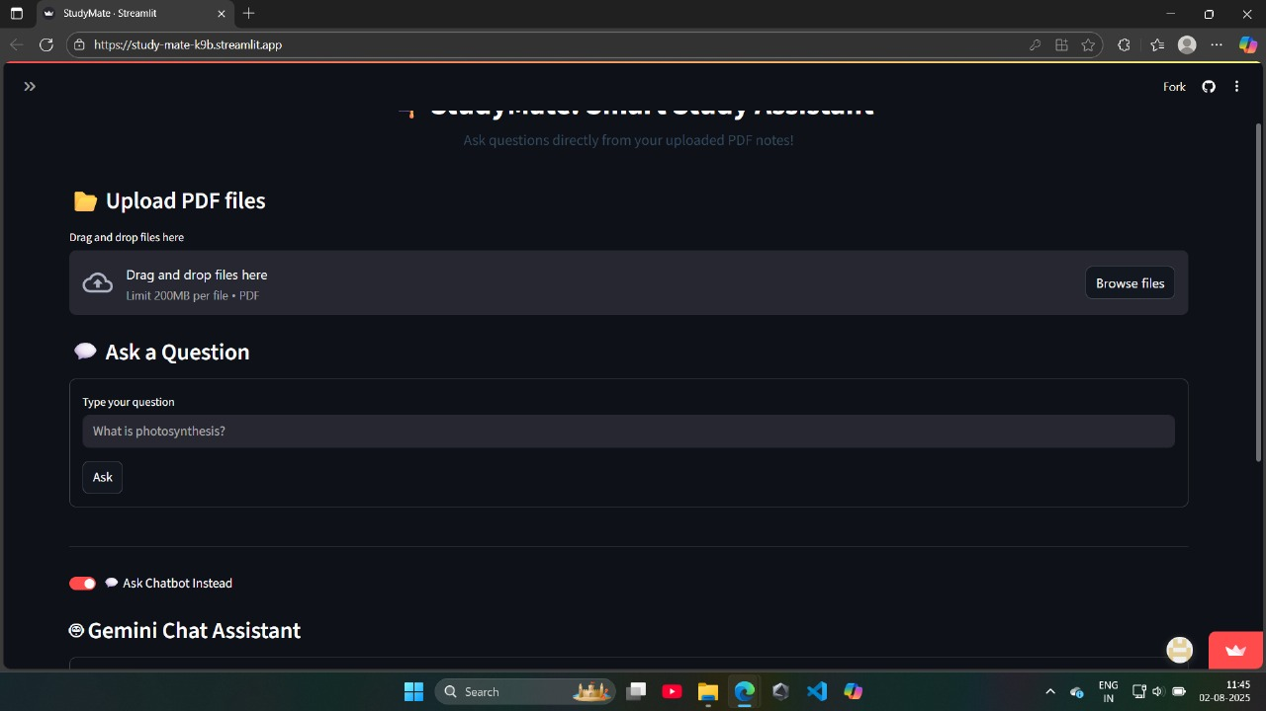

**7. Key Features**

📌 PDF Upload & AI-Powered Q&A: Extract answers only from uploaded notes.  
  
📌 Personal Revision Bank: Recently asked questions stored for quick access.  
  
📌 AI-Powered Chatbot: Helps in additional doubts outside PDFs.  
  
📌 Secure Login: Uses MongoDB backend for authentication and data privacy.  
  
📌 Multi-Page Responsive Web UI: Clean interface with user-friendly navigation.  
  
📌 Fast & Lightweight: Designed for smooth use even on low-end devices.

**8. Technology Stack**

Frontend: Streamlit (for interactive web interface)  
  
Backend: Flask (API and server logic)  
  
Database: MongoDB (user authentication & Q&A storage)  
  
AI Engine: Gemini API (answer extraction & context understanding)  
  
Programming Language: Python

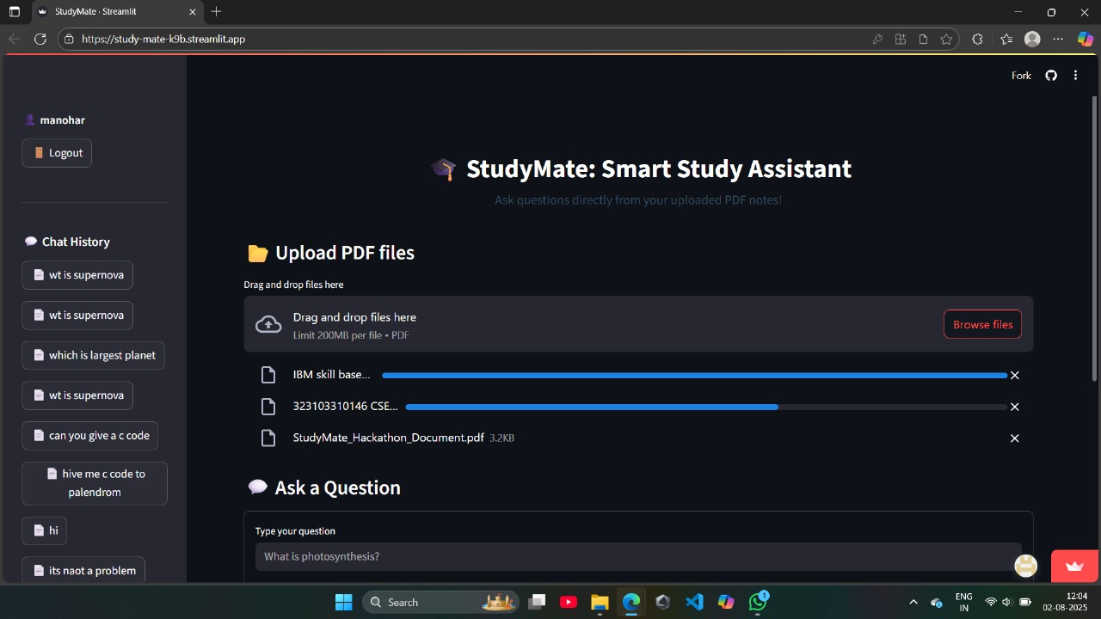

**9. Workflow / Architecture**

1️⃣ Login: User credentials validated and stored securely in MongoDB.  
2️⃣ PDF Upload: File is processed and indexed for AI search.  
3️⃣ Question Asked: User inputs query in natural language.  
4️⃣ AI Processing: Gemini API scans PDF and extracts the most relevant answer.  
5️⃣ Response: Displayed instantly, and stored in the Recent Q&A section.  
  
(Optional: Architecture Diagram can be added in PPT)

**10. Uniqueness and Innovation**

🎯 Focuses strictly on user’s PDFs instead of the internet.  
  
🎯 Works like a personal AI tutor for each student.  
  
🎯 Combines Q&A + Revision Bank + AI Chatbot in one platform.  
  
🎯 Can scale to become a college-wide learning assistant with multiple users.

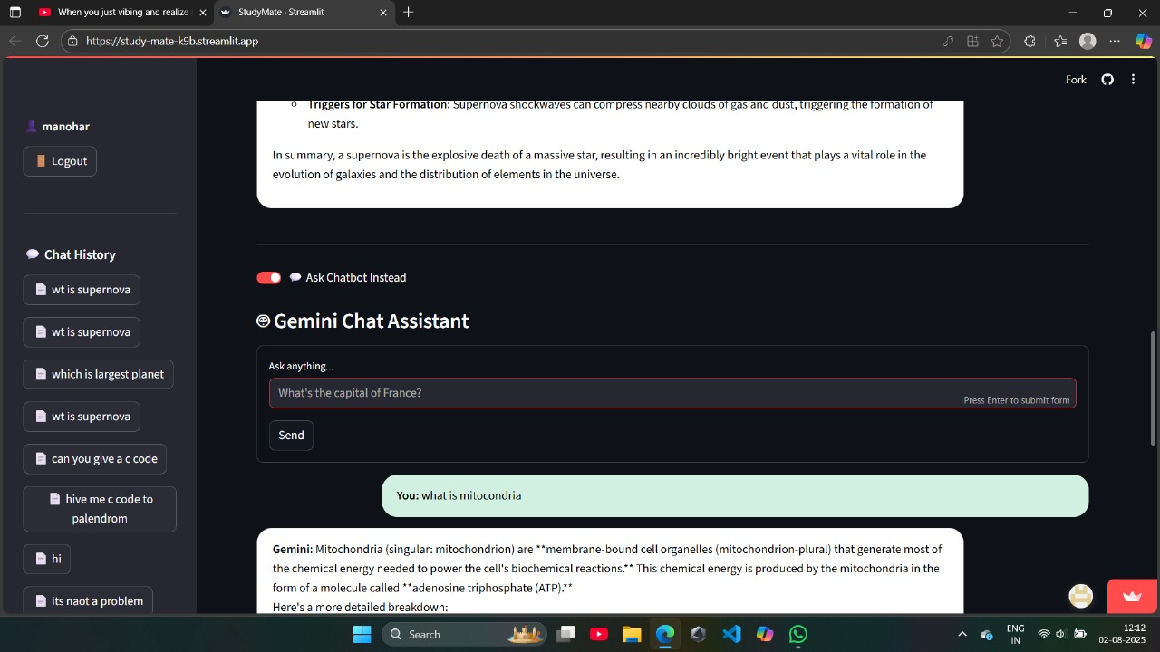

**11. Future Enhancements**

📌 Multi-PDF comparison and cross-answering.  
  
📌 Voice-based questions and speech-based answers.  
  
📌 Integration with cloud services (Google Drive, OneDrive).  
  
📌 AI-based study analytics and performance tracking.

📌 Adaptive suggestions based on student’s question history.

**12. Expected Outcome**

✅ Reduce exam stress by cutting down manual searching time.  
  
✅ Enhance personalized learning by connecting AI with user’s own notes.  
  
✅ Create a scalable educational platform suitable for students and institutions.  
  
✅ Offer a practical AI tool that blends with real academic needs.

13. System Limitations

Each PDF file uploaded must be 200 MB or less.  
Files larger than 200 MB will be rejected automatically to maintain performance and avoid processing delays.  
Supported  file type: .pdf only.

