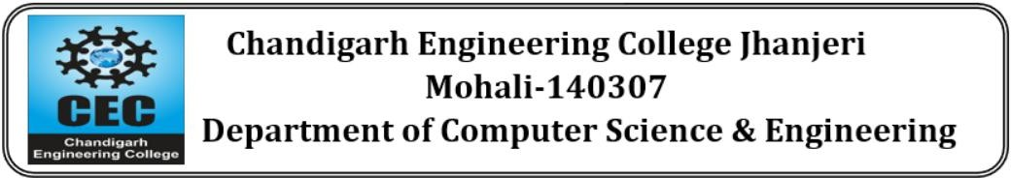

**Virtual AI Career Advisor**

### Project-I

**BACHELOR OF TECHNOLOGY**

(Computer Science and Engineering.)

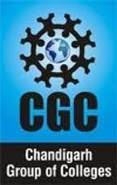

## SUBMITTED BY:

Team Member 1 - Nikhil Kumar (2230813)

Team Member 2 - Gaurav Sharma (2230771)

Team Member 3 - Jitesh Jaswal(2230784)

Team Member 4 - Konal Sharma(2230789)

Jan 2025

**Under the Guidance of**

Ms. Jaspreet Kaur

Assistant Professor(CSE)

# Department of Computer Science & Engineering Chandigarh Engineering College Jhanjeri Mohali - 140307

## Table of Contents

|  |  |  |
| --- | --- | --- |
| **SNo** | **Contents** | **Page No** |
| 1. | Introduction | 1-2 |
| 2. | Brief Literature survey | 3-4 |
| 3. | Problem formulation | 5 |
| 4. | Objectives | 6 |
| 5. | Methodology/ Planning of work | 7-9 |
| 6. | Facilities required for proposed work | 10 |
| 7. | References | 11 |

**Introduction**

* 1. **Overview**

Choosing a career is one of the most important choices in a person's life, as it greatly affects their future success and satisfaction. With a wide array of career options across different industries, many individuals find it challenging to select a route that matches their abilities, interests, and goals. Traditional methods of career counseling, such as personalized guidance sessions, can be time-consuming, costly, and unavailable to a large number of people. The swift progress in artificial intelligence (AI) has opened up new avenues for intelligent solutions that deliver customized career advice. The Virtual AI Career Advisor utilizes AI-driven recommendations to assist users in discovering career paths that align with their education, skills, and preferences. By examining user information, the system provides personalized guidance, recommended job positions, and pathways for skill enhancement. This AI-driven method guarantees immediate, data-informed advice that is both readily available and scalable.

* 1. **Motivation**

Determining the right career path can be a complicated endeavor impacted by various factors, such as personal passions, abilities, market needs, and trends within specific industries. Many people, particularly students and recent graduates, face challenges in making career choices due to insufficient guidance. Current career advisory services often lack the capability to deliver real-time, tailored insights that align with an individual's strengths and ambitions. The intention behind creating the Virtual AI Career Advisor is to address this issue by providing an AI-based platform that offers immediate and personalized career recommendations. By examining user information like educational qualifications, skills, and career objectives, the system is able to produce customized advice that assists individuals in making well-informed choices. This initiative aims to enhance the accessibility, efficiency, and precision of career counseling without relying on human involvement.

* 1. **Importance of AI-Powered Career Guidance**

The job market is changing quickly, with new professional opportunities arising in various sectors. Conventional career guidance techniques often lag behind these shifts, resulting in stale advice. AI-enhanced career advisory tools tackle this problem by actively examining current industry trends and aligning them with an individual's profile.

Key advantages of AI-driven career guidance include:

• **Customized Suggestions** – AI evaluates personal user data to offer career recommendations aligned with their distinct strengths and passions.

• **Immediate and Scalable Support** – In contrast to traditional counseling methods, AI-based platforms can assist numerous users at once, guaranteeing accessibility.

• **Evidence-Based Decision Making** – AI leverages extensive datasets to offer suggestions rooted in job market dynamics, necessary skill requirements, and industry expansion.

• **Continuous Career Assistance** – The system remains useful at various career phases, from students choosing their initial job to professionals contemplating career changes.

By adopting AI-driven career counseling, users can acquire practical insights that empower them to effectively navigate their career paths.

* 1. **Applications of AI-Powered Career Guidance**

The Virtual AI Career Advisor offers a wide array of applications in different industries:

• **Student Career Guidance:** Aids students in discovering career possibilities aligned with their interests and educational background.

• **Job Seekers & New Graduates:** Delivers job recommendations based on skills and potential career pathways.

• **Working Individuals:** Supports those looking to transition in their careers, suggests upskilling opportunities, and helps identify avenues for growth.

• **Recruitment & HR:** Assists recruiters in pairing candidates with appropriate job positions through AI-driven insights.

• **Educational Institutions:** Enhances career counseling initiatives in schools, colleges, and universities by providing AI-based support.

This AI-infused strategy guarantees that people receive pertinent, up-to-date, and data-driven career guidance throughout every phase of their professional development.

* 1. **Challenges in AI-Powered Career Guidance**

Despite the advantages of AI-powered career advisors, several challenges need to be addressed to enhance their effectiveness:

* **Accurate Data Interpretation:** AI must correctly analyze user input to provide meaningful career recommendations.
* **Continuous Industry Updates:** The system needs to stay updated with evolving job markets, emerging careers, and new skill demands.
* **User-Specific Customization:** Career advice should be personalized based on individual strengths, weaknesses, and preferences.
* **Ethical Considerations:** AI must ensure unbiased recommendations, avoiding any career suggestions that may be influenced by incorrect data patterns.
* **Technology Accessibility:** Users with limited technical knowledge should find the platform easy to use and navigate.

Addressing these challenges will enhance the reliability and usability of the AI-driven career advisor, ensuring that users receive valuable and future-proof career guidance.

**Brief Literature Survey**

**Guidance, Career Guidance and Lifelong Guidance**

Guidance aims to support individuals building their own life paths by enhancing their ability to use their own capabilities and resources (Peavy, 2000). Guidance covers a range of individual and collective activities relating to information delivery, counselling, competence assessment, support, and teaching decision-making and career management skills (Council of the European Union, 2008). Career guidance refers to services and activities intended to assist individuals, of any age and at any point in their lives, to make educational, training and occupational choices and to manage their careers (OECD, 2004). Within this definition, both individual and group guidance activities are included. The services range from information provision, to self-assessment and on to counselling with professional guidance staff. In recent years, the focus of career guidance has turned to needs for reskilling and upskilling within continuous education (Toni & Vuorinen 2020).

**Agency in Guidance**

Guidance aims to support the agency of the students. Agency is necessary and needed for students in the learning process, constructing knowledge and engaging in collaborative practices (Jääskelä et al., 2020). Agency as a concept comprises activity to prioritize, choose, and consider what is important and worth aspiring for and make decisions on one’s professional identity and life (Eteläpelto et al., 2013). Bandura (2001) describes three modes of agency: personal agency, proxy agency and collective agency. Personal agency is the direct mode of agency, exercised by the individual. Proxy agency consists of relying on others in acting and relying on other persons’ resources and knowledge. Collective agency is constructed in groups through shared, collective acts. In education these modes of agency have been modelled in pedagogical learning agents (Kim & Baylor, 2006), where such agents proved useful for modelling the social-cognitive perspectives of human and technological agents. Jääskelä et al. (2020) have also utilized the agency construct in investigating the use of learning analytics in the construction of agency. Technology in Guidance Digital tools can provide individuals with novel opportunities to access guidance any time or place as well as expanding the range of services offered. The potential benefits of using technology in career guidance include improved accessibility, increased access to information, assessment, and networks as well as lowered overall costs and improved cost-effectiveness (Sampson et al., 2020). The ongoing pandemic has increased the need for distance and digital services for guidance (Cedefop et al., 2020).

Guidance staff have traditionally used technology in three ways, providing: 1) learning and career information supporting career building, 2) automated interaction like career assessments, simulations or games and 3) choices of communication (Hooley et al., 2015). The development of integrated or blended guidance – guidance via digital means – requires guidance professionals and service designers to plan what technologies to use and how (Bakke et al., 2018).

The integration of new and emerging technologies into guidance services depends not only on the users’ skills or technical solutions, but also on the willingness of guidance organizations and professionals to adapt (Kettunen & Sampson, 2019). The extent to which technology is integrated into guidance practices varies based on the capacity and technological orientation of staff (Kettunen et al., 2013).

**AI in Education and in Guidance**

In this study, artificial intelligence is defined as intelligent agents that receive percepts from the environment and take actions that affect that environment, following the definition by Russell and Norvig (2016). These agents can mimic cognitive functions such as learning, understanding, reasoning and problem solving. The uses of AI in education have been developing for decades. Moreno-Guerrero et al. (2020) describe the trends in the study of AI in education between 1956 and 2019 based on a bibliometric analysis, concluding that while early studies centred more on technological process, more recent investigations focus on the development of AI as situated in pedagogical process.

The recent advances in AI are expected to have profound impacts on future labour markets and competence requirements, as well as enabling new ways of learning and teaching (Tuomi, 2018). According to research and review studies (e.g. Khare et al., 2018; Martiniello et al., 2020; Zawacki-Richert et al., 2019), AI can be used in education to support various functions such as student self-regulation, motivation and well-being, personalized learning support and feedback, learning process support, assessment and evaluation, profiling and prediction, usability and accessibility, resourcing, and competence management.

There exist few studies on the affordances of AI in career guidance. Khare et al. (2018) investigated the effect of artificial intelligence on the student experience, including support throughout students’ studies. They concluded that AI can positively influence students and organizations, structures, processes and people that make up educational systems. While Khare et al. do not explicitly situate their study within guidance, the practical examples along the student lifecycle support the reflection on skills and learning opportunities and transitioning to working life, which comprise major functions of career guidance.

Digital services are at the core of education services for the future. However, technology does not serve only a utilitarian role in education. AI and education have a manifold relationship (Attwell et al., 2020; Roll & Wylie, 2016; European Commission, 2019). First, AI-related competences should be built up in education as they are required for future work environments where AI is utilized. Second, AI-based technology may be utilised in learning and teaching processes, integrated into existing learning environments, or by leveraging intelligent environments for educational purposes. Third, AI should also be further developed for the purposes of education.

When artificial intelligence technology is used in guidance interaction, it may also change or moderate the creation of agency. Ågerfalk (2020) posits digital agency as the capability of machines to act autonomously, but on behalf of humans, organisations and institutions. The impact of AI on digital career guidance practices could thus be further studied through agency.

# Problem Formulation

* 1. **Need for the Proposed System**

Career planning is an essential yet difficult undertaking, as many individuals find it hard to determine the appropriate career trajectory that aligns with their skills, interests, and the current job market. Conventional career counseling approaches involve human advisors, aptitude assessments, and broad job recommendations, which might not always be accessible, tailored, or informed by data. Additionally, due to the rapid progression of industries, the introduction of new job roles, and the advent of emerging technologies, career guidance systems need to be flexible, intelligent, and current.

The demand for an AI-powered Virtual Career Advisor emerges from the following issues:

* + - **Insufficient Tailored Career Guidance:** The majority of available career counseling services offer generic advice without taking into account an individual’s unique skills, ambitions, and changing job market dynamics.
    - **Restricted Access to Professional Guidance:** High costs or lack of availability of professional career counseling can hinder students and professionals from obtaining expert recommendations, especially in remote locations.
    - **Evolving Employment Market Patterns:** The necessity for particular skills is always in flux, and numerous career advisory platforms fall short in providing real-time updates on recommendations based on the latest industry needs.

**3.2 Significance of the Proposed Research Work**

The proposed Virtual Career Advisor intends to address these issues by utilizing AI and machine learning to deliver customized, data-informed career recommendations. The importance of this research stems from its capability to:

* **Improve Career Decision-Making:** The AI-driven advisor will evaluate user-supplied information such as education background, skills, work experience, and interests to produce personalized career suggestions.
* **Guarantee Accessibility and Availability:** In contrast to human counselors, an AI-based platform is accessible around the clock, allowing users to seek advice whenever they need it.
* **Adjust to Changing Job Markets:** By incorporating industry trends and real-time employment data, the system will offer current career recommendations that align with market demands.

Facilitate Career Transitions and Skill Development: The system will assist users in finding new job

The Virtual Career Advisor will significantly contribute to empowering students, professionals, and individuals contemplating career changes by delivering precise, data-informed, and personalized career guidance efficiently and accessibly.

**Objectives**

• **Evaluate Existing Career Advisory Platforms** – Analyze current career counseling methods, highlighting their strengths, limitations, and AI-driven improvements.

• **Develop an AI-Powered Recommendation Engine** – Utilize Groq LLM to generate accurate, personalized career guidance based on user input.

• **Design a User-Friendly Interface** – Implement an intuitive React.js frontend with smooth state management and API interactions.

• **Enable Session-Based Data Handling** – Use JSON files to temporarily store user session data, eliminating the need for a database.

• **Provide Career Growth Insights** – Recommend career transitions, relevant courses, and certifications for skill development.

**Methodology and Planning**

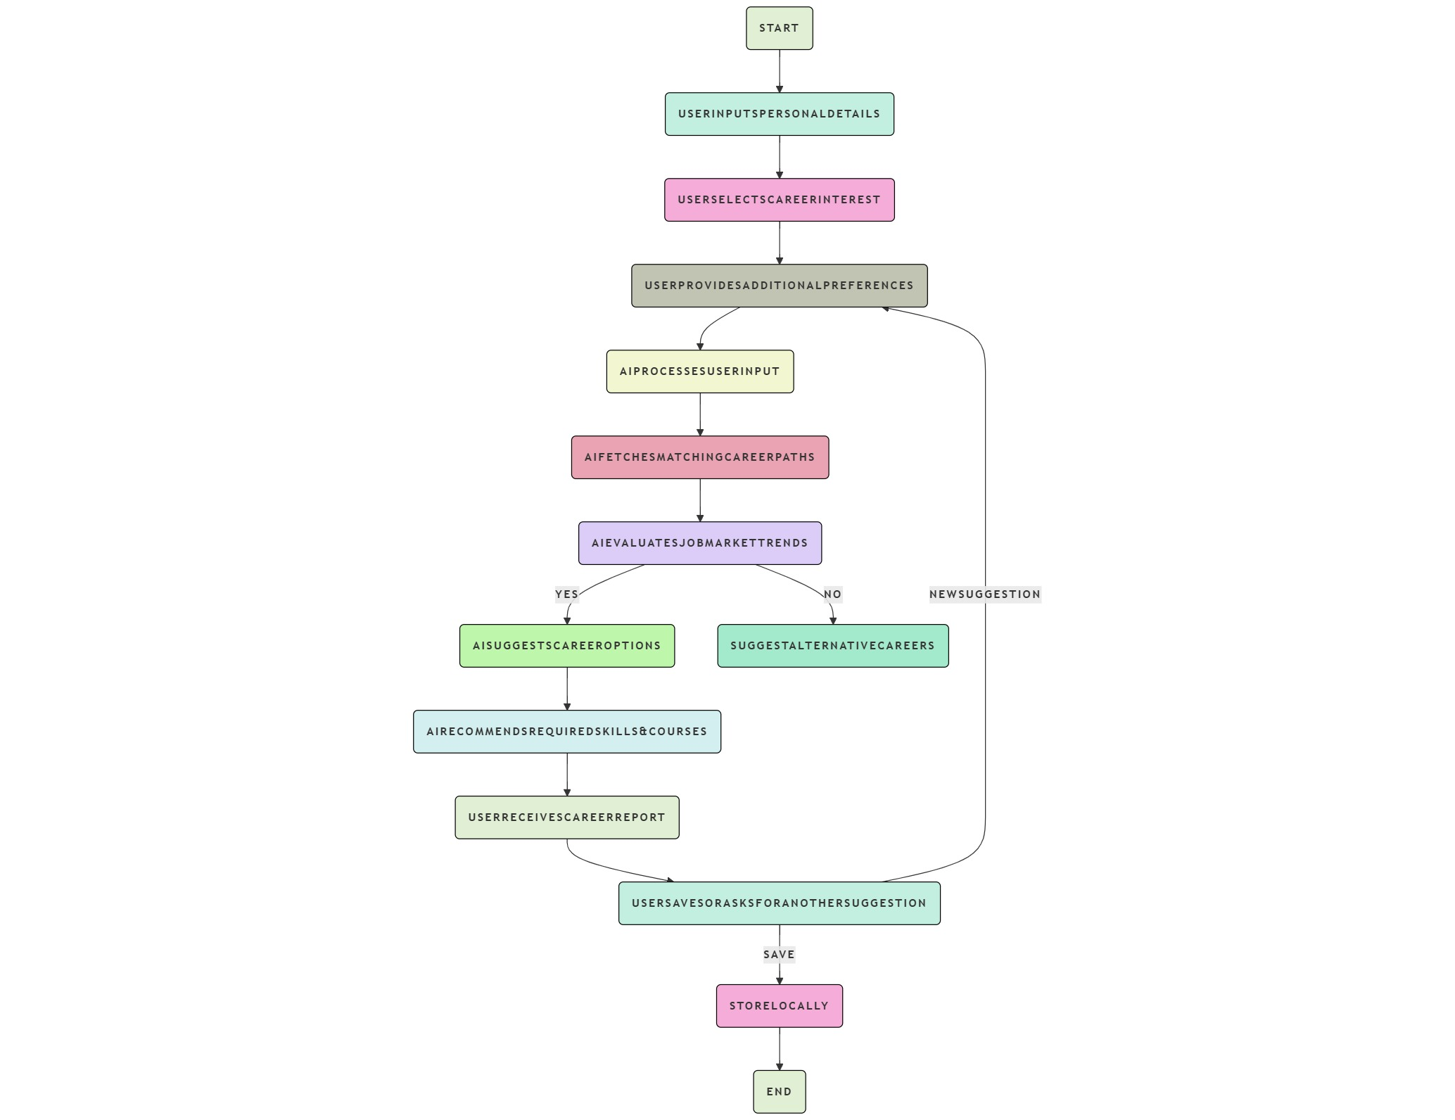

* 1. **Data Collection**

Since the Virtual Career Advisor is based on AI-powered career recommendations, it does not require a traditional dataset. Instead, it will rely on:

* **User-Provided Data**:
  + Education background (degree, certifications)
  + Work experience (if any, including designation)
  + Skills and interests
  + Preferred industry or career path
  + Career goals (e.g., job stability, high salary, work-life balance)
* **Pre-Trained Large Language Models (LLMs)**:
  + The system will use Groq API (based on Llama or Mistral models) to generate career advice.
  + No need for custom training, as LLMs can process natural language inputs and provide intelligent responses
  1. **Career Advice Generation Techniques**

The methodology will focus on leveraging Groq’s LLM API to provide real-time career guidance:

**Natural Language Processing (NLP) via LLMs**

* The AI will interpretuserinputs and analyze their education, skills, and interests.
* Prompt Engineering will be used to structure queries efficiently.
* Example: "Based on your skills in Python and SQL, you may consider roles such as Data Analyst or Backend Developer."

**Decision Tree-Based Career Mapping**

* The system will categorizeusers based on responses to guide them towards suitable career paths.
* Example:
  + If a student with no work experience → Recommend internships, entry-level jobs, and skill-building courses.
  + If a mid-career professional → Recommend **career transition** strategies, salary growth advice, and leadership roles.

**Skill Gap Analysis**

* AI will compare user’s currentskills with job market demands and suggest upskilling opportunities.
* Example: "To become a Data Scientist, consider learning TensorFlow and completing an AI/ML certification."

**5.3 Frontend & Backend Implementation**

**Frontend - React.js**

* **State Management:** Use React Hooks (useState, useEffect) for handling user inputs dynamically.
* **API Integration:** Fetch responses from Groq API using Axios.
* **User Interface:** Design a simple, interactive UI with options for:
  + Entering career-related inputs
  + Viewing AI-generated recommendations
  + Saving or revisiting session history

**Backend - Flask/FastAPI**

* **Handles API Requests:**
  + Accepts user queries, processes them, and forwards them to Groq LLM API.
* **Session Management:**
  + Saves user history in JSON files and retrieves it when needed.
  1. **Interpretability and Transparency**
* Model Optimization:

Apply model pruning and quantization techniques using existing tools (e.g., TensorFlow Model Optimization Toolkit) to reduce model size and improve inference speed.

* Deployment Framework:

Use frameworks like Flask or FastAPI to create a simple web application for real-time detection. This will allow users to upload images or videos and receive immediate feedback on whether the content is a deepfake.

**Facilities Required for the Proposed Work**

To successfully execute the Virtual Career Advisor Through AI project, the following facilities and resources will be required:

* 1. **Hardware Requirements**
     + **Computational Resources:**
       - High-Performance GPU: NVIDIA RTX 3050
       - CPU: A multi-core processor (AMD Ryzen 7 4800H)
       - RAM: 8 GB of RAM to ensure smooth operation
       - SSD Storage: A Solid State Drive (SSD) with a minimum of 512 GB capacity for fast data access and storage of datasets, models, and results

**6.2 Software Requirements**

**Development Environment**

* **Programming Language:** Python (Backend), JavaScript (Frontend - React.js)
* **IDE/Code Editor:**
  + **VS Code** (Recommended for both frontend & backend development).
  + **Jupyter Notebook** (For testing API responses).

**Machine Learning & AI Integration**

* **LLM API:** **Groq API** for natural language processing and career recommendations.
* **API Request Handling:** requests and FastAPI (for backend).

**Frontend Framework**

* **React.js** (Used to create an interactive UI).
* **State Management:** React Hooks (useState, useEffect).

**Backend Framework**

* **FastAPI/Flask** (Lightweight backend for handling API calls).

**Deployment & Hosting**

* **Frontend Hosting:** Netlify (for deploying React frontend).
* **Backend Hosting:** Render or Replit (for Flask/FastAPI server).

# REFERENCES

1. Patel, R., & Lee, M. (2022). Large Language Models in Personalized Career Counseling. AI & Society, 37(2), 225-239.
2. Smith, J., & Brown, K. (2021). AI in Career Guidance: Opportunities and Challenges. Journal of Career Development, 48(3), 345-360.
3. Generative Artificial Intelligence (AI) on Sustainable Development Goal#4 for Tertiary Education: Conversational AI With User-Centric ChatGPT-4. (2024). Researchgate. <https://doi.org/10.4018/979-8-3693-2418-9.ch010>
4. Healthcare Applications of Augmented Reality(AR) and Virtual Reality (VR): Immersive Simulation in Medical- Clinical Education. (2024). Researchgate. https://doi.org/10.4018/979-8-3693-6407-9.ch010
5. Habib, A. K. M. R. R., Akpan, E. E., Ghosh, B., & Dutta, I. K. (2024). Techniques to Detect Fake Profiles on Social Media Using the New Age Algorithms - A Survey. Researchgate. https://doi.org/10.1109/ccwc60891.2024.10427620
6. Akpan, E. E. (2022). ATU Template for Posters. Researchgate. https://www.researchgate.net/publication/380758049_ATU_Template_for_Posters
7. Shakibaie, Behnam. "Aplicaciones del microscopio quirúrgico en la implantología mínimamente invasiva." Quintessence: Publicación internacional de odontología 24, no. 7 (2011): 348-362.
8. Shakibaie, Behnam, Hamoun Sabri, and Markus Blatz. "Modified 3-Dimensional Alveolar Ridge Augmentation in the Anterior Maxilla: A Prospective Clinical Feasibility Study." Journal of Oral Implantology 49, no. 5 (2023): 465-472.
9. Shakibaie, Behnam, Markus B. Blatz, Julian Conejo, and Huthaifa Abdulqader. "From Minimally Invasive Tooth Extraction to Final Chairside Fabricated Restoration: A Microscopically and Digitally Driven Full Workflow for Single-Implant Treatment." Compendium of Continuing Education in Dentistry (15488578) 44, no. 10 (2023).