Name – Nikhil Adhau (111803035)

Name – Manish Arora (111803036)

**Problem Title :- Web Application For E-Commerce Website**

**Front End :-** HTML, CSS, Javascript, Bootstrap

**Back End :-** Python(Django)

**Github Link :-** <https://github.com/mnarora/DBMS_project>

**Functional Dependencies :-**

1. Each Customer is restricted to have only one email-address and phone number. Therefore, Customer table is in 1NF. In all other tables, attributes contain only atomic values. Therefore, all other tables are also in 1NF.

2. All the tables are in 2 NF

3. In **Products** table:

Non-prime attribute sub-category depends on another non-prime attribute category which depends on the super key p_id. Therefore, non-prime attribute sub-category transitively depends on super key p_id. This violates the 3NF form. Hence, Product table is not in 3NF form. It will be split into two tables as shown in the figure to make it in 3NF form.

All other tables are in 3NF form.

**Relational Schema :-**

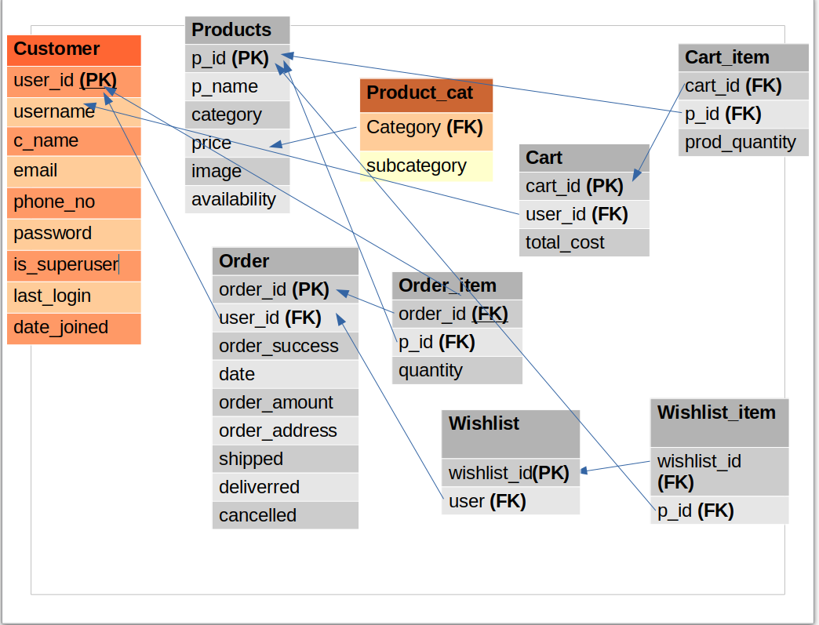

**ER Diagram :-**

