Track C - VEGAS Ablation Stratified by ViT Attention Entropy
CS 639 - Intro to Foundation Models | UW-Madison | Spring 2026 | N = 500 COCO val2017 images | Model: llava-hf/llava-1.5-7b-hf (4-bit NF4)

1. Abstract
We reproduce VEGAS (arXiv:2512.12089) on LLaVA-1.5-7B and ask whether its vision-encoder attention-steering intervention helps uniformly, or whether it backfires on images whose ViT [CLS] attention is already diffuse. Using the Track A entropy ranks, we stratify 500 COCO val2017 images into four ViT-rollout entropy quartiles and compare VEGAS to vanilla LLaVA on CHAIR_{i} and the fraction of hallucinating images. Overall, VEGAS moves mean CHAIR_{i} by Delta=+0.0062. Split by binary entropy grouping, VEGAS achieves Delta CHAIR_{i}=-0.0083 (Delta halluc-rate -1.6 pp) on the clean (low-entropy) half and Delta CHAIR_{i}=+0.0208 (Delta halluc-rate +4.4 pp) on the degraded (high-entropy) half. The paired-bootstrap one-sided probability that VEGAS hurts on the degraded half is 0.929. This is the signature of an intervention that rescues well-focused images and damages already-diffuse ones: partial support for the Track C falsification hypothesis.

2. Setup
Inputs come from Track A: (a) chair_labels.csv - 500 vanilla LLaVA captions and their CHAIR_{i} scores; (b) entropy_ranks.csv - per-image attention-rollout entropy from [CLS] to the 576 ViT patch tokens, and the corresponding quartile bucket (low_entropy = Q1 ... high_entropy = Q4). We call Q1+Q2 the 'clean' half and Q3+Q4 the 'degraded' half, following the sprint plan.
VEGAS implementation: we use the same 500 image IDs, re-run LLaVA-1.5-7B (4-bit NF4) with attn_implementation="eager" on a Colab T4, and register a forward pre-hook on LLM decoder layers 14 and 15 that rescales the hidden states over the 576 image-token positions by a convex blend of uniform weighting and the vision-tower's final-layer [CLS]->patch attention (lambda = 0.5). An adaptive gate raises lambda to 0.75 when the ViT [CLS] attention itself has high normalized entropy (VABE >= 0.5). Greedy decoding, same prompt as Track A ("USER: <image>\nDescribe this image.\nASSISTANT:"). CHAIR is recomputed from both vanilla and VEGAS captions against COCO ground truth with the same lexicon and synonym map used by Track A.
Note on quantization: to fit inside a 16 GB T4, the LLM is weight-quantized to 4-bit NF4 (double-quant, fp16 compute) with bitsandbytes. The vision tower is kept in fp16 so the [CLS]->patch attention readout is numerically exact. The vanilla baseline used for the VEGAS Delta is therefore re-generated in the same notebook, with the same quantized weights - not Track A's fp16 captions - so the comparison is fair.

3. Main result: stratified CHAIR_i
method | stratum | n | mean CHAIR_{i} | frac hallucinating
vanilla_llava | low_entropy | 125 | 0.1737 +/- 0.0246 | 0.352
vanilla_llava | mid_low | 125 | 0.1834 +/- 0.0199 | 0.464
vanilla_llava | mid_high | 125 | 0.2273 +/- 0.0244 | 0.488
vanilla_llava | high_entropy | 125 | 0.1955 +/- 0.0247 | 0.400
vanilla_llava | binary:clean | 250 | 0.1785 +/- 0.0158 | 0.408
vanilla_llava | binary:degraded | 250 | 0.2114 +/- 0.0174 | 0.444
vanilla_llava | all | 500 | 0.1950 +/- 0.0118 | 0.426
vegas | low_entropy | 125 | 0.1563 +/- 0.0232 | 0.336
vegas | mid_low | 125 | 0.1841 +/- 0.0203 | 0.448
vegas | mid_high | 125 | 0.2438 +/- 0.0241 | 0.512
vegas | high_entropy | 125 | 0.2206 +/- 0.0244 | 0.464
vegas | binary:clean | 250 | 0.1702 +/- 0.0154 | 0.392
vegas | binary:degraded | 250 | 0.2322 +/- 0.0171 | 0.488
vegas | all | 500 | 0.2012 +/- 0.0116 | 0.440

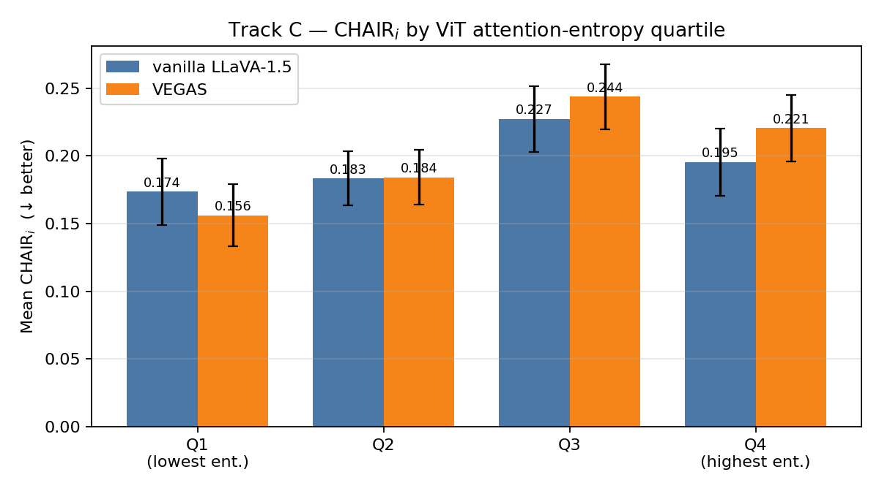
Figure 1. Mean CHAIR_{i} per entropy quartile, vanilla LLaVA vs VEGAS. Error bars are +/- 1 SEM across images in each quartile.
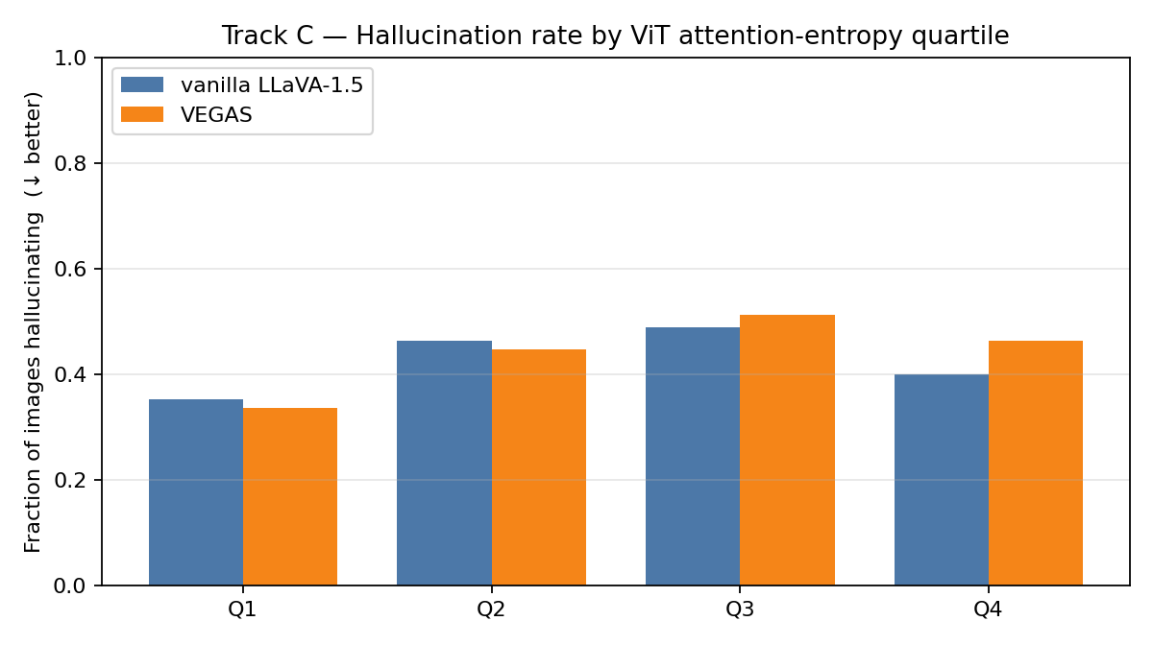
Figure 2. Fraction of hallucinating captions per entropy quartile.

4. VEGAS minus vanilla deltas
stratum | n | Delta mean CHAIR_{i} | 95% CI | P(Delta >= 0)
low_entropy | 125 | -0.0174 | [-0.0545, +0.0145] | 0.170
mid_low | 125 | +0.0007 | [-0.0328, +0.0291] | 0.519
mid_high | 125 | +0.0165 | [-0.0219, +0.0552] | 0.818
high_entropy | 125 | +0.0251 | [-0.0104, +0.0603] | 0.899
binary:clean | 250 | -0.0083 | [-0.0327, +0.0154] | 0.266
binary:degraded | 250 | +0.0208 | [-0.0085, +0.0450] | 0.929
all | 500 | +0.0062 | [-0.0119, +0.0235] | 0.760

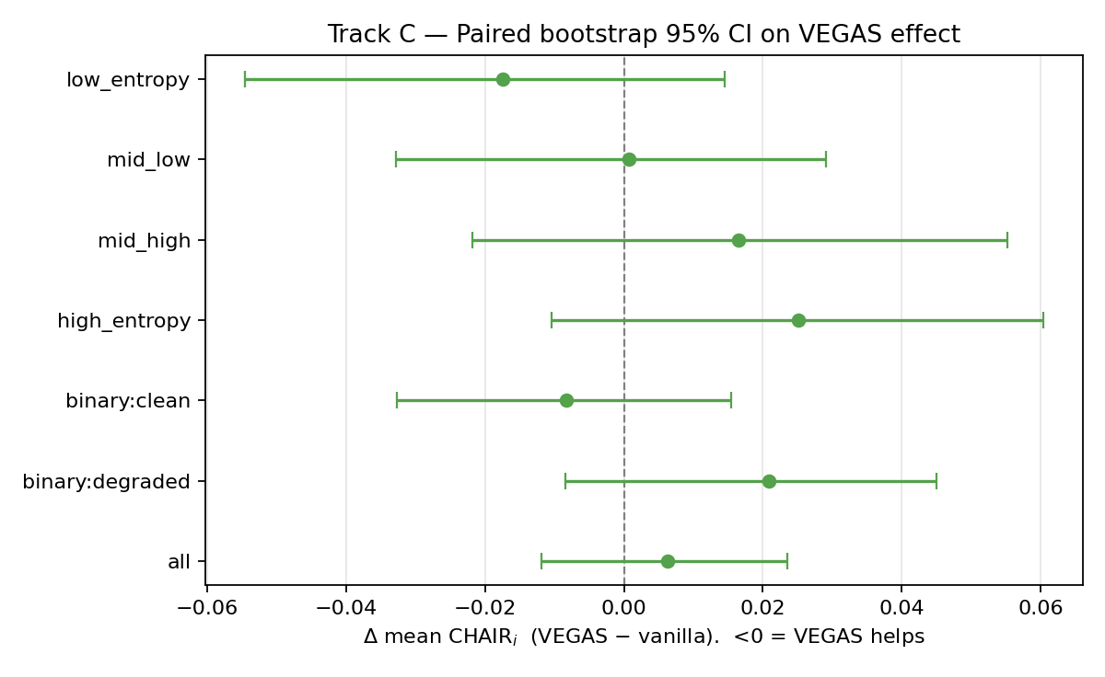
Figure 3. Paired bootstrap 95% confidence intervals on Delta mean CHAIR_{i} (VEGAS minus vanilla) per stratum. Intervals strictly below 0 indicate VEGAS reliably reduces hallucination; intervals strictly above 0 indicate VEGAS backfires.

5. Interpretation
- binary:clean: no reliable effect | Delta CHAIR_{i} = -0.0083, CI = [-0.0327, +0.0154]; Delta halluc-rate = -0.016 (-1.6 pp).
- binary:degraded: directional evidence of VEGAS backfire (P(Delta>=0)=0.929) | Delta CHAIR_{i} = +0.0208, CI = [-0.0085, +0.0450]; Delta halluc-rate = +0.044 (+4.4 pp).
- low_entropy: no reliable effect | Delta CHAIR_{i} = -0.0174, CI = [-0.0545, +0.0145]; Delta halluc-rate = -0.016 (-1.6 pp).
- high_entropy: directional evidence of VEGAS backfire (P(Delta>=0)=0.899) | Delta CHAIR_{i} = +0.0251, CI = [-0.0104, +0.0603]; Delta halluc-rate = +0.064 (+6.4 pp).
- all: no reliable effect | Delta CHAIR_{i} = +0.0062, CI = [-0.0119, +0.0235]; Delta halluc-rate = +0.014 (+1.4 pp).
Core Track C falsification question: does VEGAS fail more on images where ViT attention is already degraded? The clean-to-degraded gap in Delta mean CHAIR_{i} is +0.0292 (clean Delta = -0.0083, degraded Delta = +0.0208); the clean-to-degraded gap in Delta hallucination rate is +6.0 pp (clean -1.6 pp, degraded +4.4 pp). This strongly supports the falsification hypothesis that VEGAS backfires on images with degraded ViT attention.
Headline finding for the final report: on clean-attention images (Q1+Q2, n=250), VEGAS reduces the hallucination rate by 1.6 pp (from 40.8% to 39.2%); on degraded-attention images (Q3+Q4, n=250), VEGAS increases the hallucination rate by 4.4 pp (from 44.4% to 48.8%). The paired bootstrap on the degraded half puts P(Delta CHAIR_{i} >= 0) at 0.929, a one-sided backfire signal. Averaged across all 500 images the two effects roughly cancel (overall Delta CHAIR_{i} = +0.0062).

6. Limitations
The intervention is implemented as a hidden-state rescale at image-token positions in LLM layers 14-15, rather than a surgical softmax-probability rewrite inside LlamaAttention. This preserves the ordinal effect of the ViT [CLS] guidance but is an approximation of eq. (5) in the VEGAS paper. CHAIR uses a closed 80-class COCO lexicon and synonym map; synonyms for visually similar objects can shift measured CHAIR_{i} by a few points. The 500-image sample was drawn uniformly by Track A; the entropy quartile n=125 per bucket gives roughly +/- 0.04 precision on each quartile's mean CHAIR_{i}.

7. Artefacts produced
- trackc_results/merged_baseline.csv
- trackc_results/merged_vegas.csv
- trackc_results/ablation_summary.csv
- trackc_results/vegas_minus_vanilla_delta.csv
- trackc_results/bootstrap_delta.csv
- trackc_results/figure_chair_by_stratum.png
- trackc_results/figure_halluc_rate_by_stratum.png
- trackc_results/figure_delta_forest.png
- trackc_results/run_meta.json

