**ASSIGNMENT – SQL – ELECTRONIC GADGETS NIKHIL AGARWAL – NIKHILAG113@GMAIL.COM**

**Task:1. Database Design:**

-- 1. Create the database named "TechShop":

create database techshop;

-- using techshop database for further storage

use techshop;

-- 2. Define the schema for the Customers, Products, Orders, OrderDetails and Inventory tables based on the provided schema

CREATE TABLE Customers (

CustomerID INT AUTO_INCREMENT PRIMARY KEY,

FirstName VARCHAR(255),

LastName VARCHAR(255),

Email VARCHAR(255),

Phone VARCHAR(15),

Address VARCHAR(255)

);

CREATE TABLE Products (

ProductID INT AUTO_INCREMENT PRIMARY KEY,

ProductName VARCHAR(255),

Description TEXT,

Price DECIMAL(10, 2)

);

CREATE TABLE Orders (

OrderID INT AUTO_INCREMENT PRIMARY KEY,

CustomerID INT,

OrderDate DATE,

TotalAmount DECIMAL(10, 2),

FOREIGN KEY (CustomerID) REFERENCES Customers(CustomerID)

);

CREATE TABLE OrderDetails (

OrderDetailID INT AUTO_INCREMENT PRIMARY KEY,

OrderID INT,

ProductID INT,

Quantity INT,

FOREIGN KEY (OrderID) REFERENCES Orders(OrderID),

FOREIGN KEY (ProductID) REFERENCES Products(ProductID)

);

CREATE TABLE Inventory (

InventoryID INT AUTO_INCREMENT PRIMARY KEY,

ProductID INT,

QuantityInStock INT,

LastStockUpdate DATE,

FOREIGN KEY (ProductID) REFERENCES Products(ProductID)

);

-- 3. Create an ERD (Entity Relationship Diagram) for the database.

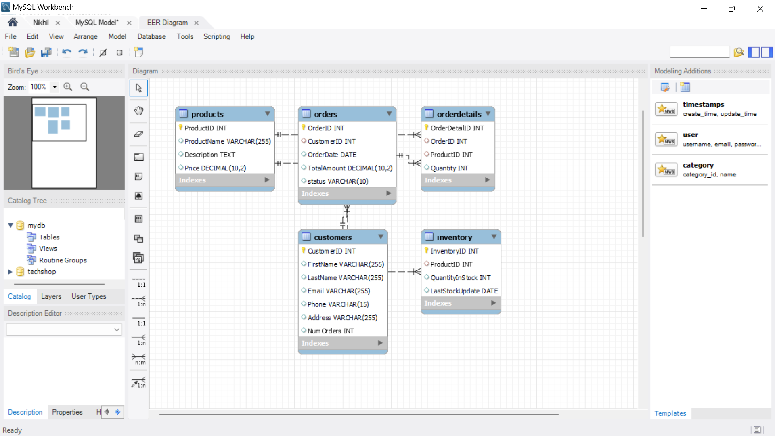

-- 4. Create appropriate Primary Key and Foreign Key constraints for referential integrity

(Primary Key and Foreign Key constraints are already included in the initial SQL statements)

-- 5. Insert at least 10 sample records into each of the following tables.

* Customers
* Products
* Orders
* OrderDetails
* Inventory

-- Insert sample records into the Customers table

INSERT INTO Customers (FirstName, LastName, Email, Phone, Address)

VALUES

('John', 'Doe', 'john.doe@example.com', '123-456-7890', '123 Main St'),

('Jane', 'Smith', 'jane.smith@example.com', '987-654-3210', '456 Oak St'),

('Bob', 'Johnson', 'bob.johnson@example.com', '111-222-3333', '789 Pine St'),

('Alice', 'Williams', 'alice.williams@example.com', '444-555-6666', '101 Elm St'),

('Charlie', 'Brown', 'charlie.brown@example.com', '777-888-9999', '202 Maple St'),

('Eva', 'Garcia', 'eva.garcia@example.com', '333-444-5555', '303 Birch St'),

('David', 'Lee', 'david.lee@example.com', '666-777-8888', '404 Cedar St'),

('Grace', 'Jones', 'grace.jones@example.com', '222-333-4444', '505 Walnut St'),

('Michael', 'Miller', 'michael.miller@example.com', '555-666-7777', '606 Pine St'),

('Sophia', 'Davis', 'sophia.davis@example.com', '888-999-0000', '707 Oak St');

-- Insert sample records into the Products table

INSERT INTO Products (ProductName, Description, Price)

VALUES

('Laptop', 'High-performance laptop with latest features', 899.99),

('Smartphone', 'Top-of-the-line smartphone with advanced camera', 699.99),

('Tablet', 'Lightweight and portable tablet for on-the-go use', 299.99),

('Headphones', 'Noise-canceling headphones with premium sound quality', 149.99),

('Smartwatch', 'Smartwatch with fitness tracking and notifications', 199.99),

('Camera', 'Professional-grade camera for photography enthusiasts', 1299.99),

('Drone', 'Quadcopter drone with HD camera for aerial photography', 799.99),

('Bluetooth Speaker', 'Portable Bluetooth speaker for wireless audio streaming', 79.99),

('Gaming Console', 'High-performance gaming console for immersive gaming', 499.99),

('Fitness Tracker', 'Fitness tracker for monitoring health and activity', 129.99);

-- Insert sample records into the Orders table

INSERT INTO Orders (CustomerID, OrderDate, TotalAmount)

VALUES

(1, '2023-01-15', 899.99),

(3, '2023-02-20', 299.99),

(5, '2023-03-10', 149.99),

(2, '2023-04-05', 199.99),

(7, '2023-05-18', 1299.99),

(4, '2023-06-22', 799.99),

(6, '2023-07-08', 79.99),

(8, '2023-08-30', 499.99),

(10, '2023-09-12', 129.99),

(9, '2023-10-25', 699.99);

-- Insert sample records into the OrderDetails table

INSERT INTO OrderDetails (OrderID, ProductID, Quantity)

VALUES

(1, 1, 1),

(2, 3, 2),

(3, 4, 3),

(4, 5, 1),

(5, 6, 1),

(6, 7, 1),

(7, 8, 2),

(8, 9, 1),

(9, 2, 1),

(10, 10, 2);

-- Insert sample records into the Inventory table

INSERT INTO Inventory (ProductID, QuantityInStock, LastStockUpdate)

VALUES

(1, 20, '2023-01-01'),

(2, 15, '2023-01-05'),

(3, 30, '2023-01-10'),

(4, 25, '2023-01-15'),

(5, 10, '2023-01-20'),

(6, 8, '2023-01-25'),

(7, 12, '2023-02-01'),

(8, 18, '2023-02-05'),

(9, 5, '2023-02-10'),

(10, 22, '2023-02-15');

**-- Task 2: Select, Where, Between, AND, LIKE**

-- 1. Retrieve the names and emails of all customers

SELECT FirstName, LastName, Email FROM Customers;

-- 2. List all orders with their order dates and corresponding customer names

SELECT Orders.OrderID, Orders.OrderDate, CONCAT(Customers.FirstName, ' ', Customers.LastName) AS CustomerName

FROM Orders

JOIN Customers ON Orders.CustomerID = Customers.CustomerID;

-- 3. Insert a new customer record into the "Customers" table

INSERT INTO Customers (FirstName, LastName, Email, Phone, Address)

VALUES ('New', 'Customer', 'new.customer@example.com', '123-456-7890', '789 New St');

-- 4. Update the prices of all electronic gadgets in the "Products" table by increasing them by 10%

UPDATE Products

SET Price = Price * 1.10;

-- 5. Delete a specific order and its associated order details from the "Orders" and "OrderDetails" tables

DELETE FROM OrderDetails WHERE OrderID = 1;

DELETE FROM Orders WHERE OrderID = 1;

-- 6. Insert a new order into the "Orders" table

INSERT INTO Orders (CustomerID, OrderDate, TotalAmount)

VALUES (1, '2023-12-07', 199.99);

-- 7. Update the contact information of a specific customer in the "Customers" table

UPDATE Customers

SET Email = 'updated.email@example.com', Address = 'Updated Address'

WHERE CustomerID = 1;

-- 8. Recalculate and update the total cost of each order in the "Orders" table

UPDATE Orders

SET TotalAmount = (

SELECT SUM(Quantity * Price)

FROM OrderDetails

JOIN Products ON OrderDetails.ProductID = Products.ProductID

WHERE OrderDetails.OrderID = Orders.OrderID

);

-- 9. Delete all orders and their associated order details for a specific customer

DELETE FROM OrderDetails WHERE OrderID IN (SELECT OrderID FROM Orders WHERE CustomerID = 1);

DELETE FROM Orders WHERE CustomerID = 1;

-- 10. Insert a new electronic gadget product into the "Products" table

INSERT INTO Products (ProductName, Description, Price)

VALUES ('New Gadget', 'Description of the new gadget', 499.99);

-- 11. Update the status of a specific order in the "Orders" table

alter table orders add status varchar(10) default 'pending';

UPDATE Orders

SET Status = 'Shipped'

WHERE OrderID = 1;

-- 12. Calculate and update the number of orders placed by each customer in the "Customers" table

alter table customers add NumOrders int;

UPDATE Customers

SET NumOrders = (

SELECT COUNT(OrderID)

FROM Orders

WHERE Orders.CustomerID = Customers.CustomerID

);

**-- Task 3: Aggregate functions, Having, Order By, GroupBy and Joins**

-- 1. Retrieve a list of all orders along with customer information for each order

SELECT Orders.OrderID, Orders.OrderDate, CONCAT(Customers.FirstName, ' ', Customers.LastName)

AS CustomerName

FROM Orders

JOIN Customers ON Orders.CustomerID = Customers.CustomerID;

-- 2. Find the total revenue generated by each electronic gadget product

SELECT Products.ProductID, Products.ProductName, SUM(OrderDetails.Quantity * Products.Price)

AS TotalRevenue

FROM Products

JOIN OrderDetails ON Products.ProductID = OrderDetails.ProductID

JOIN Orders ON OrderDetails.OrderID = Orders.OrderID

GROUP BY Products.ProductID, Products.ProductName

order by Products.ProductID, Products.ProductName;

-- 3. List all customers who have made at least one purchase

SELECT Customers.CustomerID, CONCAT(Customers.FirstName, ' ', Customers.LastName)

AS CustomerName, Customers.Email, Customers.Phone

FROM Customers

JOIN Orders ON Customers.CustomerID = Orders.CustomerID

GROUP BY Customers.CustomerID, Customers.FirstName,Customers.LastName, Customers.Email, Customers.Phone

HAVING COUNT(Orders.OrderID) > 0;

-- 4. Find the most popular electronic gadget (highest total quantity ordered)

SELECT Products.ProductID, Products.ProductName, SUM(OrderDetails.Quantity) AS TotalQuantityOrdered

FROM Products

JOIN OrderDetails ON Products.ProductID = OrderDetails.ProductID

GROUP BY Products.ProductID, Products.ProductName

ORDER BY TotalQuantityOrdered DESC limit 1;

-- 5. Retrieve a list of electronic gadgets along with their corresponding ID

SELECT ProductName, ProductId FROM Products;

-- 6. Calculate the average order value for each customer

SELECT Customers.CustomerID, CONCAT(Customers.FirstName, ' ', Customers.LastName) AS CustomerName,

AVG(Orders.TotalAmount) AS AvgOrderValue

FROM Customers

JOIN Orders ON Customers.CustomerID = Orders.CustomerID

GROUP BY Customers.CustomerID, Customers.FirstName, Customers.LastName;

-- 7. Find the order with the highest total revenue

SELECT Orders.OrderID, CONCAT(Customers.FirstName, ' ', Customers.LastName) AS CustomerName, SUM(OrderDetails.Quantity * Products.Price) AS TotalRevenue

FROM Orders

JOIN Customers ON Orders.CustomerID = Customers.CustomerID

JOIN OrderDetails ON Orders.OrderID = OrderDetails.OrderID

JOIN Products ON OrderDetails.ProductID = Products.ProductID

GROUP BY Orders.OrderID, Customers.FirstName, Customers.LastName

ORDER BY TotalRevenue DESC limit 1;

-- 8. List electronic gadgets and the number of times each product has been ordered

SELECT Products.ProductName, COUNT(OrderDetails.OrderID) AS OrderCount

FROM Products

JOIN OrderDetails ON Products.ProductID = OrderDetails.ProductID

GROUP BY Products.ProductName;

-- 9. Find customers who have purchased a specific electronic gadget product

SELECT Customers.CustomerID, CONCAT(Customers.FirstName, ' ', Customers.LastName)

AS CustomerName, Customers.Email, Customers.Phone

FROM Customers

JOIN Orders ON Customers.CustomerID = Orders.CustomerID

JOIN OrderDetails ON Orders.OrderID = OrderDetails.OrderID

JOIN Products ON OrderDetails.ProductID = Products.ProductID

WHERE Products.ProductName = 'Smartphone';

-- 10. Calculate the total revenue generated by all orders placed within a specific time period

SELECT Customers.CustomerID, CONCAT(FirstName, ' ', LastName) AS CustomerName, COUNT(OrderID)

AS OrderCount

FROM Customers

LEFT JOIN Orders ON Customers.CustomerID = Orders.CustomerID

WHERE OrderDate BETWEEN '2023-01-01' AND '2023-12-31'

GROUP BY Customers.CustomerID, FirstName, LastName;

**-- Task 4: Subquery and its type**

-- 1. Find which customers have not placed any orders

SELECT CustomerID, CONCAT(FirstName, ' ', LastName) AS CustomerName

FROM Customers

WHERE CustomerID NOT IN (SELECT DISTINCT CustomerID FROM Orders);

-- 2. Find the total number of products available for sale

SELECT COUNT(*) AS TotalProducts

FROM Products;

-- 3. Calculate the total revenue generated by TechShop

SELECT SUM(TotalAmount) AS TotalRevenue

FROM Orders;

-- 4. Calculate the average quantity ordered for products in a specific category

SELECT AVG(OrderDetails.Quantity) AS AvgQuantityOrdered FROM OrderDetails;

-- 5. Calculate the total revenue generated by a specific customer

SELECT SUM(TotalAmount) AS TotalRevenue

FROM Orders WHERE CustomerID = 2;

-- 6. Find the customers who have placed the most orders

SELECT customers.CustomerID, CONCAT(FirstName, ' ', LastName) AS CustomerName, COUNT(OrderID) AS OrderCount

FROM orders

left JOIN customers ON customers.CustomerID = orders.CustomerID

GROUP BY CustomerID, FirstName, LastName

ORDER BY OrderCount DESC limit 1;

-- 7. Find the most popular product category (highest total quantity ordered)

SELECT ProductName, SUM(OrderDetails.Quantity) AS TotalQuantityOrdered

FROM Products

JOIN OrderDetails ON Products.ProductID = OrderDetails.ProductID

GROUP BY ProductName

ORDER BY TotalQuantityOrdered DESC limit 1;

-- 8. Find the customer who has spent the most money on electronic gadgets

SELECT Customers.CustomerID, CONCAT(FirstName, ' ', LastName) AS CustomerName, SUM(OrderDetails.Quantity * Products.Price) AS TotalSpending

FROM Customers

JOIN Orders ON Customers.CustomerID = Orders.CustomerID

JOIN OrderDetails ON Orders.OrderID = OrderDetails.OrderID

JOIN Products ON OrderDetails.ProductID = Products.ProductID

GROUP BY Customers.CustomerID, FirstName, LastName

ORDER BY TotalSpending DESC limit 1;

-- 9. Calculate the average order value for all customers

SELECT AVG(TotalAmount) AS AvgOrderValue

FROM Orders;

-- 10. Find the total number of orders placed by each customer and list their names along with the order count

SELECT Customers.CustomerID, CONCAT(FirstName, ' ', LastName) AS CustomerName, COUNT(OrderID) AS OrderCount

FROM Customers

LEFT JOIN Orders ON Customers.CustomerID = Orders.CustomerID

GROUP BY Customers.CustomerID, FirstName, LastName;

**THANK YOU**