Week 4 Report
Machine Learning Model Development and Evaluation
Classifying breast tumours as benign or malignant from cell-nucleus measurements

1. Summary
This report documents an end-to-end supervised learning workflow in Python and scikit-learn: data preparation, algorithm selection, training, evaluation and critical discussion. The task is binary classification on the supplied breast_cancer_clean.csv file (569 tumour samples, 30 numeric measurements each, labelled Benign or Malignant).
Three algorithms were compared with 5-fold stratified cross-validation on the training data: logistic regression, a decision tree and a random forest. Logistic regression was selected because it had the best cross-validated scores, is the most interpretable, and showed the smallest gap between training and validation performance. On a held-out test set of 114 samples it reached 96.5% accuracy, 97.5% precision, 92.9% recall and ROC AUC 0.996.
The main weakness is not overall accuracy but the type of error: at the default 0.5 threshold the model missed 3 of 42 malignant tumours (false negatives), which is the costly direction in a screening setting. Section 7 quantifies this and Section 8 proposes improvements.

2. Data Preparation

2.1 Dataset and cleaning checks
The file contains the 30 standard Wisconsin Diagnostic Breast Cancer features (mean, standard error and "worst" value of ten nucleus properties such as radius, texture, concavity and symmetry), a diagnosis label, and 22 extra columns suffixed _yj. Table 1 summarises the checks performed and the decisions taken.
Check / action | Finding | Decision
Shape | 569 rows × 53 columns | Keep all rows
Missing values | 0 | No imputation needed
Duplicate rows | 0 | None removed
Target | Benign 357 (62.7%) / Malignant 212 (37.3%) | Encode Malignant = 1 (positive class); stratify the split
Transformed columns | 22 columns ending in _yj (Yeo-Johnson copies of original features) | Dropped: redundant and a possible leakage route (see 2.2)
Feature scale | area_* in the 100s–1000s; smoothness_* ≈ 0.1 | StandardScaler inside the pipeline
Collinearity | 21 feature pairs with |r| > 0.90 | Keep, but use L2 regularisation and read coefficients cautiously
Table 1. Data audit and preprocessing decisions.
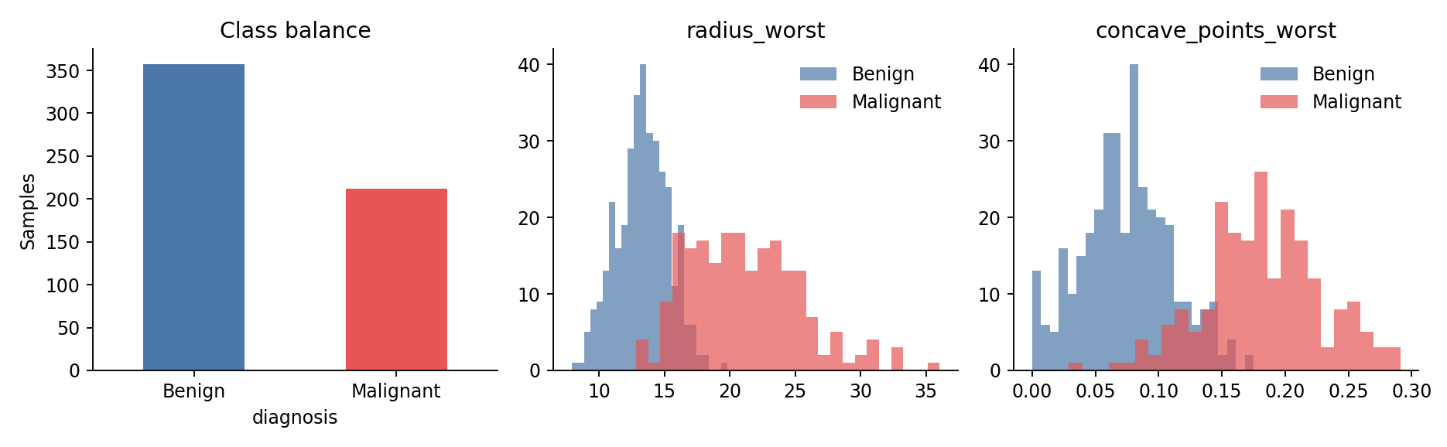
Figure 1. Class balance and the class-wise distribution of two highly discriminative features.
Figure 1 shows a moderate class imbalance (about 63/37), which is mild enough to train without resampling but large enough that accuracy alone is not a sufficient metric. It also shows that malignant tumours have visibly larger "worst" radius and more concave points, so the classes are largely separable even with a linear boundary.

2.2 Why the _yj columns were dropped
The _yj columns appear to be Yeo-Johnson power-transformed copies of skewed features. They were excluded for two reasons. First, they carry the same information as the originals, so they add dimensionality and collinearity without adding signal. Second, and more importantly, a power transform has parameters that are estimated from data. If those parameters were fitted on the entire dataset before splitting, information from the test rows leaks into the training features. The modelling therefore uses only the 30 original columns, and all fitted preprocessing (scaling) lives inside a scikit-learn Pipeline so that it is learned from training folds only.

2.3 Train / test split
The data were split 80/20 with stratification on the label and a fixed random seed (42): 455 training rows (170 malignant) and 114 test rows (42 malignant). The test set was not used for any model-selection or tuning decision; it was touched once, at the end.

3. Algorithm Selection and Justification
Algorithm | Why it was considered | Main risk
Logistic regression (chosen) | Strong baseline for tabular binary data; outputs calibrated-ish probabilities; coefficients are interpretable; L2 regularisation handles correlated features; fast and stable on 455 rows. | Assumes a linear decision boundary in the (scaled) feature space; coefficients unstable under collinearity.
Decision tree | Fully interpretable rules; no scaling needed; captures non-linearity and interactions. | High variance; an unrestricted tree memorises the training set.
Random forest | Averages many trees to reduce variance; usually a strong non-linear benchmark. | Less interpretable; many hyperparameters; little room to beat a near-linear problem.
Table 2. Candidate algorithms.
Selection was based on cross-validated performance on the training set, not on the test set. The tree and forest are included to test whether added model flexibility helps, and to illustrate overfitting (Section 6). Logistic regression was tuned over the inverse regularisation strength C (0.001 to 100) by cross-validated ROC AUC; the best value was C = 1. The decision tree was tuned over maximum depth (best depth 6) to give it a fair chance.

4. Implementation (Key Code)
The complete script (pipeline.py) is delivered alongside this report. The key steps are shown below.

4.1 Loading, feature selection and split
df = pd.read_csv("breast_cancer_clean.csv")
feat_cols = [c for c in df.columns
if c != "diagnosis" and not c.endswith("_yj")] # 30 original features
X = df[feat_cols]
y = (df["diagnosis"] == "Malignant").astype(int) # 1 = malignant

Xtr, Xte, ytr, yte = train_test_split(
X, y, test_size=0.2, stratify=y, random_state=42)

4.2 Pipelines and cross-validated comparison
models = {
"Logistic Regression": Pipeline([("sc", StandardScaler()),
("m", LogisticRegression(max_iter=5000, random_state=42))]),
"Decision Tree": Pipeline([("m", DecisionTreeClassifier(random_state=42))]),
"Random Forest": Pipeline([("m", RandomForestClassifier(
n_estimators=300, random_state=42))]),
}
cv = StratifiedKFold(5, shuffle=True, random_state=42)
for name, pipe in models.items():
s = cross_validate(pipe, Xtr, ytr, cv=cv, return_train_score=True,
scoring=["accuracy","precision","recall","f1","roc_auc"])

4.3 Hyperparameter tuning and final evaluation
grid = GridSearchCV(models["Logistic Regression"],
{"m__C": [0.001, 0.01, 0.1, 1, 10, 100]}, cv=cv, scoring="roc_auc")
grid.fit(Xtr, ytr)
best_lr = grid.best_estimator_

proba = best_lr.predict_proba(Xte)[:, 1]
pred = (proba >= 0.5).astype(int)
print(confusion_matrix(yte, pred))
print(roc_auc_score(yte, proba), recall_score(yte, pred))

5. Evaluation

5.1 Choice of metrics
Accuracy is reported but not relied on, because the classes are imbalanced and the two error types have unequal consequences. The positive class is malignant, so:
- Recall (sensitivity) = share of malignant tumours correctly found. A miss is a false negative, the most harmful error.
- Precision = share of malignant predictions that are truly malignant. A miss here is a false alarm, which causes unnecessary follow-up but is less dangerous.
- F1 balances precision and recall; ROC AUC measures ranking quality independent of any threshold.

5.2 Cross-validation results (training data, mean ± SD over 5 folds)
Model | Accuracy | Precision | Recall | F1 | ROC AUC | Train acc.
Logistic Regression | 0.974 ± 0.015 | 0.977 ± 0.028 | 0.953 ± 0.040 | 0.964 ± 0.021 | 0.996 ± 0.005 | 0.988
Decision Tree | 0.923 ± 0.033 | 0.900 ± 0.041 | 0.894 ± 0.061 | 0.896 ± 0.045 | 0.917 ± 0.038 | 1.000
Random Forest | 0.960 ± 0.016 | 0.958 ± 0.022 | 0.935 ± 0.039 | 0.946 ± 0.023 | 0.988 ± 0.007 | 1.000
Table 3. Cross-validated performance of the untuned candidates. Train acc. is accuracy on the full training set.
Logistic regression leads on every metric, with a ROC AUC of 0.996 and the lowest fold-to-fold variation in AUC. The unrestricted decision tree scores 1.000 on its own training data but only about 0.92 in cross-validation, a textbook overfitting signature.

5.3 Held-out test results
Model | Accuracy | Precision | Recall | F1 | ROC AUC
Logistic Regression | 0.965 | 0.975 | 0.929 | 0.951 | 0.996
Decision Tree | 0.921 | 0.923 | 0.857 | 0.889 | 0.895
Random Forest | 0.974 | 1.000 | 0.929 | 0.963 | 0.994
Table 4. Test-set metrics at the default 0.5 threshold (tuned logistic regression and tree; default random forest).
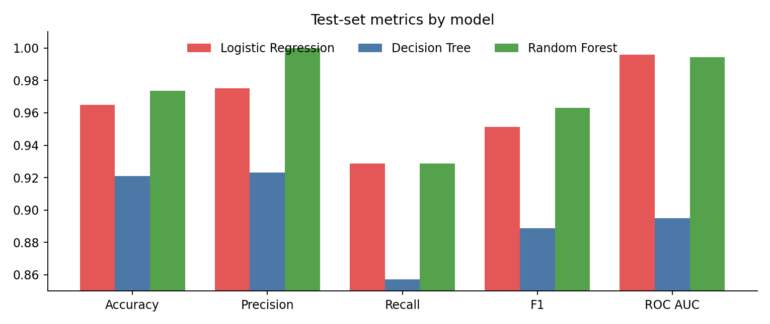
Figure 2. Test-set metrics compared across the three models.
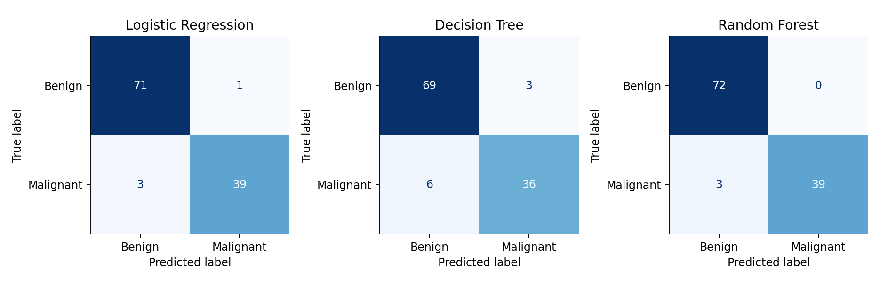
Figure 3. Confusion matrices on the 114 test samples.
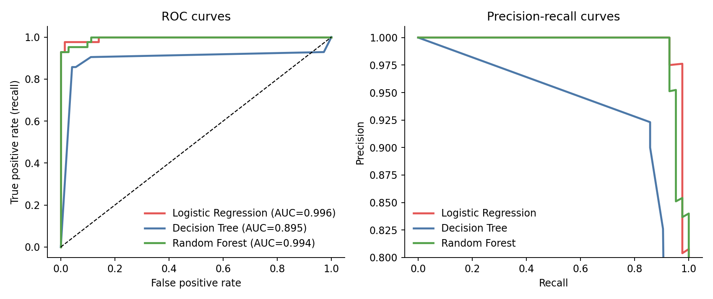
Figure 4. ROC curves (left) and precision-recall curves (right) on the test set.
Logistic regression and random forest are effectively tied: the forest has one more correct prediction (111 vs 110 of 114), which is a single sample and well within noise. Their ROC AUCs are 0.996 and 0.994. The decision tree is clearly worse (AUC 0.895, 9 errors). Because cross-validation favoured logistic regression and it is far easier to explain, it remains the selected model. The result should be read as "a regularised linear model is sufficient for this dataset", not as "the forest is worse".
Model | TN | FP | FN | TP | Errors / 114
Logistic Regression | 71 | 1 | 3 | 39 | 4
Decision Tree | 69 | 3 | 6 | 36 | 9
Random Forest | 72 | 0 | 3 | 39 | 3
Table 5. Confusion-matrix counts (positive class = malignant).

6. Overfitting and Underfitting
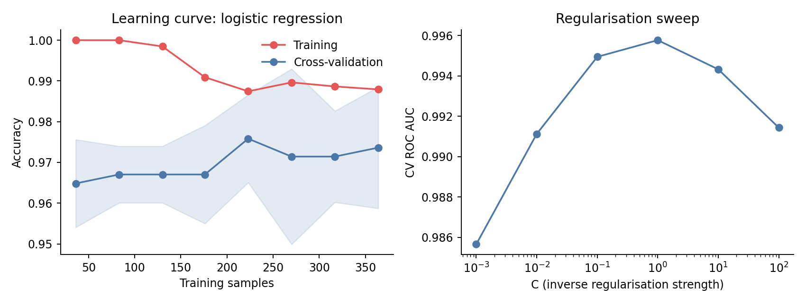
Figure 5. Learning curve (left) and regularisation sweep (right) for logistic regression.
- Decision tree: overfitting. The default tree reached 1.000 training accuracy against 0.923 cross-validated accuracy. Limiting depth to 6 reduced the gap on training data (0.993) but the tree still trailed the other models on the test set. A single tree is too high-variance for 455 samples and 30 features.
- Random forest: mild overfitting. Training accuracy is 1.000 (typical for forests, since each tree sees most training rows) against 0.960 in cross-validation. Averaging keeps the validation score high, so this gap is less worrying than the tree's.
- Logistic regression: well fitted. Training accuracy 0.988 versus cross-validated 0.974 at full training size, a gap of about 1.5 percentage points. In Figure 5 (left) the two curves converge as data grows, and both are high, so there is no sign of underfitting. A small remaining gap suggests that more data would help marginally.
- Regularisation sweep. Cross-validated AUC is 0.986 at very strong regularisation (C = 0.001, mild underfitting), peaks at 0.996 at C = 1, and falls to 0.991 at C = 100 as the model starts fitting noise. The peak is flat between C = 0.1 and 10, so the result is not sensitive to this choice.

7. Error Analysis
At the 0.5 threshold, logistic regression made 4 errors on 114 samples: 3 false negatives and 1 false positive. The error rate is therefore 3.5%, but the false-negative rate among malignant cases is 7.1% (3 of 42), which is the figure that matters clinically.
Because the model outputs probabilities, the trade-off can be moved by changing the decision threshold. Table 6 shows the effect on the test set.
Decision threshold | Recall | Precision | False negatives | False positives
0.5 | 0.929 | 0.975 | 3 | 1
0.3 | 0.976 | 0.976 | 1 | 1
0.2 | 0.976 | 0.911 | 1 | 4
Table 6. Effect of lowering the malignant-probability threshold (logistic regression).
Lowering the threshold to 0.3 cut false negatives from 3 to 1 at no cost in false positives on this sample. Lowering it to 0.2 gained nothing further on recall and added three false alarms. An important caveat: this table was computed on the test set purely to illustrate the trade-off. In a real workflow the threshold must be chosen on validation data (for example, out-of-fold cross-validated predictions), otherwise the test estimate becomes optimistic.
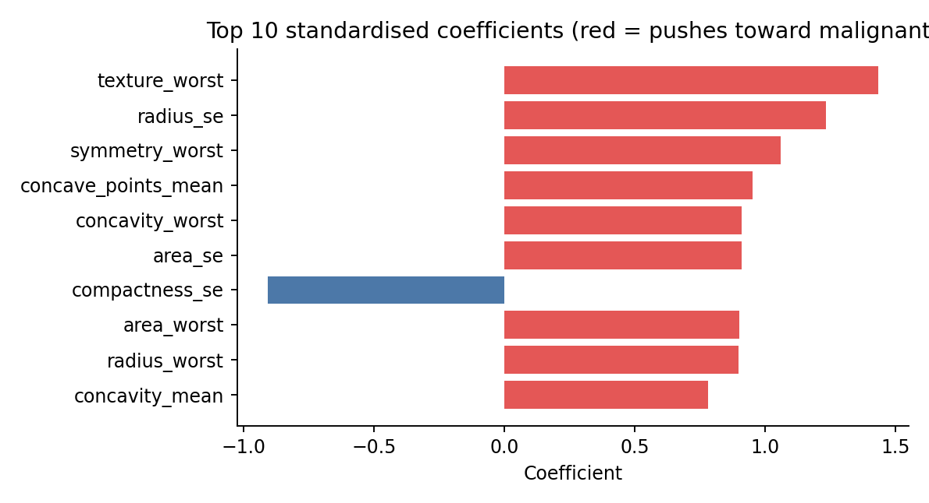
Figure 6. Largest standardised coefficients in the final logistic regression.
The strongest positive contributors are texture_worst, radius_se, symmetry_worst, concave_points_mean and concavity_worst, which is consistent with the pattern in Figure 1 (irregular, larger, more concave nuclei are more likely malignant). The negative coefficient on compactness_se should not be read as a clinical effect: radius, perimeter, area, concavity and compactness features are strongly correlated, so individual coefficients trade off against each other. Coefficients here describe the fitted model, not independent causal drivers.

8. Sources of Error and Limitations
- Small test set. Only 114 test samples (42 malignant) means each error moves recall by about 2.4 points. A bootstrap 95% interval for test accuracy is 93.0% to 99.1% and for recall 84.1% to 100.0%. The models' differences in the top tier are not statistically distinguishable.
- Single split. The test numbers come from one random split. Cross-validation partially mitigates this, but repeated or nested cross-validation would give a more reliable estimate.
- Possible leakage in the supplied file. The _yj columns suggest preprocessing was applied to the full dataset before it was given to us. Dropping them removes the visible part of this risk; other upstream steps cannot be audited.
- Single-source, curated data. The measurements come from digitised fine-needle-aspirate images from one study. Performance will likely drop on data from other labs, scanners or populations (dataset shift), and the dataset contains no patient-level metadata, so we cannot check whether several samples came from the same patient.
- Class imbalance and unequal costs. Optimising accuracy or a 0.5 cut-off treats both errors as equal, which does not match the clinical cost of missing a cancer.
- Collinearity. Highly correlated features make coefficients unstable and limit their interpretation, although they do not hurt prediction much under L2 regularisation.
- Not a clinical tool. This is a learning exercise on a benchmark dataset. A model like this would need prospective validation, calibration checks and regulatory review before any clinical use.

9. Suggestions for Improvement
- More reliable evaluation: repeated stratified k-fold or nested cross-validation, and confidence intervals reported for every metric.
- Principled threshold selection: choose the cut-off from out-of-fold predictions against an explicit recall target (for example, at least 98% sensitivity), then confirm once on the test set.
- Probability calibration: check a reliability curve and apply Platt scaling or isotonic regression if needed, so probabilities can be trusted.
- Feature work: reduce collinearity with PCA or by keeping one feature per correlated cluster; try feature selection with L1 regularisation.
- Other model families: gradient boosting, SVM with an RBF kernel, or a small neural network. Given the near-linear separability, large gains are unlikely, but they are cheap to test.
- Error review: inspect the individual misclassified samples with a domain expert to see whether they are borderline cases, label noise or a systematic blind spot.
- External validation: test on an independent dataset to measure how well the model generalises beyond this source.

10. Conclusion
A standardised, L2-regularised logistic regression is an effective and transparent model for this dataset, with cross-validated ROC AUC of 0.996 and a test accuracy of 96.5%. More complex models gave no reliable improvement, and the unrestricted decision tree clearly demonstrated overfitting. The pipeline avoids preprocessing leakage by construction and keeps the test set untouched until final evaluation. The main remaining concern is the false-negative rate at the default threshold and the uncertainty implied by a small test set; both are addressable with threshold tuning on validation data and more rigorous resampling-based evaluation.

