WEEK 2 TASK
Reading the Story in 569 Tumour Samples
Advanced Data Visualization and Storytelling with Python
Dataset: Breast cancer diagnostic measurements (breast_cancer_clean.csv, cleaned in Week 1)
Tools: Python, Pandas, Matplotlib, Seaborn, SciPy, scikit-learn
Audience: Non-technical readers, such as managers, clinicians and students
Date: October 2026

Executive Summary
When doctors examine a breast lump, they often take a tiny sample of cells with a fine needle and look at it under a microscope. A computer can measure each cell nucleus in the image: how big it is, how rough its outline is, how uneven its texture is. This report turns 30 such measurements, taken from 569 samples, into a visual story about one question: can the shape and size of cells tell us whether a tumour is benign or malignant?
The short answer is yes, and the pictures show why. Malignant cell nuclei are consistently larger and have more irregular, dented outlines. Three of the six charts show this directly, one chart shows that many of the 30 measurements are repeats of the same idea, and two charts show how much of the answer is captured by just two measurements, and by the whole dataset flattened onto a single map.
Five findings to remember:
- Size separates the groups. The typical malignant sample has a nucleus about 42% larger in radius (17.3 vs 12.2 units), and the most extreme-cell area is about 2.4 times larger (1,303 vs 547).
- Outline roughness is the strongest single clue. The number of dents in the cell outline ("concave points") separates the two groups more strongly than any other measurement.
- The data is highly repetitive. Radius, perimeter and area are almost perfect copies of each other (correlation above 0.98), and 21 pairs of measurements are correlated above 0.9.
- Two measurements go a long way. A very simple rule using only worst radius and worst concave points classified about 95% of samples correctly in cross-validation.
- All 30 measurements together do better. A simple model reached about 98% cross-validated accuracy, but a small grey zone of borderline cases remains.

1. Introduction

1.1 Purpose of this report
The goal of this task is to move beyond "making charts" and toward data storytelling: choosing each visual so that it answers one clear question, and arranging the visuals so that together they build an argument a non-specialist can follow. Every chart in this report therefore has a caption, a plain-language description, a reason for the chart type, and an explanation of its role in the overall narrative.

1.2 The dataset and why it was chosen
The dataset is the cleaned version of the dataset prepared in Week 1. It contains 569 tumour samples, each described by 30 numerical measurements and one label: Benign (357 samples, 63%) or Malignant (212 samples, 37%). The 30 measurements come from ten properties of the cell nuclei, each recorded three ways:
- Mean: the average value across all nuclei in the sample.
- Standard error (se): how much the value varies from nucleus to nucleus.
- Worst: the average of the three most extreme nuclei, which captures the most abnormal cells.
The ten properties are radius, texture, perimeter, area, smoothness, compactness, concavity, concave points, symmetry and fractal dimension. In everyday terms: how big the nucleus is, how grainy it looks, how long its outline is, how much space it covers, how smooth or bumpy the edge is, how compact or irregular the shape is, how deep the dents in the outline are, how many dents there are, how lopsided it is, and how "wiggly" the edge is.
This dataset suits a storytelling exercise for three reasons. It has a clear and important question behind it. It has a mix of strong and weak signals, so there is something to discover. And it contains a genuine data-analysis trap, redundant measurements, that is worth explaining to a general audience.

1.3 The story in one sentence
Dangerous tumours are made of bigger, more irregular cells, a handful of measurements capture that difference well, and the rest of the dataset mostly repeats what those few already say.

1.4 How to read this report
Section 2 explains the method. Section 3 presents six visualizations as six short chapters, each building on the last. Section 4 states the conclusions, and Section 5 explains what they could mean for medicine and for organizations that work with this kind of data, together with the limits of what this dataset can show.

2. Methods

2.1 Data preparation
The data was acquired, cleaned and explored in Week 1. The cleaned file contains no missing values. It also contains extra columns ending in "_yj", which are Yeo-Johnson transformed versions of the skewed measurements, created in Week 1 to make them more bell-shaped for modelling. For this report, the original (untransformed) measurements are used for every chart. This is deliberate: a non-technical reader can interpret "area" or "radius" directly, but not a mathematically transformed version of them.

2.2 Analysis steps
- Counted the two diagnosis groups to understand balance and context (Figure 1).
- Compared the distributions of key measurements between groups, including outliers (Figures 1 and 2).
- Calculated correlations between measurements to find redundancy (Figure 3).
- Plotted the two strongest measurements against each other and fitted a simple two-feature logistic regression to draw a decision boundary (Figure 4).
- Ranked all 30 measurements by effect size, Cohen's d, meaning the gap between the group averages divided by the typical spread (Figure 5).
- Applied Principal Component Analysis (PCA) to compress all 30 standardized measurements into two dimensions (Figure 6).
- Checked how well simple models separate the groups using 5-fold cross-validation, so that accuracy is measured on samples the model has not seen.

2.3 Design principles applied to every chart
- One message per chart. Each title or annotation states the takeaway, not just the topic.
- Consistent colour meaning. Teal always means benign and coral always means malignant. The pair was chosen to remain distinguishable for readers with common forms of colour blindness.
- Direct labelling. Medians, outliers and key regions are labelled on the chart so the reader does not have to search a legend.
- Plain language. Technical terms are explained the first time they appear.
- Variety of chart types. Donut, density, violin with box and points, clustered heatmap, scatter with marginal densities, lollipop ranking and PCA map were each chosen because they are the best fit for a different kind of question (see the "Why this chart type" notes below).

2.4 Tools and reproducibility
All charts were produced in Python with Matplotlib and Seaborn. SciPy and scikit-learn were used for statistics and modelling. The complete script (week2_visualizations.py) regenerates every figure and every number quoted in this report from the cleaned CSV file.

3. Visual Analyses: Six Chapters of the Story

Chapter 1: Meeting the data
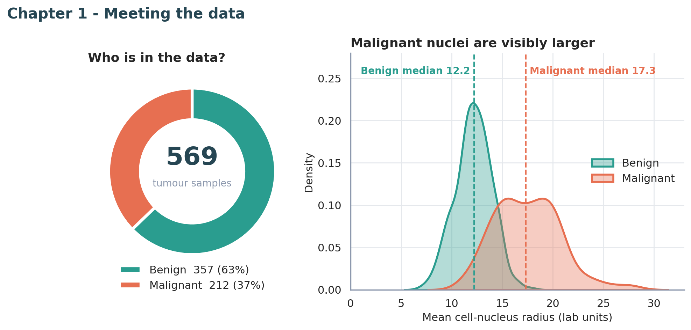
Figure 1. Left: the share of benign and malignant samples. Right: distribution of mean nucleus radius, with group medians marked.
What it shows. The donut shows that 357 of 569 samples (63%) are benign and 212 (37%) are malignant. The density curves on the right show how mean nucleus radius is spread across each group. The benign curve peaks sharply around a radius of 12, while the malignant curve is flatter and centred higher, with a median of 17.3 compared with 12.2.
Why this chart type. A donut gives an instant picture of proportions with the total in the centre, which orients a new reader. For the distribution, overlapping density curves are easier for a non-technical audience than two separate histograms, because the overlap itself becomes the visible message. Dashed median lines give each group a single memorable number.
How it moves the story. This opening chart sets the stage and plants the first clue: size matters. It also shows honestly that the groups overlap, since benign and malignant curves share a region around radius 14 to 16. That overlap raises the question the next chapters try to answer: which measurements separate the groups better?

Chapter 2: Where do the groups pull apart?
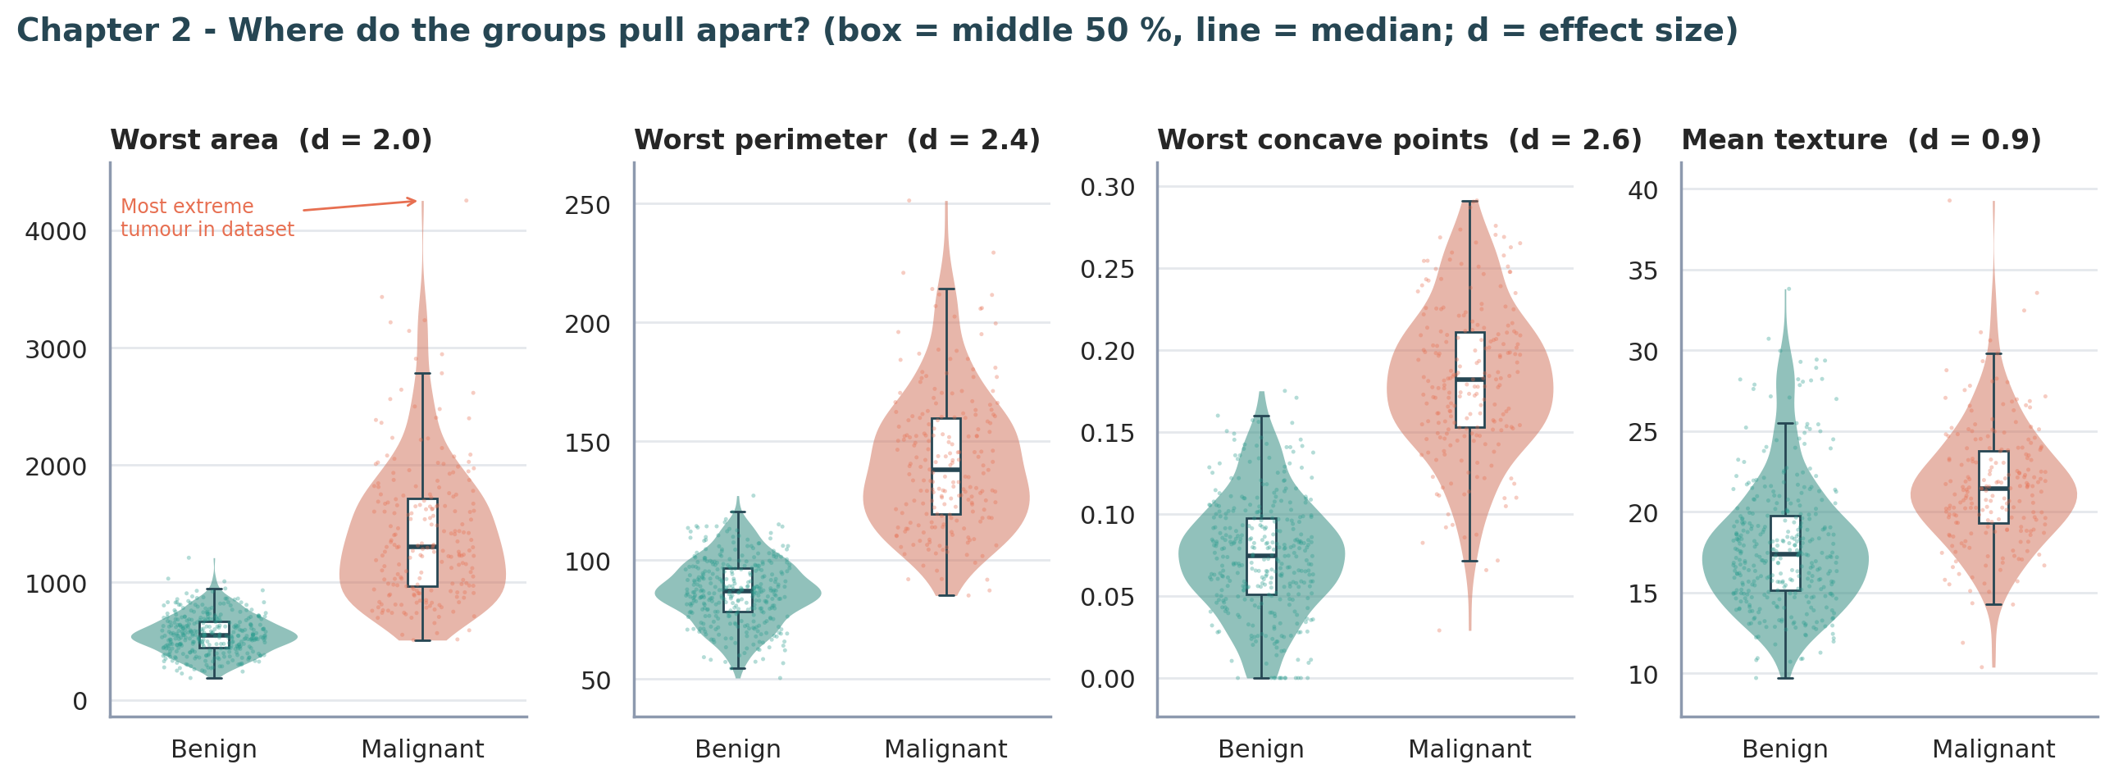
Figure 2. Four measurements compared across groups. Violin shapes show the spread, boxes show the middle 50% and the median line, dots are individual samples. d is the effect size.
What it shows. For four measurements, the malignant group sits clearly higher. The typical worst area is 1,303 for malignant samples versus 547 for benign, more than double. Worst perimeter and worst concave points show the same pattern with even less overlap. Mean texture, shown for contrast, separates the groups much less (effect size 0.9 against 2.0 to 2.6 for the others). One malignant sample, labelled on the chart, has the largest worst area in the whole dataset, at over 4,000.
Why this chart type. A violin shows the full shape of the data, a box inside it gives exact summary values for those who want them, and the individual dots reassure the reader that real samples sit behind the shape, including outliers. Placing four panels side by side with the same layout lets the eye compare them quickly. Including a weaker measurement, texture, is intentional: a story with only strong evidence would be less credible.
How it moves the story. Chapter 1 showed one measurement. Chapter 2 shows the pattern is not a fluke of radius: several independent descriptions of the cells tell the same story. It also introduces the idea of effect size, a single number for how far apart two groups are, which becomes the basis of Chapter 5.

Chapter 3: Many measurements, few independent ideas
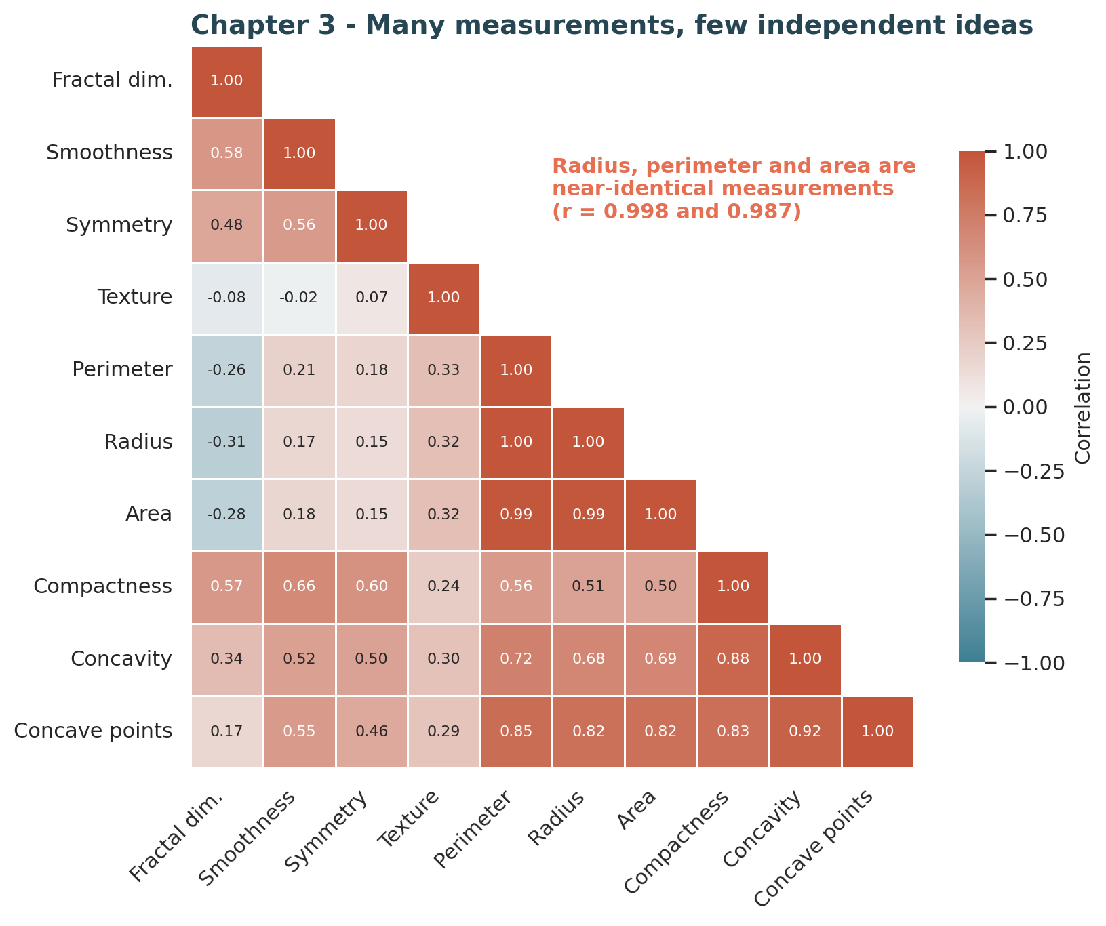
Figure 3. Correlation between the ten "mean" measurements, grouped so that similar measurements sit together. Dark red means two measurements move almost perfectly together.
What it shows. Each square shows how strongly two measurements rise and fall together, from 1.00 (identical behaviour) down to 0. Radius, perimeter and area form a solid block of dark red with correlations of 0.99 or higher, which is natural because they are all different ways of describing how big a circle-like shape is. Concavity, concave points and compactness also move together. Texture and fractal dimension are mostly independent of the rest. Across all 30 measurements, 21 pairs are correlated above 0.9.
Why this chart type. A heatmap is the standard tool for scanning many pairwise relationships at once. Showing only the lower triangle removes duplicated information, ordering the rows so that similar measurements sit together makes the blocks visible, and printing the numbers inside the squares lets the reader check the colour against the value.
How it moves the story. This chapter is the turning point of the story. It warns the reader that having 30 measurements does not mean having 30 pieces of evidence. Much of the dataset repeats itself. This has a practical consequence: a small set of well-chosen measurements may be enough, which is tested in Chapter 4, and the full dataset can be summarized compactly, which is shown in Chapter 6.

Chapter 4: Two measurements already separate most cases
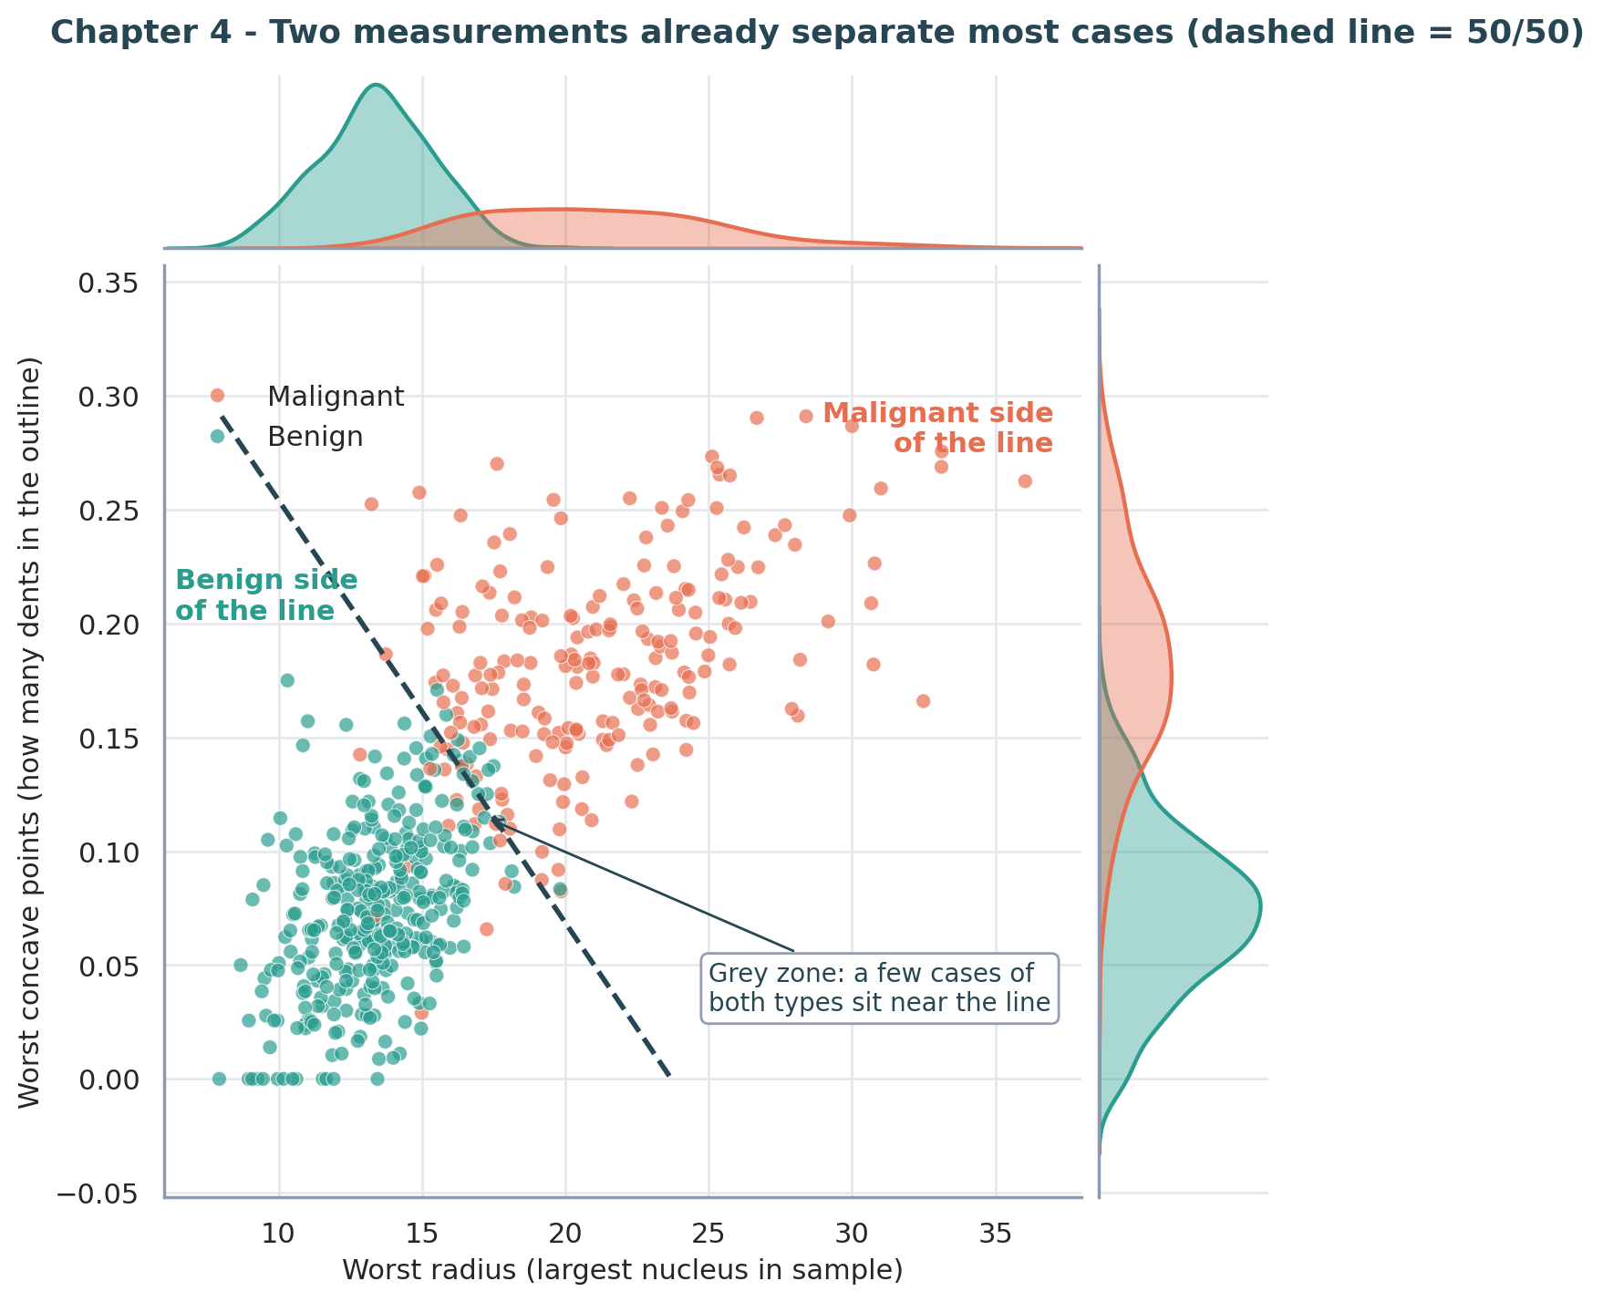
Figure 4. Each dot is one sample, positioned by its worst radius (across) and worst concave points (up). The dashed line is where a simple model is 50/50 between the two diagnoses. Curves along the edges show the distribution of each group on that single measurement.
What it shows. Benign samples cluster in the lower left (small nuclei, smooth outlines) and malignant samples in the upper right (large nuclei, many dents). A single straight line separates the two clouds reasonably well. A simple model using only these two measurements classified about 95% of samples correctly in cross-validation. The chart also shows where it struggles: near the line, a small number of benign and malignant samples sit side by side.
Why this chart type. A scatter plot is the right tool when two measurements are combined to make a decision. Marginal density curves along the top and right show what each measurement achieves alone, and the main panel shows that the combination does better. The dashed line translates a statistical model into a visual rule anyone can follow: which side of the line is a sample on?
How it moves the story. Chapter 3 suggested that a few measurements could be enough. Chapter 4 proves it with the two strongest candidates. It also introduces the idea of a grey zone, which matters for the implications: even a strong signal leaves some cases uncertain, and those cases are where human expertise matters most.

Chapter 5: Which measurements matter most?
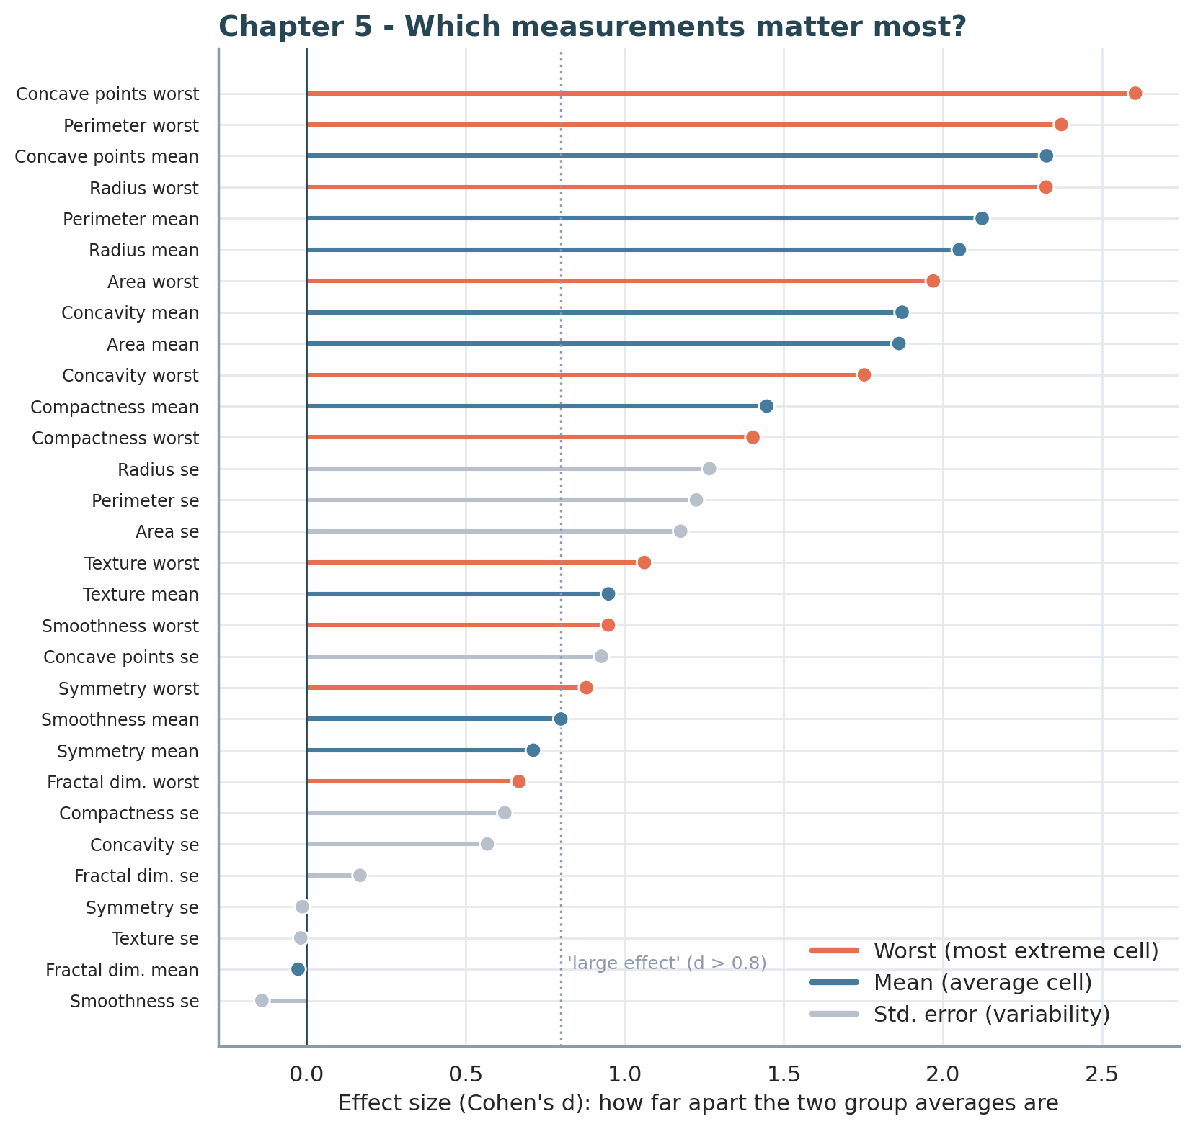
Figure 5. All 30 measurements ranked by effect size (Cohen's d). The longer the bar, the further apart the benign and malignant averages are. Colour shows whether the measurement is a mean, a worst value, or a standard error.
What it shows. Twenty of the 30 measurements pass the conventional threshold for a "large" effect (d above 0.8). The top three are worst concave points (2.60), worst perimeter (2.37) and mean concave points (2.33). On average, "worst" measurements separate the groups best (average effect size 1.60), followed by "mean" (1.41) and then standard error (0.58). A few measurements, such as the variability of symmetry and texture, carry almost no signal at all (effect size close to zero).
Why this chart type. A ranked lollipop chart is clearer than a bar chart for 30 items because the long thin lines keep the labels readable and draw the eye to the dot position. Sorting from strongest to weakest turns the chart into a priority list. Colour-coding by measurement type reveals a second insight without extra text: the most abnormal cells in a sample tell us more than the average cells do.
How it moves the story. Chapters 2 to 4 each looked at a few hand-picked measurements. Chapter 5 shows the reader that those choices were not arbitrary: they come from the top of a ranking of all 30. It also gives a clear takeaway for anyone designing a measurement process: focus on outline irregularity and size, and on the most extreme cells.

Chapter 6: The whole picture
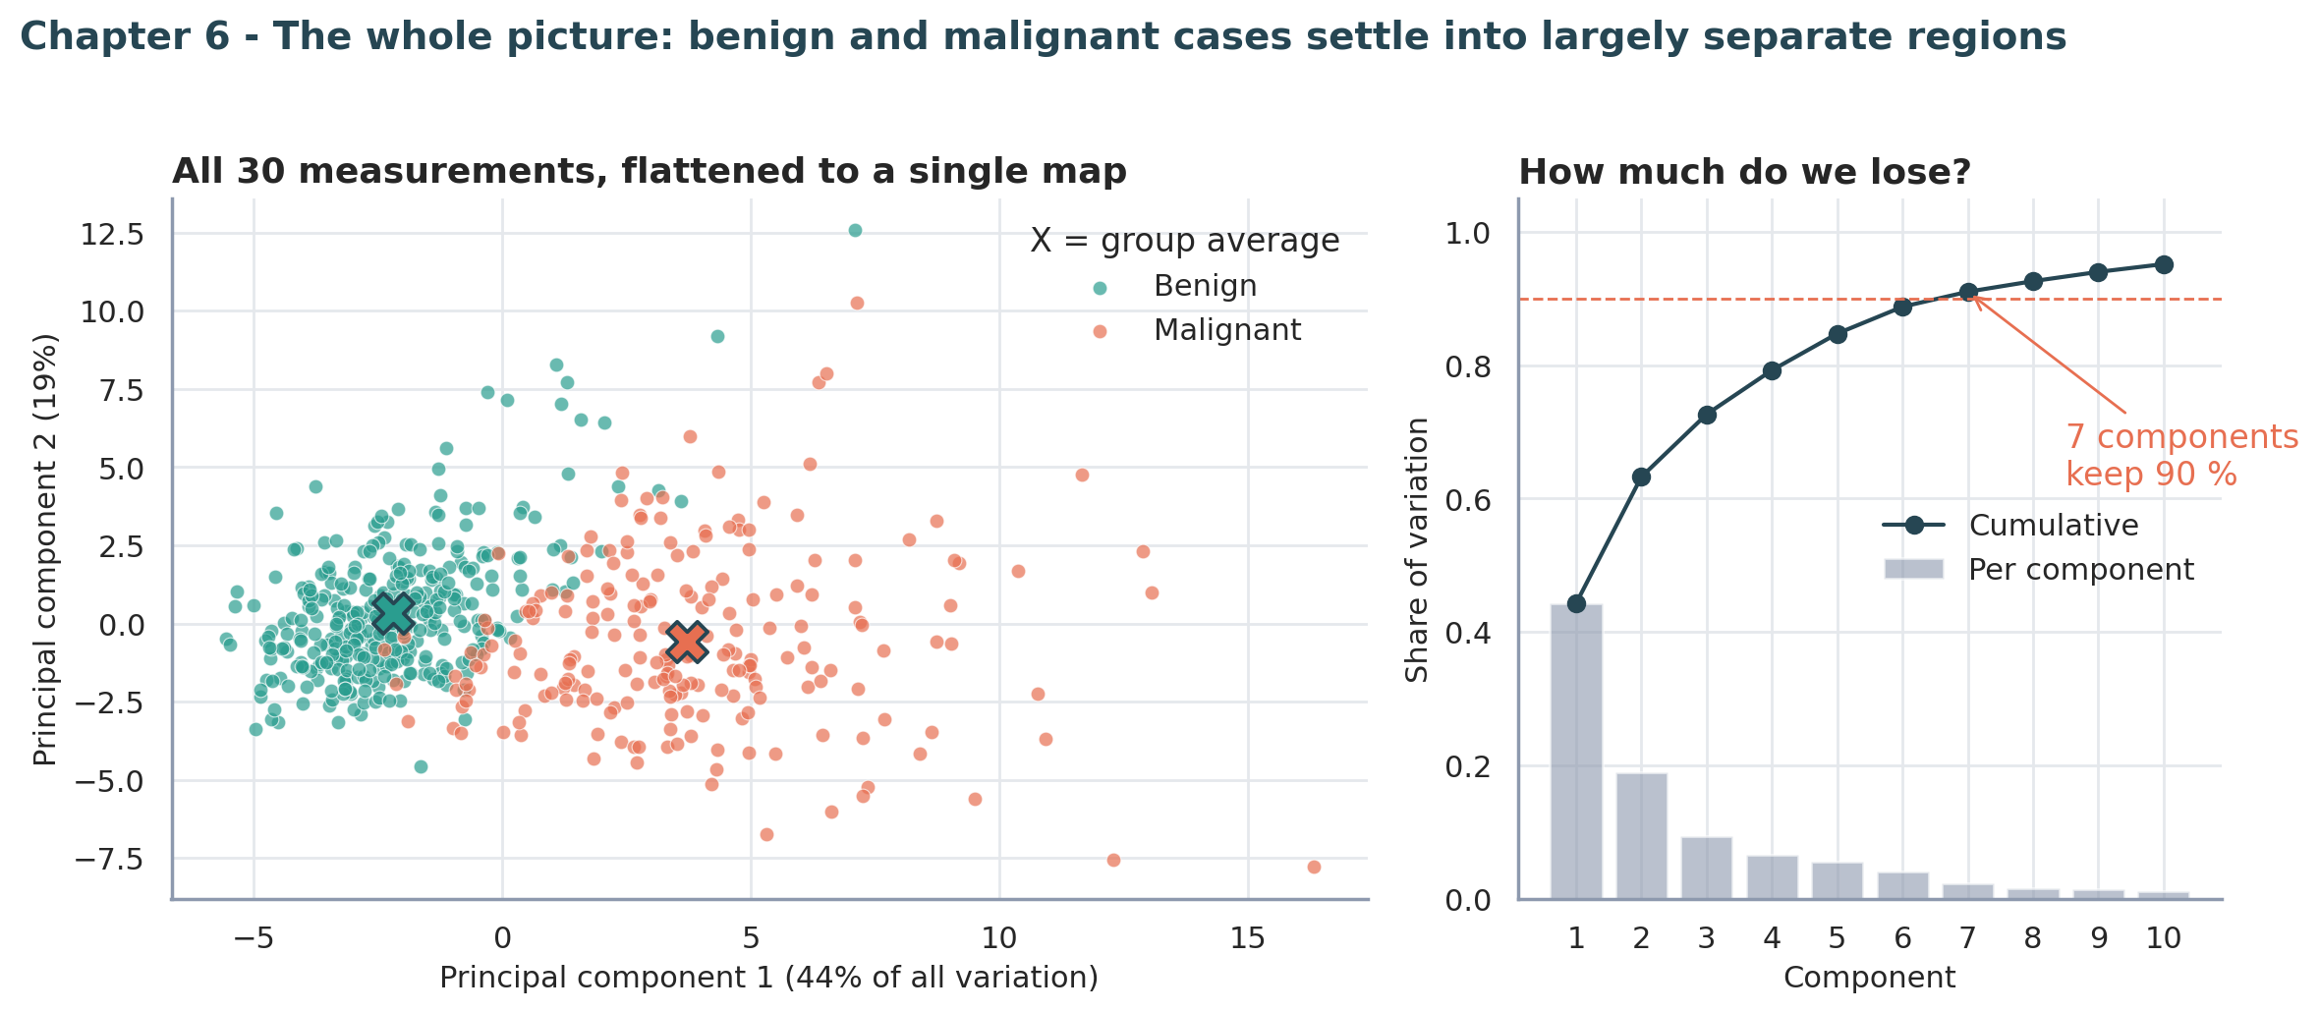
Figure 6. Left: all 30 measurements combined and flattened onto two axes using PCA. The X marks show the average position of each group. Right: how much information each additional axis keeps.
What it shows. PCA finds the two directions along which the samples differ most and uses them as the map axes. On this map, benign and malignant samples settle into largely separate regions, with the group averages far apart. The first axis alone holds 44% of all the variation in the data and the first two hold about 63%. The right panel shows that 7 axes are enough to keep 90% of the information, down from 30. A simple model using only the two map axes classified about 95% of samples correctly.
Why this chart type. PCA is the standard way to show high-dimensional data in two dimensions. Coloured dots show whether the groups separate, group-average markers make the distance between them tangible, and the accompanying curve shows what was lost by simplifying. Together they answer the natural question: is this picture trustworthy?
How it moves the story. This final chapter zooms out. After looking at single measurements, pairs and rankings, the reader sees the entire dataset at once and finds the same story: two types of tumour that differ systematically in the shape and size of their cells, with a thin zone of overlap in the middle. It also confirms the point of Chapter 3: 30 measurements compress into far fewer underlying ideas.

Summary of the six visualizations
Figure | Chart type | Question answered | Contribution to the story
1 | Donut + density curves | Who is in the data, and does size differ? | Introduces the cast and the first clue
2 | Violin + box + points | Do several measurements agree? | Shows the pattern is robust, not a fluke
3 | Clustered heatmap | Are the measurements independent? | Warns about redundancy; motivates simplification
4 | Scatter + marginal densities | Do two measurements suffice? | Gives a visible rule and shows the grey zone
5 | Ranked lollipop chart | Which measurements matter most? | Justifies the choices; gives a priority list
6 | PCA map + variance curve | What does the whole dataset look like? | Confirms the story at full scale

4. Conclusions
Taken together, the six chapters tell one consistent story.
- Malignant and benign samples differ in a measurable, systematic way. Malignant nuclei are larger and have more irregular outlines, and this appears in every chart.
- The strongest evidence comes from outline irregularity and from the most extreme cells. Worst concave points, worst perimeter and mean concave points lead the ranking.
- The dataset is smaller than it looks. Many measurements are near-duplicates, so 30 columns carry far fewer than 30 independent ideas.
- A small amount of information goes a long way. Two measurements reach about 95% cross-validated accuracy, and the full set reaches about 98%.
- Uncertainty never fully disappears. A thin band of cases sits between the two groups in every view. Charts that hide this overlap would give a false impression of certainty.

Key numbers at a glance
Measure | Value
Samples (benign / malignant) | 569 (357 / 212)
Median mean radius, benign vs malignant | 12.2 vs 17.3
Median worst area, benign vs malignant | 547 vs 1,303
Strongest single measurement (effect size) | Worst concave points (2.60)
Measurements with a large effect (d > 0.8) | 20 of 30
Measurement pairs correlated above 0.9 | 21
Accuracy using 2 measurements (5-fold CV) | about 95%
Accuracy using all 30 measurements (5-fold CV) | about 98%
PCA axes needed to keep 90% of information | 7 of 30

5. Implications and Limitations

5.1 Scientific and medical implications
- Prioritise the right measurements. Because outline irregularity and the most extreme cells carry the most information, image-analysis research could focus on measuring these accurately rather than collecting every possible feature.
- Decision support, not decision replacement. A simple model that is right about 95% to 98% of the time could help a pathologist prioritise cases or provide a second opinion. The grey zone shows that borderline cases still need expert judgement and further testing.
- Explainable results build trust. Because the signal is carried by a few intuitive properties (size and roughness), a clinician can understand and check why a sample was flagged, which is harder with complex black-box models.

5.2 Business and organisational implications
- Cheaper, simpler data pipelines. Redundant measurements add storage, processing and maintenance cost without adding information. Retaining the strongest, least repetitive measurements could cut cost while keeping most of the accuracy.
- Better triage and resource use. Even a simple scoring rule could help a laboratory decide which samples to send for a faster expert review, so that specialist time goes where uncertainty is greatest.
- A template for communicating analytics. The same structure, starting with the context, showing the strongest evidence, warning about pitfalls, quantifying the result, and ending with the overall picture, applies to any dataset where managers need to trust a model before adopting it.

5.3 Limitations and cautions
- This is a single, relatively small dataset (569 samples) from one source. Results may not carry over to other hospitals, equipment or patient groups.
- Cross-validated accuracy is an estimate. It is encouraging, but it is not a substitute for testing on completely new data.
- Accuracy alone hides the cost of different mistakes. Missing a malignant tumour is far more serious than flagging a benign one for extra review, so any real-world use would need to measure and tune the two error types separately.
- The analysis shows association, not mechanism. It describes how malignant and benign samples differ, not why.
- This report is a data-visualization exercise. It is not clinical guidance, and nothing here should be used to diagnose any individual.

5.4 Suggested next steps
- Test the simple model on an independent dataset.
- Report sensitivity and specificity (the two kinds of error) separately, and examine the borderline cases individually.
- Build an interactive version of Figures 4 and 6 so that readers can explore the grey zone themselves.

Appendix: Reproducing this report
The following files accompany this report:
- breast_cancer_clean.csv - the cleaned dataset from Week 1.
- week2_visualizations.py - a single script that creates all six figures and prints every statistic quoted above.
To regenerate everything, place both files in the same folder and run:
python week2_visualizations.py
Required Python libraries: pandas, numpy, matplotlib, seaborn, scipy and scikit-learn.

Glossary for non-technical readers
Term | Plain-language meaning
Benign / malignant | Not cancerous / cancerous.
Nucleus | The control centre of a cell; its size and shape are what the measurements describe.
Concave points | The number of inward dents in the outline of a nucleus; more dents mean a more irregular shape.
Effect size (Cohen's d) | How far apart two group averages are, measured in units of their typical spread. Above 0.8 is considered large.
Correlation | How closely two measurements rise and fall together. 1 means perfectly together, 0 means unrelated.
PCA | A technique that squeezes many measurements into a few new ones that keep as much information as possible.
Cross-validation | Testing a model on data it was not trained on, repeated several times, to get an honest accuracy estimate.

