1. **Task Description**

Create a shopping cart component with the ability to add, remove, and update item quantities.

1. **Task Output Screenshot**

HOME PAGE –

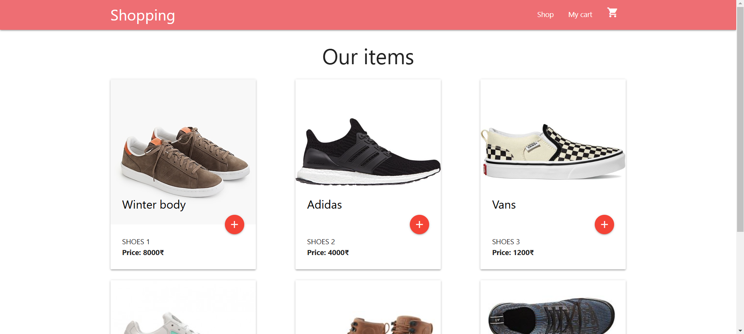

CART PAGE –

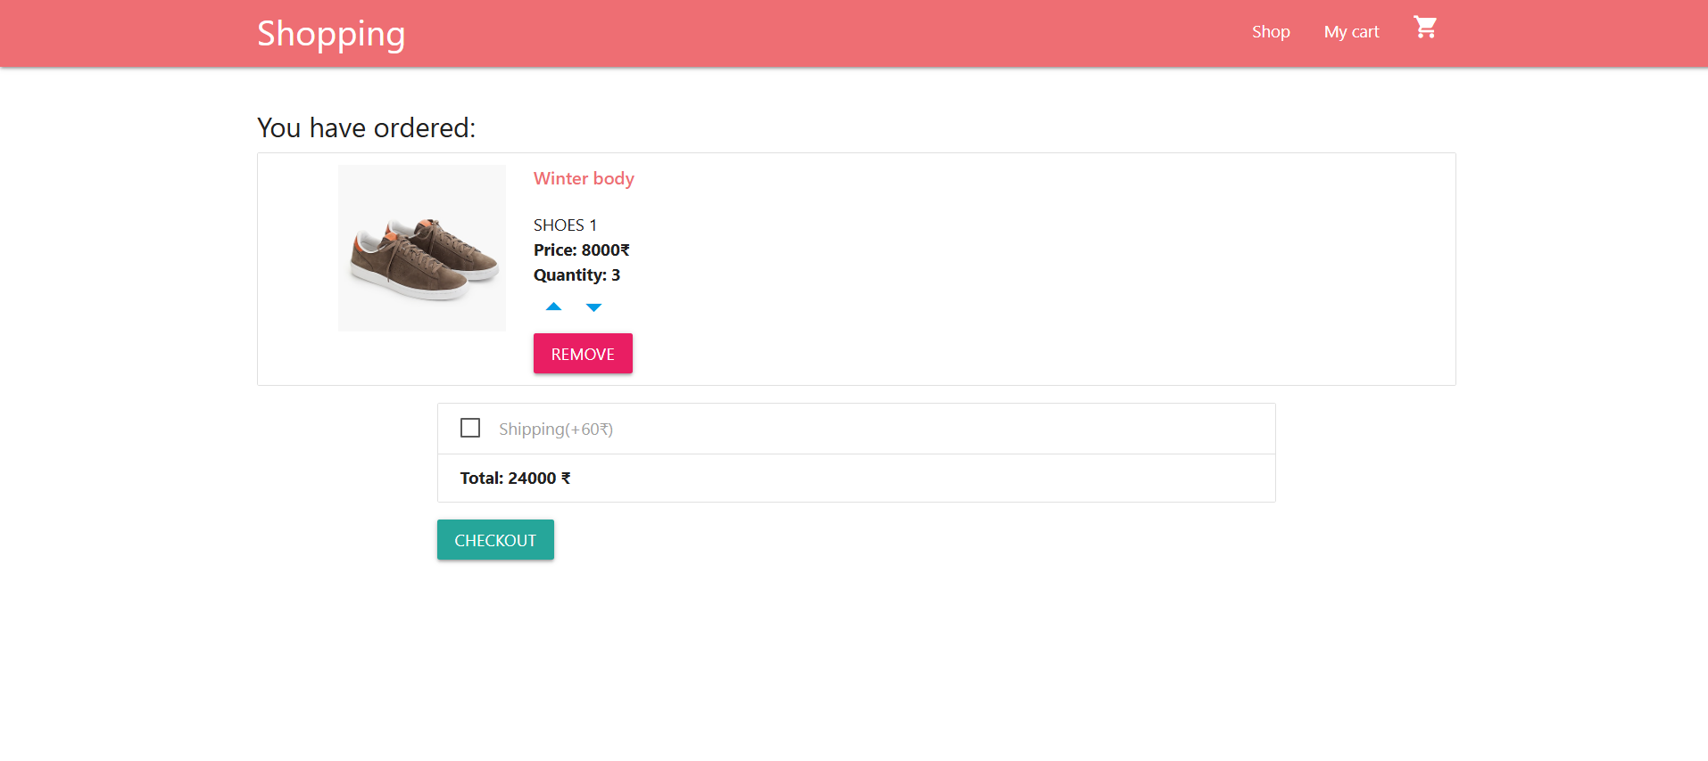

1. **Widget/Algorithm Used In Task**

* On home page showing all item in store on local database
* Click on + button to add item in My cart
* In my cart we can update item, increasing item, decreasing item and also remove item on this page
* It is a shopping cart component with the ability to add, remove, and update item quantities.