**Descriptive Statistics of Key Variables, Interpretation of Mean & Skewness**

Descriptive Statistics

|  |  |  |  |  |  |  |  |
| --- | --- | --- | --- | --- | --- | --- | --- |
| Statistic | N | Mean | Std. Dev. | Median | Pctl(25) | Pctl(75) | IQR |
| box_office_revenue | 250 | 201.964 | 137.082 | 187.046 | 77.490 | 303.494 | 226.004 |
| movie_budget | 250 | 81.003 | 35.276 | 84.766 | 58.688 | 105.967 | 47.279 |
| audience_score | 250 | 64.023 | 16.694 | 62.993 | 51.986 | 76.599 | 24.613 |

*Table 1.1 Summary Statistics for box_office_revenue, movie_budget, audience_score*

Interpretation of Mean:

The average box office revenue at theatres for movies in this sample is $201.964m, a baseline estimate for the total box office collections. Similarly, the mean production budget for the films in the sample is $81.003m. The average audience score for movies in this sample is 64.023 out of 100, the rating on Rotten Tomatoes.

Symmetry:

The median box office revenue for films in this sample is $187.046m, which is less than the mean of $201.964m. The distance between the third quartile (Q3) from the median ($116.448m) is slightly larger than the distance between the first quartile and the median ($109.556m). These two factors suggest that box office revenue is positively skewed.

The median movie budget is $84.766m, which is slightly higher than the mean of $81.003m. The distance between Q1 and the median ($26.078m) is larger than the distance between Q3 and the median ($21.201m). Consequently, these observations imply a negative skew in movie budgets.

The median audience score is 62.993 out of 100, slightly lower than the mean audience score of 64.023 out of 100. The distance between Q3 and the median (13.606 points) is larger than the distance between Q1 and the median ($11.007m). As a result, we can infer that there is a positive skew in audience scores on Rotten Tomatoes.

**Confidence Intervals for Means**

95% CI(**μbox_office_revenue**) = [184.972, 218.957] ($m)

95% CI(**μmovie_budget**) = [76.631, 85.376] ($m)

95% CI(**μaudience_score**) = [61.954, 66.093] (out of 100)

**Density Function and Skewness of Box Office Revenue**

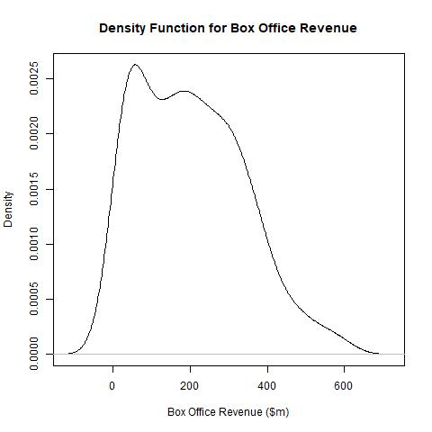

Figure 3.1 Density Function for Box_Office_Revenue

The density function (Figure 3.1) for box office revenue shows an evident positive skew as the values tail off to the right. Economically, we can observe that the minimum box office revenue is 0, however, because films can be superhits or blockbusters, they can generate colossal box office revenues. These revenues may greatly exceed the median, resulting in a positive skew.

**High Budget vs Low Budget Films Density Functions**

Henceforth, we shall define high budget films as the subset of data for which movie_budget is greater than or equal to the median movie_budget for the sample data. Low budget films are all the films in the sample for which the movie_budget is less than the median movie_budget.

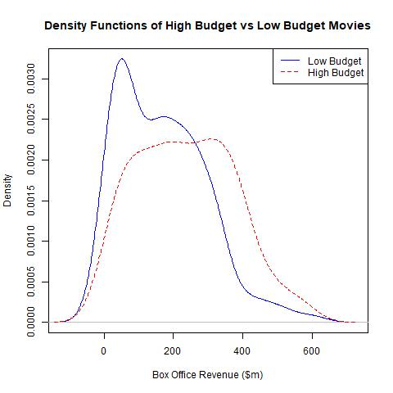

From Figure 4.1, we can observe that the box office revenue of high budget films tends to be higher than low budget firms, represented with a higher density for higher values of box office revenue. Furthermore, there is a lower density for high budget movies for lower values of box office revenue when compared to low budget movies. This is due to the fact that a majority of the high budget density is shifted further to the right compared to the low budget density. This suggests a positive relationship between the box office revenue and the movie budget.

The mean revenue for high budget movies is $235.738m whereas, the mean revenue for low budget movies is $168.190m, reflecting a large disparity in revenue. A potential explanation for this is that higher budget films have more money to invest in a higher quality production team, recognisable actors and more advertising for the movies, enabling it to reach a wider audience. A consequence of reaching a wider audience may be more box office revenue as greater public interest may surround the film.

*Figure 4.1 - Density Functions for*

*box_office_revenue for High and Low Budget Films*