Directive Sound System

By : Jidhu Mohan M
University College of Engineering,
Kariavattom, Trivandrum.

All loudspeakers today have one thing in common, they are direct radiating i.e. they are fundamentally a piston-like device designed to directly pump air molecules into motion to create the audible sound waves we hear. The Directive Sound System is a revolutionary new audio technology that creates sound in a narrow beam, just like light. We can aim the flat, thin speaker disc to our desired listening area, and provide all of the sound with no noise. Also it is a completely new technology that creates sound “in air.” It is a new paradigm in sound production based on solid, well-known principles of physics. There are no enclosures, crossovers, woofers, mid range or tweeter elements. ‘The sound is generated in the air itself ’, indirectly, as a conversion by-product of the interaction of ultrasonic waves.
This technology gives us the ability to direct sound exactly where you want it. With the combination of an ultrasonic emitter, a proprietary signal processor and an amplifier, projects a column of modulated ultrasonic frequencies into the air. These ultrasonic frequencies are inaudible by themselves. However, the interaction of the air and modulated ultrasonic frequencies creates audible sounds that can be heard along the column. This audible acoustical wave is caused when the air down-converts the ultrasonic frequencies to the lower frequency spectrum that humans can hear. Since the audible sound is produced inside the column of ultrasonic frequencies, an important by-product is that the audible sound can be tightly focused in any direction within the listening environment.
Advantages:
  - Ultimate control in audio placement - Now your target audience can hear exactly what you want, exactly where you want them to. Designed to target a specific area, Directive Sound System uses a tightly focused directional beam of sound that is heard only by those in the selected area.
  - Minimizes noise pollution - The high-precision targeting significantly minimizes the levels of noise pollution in both open and confined spaces and anywhere else ambient noise is an issue. It also ensures that your intended audience receives the messages conveyed through the system clearly and intelligibly.
  - Virtual Sound Source - We can reflect the beam by using special reflecting surfaces and thus the listener will have an illusion that the sound is originating from the reflecting surface.
  - Small Size - Not only has the conventional speaker's crossover network and enclosure been eliminated, but ultrasonic emitter is so small and light-weight that the inertial considerations ordinarily associated with traditional direct-radiation speakers are virtually non-existent. (And so is just about everything else associated with the conventional speaker: the voice coil and support structure normally used to attach the moving cone in place.)
  - Point Source - The ability to produce the entire audible spectrum of frequencies from a single point source has been the goal of transducer engineers for the past 50 years. The improvement in phase response, time alignment, and frequency response becomes obvious.
  - Frequency response from 20 Hz to 20 kHz

HISTORY
This technology was originally developed by the US Navy and Soviet Navy for underwater sonar in the mid-1960s, and was briefly investigated by Japanese researchers in the early 1980s, but these efforts were abandoned due to extremely poor sound quality (high distortion) and substantial system cost. These problems went unsolved until a paper published by Dr. F. Joseph Pompei of the Massachusetts Institute of Technology in 1998 (105th AES Conv, Preprint 4853, 1998) fully described a working device that reduced audible distortion essentially to that of a traditional loudspeaker
Technology
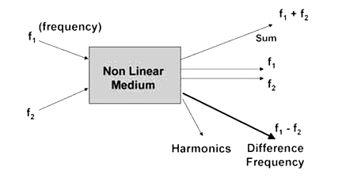
Non-Linear Medium : It is understood from the world of electronics, that sending two frequencies(represented here by f1 andf2), into a Non Linear device (such as a mixer or heterodyne circuit) produces an output which contains both of the original signals F1 and F2, plus the sum of the two, the difference of the two, and a set of harmonics. Here we are most interested in the difference frequency, f1 minus f2. There are now four tones where before there were only two. It can be demonstrated mathematically that the two new tones correspond to the sum and the difference of the two original ones, which we refer to as combination tones.
For example, if you were to emit 200,000 Hz and 201,000 Hz into the air, with sufficient energy to produce a sum and difference tone, you would produce the sum - 401,000 Hz - and the difference - 1,000 Hz, which is in the range of human hearing.
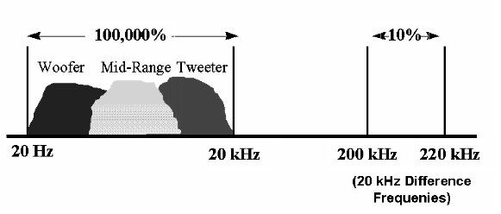
The concept originates from this theory of combination tones, a phenomenon known in music for the past 200 years as "Tartini tones." It was long believed that Tartini Tones were a form of beats because their frequency equals the calculated beat frequency. However, it was Hermann von Helmholtz (1821-1894) who completely re-ordered the thinking on these tones. By reporting that he could also hear summation tones (whose frequency was the sum rather than the difference of the two fundamental tones) Helmholtz demonstrated that the phenomenon reporting that he could also hear summation tones (whose frequency was the sum rather than the difference of the two fundamental tones) Helmholtz demonstrated that the phenomenon had to result from a non-linearity.
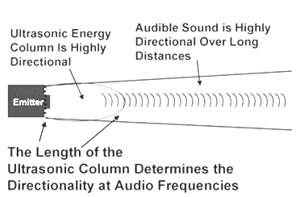

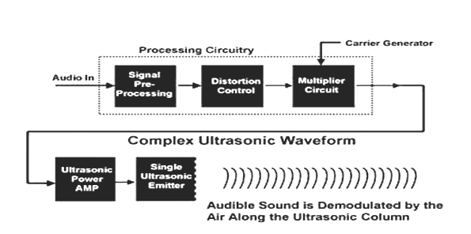
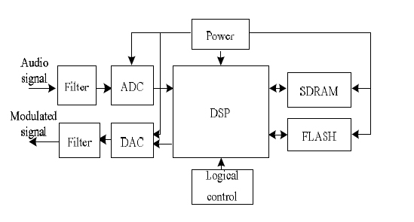
Range of Hearing
The human ear is sensitive to frequencies from 20 Hz to 20,000 Hz (the "audio" range), and can detect the vibration amplitudes that are comparable in size to a hydrogen atom.
If the range of human hearing is expressed as a percentage of shifts from the lowest audible frequency to the highest, it spans a range of 100,000%. No single loudspeaker element can operate efficiently or uniformly over this range of frequencies. In order to deal with this speaker manufacturers carve the audio spectrum into smaller sections. This requires multiple transducers and crossovers to create a 'higher fidelity' system with current technology.
Using a technique of multiplying audible frequencies upwards and superimposing them on a "carrier" of say, 200,000 cycles the required frequency shift for a transducer would be only 10%. Building a transducer that only needs to produce waves uniformly over only a 10% frequency range. For example, if a loudspeaker only needed to operate from 1000 to 1100 Hz (10%), an almost perfect transducer could be designed.
If the audio spectrum could be superimposed on this high frequency carrier and emitted into the air as an ultrasonic acoustical wave front, the only thing remaining would be to "down convert" the ultrasonic energy to sonic energy we could hear.
Applications
- Museums, aquariums, zoos, monuments and other self-guided or tour-led facilities can enhance the visitor experience through targeted communication about artistic displays, historical documents, artifacts, animal and marine life, without the need for headphones.
- In high ambient noise environments such as airports, rail lines, busses, commuter train stations, or port terminals, HSS can intelligibly target traveling information and local area tourist information to a specific area.
- Retailers of all types can provide targeted, unobtrusive advertising directly at the point of purchase.
- If we need to communicate clearly and efficiently over long distances to a single group of people, it lets you “beam” sound to a single point hundreds of feet away.
- Focus drive-thru restaurant ordering station sound directly into the car window, eliminating “noise pollution” of the surrounding environment.
- In a grocery store aisle, advertise a special sale price or promotion directly in front of the product, without disturbing other customers. Directive Sound can “focus” audio at your tradeshow exhibit. It lets you communicate directly with your target customer at a demonstration kiosk without bothering anyone else around the exhibit. As you move from display to display in a museum, it can present the “audio story” for each individual display.
- Computers - They require audio transducers to be small in size, easy to mount, have no magnets to interfere with the video screen, be low-cost, and provide high-fidelity audio. That describes HSS. One additional benefit to computers is the "beaming" ability of HSS technology. Imagine rows and rows of computer users, each listening to his or her own audio system without interfering with their neighbors.
- Autos - They require audio transducers to be small in size, easy to mount, low in cost, and provide high fidelity audio. Imagine HSS emitters in the dome light area of your automobile: Two for the front seat and two for the rear. The front seat occupants could listen to classical music while the rear seat occupants listen to rock.
- Hi-Fi and Home Theater - Imagine the ability to mount multiple HSS transducers to your stereo TV at the front of your living room and direct the sound to the rear corners without the need for wires or speaker cabinets in the rear; or maybe a cluster of HSS transducers on a dome shaped device on the ceiling, directing sound channels to 16 different locations.
- Besides consumer electronics, the entertainment industry is expected to be fundamentally influenced by this development. In a movie theater, sound can be made to emanate directly from an actor's mouth on the screen. Special effects will no longer be limited to the capability of loudspeakers positioned around the auditorium.
- You might want to project concert sound throughout an audience instead of using huge speaker stacks in front. A small table radio might project sound around an entire room. Why not equip your back yard with tightly focused HSS emitters to project sound all around your yard for that next pool party.

Products
There are currently four known devices being marketed that use ultrasound to create an audible "beam" of sound.
- AudioBeam
The German audio company Sennheiser Electronic offers their "AudioBeam" product. There are no known commercial applications of the technology.
- Audio Spotlight
F. Joseph Pompei of MIT developed technology he calls "Audio Spotlight", and made it commercially available in 2000 by his company Holosonics, which according to their website claims to have sold "thousands" of their "Audio Spotlight" systems. Disney was amongst the first major corporations to adopt it for use at the Epcot Center, and many other application examples are shown on the Holosonics website. (Source - ABC news 21 August 2006)
- HyperSonic Sound
Elwood "Woody" Norris, founder and Chairman of American Technology Corporation (ATC), announced he had successfully created a device which achieved ultrasound transmission of sound in 2002. ATC named and trademarked their device as "HyperSonic Sound" (HSS). In December 2002, Popular Science named HyperSonic Sound the best invention of 2002. Norris received the 2005 Lemelson-MIT Prize for his invention of a "hypersonic sound".³ Commercial adaptation of the device has occurred at ATC.
Matsushita Electric Industrial Co., Ltd. (Osaka, JP).
Matsushita apparently offers a sound from ultrasound product named the "MSP-50E"⁴ but commercial availability has not been confirmed.

BIBLIOGRAPHY

- K. A Navas, “Electronics Lab Manual-volume 1”,Rajath publications
- K. A Navas, “Electronics Lab Manual-volume 2”,Rajath publications
- Roy Choudhary, “Linear Integrated Circuits”, new Age International.
- F.J. Pompei, “The Use of Airborne Ultrasonics for Generating Audible Sound Beams,” J. Audio Engineering Society
- Chen Min, Huang Da-gui, Xu Shou-heng, Xu Li-mei, “An Approximate Realization Method of the Square Root Signal Processing Algorithm of the Audio Directional loud speaker”
- Min Chen, Li Mei Xu, Jun Meng, “Design of Signal Processing for a Novel Audio Beam Loudspeaker Based on DSP”
- Peifeng Ji, Chao Ye, and Jing Tian, “Development of a directional loudspeaker system For sound reproduction”
- Min Chen, Da-Gui Huang, Li-Mei Xu, Tian-You Hu, “Research on A Novel Audio Beam Loudspeaker Based on Digital Signal processor”
- Elwood G. Norris. “The creation of audible sound from ultrasonic energy: A fundamental paradigm shift”

