Product Design

|  |  |
| --- | --- |
| **Team** | **<49, Fine-Grained Data Visualisation , Team Memebers→ Mohit Chandra, Yash Verma, Nikhil Gogate>** |

# Design Model

Draw a simple class diagram and describe the classes in the table in this section. This diagram should represent the classes and their relationships. It is only necessary to show methods that are publically accessible by other classes. Only show an instance variable of a class if it is publically accessible. The diagram and the table should be consistent with each other.

Identify the classes (logical groupings of software methods that provide a related set of services). Make sure the design conforms to good design principles.

For each class, specify the information it maintains and the functionality it provides. Provide sufficient detail so that the purpose of each class in the design is clear.

|  |  |
| --- | --- |
| **Contour Graph 3D** | Class state   * This class is responsible for taking input dataset from user and plotting the graph   Class behavior   * Input from User * Analysis of dataset and conversion (if required) * Output the 3-D contour graph |
| **Live Streaming data analysis** | Class state   * This class is responsible for analysis twitter tweets and plotting a bar graph   Class behavior   * Input from Twitter tweets * Analysis of Hash tags of the tweets * Output the bar graph on the no. of times hash tag used |
| **3-D Modeling using Delaunay Triangulation** | Class state   * This class is responsible for taking input dataset from user and plotting the graph   Class behavior   * Input from User * Analysis of dataset and conversion (if required) * Output the 3-D contour graph |

.

|  |  |
| --- | --- |
| **Covex Hull Creater** | Class state   * This class is responsible for taking input dataset from user and creating a convex hull out of the random points.   Class behavior   * Input from User * Analysis of dataset in terms of skyline points. * Output the convex hull. |
|  |  |

# Sequence Diagram(s)

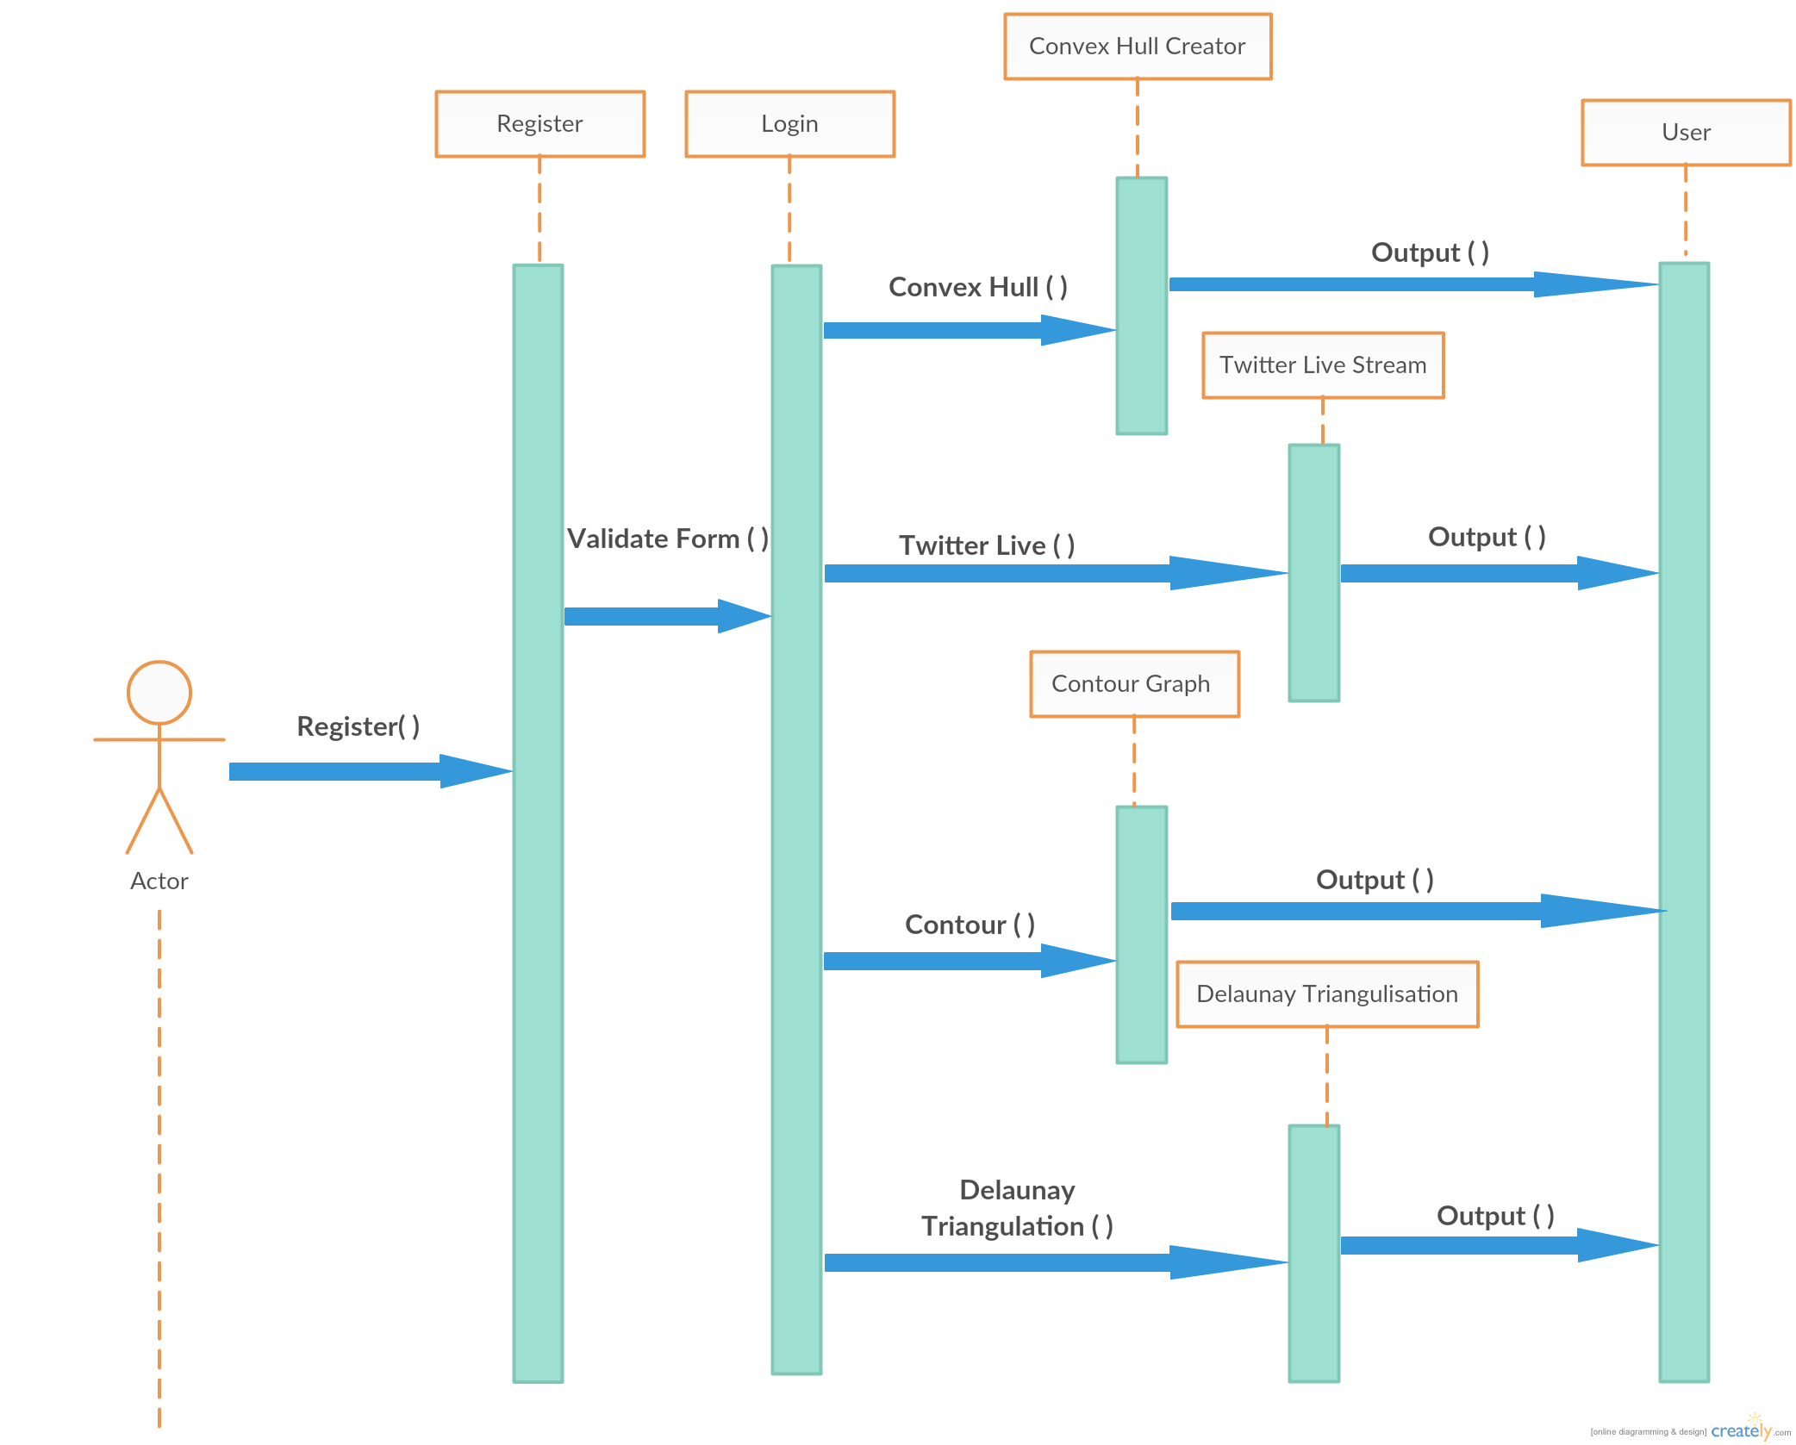

# Design Rationale

1) Our First Design Included only Contour Visualisation and no other functionality . Then we expanded our idea into several other fields where visualisation can be applied.

2) The idea of a website integrated with modules was also a part of modified design.

3) Adding Social Login with comment & like facility.

4) Further modification of design now allows the user to share their creations with others.