Software Requirements Specification (SRS) Document
Fine-Grained Data Visualization
SSAD05
Nikhil Gogate,Yash Verma,Mohit Chandra

Brief problem statement
The project mainly deals with the problem of representing millions of “data points” in a small area to reflect some useful information or pattern. The data points referred here are basically pixels and this pixel density would be responsible for reflecting the information to the user. The main problem with this is how we can efficiently represent those points in the desired way.

System requirements
1) No Particular client requirements regarding the technology to be used.
2) We are developing our system on python using various librar ies.

Users profile
The profile user for this project vary from children to adults.
Children (8-16 yrs) : Children in this age group can use the software for pictorial/pattern matching/finding as the points can be used to create patterns.
Adults: More informative utilization of the the product would be representing some data in the form of various point density maps which can reflect useful information.

Feature requirements (described using use cases)

No. | User Case Name | Description | Release
1 | Login | User will be able to login and see their old activities | R1
2 | Visualization of given dataset in form of heatmap | User will be able to provide a 2D dataset and provided with a 3D bar graph showing distribution of points in 2D plane. | R1
3 | Take dataset from user | Take input from user in terms of 2D or 3D dataset | R1
4 | Twitter popularity comparer | Take 3 hashtags as input from the user and compares their popularity by live streaming tweets from twitter and operating on them | R1
5 | Convex Hull
6 | Archive | Users can archive into local machine | R1
7 | Landscape Visualization | Users will upload 2D dataset to the website and | R2
8 | Offline app to integrate all visualization | Users can use all visualization through a single user interface | R2

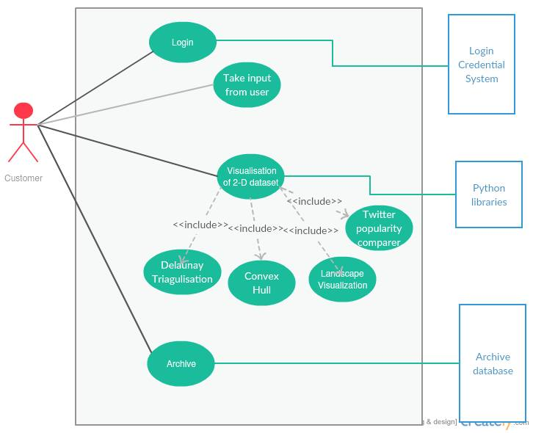

Use case description (Till Release 1)

Use Case Number: | UC - 1
Use Case Name: | Login
Overview: | User will be able to login on site to use the tools provided and see their past activities and visualizations
Actors: | User
Pre condition: | User should be registered with the site for logging in
Flow: | User provides their user name and password to login  If their credentials are correct then they successfully login in site
Alternate Flow :
User name and password credentials are displayed as invalid
Post Condition: | User should be able to use data visualization features provided in site

Use Case Number: | UC - 2
Use Case Name: | Visualization of given dataset in form of heatmap
Overview: | User will have choice to upload a 2D or 3D dataset or choose a random set of points generated by the system itself and create visualizations from the uploaded dataset
Actors: | User, random point generator (supporting actor), Archive (supporting actor)
Pre condition: | ->User should be logged in system to access this features  ->User should have uploaded an appropriate dataset or chosen option to generate random dataset
Flow: | Main (success) Flow:  User logins the system.  User uploads appropriate dataset or chooses to generate random dataset  User selects the option for data visualization  User is able to see the end result
Alternate Flows:
User uploads a dataset with dimensions more than 3 and gets an appropriate error
Post Condition: | User is able to see the end result and have option to make the visualization public and put it in archive

Use Case Number: | UC-3
Use Case Name: | Identification of patterns in given image
Overview: | Detects common life objects in a given image and forms artistic impressions using trace of objects
Actors: | Customer,Archive Database(Supporting Actor)
Pre condition: | Input image from user
Flow: | user uploads image  a new image with artistic patterns tracing image
Alternate Flows: If object is not detected in image no patterns can be formed,
random patterns will be formed
Post Condition: | If users permit image should be archived and publicised

Use Case Number: | UC-4
Use Case Name: | Twitter popularity comparer
Overview: | Users will be able to upload images for different visualizations.
Actors: | Customer,Image database
Pre condition: | User should be logged In
Flow: | User clicks on upload option and uploads images  choose type of pattern and redirects to image containing patterns.
Alternate Flows: Image uploaded is not valid image.
Appropriate error is displayed.
Post Condition: | Image is uploaded and processed.

Use Case Number: | UC-5
Use Case Name: | Input 2-D or 3-D dataset from user
Overview: | Take input from user in terms of 2D or 3D dataset
Actors: | Customer,Random point generator,database
Pre condition: | User should be Logged In
Flow: | Main (success) Flow:  User selects between random points or User given input.  User gives input points or random points are generated.  Points are stored and passed for further processing.
Alternate Flows: User gives invalid number of dimensions.
Shows appropriate error.
Post Condition: | Valid Points are there for processing.

Use Case Number: | UC-6
Use Case Name: | Archive
Overview: | Users can make their visualizations public which can be seen by everybody
Actors: | Customer,archive database
Pre condition: | Processed Pattern image should be generated.
Flow: | Main (success) Flow:  User chooses to archive particular pattern image.  Pattern is publicised as news feed to everyone.
Alternate flow :
If user choose not to archive pattern image is stored just in his own collection.
Post Condition: | Image is availaible for public view.

Use Case Number: | UC-7
Use Case Name: | Landscape Visualization
Overview: | User can generate a landscape visualization with hills,rivers,valleys
Actors: | Customer
Pre condition: | No such precondition required
Flow: | Main (success) Flow:  User upload dataset as file  Data set is processed  Visualization is displayed.
Alternate flow :
Visualization can be blank if format of dataset in file is not appropriate
Post Condition: | User can zoom in,out and see visualization from different directions

Use Case Number: | UC-8
Use Case Name: | Integrated Offline Application
Overview: | User can download an offline application and use visualization through single UI
Actors: | Customer
Pre condition: | Setup.py should be executed before running offline application
Flow: | Main (success) Flow:  User downloads application  Runs setup.py to install dependencies  Use any visualization
 | Alternate flow :
Post Condition: | An Offline Application is ready for use

