Task 1: Dynamic Student Report Card Using Destructuring and Template Literals

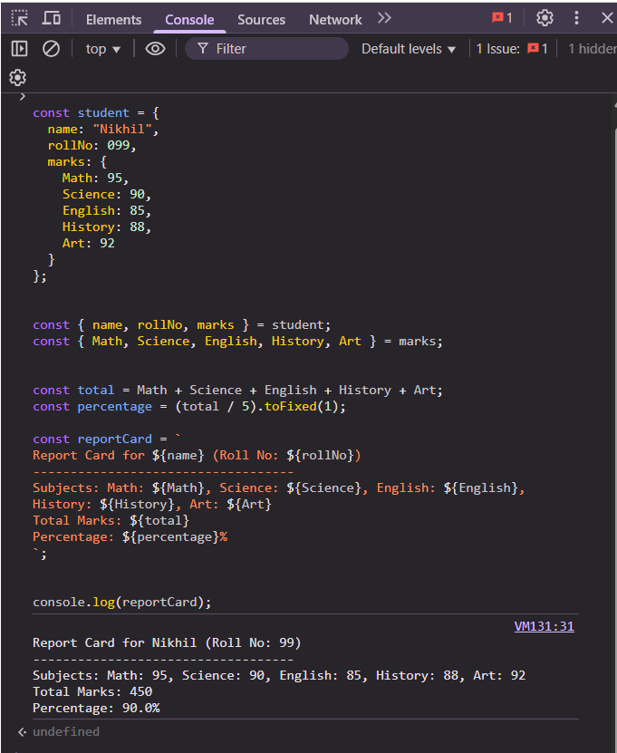

Task 2: Build a Custom Greeting Generator with Default Parameters and Arrow Functions

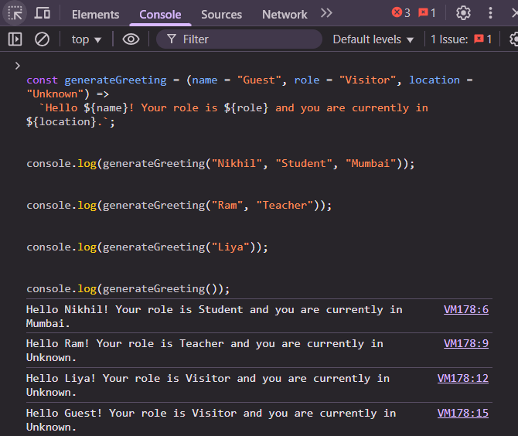

Task 3: Implement a Data Type Analyzer (without typeof)

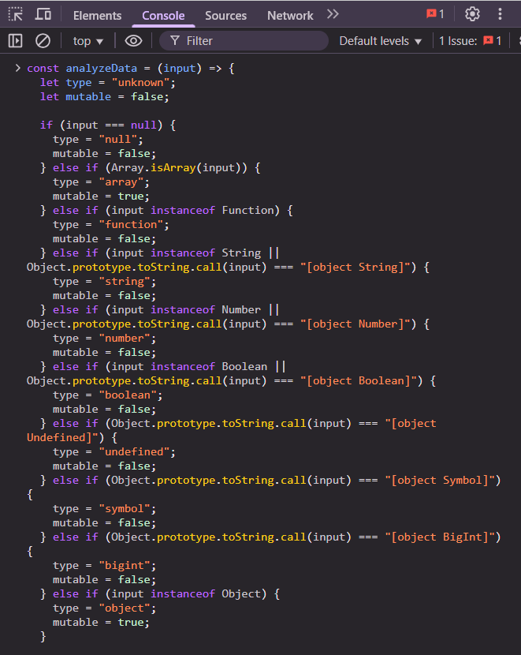

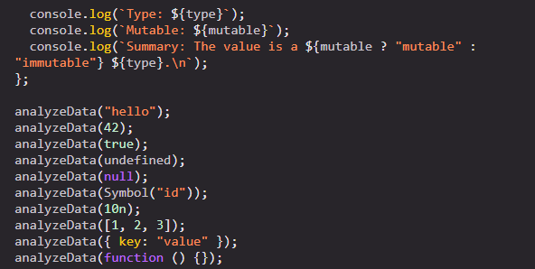  
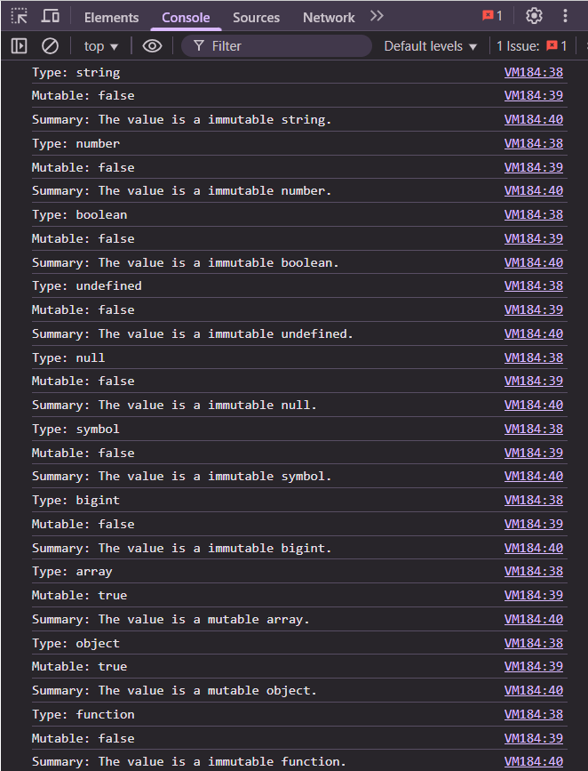

Task 4: Color Mixer using Destructuring and Spread/Rest Operators

