**EXAMPLE (ARRAY WITH 5 NUMBERS):**

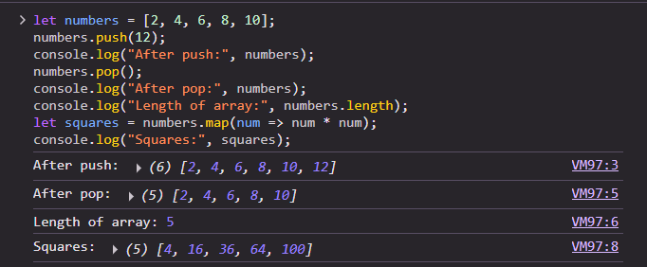

**EXAMPLE (PRODUCTS):**

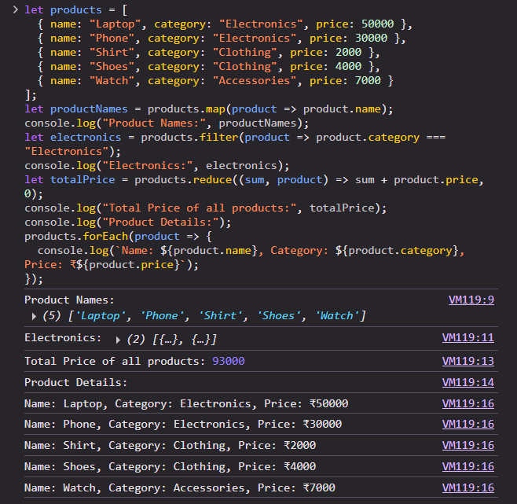

**TASK 1:**

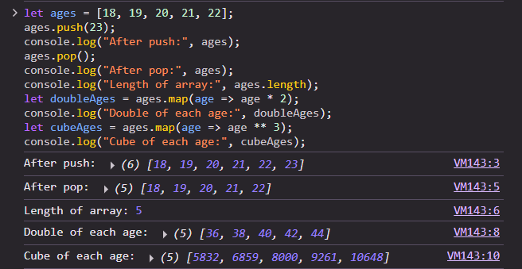

**TASK 2:**

