**Skill 5**

ID: 2000030384

Name: Jatla Nikhil Sai Lalith

Section No: S09

2.

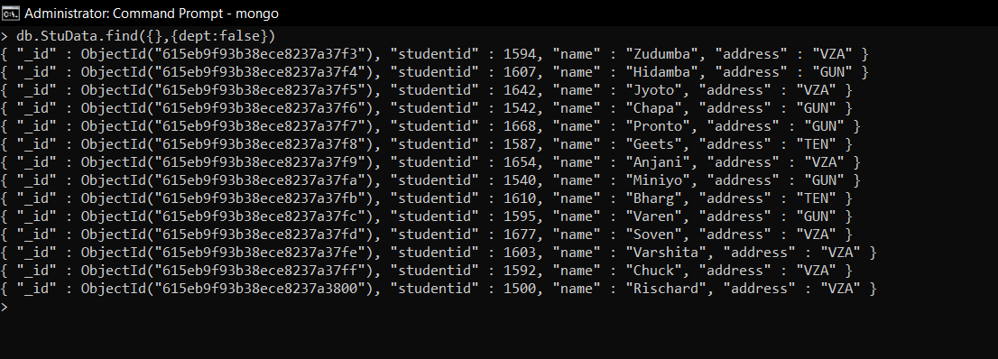

4.

Asc:

Desc:

5.

