**Skill-5**

ID: 2000030384

Name: Jatla Nikhil Sai Lalith

Section No: S09

1.

2.

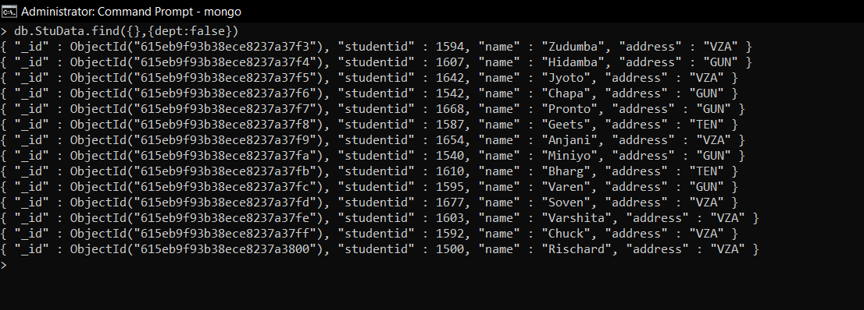

3.

4.

5.

