2.
A. (Fine Chit = True | Traffic = Slow, See Personnel = True) = 25%

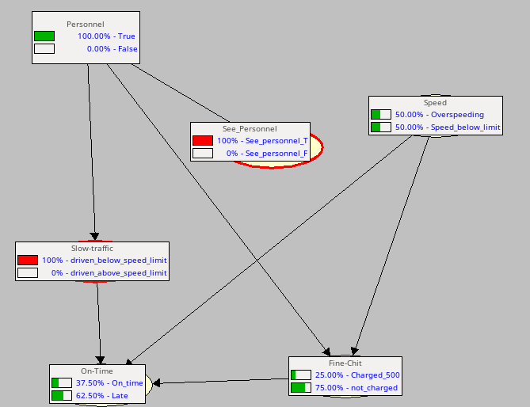

(Fine Chit = True | Traffic = Slow, See Personnel = False) = 2.65%

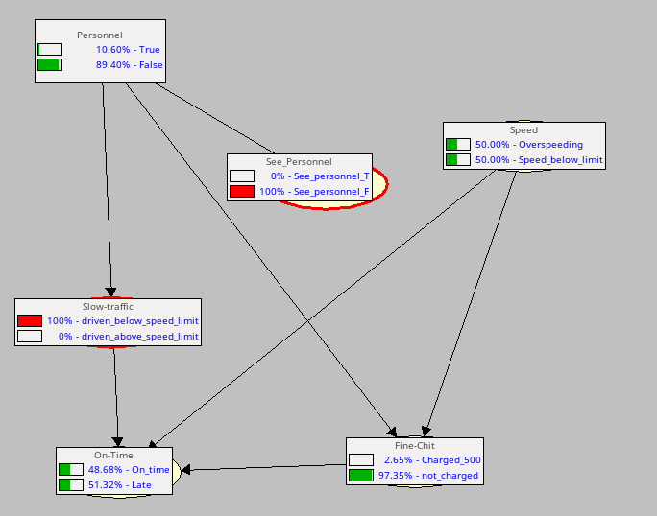

Hence, in case the traffic is slow, seeing the Personnel will affect the probability of the cab driver getting a Fine Chit.

B.) (Fine Chit = True | On Time = True, See Personnel = True) = 0.00%

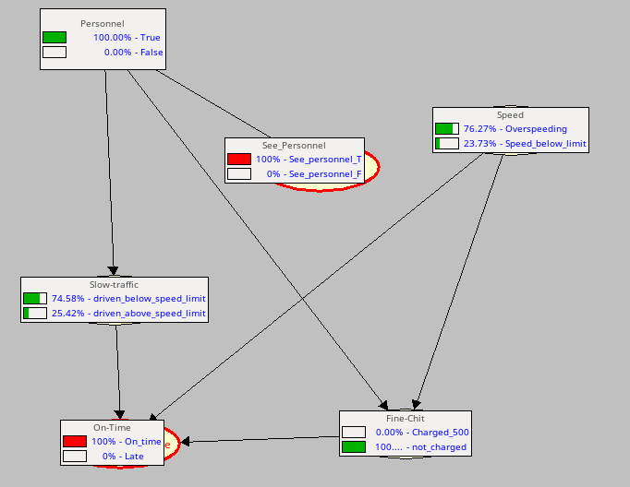
(Fine Chit = True | On Time = True, See Personnel = False) = 0.00%
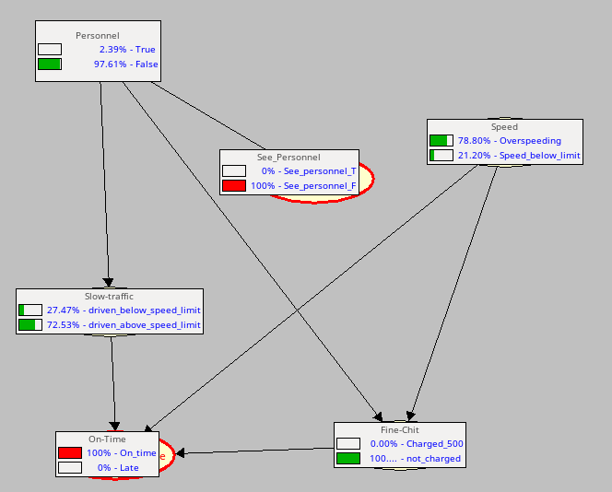

Hence, in case the taxi is on-time, seeing the Personnel will not affect the probability of the cab driver getting a Fine Chit.

