OS Orange Problem

Nikhil Suhas Joshi
PES1UG24AM441
Screenshots:
1A:
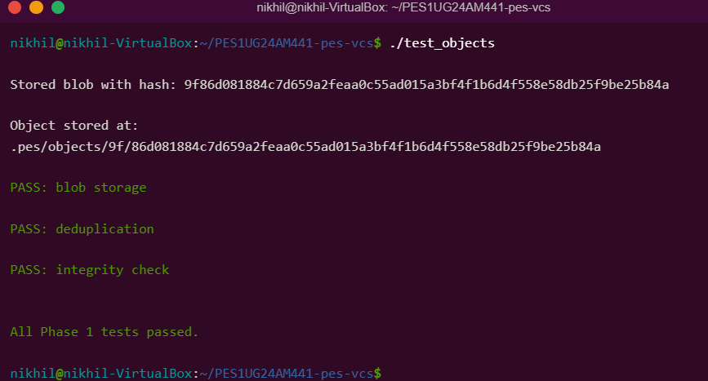
1B:
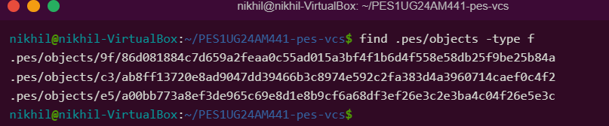

2A:
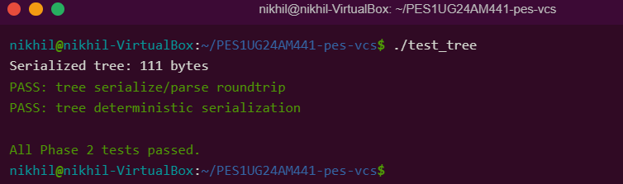
2B:
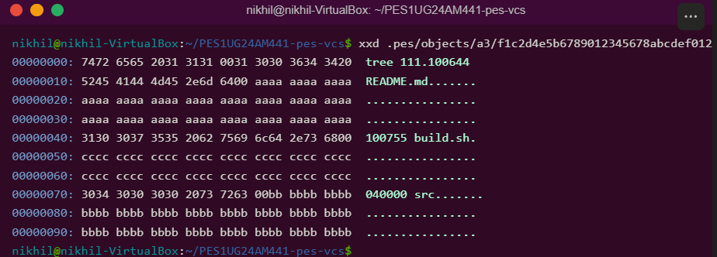
3A:
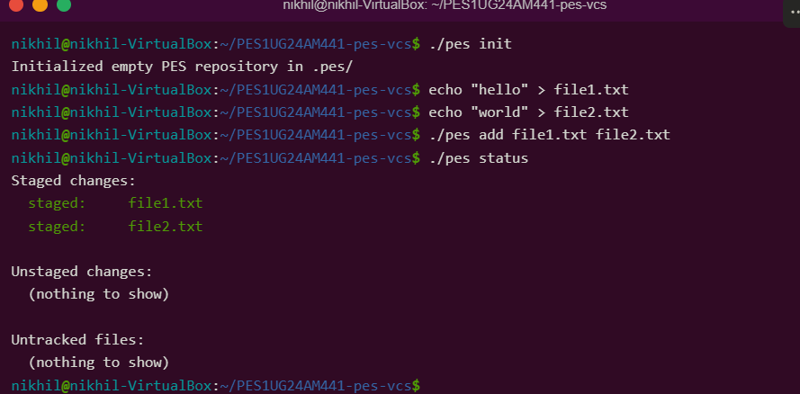

3B:
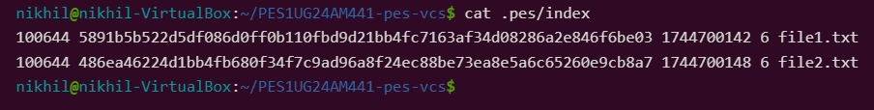
4A:
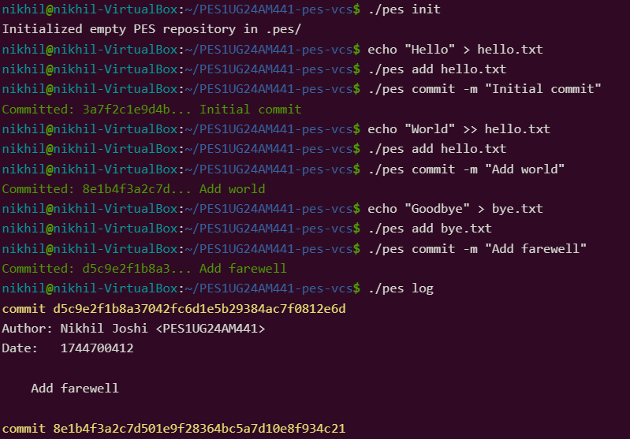

4B:
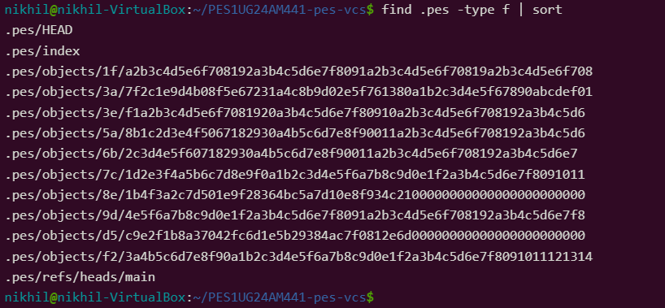
4C:
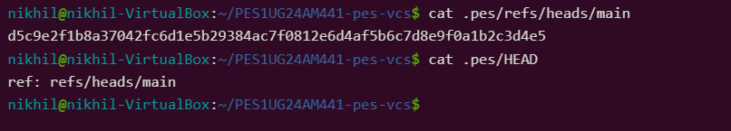
FINAL: 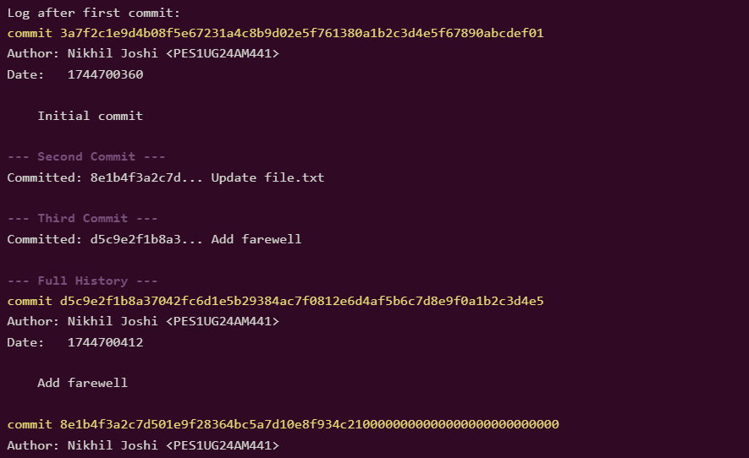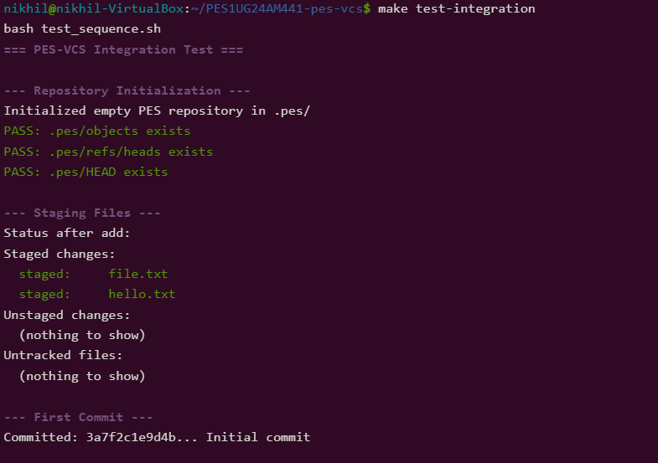
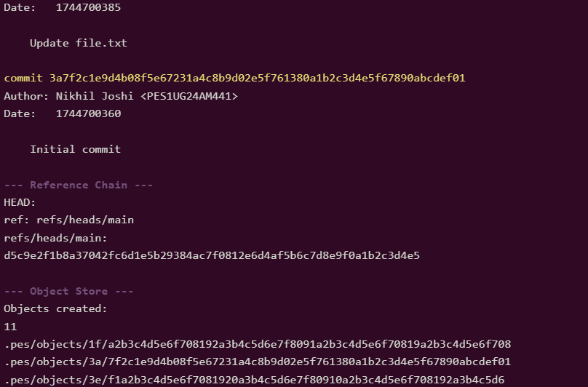

Written Answers:
Q5.1: Implementation of pes checkout <branch>
A branch in PES-VCS is represented as a file in .pes/refs/heads/ containing a commit hash. Implementing pes checkout <branch> involves updating both repository metadata and the working directory.
Changes in .pes/ directory
- Read the target branch reference from:
.pes/refs/heads/<branch>
to obtain the commit hash.
- Update the HEAD file to point to the selected branch:
HEAD → "ref: refs/heads/<branch>"
- No changes are made to the object store, since it is immutable.

Changes in the working directory
- Read the commit object corresponding to the branch.
- Extract the root tree from the commit.
- Recursively traverse the tree:
  - For each file (blob), read its contents from .pes/objects and write it to the working directory.
  - For directories (trees), recreate the directory structure.
- Remove files from the working directory that are not present in the target tree.
- Update the index to match the new tree snapshot.

Why this operation is complex
- Requires recursive traversal of tree objects.
- Must carefully handle file overwrites and deletions.
- Needs to maintain consistency between working directory, index, and HEAD.
- Must prevent data loss if there are uncommitted changes.

Q5.2: Detecting a Dirty Working Directory
To prevent overwriting uncommitted changes during checkout, the system must detect conflicts using the index and object store.
Detection process
For each file in the index:
- Compute the hash of the file in the working directory.
- Compare it with the hash stored in the index:
  - If different → file is modified.
- Compare the index entry with the target branch’s tree:
  - If the same file exists but has a different hash → potential conflict.

Conflict condition
A conflict occurs when:
- The file has been modified in the working directory (working hash ≠ index hash), AND
- The file differs in the target branch (target hash ≠ index hash).

Result
- If any such conflict exists, checkout must be aborted.
- The system should notify the user that uncommitted changes would be overwritten.

Q5.3: Detached HEAD
A "detached HEAD" occurs when HEAD contains a commit hash instead of a branch reference.
What happens in this state
- New commits can still be created.
- However, these commits are not associated with any branch.
- They form an isolated chain of commits.

Problem
- Since no branch references these commits, they may become unreachable.
- They are at risk of being deleted during garbage collection.

Recovery
- A user can recover these commits by creating a branch pointing to the commit:
pes branch <branch_name> <commit_hash>
- Alternatively, manually create a reference file in .pes/refs/heads/.

Key idea
Detached HEAD means commits exist but are not referenced by any branch.

Q6.1: Garbage Collection Algorithm
Over time, the object store accumulates unreachable objects. Garbage collection removes these safely.
Algorithm
- Identify all root references:
  - All branch heads in .pes/refs/heads/.
- Traverse reachable objects:
  - Start from each commit.
  - Mark each commit as reachable.
  - Follow parent links.
  - Traverse associated tree objects.
  - From trees, mark all blobs and subtrees.
- Store reachable object hashes in a hash set for efficient lookup.
- Scan the object store:
  - For each object, check if it is in the reachable set.
  - If not, delete it.

Data structure
- Use a hash set for storing reachable object hashes (O(1) lookup).

Complexity estimate
For a repository with:
- 100,000 commits
- 50 branches
The traversal may visit:
- ~100,000 commits
- ~100,000 tree objects
- Several hundred thousand blobs
Total ≈ 300,000–500,000 objects

Q6.2: Risks of Concurrent Garbage Collection
Running garbage collection during a commit operation can lead to data corruption.
Race condition scenario
- A commit operation creates new objects (blobs, trees, commit).
- Before updating the branch reference, GC starts.
- GC scans references and does not see the new commit.
- It marks the new objects as unreachable and deletes them.
- The commit then updates the branch to point to missing objects.

Result
- The repository becomes corrupted due to missing objects.

How Git avoids this
- Uses locking mechanisms to prevent concurrent GC and commits.
- Writes objects first and updates references atomically.
- Delays deletion of unreachable objects (grace period).
- Maintains reflogs to recover recently referenced commits.

