**APPENDIX I:**

**Result Table:**

|  |  |  |  |
| --- | --- | --- | --- |
| **Classifier** | **Precision** | **Recall** | **Accuracy** |
| **Random Forest** | 0.59 | 0.066 | 52.43 |
| **Gaussian Naiive**  **Bayes** | 0.048 | 0.070 | 33.40 |
| **Adaboost** | 0.003 | 0.0101 | 14.14 |
| **XGBoost** | 0.0005 | 0.00215 | 2.513 |
| **KNN** | 0.006 | 0.001 | 7.5432 |

**Screenshots**

**Random Forest- Accuracy- 52.4364**

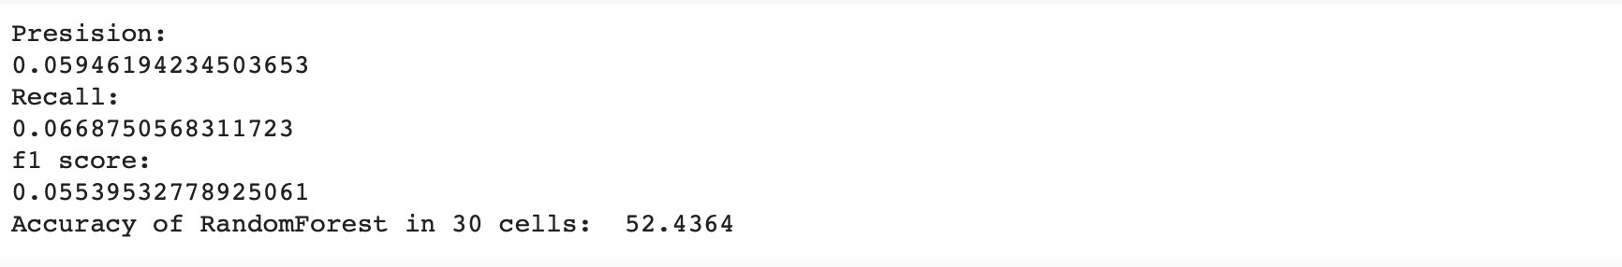

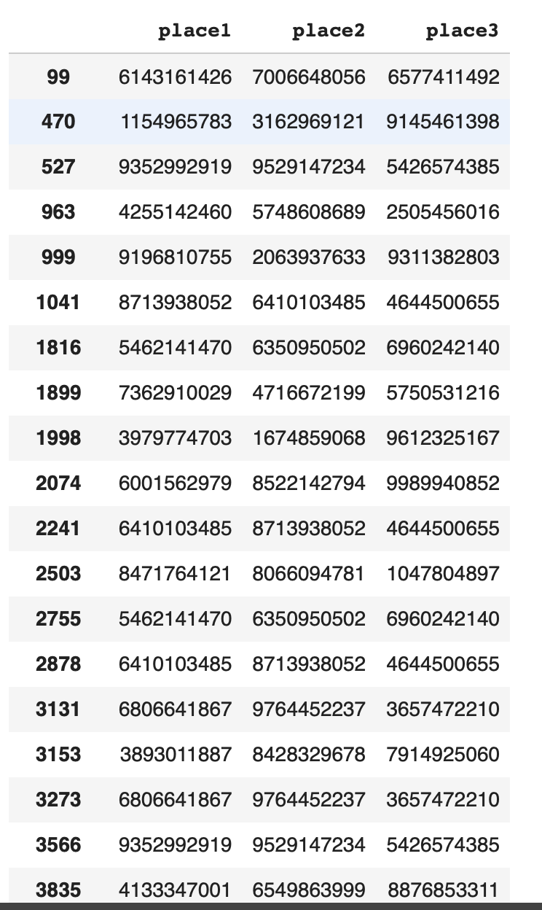

**Gaussian Naïve Bayes: 33.401 Accuracy**

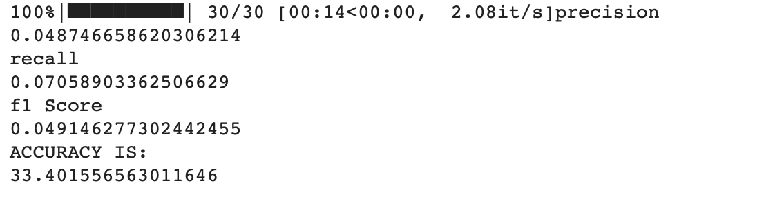

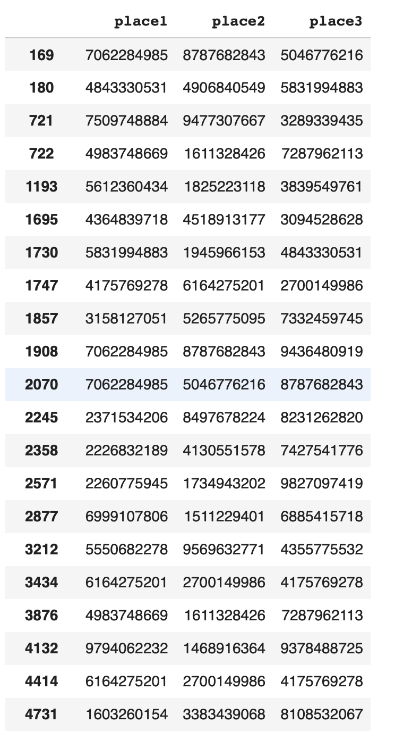

**Adaboost : 14.4 Accuracy**



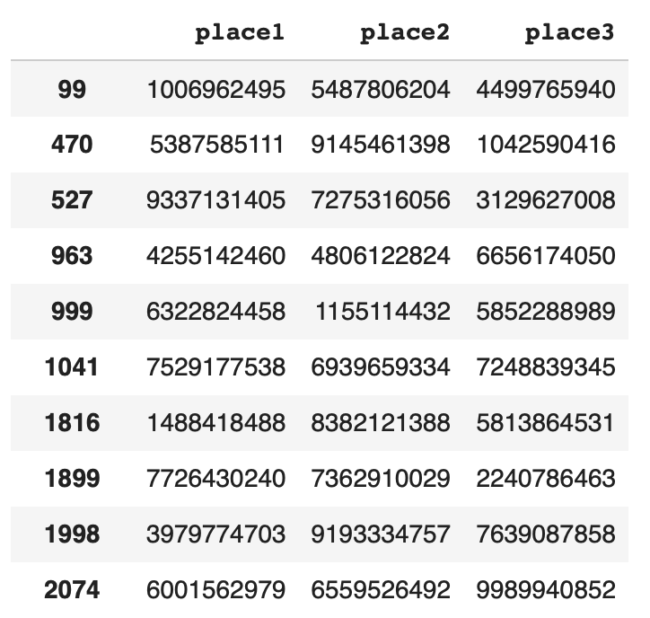

**XG BOOST: Accuracy- 2.5**

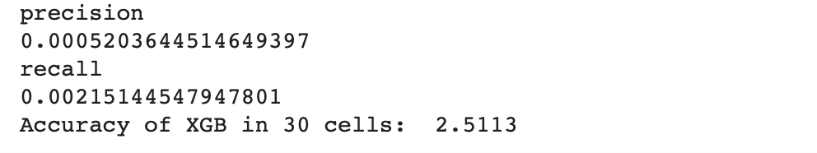

**KNN RESULTS: 7.5432 Accuracy**

