CI/CD PIPELINE DESIGN DOCUMENT
Intelligent AI-Based Railway Asset Monitoring and
Predictive Maintenance Platform
Problem Statement 9 — CI/CD Pipeline Design Exercise (CO4, Assessment Tool 2)
Covers: requirement & pipeline analysis, pipeline architecture & workflow, tools & technology selection, automated testing & quality integration, deployment/security/rollback strategy, and pipeline diagram & documentation.

1. Requirement & Pipeline Analysis
The Railway Asset Monitoring platform ingests continuous IoT sensor streams, runs machine-learning anomaly detection, generates predictive-maintenance forecasts, and drives safety-critical alerts and maintenance-prioritization decisions. Because the system is safety-critical, continuously evolving (frequent ML model updates), and composed of multiple loosely-coupled services (ingestion, ML inference, prioritization, reporting, alerting, web dashboard), it needs a CI/CD pipeline that automates integration, verification, and deployment while enforcing strong quality and security gates before anything reaches production.

1.1 Key CI/CD Drivers for this System
- Frequent change cadence: ML models, microservices, and dashboard code are updated independently and often — manual builds/releases cannot keep pace.
- Safety-critical correctness: undetected regressions in anomaly-detection or prioritization logic can delay a genuine defect alert, so automated testing and quality gates must run on every change.
- Multi-service architecture: ingestion, ML inference, prioritization engine, reporting, alerting, and the web dashboard are independently deployable — the pipeline must build/test/deploy each service in isolation while validating integration.
- Regulatory & data-sensitivity requirements: sensor/location data and access-control logic require security scanning (SAST/dependency scanning) and encrypted secrets management on every build.
- High availability target (99.9% uptime): deployments must not interrupt live monitoring, so the pipeline needs zero/low-downtime deployment and automatic rollback.
- Traceable releases: every production deployment must be traceable to a commit, build, test result, and approver for audit purposes.

1.2 CI/CD Requirements Identified
ID | CI/CD Requirement
CR-01 | Automatically build and validate every commit/PR to each microservice.
CR-02 | Run unit, integration, API, and ML-model validation tests automatically on every build.
CR-03 | Enforce static code analysis and security scanning (SAST + dependency/container scanning) as a quality gate.
CR-04 | Package services as versioned, immutable container images and publish to a private registry.
CR-05 | Deploy automatically to Dev and Staging; require manual approval before Production.
CR-06 | Support zero-downtime production deployment (canary/blue-green) with health-check-based automatic rollback.
CR-07 | Send pipeline status notifications to the DevOps/engineering team at each critical stage.
CR-08 | Store secrets (API keys, DB credentials, model registry tokens) securely — never in source control.
CR-09 | Provide full audit trail: commit → build → test results → approval → deployment.

2. Pipeline Architecture & Workflow
The pipeline is organized into ten sequential stages, from source commit to production monitoring, with an automated rollback path and event-driven notifications. Each microservice (ingestion, ML inference, prioritization engine, reporting, alerting, dashboard) runs through the same pipeline template with its own build/test artifacts.

2.1 Pipeline Diagram
The diagram below shows the workflow from code commit through to production monitoring, including the manual approval gate before production, the automatic rollback path, and notification touch-points.
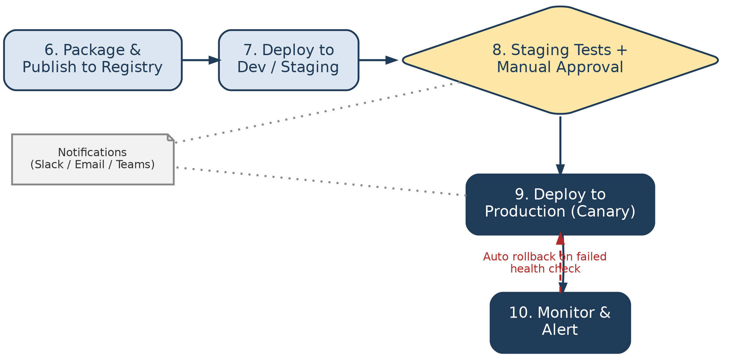
Figure 1: CI/CD pipeline — code commit to production monitoring (top: stages 1–5; bottom: stages 6–10), with automatic rollback and notifications.

2.2 Stage-by-Stage Workflow
# | Stage | What Happens
1 | Code Commit | Developer commits to a feature branch and opens a Pull Request against `develop`.
2 | Source Control Management | Git host (branch protection + mandatory PR review) triggers the pipeline automatically via webhook on push/PR.
3 | Build | Each changed microservice is built inside a multi-stage Docker build; dependencies are resolved and compiled/bundled.
4 | Static Code & Security Analysis | Static analysis (code smells, complexity, coverage) and security scans (SAST + open-source dependency/container CVE scan) run; pipeline fails the build if the quality gate is not met.
5 | Automated Testing | Unit, integration, API/contract, and ML-model validation tests execute against the freshly built image.
6 | Package & Publish | A versioned, immutable container image is tagged with the commit SHA and pushed to a private container registry.
7 | Deploy to Dev / Staging | The image is automatically deployed to the Dev, then Staging (pre-production) namespace on Kubernetes using Helm.
8 | Staging Tests + Manual Approval | Smoke tests and end-to-end tests run in Staging; a designated release approver signs off before Production deployment proceeds.
9 | Deploy to Production | A canary release routes a small percentage of live traffic to the new version; automated health checks monitor error rate and latency.
10 | Monitor & Alert | Production is continuously monitored; if health checks fail, the pipeline automatically rolls back to the last known-good version and notifies the team.

3. Tools & Technology Selection
Tools were selected for strong Kubernetes/container-native integration, wide industry adoption (lower onboarding cost), and native support for the quality/security gates this safety-critical system requires.
Pipeline Stage | Selected Tool(s) | Justification
Source Control Management | Git (GitHub / GitLab) with branch protection rules | Industry-standard distributed VCS; PR-based review and branch protection enforce peer review before merge, which is essential for a safety-critical codebase.
CI/CD Orchestrator | Jenkins (or GitHub Actions / GitLab CI) | Mature, widely supported pipeline-as-code orchestrator with a large plugin ecosystem for Docker, Kubernetes, SonarQube, and notification integrations.
Build & Containerization | Docker (multi-stage builds) | Produces small, reproducible, immutable images; multi-stage builds keep runtime images lean and free of build-time secrets/tools.
Static Code Analysis | SonarQube | Automates code-smell, complexity, duplication, and unit-test-coverage checks with a configurable Quality Gate that can fail the build.
Security Scanning (SAST + SCA) | Snyk / OWASP Dependency-Check + Trivy (container image scan) | Detects vulnerable open-source dependencies and CVEs inside container images before they reach a registry, addressing the platform's data-sensitivity requirements.
Automated Testing | JUnit / PyTest (unit), Postman + Newman (API), Selenium (UI), custom ML-validation harness | Covers each layer of the stack (service logic, REST APIs, dashboard UI, ML model accuracy) with tools already standard for each respective layer.
Artifact/Image Registry | Private container registry (e.g., Amazon ECR / Harbor) | Stores versioned, immutable images with access control and vulnerability scanning integration.
Deployment / Orchestration | Kubernetes + Helm | Enables declarative, repeatable deployments and native support for canary/blue-green rollout strategies and self-healing.
Secrets Management | HashiCorp Vault / Kubernetes Secrets (encrypted at rest) | Keeps credentials and API keys out of source control and pipeline logs, satisfying CR-08.
Infrastructure as Code | Terraform | Ensures Dev/Staging/Production environments are provisioned consistently and are version-controlled.
Monitoring & Alerting | Prometheus + Grafana, ELK/Loki for logs | Provides the health-check signal used to drive automated rollback and gives operators real-time visibility into asset-monitoring service health.
Notifications | Slack / Microsoft Teams + Email (via webhook) | Delivers immediate build/test/deployment status to the DevOps and engineering channels, satisfying CR-07.

4. Automated Testing & Quality Integration
Testing is layered so that fast, cheap checks run first and fail the build early, while slower end-to-end checks run later in Staging — minimizing feedback time for developers.

4.1 Automated Testing Strategy (Test Pyramid)
Test Type | Pipeline Stage | Tooling | Purpose | Pass Criteria / Quality Gate
Unit Tests | Build stage (on every commit) | JUnit / PyTest | Validate individual functions/classes — e.g., anomaly-threshold calculation, prioritization decision-table logic. | Minimum 80% code coverage; build fails below threshold.
Integration Tests | After build, before packaging | PyTest / TestContainers | Validate service-to-service and service-to-database interaction, e.g., ingestion service → message queue → ML inference service. | All critical integration paths pass.
ML Model Validation | After build (ML service only) | Custom validation harness against a held-out labelled dataset | Confirm the anomaly-detection model still meets the accuracy/false-positive-rate requirement before being packaged. | ≥ 90% detection accuracy, defined max false-positive rate.
API / Contract Tests | Post-deployment to Dev | Postman + Newman | Verify REST API contracts (request/response schema) between microservices haven't broken. | 100% of defined contract tests pass.
Security Tests (SAST/SCA) | Static Code & Security Analysis stage | SonarQube, Snyk, Trivy | Detect vulnerable dependencies, hardcoded secrets, and insecure code patterns. | Zero critical/high vulnerabilities open.
UI / End-to-End Tests | Staging stage | Selenium | Validate the operator dashboard workflow end-to-end (login → view alert → prioritize → close ticket). | All defined E2E user journeys pass.
Smoke Tests | Immediately after each deployment | Lightweight health-check scripts | Confirm the newly deployed version starts correctly and responds to basic requests. | All health endpoints return 200 OK.
Performance/Load Tests | Staging stage (nightly / pre-release) | JMeter / k6 | Confirm ingestion pipeline sustains target throughput (10,000+ concurrent sensor streams) within latency SLA. | P95 latency ≤ 2 seconds under target load.

4.2 Quality Gates
- Build fails automatically if unit/integration test coverage falls below 80%.
- SonarQube Quality Gate blocks the pipeline on new critical bugs, code smells above threshold, or duplicated code above 3%.
- Snyk/Trivy scan blocks packaging if any critical or high-severity CVE is found in dependencies or the base image.
- ML validation harness blocks packaging of the ML inference service if model accuracy drops below the agreed threshold or false-positive rate rises above it.
- Staging E2E and smoke tests must pass before the manual approval gate is even presented to the release approver.

5. Deployment, Security & Rollback Strategy

5.1 Environments
Environment | Trigger | Infrastructure | Purpose
Development | Auto-deploy on every successful merge to `develop` | Shared namespace on Kubernetes; synthetic/replayed sensor data | Fast feedback for developers; no approval required.
Staging / Test (Pre-production) | Auto-deploy after Dev validation; mirrors Production sizing | Production-like Kubernetes cluster; anonymized historical sensor data | Full regression, E2E, performance, and security validation before release sign-off.
Production | Manual-approval-gated deploy from Staging, canary rollout | Production Kubernetes cluster (multi-zone), live sensor/asset data | Serves live railway monitoring traffic; protected by approval gate, canary rollout, and automatic rollback.

5.2 Deployment Strategy
Production deployments use a canary release strategy: the new version is rolled out to a small percentage (e.g., 10%) of pods/traffic first, monitored against health and error-rate metrics for a defined bake time, then progressively scaled to 100% if metrics remain healthy. This is preferred over a big-bang release because a safety-critical monitoring platform cannot tolerate a full-fleet outage from a bad release; a blue-green strategy is used as a fallback for changes that cannot be safely canaried (e.g., database schema migrations).

5.3 Security Practices Embedded in the Pipeline
- Static Application Security Testing (SAST) via SonarQube on every build.
- Software Composition Analysis (SCA) via Snyk/OWASP Dependency-Check to catch vulnerable open-source libraries.
- Container image scanning (Trivy) before an image is allowed into the registry.
- Secrets (DB credentials, API keys, model registry tokens) are injected at deploy time from HashiCorp Vault / Kubernetes Secrets — never stored in source control or pipeline scripts.
- Role-based access control on the CI/CD orchestrator itself, so only authorized engineers can approve production deployments or modify pipeline configuration.
- All production deployments require a named human approver, and every approval is logged for audit.

5.4 Rollback Mechanism
- Automated health checks (error rate, latency, pod-readiness) are evaluated continuously during and after the canary rollout.
- If a health check breaches its threshold during the bake time, the pipeline automatically halts the rollout and reverts traffic to the last known-good image version — no human action required.
- Every deployed image is immutable and versioned by commit SHA, so rollback is a routing change (Kubernetes/Helm revision rollback), not a rebuild — this keeps rollback time under a target of 5 minutes.
- A rollback event automatically triggers a high-priority notification to the on-call engineer and DevOps channel.

5.5 Notifications
The pipeline sends status notifications to a dedicated Slack/Teams channel and email distribution list at four key points: (1) build/test failure, (2) successful Staging deployment awaiting approval, (3) production deployment start/completion, and (4) any automatic rollback event. This keeps the DevOps and engineering team continuously informed without requiring them to watch the pipeline dashboard.

6. Conclusion
The proposed CI/CD pipeline automates the Railway Asset Monitoring platform's journey from code commit to production monitoring across ten stages, applying layered automated testing (unit, integration, ML-model validation, API, security, E2E, performance), mandatory quality and security gates, a manual approval checkpoint before Production, and a canary deployment strategy backed by automatic health-check-driven rollback. Together these practices reduce release risk for a safety-critical system, shorten the time to deliver verified fixes and ML model improvements, and provide a fully auditable trail from commit to deployment — directly supporting the platform's goals of improved railway safety, reduced service interruptions, and reliable operation.

