1. Introduction

1.1 Purpose
This Software Requirement Specification (SRS) document defines the functional and non-functional requirements for the Intelligent AI-Based Railway Asset Monitoring and Predictive Maintenance Platform. The purpose of the system is to enable continuous, automated monitoring of railway infrastructure — tracks, bridges, signaling systems, locomotives, and electrical equipment — using IoT sensors, computer vision, drones, and machine learning, so that developing faults are detected and prioritized for repair before they cause safety incidents or service disruption.

1.2 Intended Audience
This document is intended for railway operations management, maintenance engineering teams, software architects and developers, AI/ML engineers, quality assurance teams, and regulatory/safety auditors involved in the design, development, and approval of the platform.

1.3 Project Scope Overview
The platform will ingest real-time sensor and imagery data from distributed railway assets, apply AI-based anomaly detection and predictive analytics, and present prioritized maintenance recommendations and safety alerts to railway personnel through web and mobile interfaces. It replaces / augments periodic manual inspection with continuous, data-driven condition monitoring.

2. Problem Description
Railway infrastructure requires continuous monitoring to ensure operational safety and reliability, yet traditional maintenance approaches rely on periodic manual inspections that frequently fail to identify developing faults in time. This results in undetected infrastructure defects and equipment failures that cause operational delays, safety risks, and costly emergency repairs. The proposed platform must collect real-time sensor data from railway infrastructure, detect anomalies using machine learning algorithms, predict maintenance requirements before failure occurs, and prioritize repair activities so that railway safety is enhanced, asset utilization is improved, and service interruptions are reduced.

Business Domain
The system operates in the railway transportation and infrastructure asset management domain, at the intersection of operational technology (OT) — sensors, SCADA, signaling — and information technology (IT) — cloud analytics, AI/ML, and enterprise reporting.

Existing Challenges
- Periodic manual inspections cannot detect faults that develop between scheduled inspection cycles.
- Delayed fault detection increases the risk of safety incidents and unplanned service disruption.
- Reactive, failure-driven maintenance is more costly than planned, condition-based maintenance.
- Large volumes of heterogeneous sensor, image, and telemetry data are difficult to analyze manually.
- Maintenance crews lack a data-driven method to prioritize which assets need attention first.

3. Scope of the System

In Scope
- Real-time acquisition of sensor and telemetry data from tracks, bridges, signaling, and rolling stock.
- AI/ML-based anomaly detection and predictive maintenance modelling.
- Computer-vision-based defect detection from drone and fixed-camera imagery.
- Maintenance prioritization, scheduling, and work-order generation.
- Dashboards, alerts, and asset performance reporting for railway personnel.
- Role-based access for inspectors, engineers, control room operators, and administrators.

Out of Scope
- Direct automated control of signaling or train movement (the platform is advisory/monitoring, not a safety-control system).
- Physical repair execution — the system generates and tracks work orders but does not perform maintenance.
- Passenger-facing ticketing, scheduling, or fare systems.

4. Functional Requirements
The following functional requirements (FR) define the observable behaviour the system must provide.
ID | Requirement | Description
FR-01 | Real-Time Data Acquisition | The system shall continuously collect sensor and telemetry data from tracks, bridges, signaling, and rolling stock.
FR-02 | Anomaly Detection | The system shall apply machine learning algorithms to detect anomalies in incoming sensor and imagery data.
FR-03 | Defect Detection (Computer Vision) | The system shall analyze drone/CCTV imagery to automatically identify visible structural defects.
FR-04 | Predictive Maintenance | The system shall predict future maintenance requirements based on historical and real-time asset condition data.
FR-05 | Track & Bridge Condition Monitoring | The system shall continuously monitor and display the condition status of tracks and bridges.
FR-06 | Maintenance Prioritization | The system shall rank and prioritize maintenance activities based on risk score and asset criticality.
FR-07 | Work Order Management | The system shall allow engineers to generate, assign, and track maintenance work orders.
FR-08 | Alerting & Notification | The system shall generate real-time alerts to relevant personnel when a critical anomaly is detected.
FR-09 | Asset Performance Reporting | The system shall generate periodic and on-demand asset performance and reliability reports.
FR-10 | Role-Based Access Control | The system shall restrict features and data visibility according to user role.
FR-11 | Inspection Logging | The system shall allow field inspectors to log manual inspection findings via a mobile application.
FR-12 | Sensor & Drone Configuration | The system shall allow administrators to configure, calibrate, and manage connected sensors and drones.

5. Non-Functional Requirements
Category | Requirement
Performance | The system shall process streaming sensor data and raise critical anomaly alerts within 30 seconds of detection.
Security | All data in transit and at rest shall be encrypted; access shall be governed by role-based authentication (OAuth2 / MFA for admins).
Reliability | The system shall maintain a fault-detection accuracy target (e.g., ≥90% recall on validated failure modes) and log all missed/false detections for model retraining.
Usability | Dashboards and mobile interfaces shall be usable by field personnel with minimal training, following consistent UI/UX conventions.
Scalability | The system shall scale horizontally to support growth in the number of connected sensors and drones without performance degradation.
Maintainability | The platform shall be built using modular, loosely-coupled components to allow independent updates to AI models and services.
Availability | Core monitoring and alerting services shall maintain at least 99.5% uptime, given the safety-critical nature of railway operations.
Interoperability | The system shall expose standard APIs to integrate with SCADA, GIS, ERP, and regulatory reporting systems.

6. Actors and Use Cases

6.1 Primary Actors
- Track Inspector — field personnel who log inspection findings and review AI-flagged defects.
- Maintenance Engineer — plans, prioritizes, and executes maintenance based on system recommendations.
- Drone Operator — captures visual imagery of tracks and bridges for computer-vision defect analysis.
- Control Room Operator — monitors the live dashboard and responds to real-time safety alerts.
- System Administrator — configures sensors, manages user access, and maintains platform health.

6.2 Secondary (System) Actors
- AI/ML Prediction Engine — performs anomaly detection and predictive maintenance analytics.
- IoT Sensor Network — continuously streams condition data from field-deployed sensors.

6.3 Use Case Descriptions
Use Case | Primary Actor | Description
Monitor Asset Conditions | Control Room Operator | View live condition status of tracks, bridges, and signaling equipment on the dashboard.
Detect Anomalies (AI) | AI/ML Prediction Engine | Automatically analyze incoming sensor data to flag abnormal readings.
Capture Track/Bridge Imagery | Drone Operator | Fly scheduled or ad-hoc drone missions to capture inspection imagery.
Predict Maintenance Needs | AI/ML Prediction Engine | Forecast the likelihood and timing of asset failure based on trend data.
Prioritize Maintenance Schedule | Maintenance Engineer | Rank pending maintenance actions by risk and criticality, and schedule crews.
Raise Maintenance Work Order | Maintenance Engineer | Create and assign a work order for a flagged asset.
Receive Safety Alerts | Control Room Operator | Receive and acknowledge real-time critical safety notifications.
Log Inspection Findings | Track Inspector | Record manual inspection notes and observations via mobile app.
Configure Sensor Network | System Administrator | Add, calibrate, or decommission IoT sensors and drones.
Manage User Access & Roles | System Administrator | Create user accounts and assign role-based permissions.
Generate Performance Reports | Maintenance Engineer / Control Room Operator | Produce asset reliability and maintenance cost reports.
Escalate Critical Safety Fault | Control Room Operator | Escalate a critical, safety-impacting fault to emergency response protocol.

6.4 Use Case Diagram
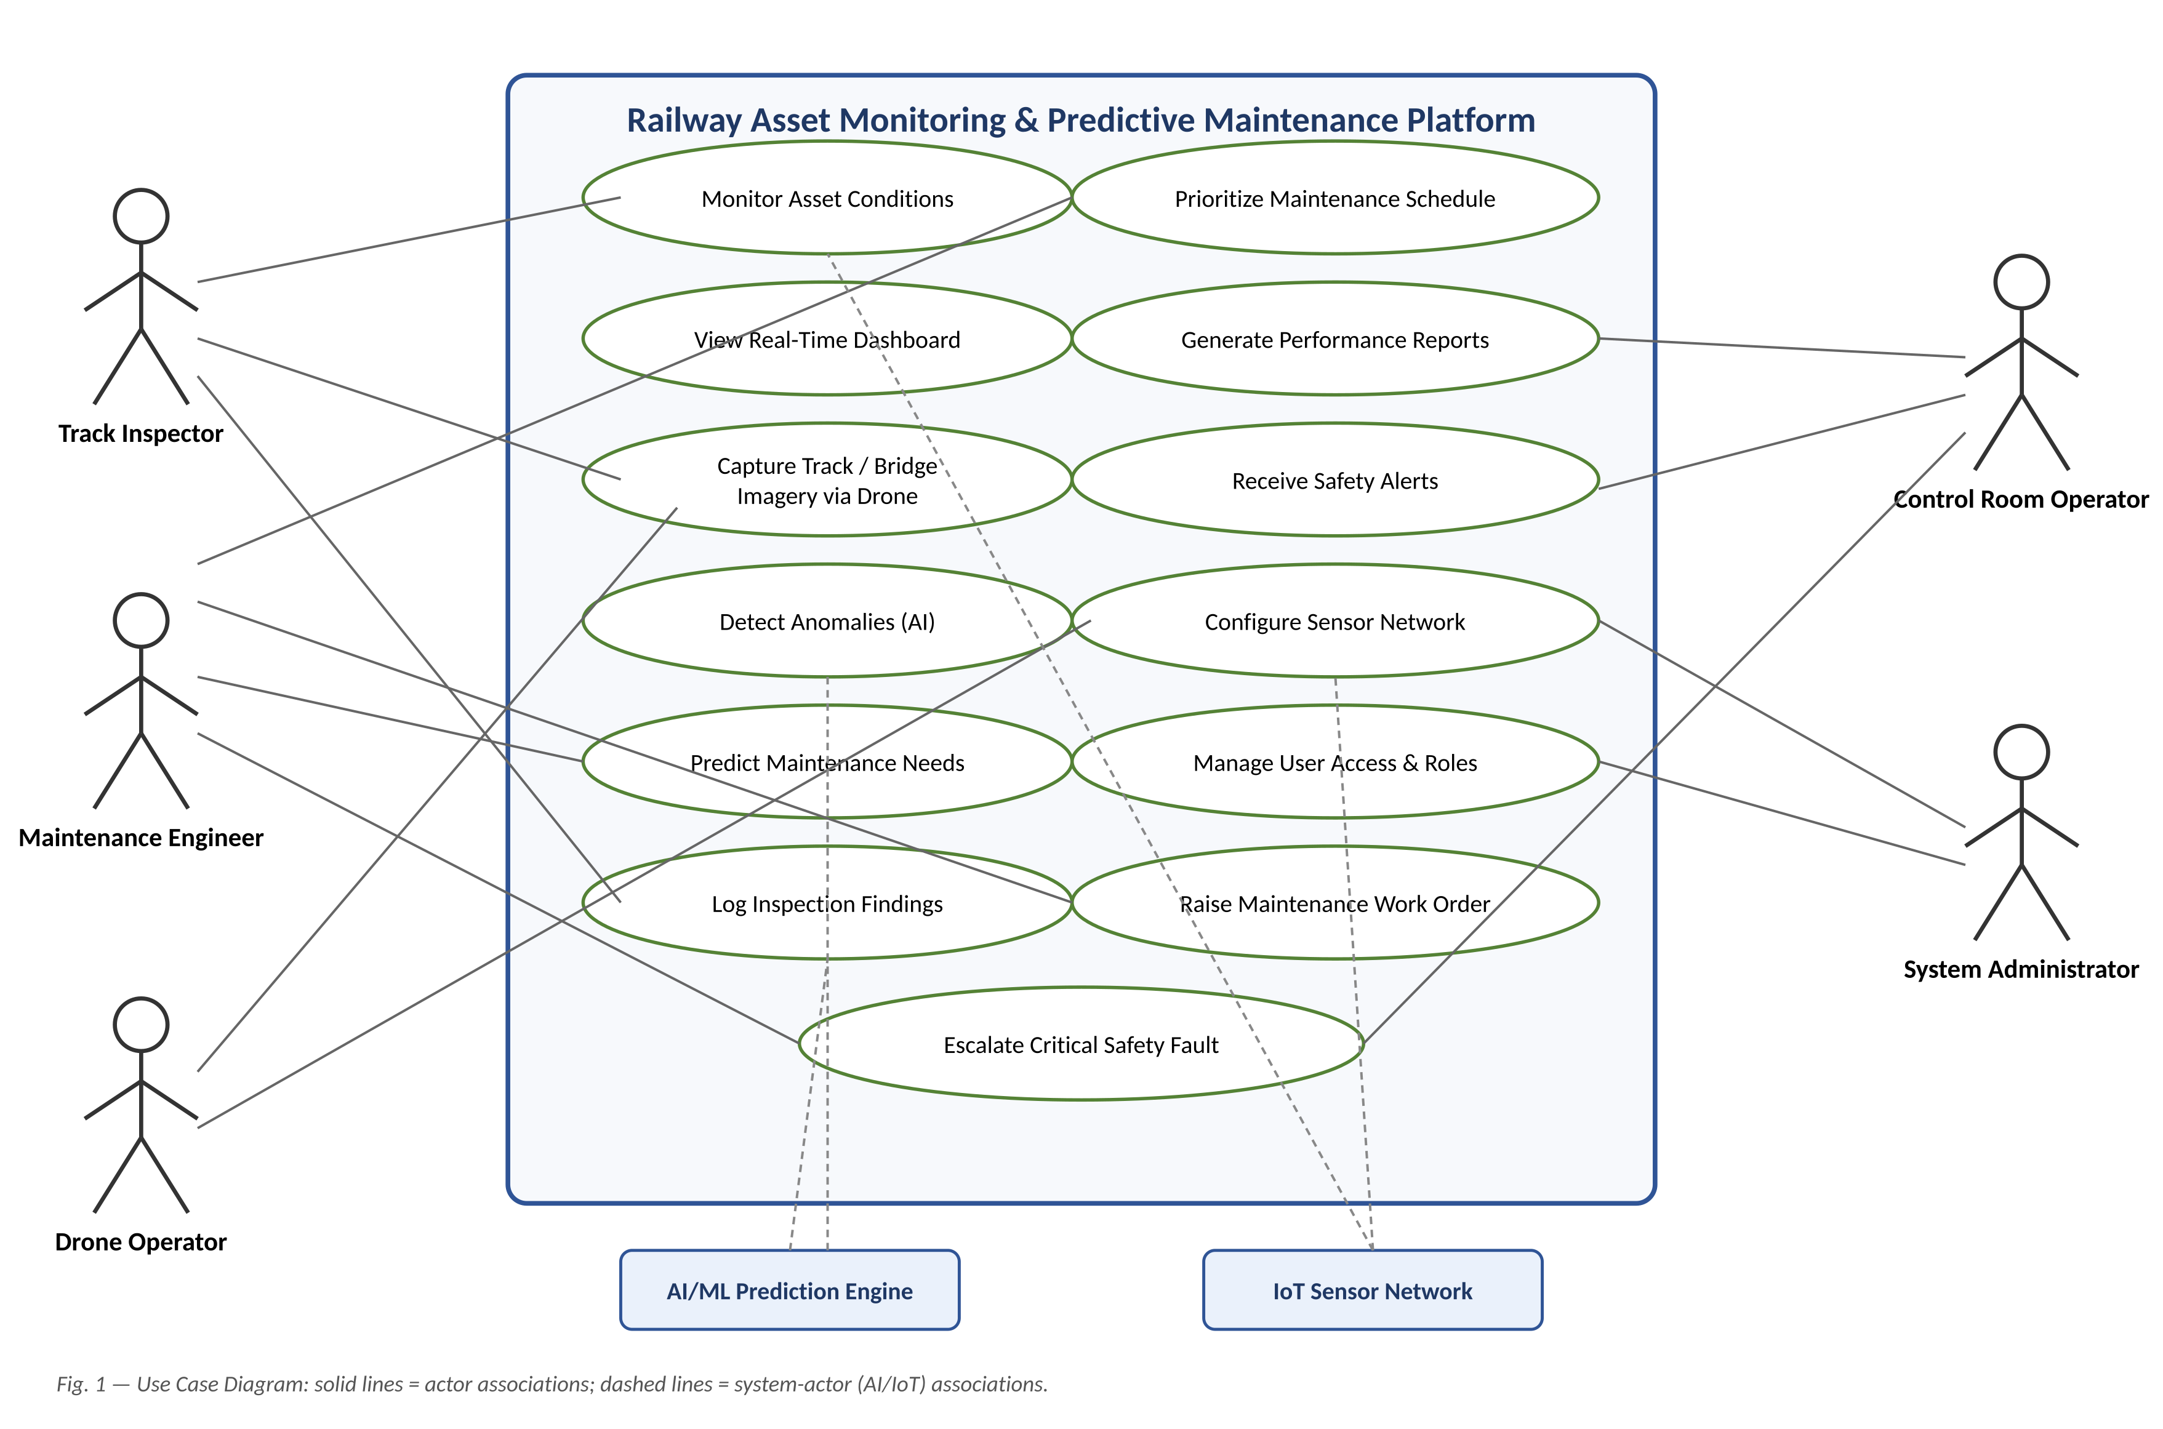
Fig. 1 — Use Case Diagram for the Railway Asset Monitoring & Predictive Maintenance Platform

7. Data Requirements
- Sensor telemetry data: vibration, strain, temperature, alignment, and electrical load readings, time-stamped and geo-tagged.
- Imagery and video data: drone and CCTV captures of track, bridge, and structural surfaces for defect analysis.
- Asset master data: identifiers, location, installation date, specification, and maintenance history for each railway asset.
- Predictive model outputs: anomaly scores, failure-probability predictions, and confidence levels.
- Maintenance records: work orders, inspection logs, repair history, and technician notes.
- Alert and incident logs: generated safety alerts, acknowledgements, and escalation timestamps.

8. External Interface Requirements

8.1 User Interfaces
- Web-based dashboard for control room monitoring, reporting, and administration.
- Mobile application for field inspectors and maintenance engineers (online/offline capable).

8.2 Hardware Interfaces
- IoT sensors (vibration, strain, temperature, displacement) with wireless/wired data interfaces.
- Drone and fixed CCTV camera systems for image/video capture.
- Edge gateways for local data pre-processing and buffering.

8.3 Software Interfaces
- Integration with SCADA / signaling systems for supplementary condition data.
- Integration with GIS mapping services for asset location visualization.
- Integration with weather data services to correlate environmental factors with asset condition.
- Integration with enterprise ERP/asset-management systems for work-order synchronization.

8.4 Communication Interfaces
- 4G/5G, LoRaWAN, and satellite backhaul for remote or low-connectivity track sections.
- Secure REST/MQTT APIs with TLS encryption for all data exchange.

9. System Features
- Real-Time Monitoring Dashboard — live visualization of asset health across the rail network.
- Predictive Maintenance Alerts — AI-generated early warnings before failure thresholds are reached.
- Computer-Vision Defect Detection — automated identification of cracks, corrosion, and structural defects from imagery.
- Maintenance Prioritization Engine — risk-based ranking of maintenance tasks across the asset base.
- Asset Performance Reporting — historical and trend reports for reliability and cost analysis.
- Mobile Inspection Tool — enables field logging of inspection findings, synced to the central platform.

10. Assumptions and Constraints

10.1 Assumptions
- IoT sensors and drones are properly calibrated and maintained by field teams.
- Reliable network connectivity (or store-and-forward capability) is available across most of the rail network.
- Sufficient historical maintenance and failure data exists to train initial predictive models.
- Railway personnel receive basic training on using the dashboard and mobile application.

10.2 Constraints
- Technical: must integrate with existing legacy signaling/SCADA infrastructure without disrupting operations.
- Operational: the platform must support 24/7 uptime given continuous railway operations.
- Economic: hardware (sensors, drones, edge gateways) and cloud compute costs must remain within the allocated project budget.
- Legal / Regulatory: must comply with railway safety regulations and data privacy/protection laws governing surveillance imagery.
- Time: phased rollout is required, prioritizing high-risk corridors before network-wide deployment.

11. Requirement Validation — Completeness and Consistency
Each requirement was checked for traceability to a stakeholder objective, and reviewed for ambiguity, redundancy, and internal consistency. The validation checklist below summarizes this review.
Validation Check | Status | Notes
All stakeholder objectives traced to at least one requirement | Addressed | Each of the 8 stated objectives maps to one or more FRs (e.g., Objective 3 → FR-04; Objective 6 → FR-09).
Ambiguity check | Mostly addressed | NFR-01 latency target is illustrative and should be finalized with stakeholders after a pilot deployment.
Redundancy check | No redundancy found | FR-05 (condition monitoring) and FR-01 (data acquisition) were reviewed to confirm they address distinct capabilities (raw ingestion vs. status display).
Consistency check | Consistent | No conflicting requirements identified between functional and non-functional requirement sets.
Missing requirement check | Gap identified | Explicit data retention/archival and model-explainability requirements were missing; added as suggested improvements below.

Suggested Improvements
- Add explicit data-retention and archival requirements for sensor and imagery data to fully satisfy legal/regulatory constraints.
- Define measurable service-level targets (e.g., exact alert latency in seconds) once field trial data is available, to remove ambiguity in NFR-01.
- Introduce a formal requirement for model explainability so maintenance engineers can understand why an asset was flagged, improving trust and adoption.
- Add a requirement for graceful degradation when connectivity is lost in remote track sections, to avoid a gap between FR and NFR coverage.

