1. System Requirement Analysis

1.1 System Objectives
The platform must continuously monitor railway assets, detect infrastructure defects using AI, predict maintenance requirements ahead of failure, monitor track and bridge conditions, prioritize maintenance schedules by risk, generate asset performance reports, and ultimately improve railway safety while reducing maintenance costs and service interruptions.

1.2 Requirements Influencing the Architecture
- High-volume, continuous data ingestion — thousands of distributed sensors and periodic drone imagery generate a constant stream of heterogeneous data, requiring an architecture built around asynchronous, event-driven ingestion rather than simple request/response.
- Computationally intensive AI/ML workloads — anomaly detection, computer vision, and predictive analytics require independently scalable processing, favoring service isolation over a single monolithic codebase.
- Safety-critical, low-latency alerting — critical faults must be surfaced to control room operators within seconds, demanding a low-latency path from detection to notification.
- Integration with legacy OT systems — SCADA and signaling systems were not designed for cloud integration, requiring a well-defined API/gateway boundary between operational technology and the new platform.
- Geographic distribution — railway assets span wide geographic areas with variable connectivity, requiring edge pre-processing and resilient communication.

1.3 Key Quality Attributes
Quality Attribute | Why It Matters Here
Scalability | Sensor and drone count will grow over time; the platform must absorb increasing data volume and processing load.
Maintainability | AI models require frequent retraining/updates; services must be independently deployable.
Reliability | Missed or false anomaly detections directly affect railway safety outcomes.
Availability | Continuous railway operations require near-continuous monitoring uptime.
Performance | Critical safety alerts must reach operators with minimal latency.
Security | Sensor, imagery, and OT-integration data must be protected against unauthorized access and tampering.

2. Selection of Suitable Software Architecture

2.1 Selected Architecture
A Hybrid Architecture combining Event-Driven Architecture (for data ingestion and streaming) with Microservices Architecture (for AI/ML processing and application logic), layered on top of an Edge Computing tier, is selected for this platform.

2.2 Justification
- Event-driven ingestion naturally matches the continuous, asynchronous nature of sensor telemetry and imagery streams, decoupling data producers (sensors, drones) from consumers (AI services) via a message broker.
- Microservices allow the anomaly detection, computer vision, predictive maintenance, and prioritization capabilities to be developed, deployed, and scaled independently — important because AI workloads have very different resource profiles (e.g., GPU-heavy vision models) from lightweight services like alerting.
- Edge pre-processing at gateways near track-side sensors reduces bandwidth usage and latency for remote sections with limited connectivity, and enables basic local anomaly filtering before data reaches the cloud.
- A clear API Gateway boundary isolates legacy OT systems (SCADA, signaling) from the new platform, reducing integration risk to existing safety-critical infrastructure.
This hybrid approach was chosen over a pure monolithic or pure layered architecture because a monolith would not allow independent scaling of GPU-intensive AI services, and over a pure microservices-only design because the raw ingestion problem (many small, frequent messages from distributed sensors) is a better fit for event streaming than for direct service-to-service REST calls.

3. Software Architecture Diagram
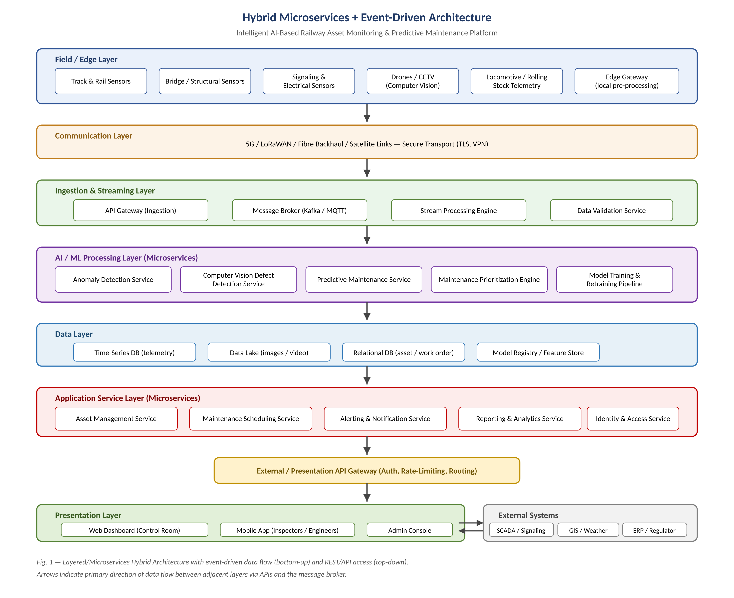
Fig. 1 — Layered / Microservices Hybrid Architecture for the Railway Asset Monitoring & Predictive Maintenance Platform

4. Components and Their Interactions
Component | Responsibility | Communicates Via
Field/Edge Sensors & Drones | Capture raw condition data and imagery from railway assets. | Wireless telemetry to Edge Gateway
Edge Gateway | Local pre-processing, filtering, and buffering before transmission. | 5G/LoRaWAN/Satellite to API Gateway
Ingestion API Gateway | Authenticates and routes incoming device data into the platform. | Publishes to Message Broker
Message Broker (Kafka/MQTT) | Durable, asynchronous event backbone decoupling producers and consumers. | Pub/Sub to Stream Processing & AI services
Stream Processing Engine | Real-time filtering, enrichment, and routing of event streams. | Feeds AI/ML Processing Layer
Anomaly Detection Service | Identifies abnormal sensor readings using ML models. | Writes results to Data Layer; publishes alerts
Computer Vision Service | Detects visible structural defects from drone/CCTV imagery. | Writes results to Data Layer
Predictive Maintenance Service | Forecasts failure likelihood and maintenance timing. | Writes predictions to Data Layer
Data Layer (TSDB / Data Lake / RDBMS) | Persists telemetry, imagery, asset, and prediction data. | Queried by Application Services via internal APIs
Application Microservices | Asset management, scheduling, alerting, reporting, identity/access. | REST APIs via External Gateway
External API Gateway | Authenticates, rate-limits, and routes external/client requests. | HTTPS to Presentation Layer & External Systems
Presentation Layer | Web dashboard, mobile app, and admin console for end users. | HTTPS/REST to External API Gateway

4.1 Overall Workflow
Sensors, cameras, and drones at the Field/Edge Layer capture raw condition data, which edge gateways lightly pre-process before transmitting it over the Communication Layer (5G/LoRaWAN/satellite) to the cloud. The Ingestion & Streaming Layer receives this data through the API Gateway and publishes it to a message broker (e.g., Kafka), where it is validated and passed to the AI/ML Processing Layer. There, microservices perform anomaly detection, computer-vision defect analysis, and predictive maintenance scoring, writing results to the Data Layer (time-series database, data lake, relational database, and model registry). The Application Service Layer consumes this processed data to manage assets, schedule maintenance, raise alerts, and generate reports. Finally, the External/Presentation API Gateway exposes this functionality securely to the Presentation Layer (web dashboard, mobile app, admin console) and to External Systems (SCADA, GIS, ERP, regulatory reporting) through well-defined APIs.

5. Discussion of Quality Attributes

5.1 Scalability
Each microservice (anomaly detection, computer vision, predictive maintenance) can be scaled horizontally and independently based on load. The Kafka-based message broker supports partitioning, allowing ingestion throughput to grow with the number of connected sensors without architectural change.

5.2 Security
All communication uses TLS encryption; the API Gateway enforces authentication (OAuth2) and role-based authorization. Network segmentation isolates the OT-facing edge/communication layers from the IT-facing application layers, reducing the attack surface on safety-critical infrastructure.

5.3 Performance
Edge pre-processing filters noise and reduces data volume before transmission, lowering end-to-end latency. Stream processing at the ingestion layer enables near-real-time anomaly detection, keeping the alert path fast enough for safety-critical notifications.

5.4 Reliability
The message broker provides durable, replayable storage of ingested events, so processing failures do not result in data loss. Circuit breakers and retry policies between microservices prevent cascading failures across the platform.

5.5 Maintainability
Loose coupling between microservices, combined with well-defined API contracts, allows AI models and application features to be updated independently through CI/CD pipelines without requiring a full-system redeployment.

5.6 Availability
Critical services are deployed with redundancy and health-check-driven failover across multiple availability zones, supporting the 99.5%+ uptime target required for continuous railway operations.

6. Justification of Architectural Decisions

6.1 Rationale
The combination of event-driven ingestion and microservices processing directly addresses the two defining characteristics of this problem: a continuous, high-volume, asynchronous data stream from distributed field assets, and computationally diverse AI workloads that must scale independently. Edge pre-processing was included specifically to address the geographic and connectivity constraints of railway networks.

6.2 Trade-offs Considered
- Complexity vs. simplicity — a microservices approach introduces operational complexity (service discovery, distributed tracing, inter-service communication) compared to a monolith, but this is justified by the independent scaling needs of AI workloads.
- Eventual consistency vs. strong consistency — the event-driven pipeline favors eventual consistency between ingestion and processing, which is acceptable for monitoring/analytics but was explicitly excluded from safety-control functions (signaling remains outside platform scope).
- Cost vs. responsiveness — edge pre-processing adds hardware/deployment cost at trackside locations but significantly reduces bandwidth cost and alert latency for remote corridors.

6.3 Support for Future Enhancements
- New sensor types or additional railway asset categories can be onboarded by adding new producers to the existing message broker without redesigning downstream services.
- Additional AI/ML models (e.g., for weather-correlated risk prediction) can be deployed as new microservices consuming the same event streams.
- The API Gateway boundary allows future integration with national railway information systems or third-party analytics platforms with minimal impact on internal services.
- The modular design supports long-term maintainability, as individual services can be re-architected or replaced (e.g., migrating a model to a new ML framework) without affecting the rest of the platform.

