Login Page:

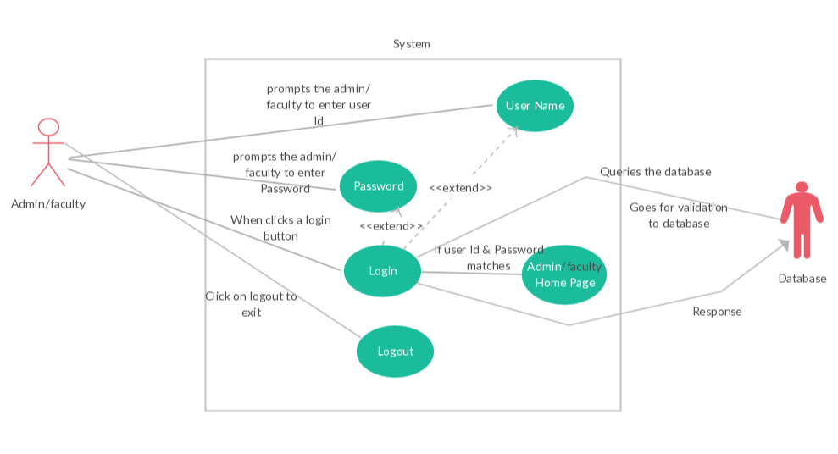

Description:

Login details should need to be provide to access the page. The login page is same for both Admin and Faculty with respect to their credentials the page will direct them to their respective home page.

1. Click on the user Id text field and enter the user Id.
2. Click on the password text field and enter the password.
3. Click on the login button.
4. The user Id & password will authenticated from the database and provides the user to login.

Admin Home Page:

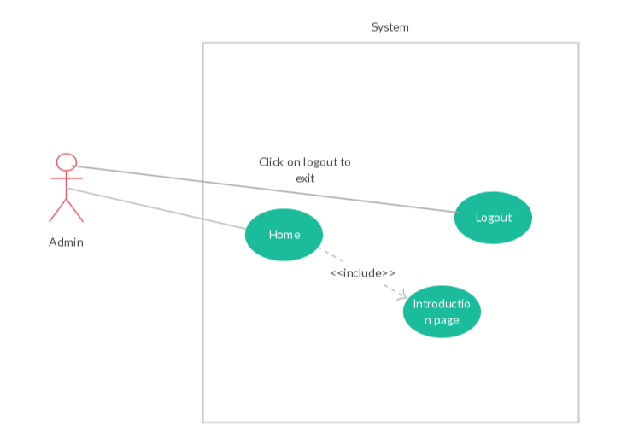

Description:

Admin provides the credentials and logs into the home page where he can find a button logout for exiting cite. The home page contains the general information of the university.

Admin Scheduler Page:

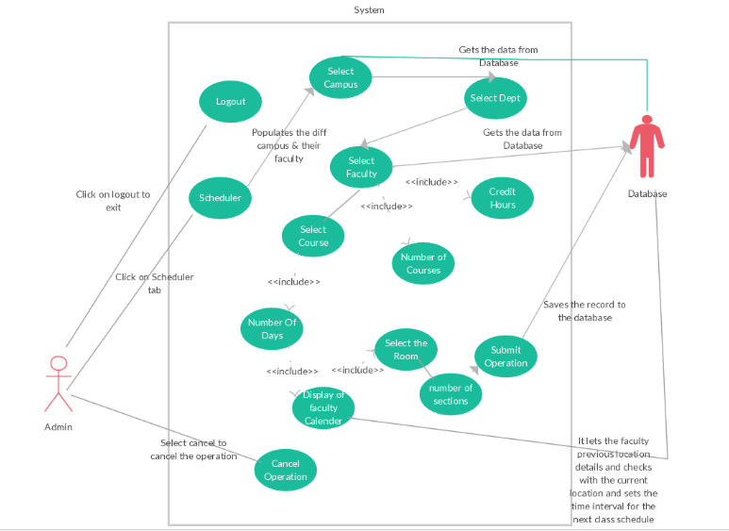

Description:

By clicking on the scheduler button in the home page it directs to this page and where the faculty schedule will be made. There are few steps in this process they are.

1. Select the campus where the faculty need to teach.
2. Select the department of the subject.
3. Select the faculty from the list which is provided under the department.
4. Enter the number of credit hours the faculty is teaching.
5. Enter the number of subjects that particular faculty is teaching.
6. Now select the course of the faculty.
7. Enter the number of days the faculty want teach with a weak.
8. Now with the available details display the free time of the faculty and select the time.
9. After the selection now we will for the available room for that subject and book the room.
10. Finally if all the credentials are correct click on submit else you can cancel the operation by clicking on the cancel button.

Admin Calendar Page:

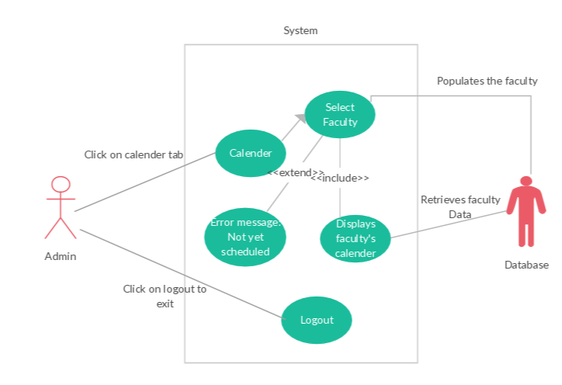

Description:

By clicking on the Calendar button it directs you to this page. It will displays the calendar of each faculty. Select the faculty from the list to whom you want check the calendar. If he doesn’t have any schedules then it popups an error message “Not yet scheduled” and if he is scheduled then it displays the calendar of that faculty.

1. Click on the calendar button
2. Select the faculty from the drop down list.
3. If the faculty has schedule then it displays the calendar else it through an error message ”Not yet scheduled”

Admin Course Page:

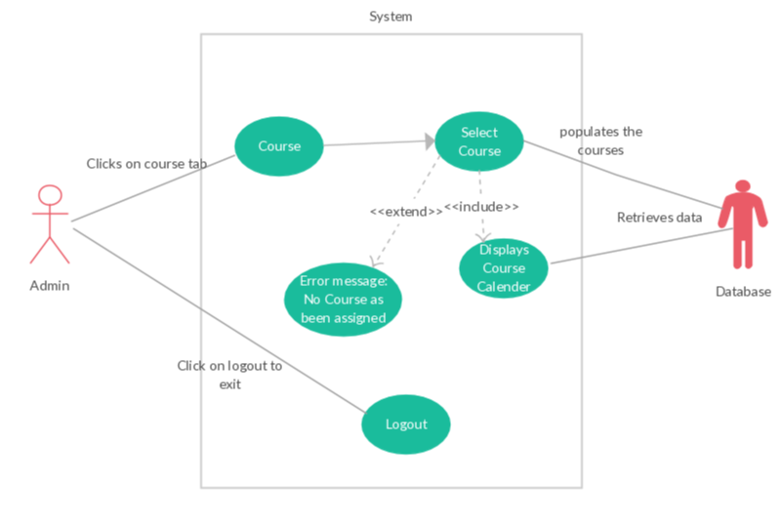

Description:

Course button will be displayed on the home page by clicking on the button it will direct you to this page. This page displays the calendar of the individual course and how many faculty are teaching this course and what are the timing for that course.

By selecting the course from the list displayed it will display the calendar of the course. If there is no course scheduled then an error message “No course has been assigned” will display.

1. Click on the Course button.
2. Select the course
3. If the course has schedule then it displays the calendar else it through an error message ”Not yet scheduled”.

Faculty Home Page:

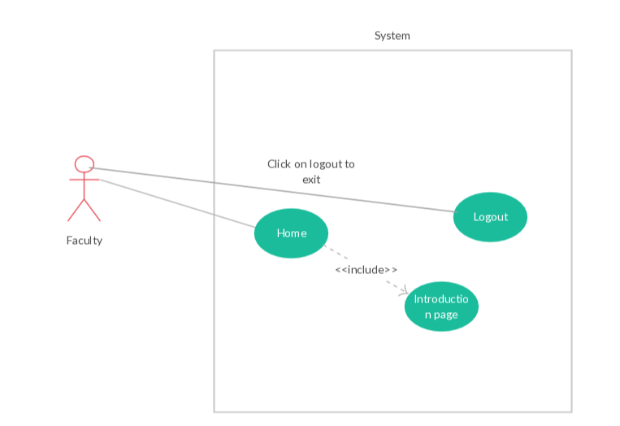

Description:

Faculty provides the credentials and logs into the home page where he can find a button logout for exiting cite. The home page contains the general information of the university.

Faculty Calendar Page:

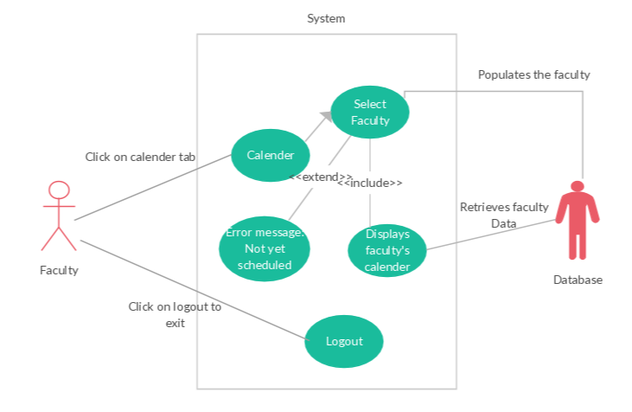

Description:

By clicking on the Calendar button it directs you to this page. It will displays their calendar with course details. If he doesn’t have any schedules then it popups an error message “Not yet scheduled” and if he is scheduled then it displays the calendar of that faculty.

1. Click on the calendar button
2. If the faculty has schedule then it displays the calendar else it through an error message ”Not yet scheduled”

Faculty Course Page:

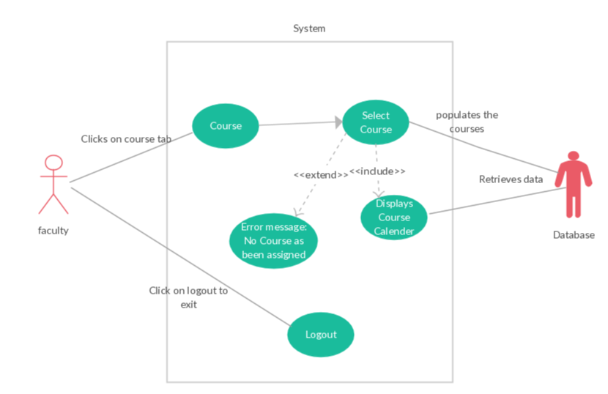

Description:

Course button will be displayed on the home page by clicking on the button it will direct you to this page. This page displays the calendar of the individual course and how many faculty are teaching this course and what are the timing for that course.

By selecting the course from the list displayed it will display the calendar of the course. If there is no course scheduled then an error message “No course has been assigned” will display.

1. Click on the Course button.
2. Select the course
3. If the course has schedule then it displays the calendar else it through an error message ”Not yet scheduled”.

Adding a Faculty:

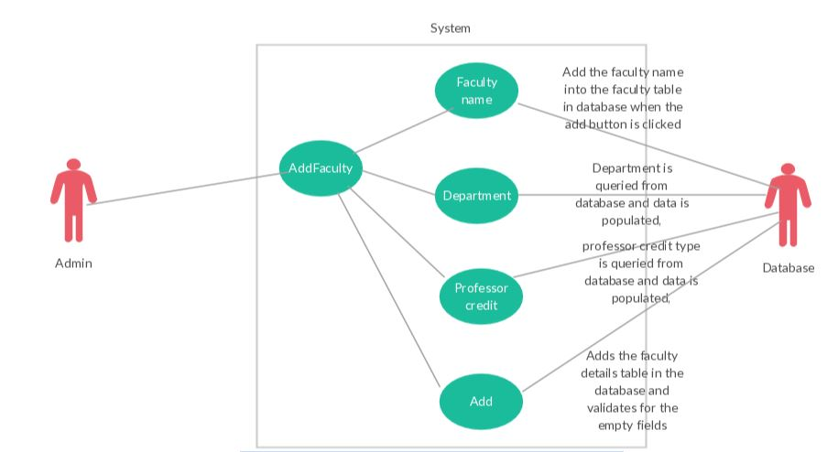

Description:

Whenever a new faculty joins the school, the admin will add the faculty details to the database.

1. Admin will add the new faculty by clicking on the Add Faculty button.
2. Faculty name, department and professor teaching credits will entered and click on add button.
3. And then the faculty will be added to database.

Deleting a Faculty:

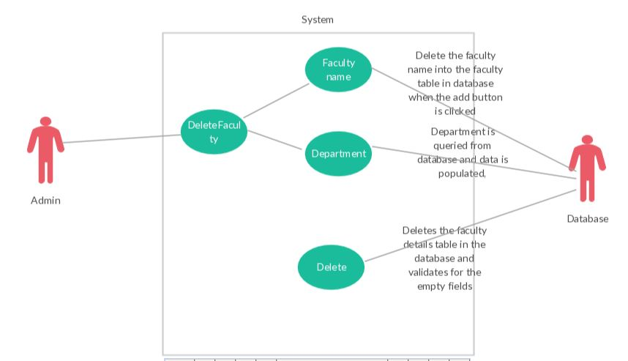

Description:

Whenever a faculty leaves the school, the admin will delete the faculty details from the database.

1. Admin will delete the existing faculty by clicking on the delete Faculty button.
2. Faculty name and department will entered and click on delete button.
3. And then the faculty will be deleted.

Location validation:

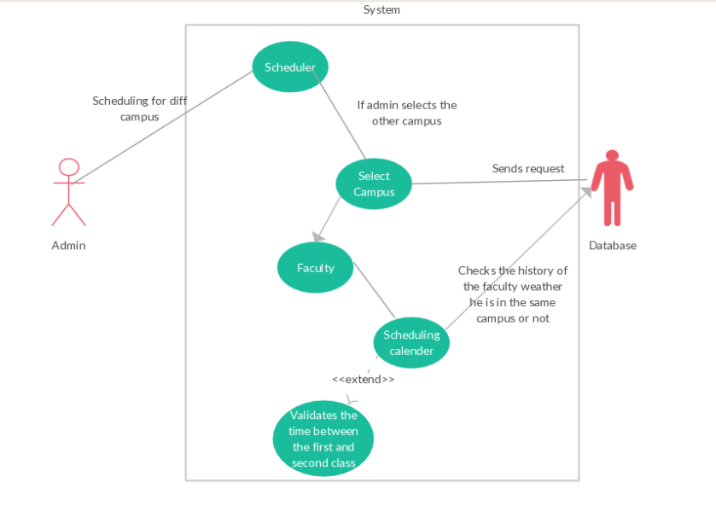

Description:

While admin scheduling the time table for the faculty, he selects the campus and then the faculty and after that the scheduling calendar of the faculty will be displayed.

While selecting the campus the database will check the previous teaching location of the faculty and if it is not at the same location then the travelling time for the next class will be deactivated so that the faculty will have some time to travel the distance between the two campuses.