Lab 3

Nikhil Malhotra – 20368862

Miguel de Arcos – 20400557

# Introduction

The purpose of this lab is to apply classification techniques on images. MICD discriminants are made using a set of image sample blocks of 10 textures and 3 sizes (2x2, 8x8 and 32x32 pixels) and then applied to another three test data sets of feature sets in order to measure and compare error rates. The same MICD discriminant, specifically the 8x8, is applied to a final image containing multiple textures in order to better understand the effectiveness of certain sample sizes. Finally all data is treated as unlabeled and then classified using the k-mean and fuzzy k-mean algorithm.

# Feature Analysis

## Initial Glance:

1. Looking at the texture images themselves on the SYDE372 homepage it is noted that some textures can be confused for other textures and vice versa. The textures are listed below:
   1. Raiffa can be mistaken for wood as the vertical stripes are as predominant in Raiffa as in the Wood texture
   2. Pigskin, Paper and Cork can be mistaken for each other as they all have a similar Stucco like pattern
   3. Grass and stone can be mistaken for each other as they have a similar pattern although grass has sharper distinctions between dark and light shades
   4. Cloth and Cotton and be mistaken for each other as they both have similar uniform features
2. The face texture is the most distinct as long as the whole face is viewed as there are many distinct features that must exist, such as the eyes and mouth, features that are highly unlikely to be found in the other textures in a similar pattern.

## 2x2 Block:

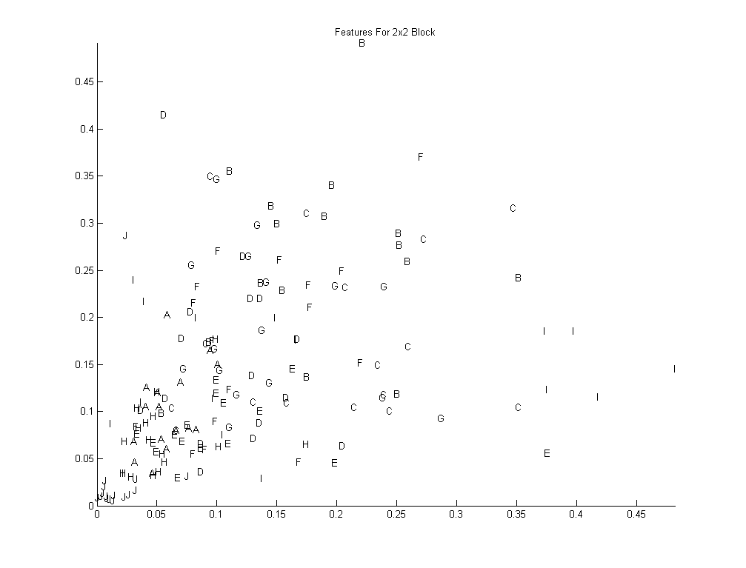

Figure : 2x2 Block Feature Plot

1. Looking at the feature data plotted above, it is noted that some textures can be confused for other textures and vice versa. The textures are listed below:
   1. Cloth (A), D,E, H
   2. B, C, F, G, I
   3. C, D
   4. D, F, G
   5. E, I
2. The face texture is the most distinct despite using a 2x2 feature block.

## 8x8 Block:

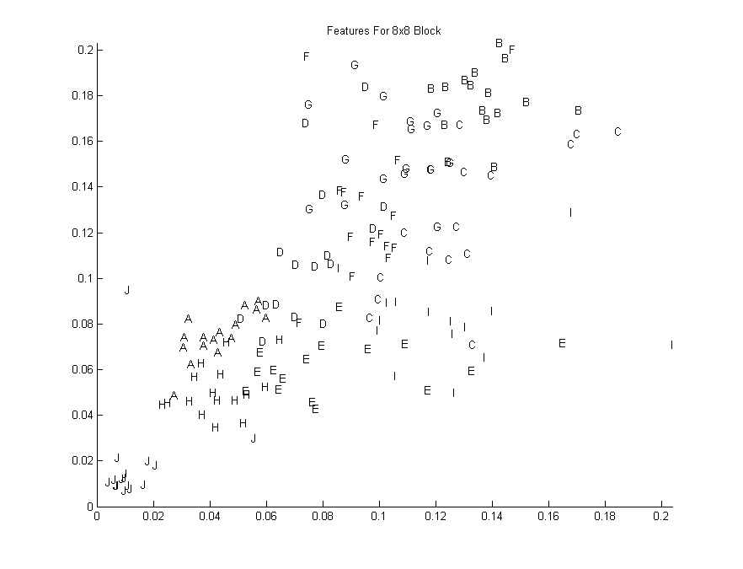

Figure : 8x8 Block Feature Plot

1. Looking at the feature data plotted above, it is noted that some textures can be confused for other textures and vice versa. The textures are listed below:
   1. Cloth (A),E, H
   2. B, C, F, G
   3. C, I
   4. D,E, F, G
   5. E, I
   6. F,I
2. The face texture is the most distinct using a 8x8 feature block.

## 32x32 Block:

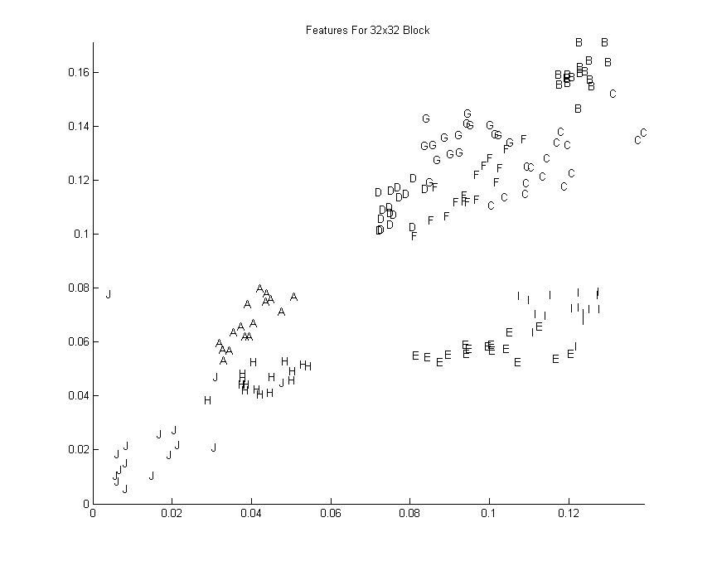

Figure : 32x32 Block Feature Plot

1. Looking at the feature data plotted above, it is noted that some textures can be confused for other textures and vice versa. The textures are listed below:
   1. C,F
   2. D,F,G
   3. E,I
2. The face texture is the most distinct using an 8x8 feature block.

# Labelled Classification

## 2x2 Block

|  |  |  |  |  |  |  |  |  |  |  |  |
| --- | --- | --- | --- | --- | --- | --- | --- | --- | --- | --- | --- |
| Truth | Classified | | | | | | | | | | Error |
|  | A | B | C | D | E | F | G | H | I | J |
| A | 3 | 0 | 0 | 1 | 4 | 1 | 0 | 5 | 2 | 0 | 81.25% |
| B | 0 | 6 | 1 | 2 | 0 | 3 | 3 | 0 | 1 | 0 | 62.50% |
| C | 0 | 1 | 1 | 2 | 2 | 2 | 7 | 0 | 1 | 0 | 93.75% |
| D | 2 | 2 | 3 | 2 | 1 | 4 | 0 | 2 | 0 | 0 | 87.50% |
| E | 2 | 2 | 0 | 1 | 4 | 1 | 1 | 1 | 4 | 0 | 75.00% |
| F | 1 | 1 | 1 | 2 | 1 | 5 | 3 | 1 | 1 | 0 | 68.75% |
| G | 0 | 3 | 1 | 2 | 1 | 3 | 4 | 0 | 2 | 0 | 75.00% |
| H | 2 | 0 | 0 | 3 | 5 | 1 | 0 | 5 | 0 | 0 | 68.75% |
| I | 0 | 1 | 3 | 2 | 2 | 3 | 4 | 0 | 1 | 0 | 93.75% |
| J | 1 | 0 | 1 | 0 | 0 | 0 | 0 | 2 | 0 | 12 | 25.00% |
| Average Error | | | | | | | | | | | 73.12% |

## 8x8 Block

|  |  |  |  |  |  |  |  |  |  |  |  |
| --- | --- | --- | --- | --- | --- | --- | --- | --- | --- | --- | --- |
| Truth | Classified | | | | | | | | | | Error |
|  | A | B | C | D | E | F | G | H | I | J |
| A | 15 | 0 | 0 | 1 | 0 | 0 | 0 | 0 | 0 | 0 | 6.25% |
| B | 0 | 13 | 3 | 0 | 0 | 0 | 0 | 0 | 0 | 0 | 18.75% |
| C | 0 | 2 | 4 | 0 | 1 | 5 | 0 | 0 | 4 | 0 | 75.00% |
| D | 1 | 0 | 1 | 9 | 0 | 1 | 3 | 0 | 1 | 0 | 43.75% |
| E | 2 | 0 | 0 | 0 | 8 | 0 | 0 | 3 | 3 | 0 | 50.00% |
| F | 0 | 0 | 4 | 5 | 0 | 3 | 4 | 0 | 0 | 0 | 81.25% |
| G | 0 | 2 | 4 | 0 | 0 | 3 | 7 | 0 | 0 | 0 | 56.25% |
| H | 3 | 0 | 0 | 0 | 0 | 0 | 0 | 13 | 0 | 0 | 18.75% |
| I | 0 | 0 | 1 | 1 | 7 | 2 | 0 | 0 | 5 | 0 | 68.75% |
| J | 2 | 0 | 0 | 0 | 0 | 0 | 0 | 2 | 0 | 12 | 25.00% |
| Average Error | | | | | | | | | | | 44.37% |

## 

## 32x32 Block

|  |  |  |  |  |  |  |  |  |  |  |  |
| --- | --- | --- | --- | --- | --- | --- | --- | --- | --- | --- | --- |
| Truth | Classified | | | | | | | | | | Error |
|  | A | B | C | D | E | F | G | H | I | J |
| A | 16 | 0 | 0 | 0 | 0 | 0 | 0 | 0 | 0 | 0 | 0.00% |
| B | 0 | 16 | 0 | 0 | 0 | 0 | 0 | 0 | 0 | 0 | 0.00% |
| C | 0 | 0 | 8 | 0 | 0 | 8 | 0 | 0 | 0 | 0 | 50.00% |
| D | 0 | 0 | 0 | 16 | 0 | 0 | 0 | 0 | 0 | 0 | 0.00% |
| E | 0 | 0 | 0 | 0 | 16 | 0 | 0 | 0 | 0 | 0 | 0.00% |
| F | 0 | 0 | 1 | 0 | 0 | 14 | 1 | 0 | 0 | 0 | 12.50% |
| G | 0 | 0 | 0 | 0 | 0 | 3 | 13 | 0 | 0 | 0 | 18.75% |
| H | 1 | 0 | 0 | 0 | 0 | 0 | 0 | 14 | 0 | 1 | 12.50% |
| I | 0 | 0 | 0 | 0 | 1 | 0 | 0 | 0 | 15 | 0 | 6.25% |
| J | 1 | 0 | 0 | 0 | 0 | 0 | 0 | 4 | 0 | 11 | 31.25% |
| Average Error | | | | | | | | | | | 13.13% |

Based on the numbers above it is clear as more information is added for each feature through an increase in sample image block size the easier it is for the MICD classifier to distinguish between each class when the training data is applied. As a result, there is a dramatic reduction in the average error rate, reducing by 60.68% when the change is from a 2x2 block to an 8x8 block and a reduction of 29.58% from an 8x8 block to a 32x32 block. It is noted that the remaining misclassifications for the 32x32 block only occurred among feature clusters that were very close to each other (figure 3). In this case between C, F, G, and between E & I, and between A, H, J. In order to reduce the error rate to 0% one would have to increase the sample block size until all clusters were well distinguishable from each other at least in the application for MICD.

# Image Classification and Segmentation

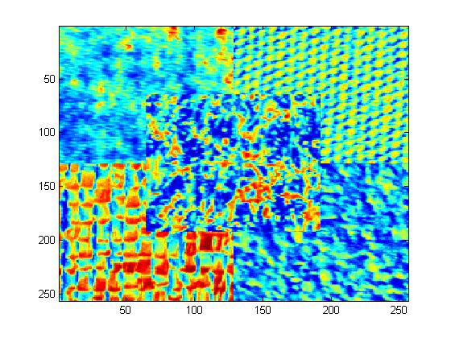

Figure : Original Image

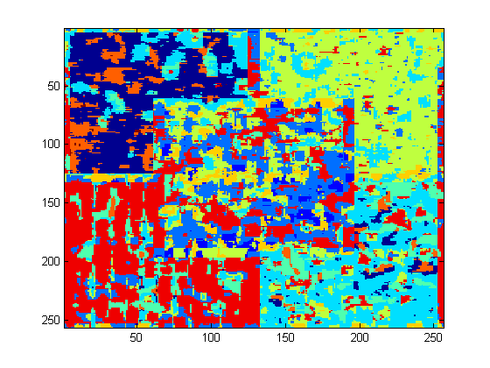

Figure : 8x8 MICD Classified Image

Comparing the original image with the classified version it is clear that using the 8x8 trained MCID discriminant resulted in unique and adequate representations of the 4 textures on the four corners, but the middle texture is far too noisy to be considered adequate. Texture edges however are easily distinguishable so one could technically isolate each area of the image for further classification if required. The misclassification of a few pixels is very consistent across each texture suggesting that the sample 8x8 block used to generate the MCID classifier limits the accuracy of classifying the segmented image.

# Unlabeled Clustering

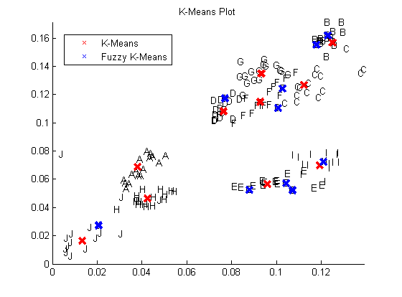

Figure : K-Means Plot

After running the K-means algorithms a few times it is noted that both crisp and fuzzy algorithms tend to hug whatever is deemed a cluster. Due to the limitations on how many final clusters can be represented there are times when an actual cluster is ignored entirely and instead a more distributed cluster is treated and multiple clusters. This hints that the K-means classification is ideal for compact and separated clusters. A similar problem is evident in the use of fuzzy K-means but the issue is far worse as sometimes the algorithm ignores multiple separate clusters in favour of larger and more mixed clusters. This would be considered ideal for rapid object tracking or to get a good idea on where further analysis maybe required by another classifier.

Utilizing K-means on the data in multf8 would highly depend on the initial K estimate and it would end up favoring the four corners over the middle. This is due to the fact that the four corners are fairly large clusters while the middle is too small and like in figure 6 smaller clusters can be ignored if larger more distributed feature clusters exist. Unlabeled clustering can be used but it would not be considered ideal for this situation when some prior knowledge of what is being classified would assist immensely.

# Conclusion

In conclusion when classifying image features it is ideal to use the K-means approach to rapidly find large feature clusters, then utilize a discriminant trained on an adequately sized sample block (a 32x32 is better than an 8x8) to further analyze and pick out any feature clusters that are grouped together.