**Project Name: Rising Sports Club (Sports Complex Management System)**

**Project Member:**

**Raghav Patil 210943120065**

**Nikhil Mane 210943120060**

**Shubham Singh 210943120100**

**Shubham Torkad 210943120111**

**Abstract:**

A sport club management system provides and manages various club activities such as member registration, registration for various sports, getting sports details and finally getting score card and more. The sports club management system software is a system that manages the entire club activities and provides respective functionality for various types of visitors. It allows normal users to avail for club membership, to subscribe for desired game and achieve the membership through registration. The system is with built in security with two factor authentication.

This is a crucial factor in having an online sports club website, that keeps itself fresh and live and updated at all times.

This is sport club management system...to be well organized sports activities it needs to be user friendly as well as well managed.

**Implementation Technologies:**

1. **Spring Boot Framework:**

Spring Boot is an open source, microservice-based Java web framework. The Spring Boot framework creates a fully production-ready environment that is completely configurable using its prebuilt code within its codebase. The microservice architecture provides developers with a fully enclosed application, including embedded application servers.

Spring Boot is just extension of the already existing and expansive Spring frameworks, but it has some specific features that make the application easier for working within the developer ecosystem. That extension includes pre-configurable web starter kits that help facilitate the responsibilities of an application server that are required for other Spring projects.

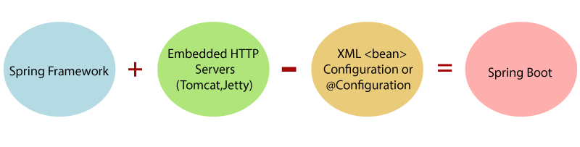

**1.1 Features of Spring Boot Framework:**

**Web Development**

It is a well-suited Spring module for web application development. We can easily create a self-contained HTTP application that uses embedded servers like **Tomcat, Jetty,** or Undertow. We can use the **spring-boot-starter-web** module to start and run the application quickly.

**SpringApplication**

The SpringApplication is a class that provides a convenient way to bootstrap a Spring application. It can be started from the main method. We can call the application just by calling a static run() method.

1. **public** **static** **void** main(String[] args)
2. {
3. SpringApplication.run(ClassName.**class**, args);
4. }

**Application Events and Listeners**

Spring Boot uses events to handle the variety of tasks. It allows us to create factories file that is used to add listeners. We can refer it to using the **ApplicationListener key**.

Always create factories file in META-INF folder like **META-INF/spring.factories**.

**Admin Support**

Spring Boot provides the facility to enable admin-related features for the application. It is used to access and manage applications remotely. We can enable it in the Spring Boot application by using **spring.application.admin.enabled** property.

**Externalized Configuration**

Spring Boot allows us to externalize our configuration so that we can work with the same application in different environments. The application uses YAML files to externalize configuration.

**Properties Files**

Spring Boot provides a rich set of **Application Properties**. So, we can use that in the properties file of our project. The properties file is used to set properties like **server-port =8082** and many others. It helps to organize application properties.

**YAML Support**

It provides a convenient way of specifying the hierarchical configuration. It is a superset of JSON. The SpringApplication class automatically supports YAML. It is an alternative of properties file.

**Type-safe Configuration**

The strong type-safe configuration is provided to govern and validate the configuration of the application. Application configuration is always a crucial task which should be type-safe. We can also use annotation provided by this library.

**Logging**

Spring Boot uses Common logging for all internal logging. Logging dependencies are managed by default. We should not change logging dependencies if no customization is needed.

**Security**

Spring Boot applications are spring bases web applications. So, it is secure by default with basic authentication on all HTTP endpoints. A rich set of Endpoints is available to develop a secure Spring Boot application.

**1.2 Advantages of Spring Boot Framework:**

* It creates **stand-alone** Spring applications that can be started using Java **-jar**.
* It tests web applications easily with the help of different **Embedded** HTTP servers such as **Tomcat, Jetty,** etc. We don't need to deploy WAR files.
* It provides opinionated '**starter**' POMs to simplify our Maven configuration.
* It provides **production-ready** features such as **metrics, health checks,** and **externalized configuration**.
* There is no requirement for **XML** configuration.
* It offers a **CLI** tool for developing and testing the Spring Boot application.
* It offers the number of **plug-ins**.
* It also minimizes writing multiple **boilerplate codes** (the code that has to be included in many places with little or no alteration), XML configuration, and annotations.
* It **increases productivity** and reduces development time.

1. **Hibernate**

Hibernate is a Java framework that simplifies the development of Java application to interact with the database. It is an open source, lightweight, ORM (Object Relational Mapping) tool. Hibernate implements the specifications of JPA (Java Persistence API) for data persistence.

## **ORM Tool**

An ORM tool simplifies the data creation, data manipulation and data access. It is a programming technique that maps the object to the data stored in the database.

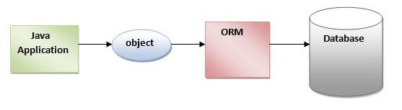

## **What is JPA?**

Java Persistence API (JPA) is a Java specification that provides certain functionality and standard to ORM tools. The **javax.persistence** package contains the JPA classes and interfaces.

## **Advantages of Hibernate Framework**

Following are the advantages of hibernate framework:

### **1) Open Source and Lightweight**

Hibernate framework is open source under the LGPL license and lightweight.

### **2) Fast Performance**

The performance of hibernate framework is fast because cache is internally used in hibernate framework. There are two types of cache in hibernate framework first level cache and second level cache. First level cache is enabled by default.

### **3) Database Independent Query**

HQL (Hibernate Query Language) is the object-oriented version of SQL. It generates the database independent queries. So you don't need to write database specific queries. Before Hibernate, if database is changed for the project, we need to change the SQL query as well that leads to the maintenance problem.

### **4) Automatic Table Creation**

Hibernate framework provides the facility to create the tables of the database automatically. So, there is no need to create tables in the database manually.

### **5) Simplifies Complex Join**

Fetching data from multiple tables is easy in hibernate framework.

### **6) Provides Query Statistics and Database Status**

Hibernate supports Query cache and provide statistics about query and database status.

1. **MySQL**

MySQL, the most popular Open-Source SQL database management system, is developed, distributed, and supported by Oracle Corporation.

Features of MySQL:

* **MySQL is a database management system.**

A database is a structured collection of data. It may be anything from a simple shopping list to a picture gallery or the vast amounts of information in a corporate network. To add, access, and process data stored in a computer database, you need a database management system such as MySQL Server. Since computers are very good at handling large amounts of data, database management systems play a central role in computing, as standalone utilities, or as parts of other applications.

* **MySQL databases are relational.**

A relational database stores data in separate tables rather than putting all the data in one big storeroom. The database structures are organized into physical files optimized for speed. The logical model, with objects such as databases, tables, views, rows, and columns, offers a flexible programming environment.

* **MySQL software is Open Source.**

Open-Source means that it is possible for anyone to use and modify the software. Anybody can download the MySQL software from the Internet and use it without paying anything.

* **The MySQL Database Server is very fast, reliable, scalable, and easy to use.**

MySQL Server was originally developed to handle large databases much faster than existing solutions and has been successfully used in highly demanding production environments for several years. Although under constant development, MySQL Server today offers a rich and useful set of functions. Its connectivity, speed, and security make MySQL Server highly suited for accessing databases on the Internet.

* **MySQL Server works in client/server or embedded systems.**

The MySQL Database Software is a client/server system that consists of a multithreaded SQL server that supports different back ends, several different client programs and libraries, administrative tools, and a wide range of application programming interfaces (APIs).

1. **Thymeleaf**

The**Thymeleaf** is an open-source Java library that is licensed under the **Apache License 2.0**. It is a **HTML5/XHTML/XML** template engine. It is a **server-side Java template**engine for both web (servlet-based) and non-web (offline) environments. It is perfect for modern-day HTML5 JVM web development. It provides full integration with Spring Framework.

It applies a set of transformations to template files in order to display data or text produced by the application. It is appropriate for serving XHTML/HTML5 in web applications.

The goal of Thymeleaf is to provide a **stylish** and **well-formed**way of creating templates. It is based on XML tags and attributes. These XML tags define the execution of predefined logic on the DOM (Document Object Model) instead of explicitly writing that logic as code inside the template. It is a substitute for **JSP**.

The architecture of Thymeleaf allows the **fast** **processing** of templates that depends on the caching of parsed files. It uses the least possible number of I/O operations during execution.

## **Thymeleaf Features**

* It works on both web and non-web environments.
* Java template engine for HTML5/ XML/ XHTML.
* Its high-performance parsed template cache reduces I/O to the minimum.
* It can be used as a template engine framework if required.
* It supports several template modes: XML, XHTML, and HTML5.
* It allows developers to extend and create custom dialect.
* It is based on modular features sets called dialects.
* It supports internationalization.

1. **Hardware and Software Requirements (Minimum):**

**Hardware:**

1. Intel i3 processor 3rd generation or later / AMD Ryzen 200 2nd generation or later

2. 2 GB ddr3 ram.

3. Windows 7 Home edition or later.

4. 200 GB Sata HDD Space

5. Data Connection 200 kbps

**Software:**

1. Eclipse 4.7 Oxygen or later
2. MySQL 5.7 with Workbench 8.0
3. Google Chrome version 94.0
4. Apache Tomcat Server 9.0
5. Maven Dependencies
6. **ER Diagram:**

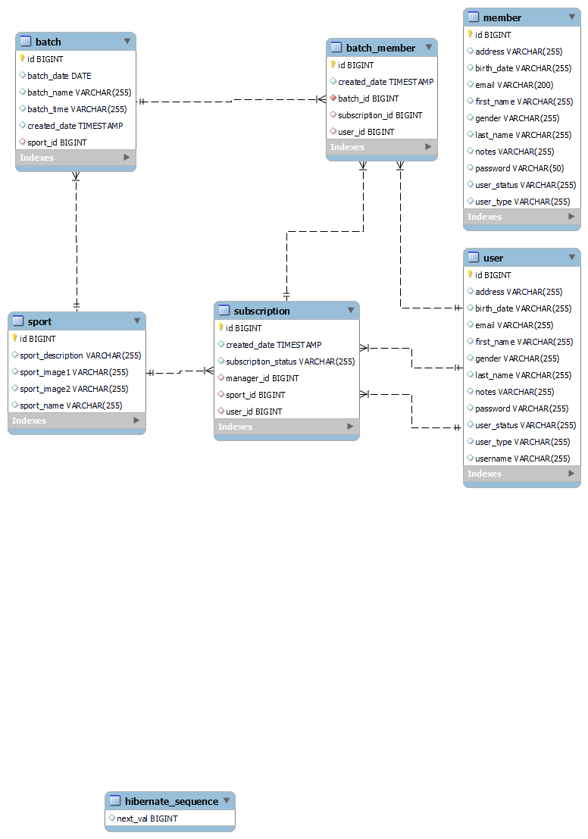

Figure 1: ER Diagram

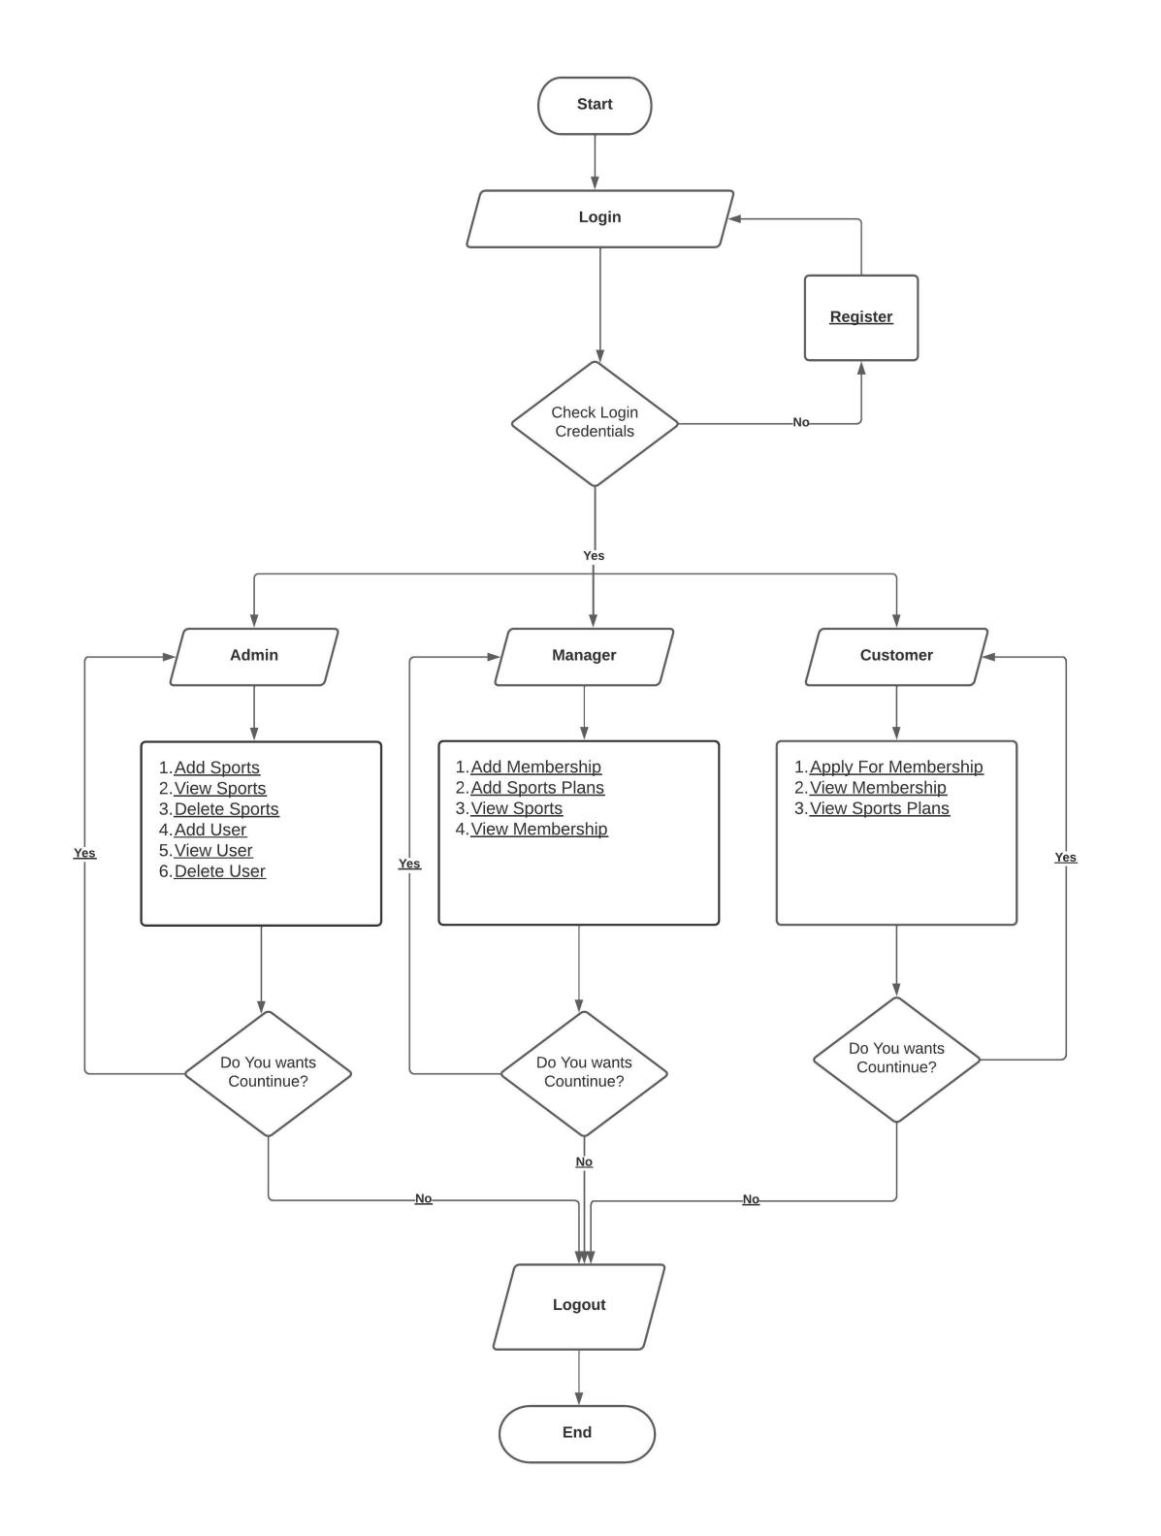

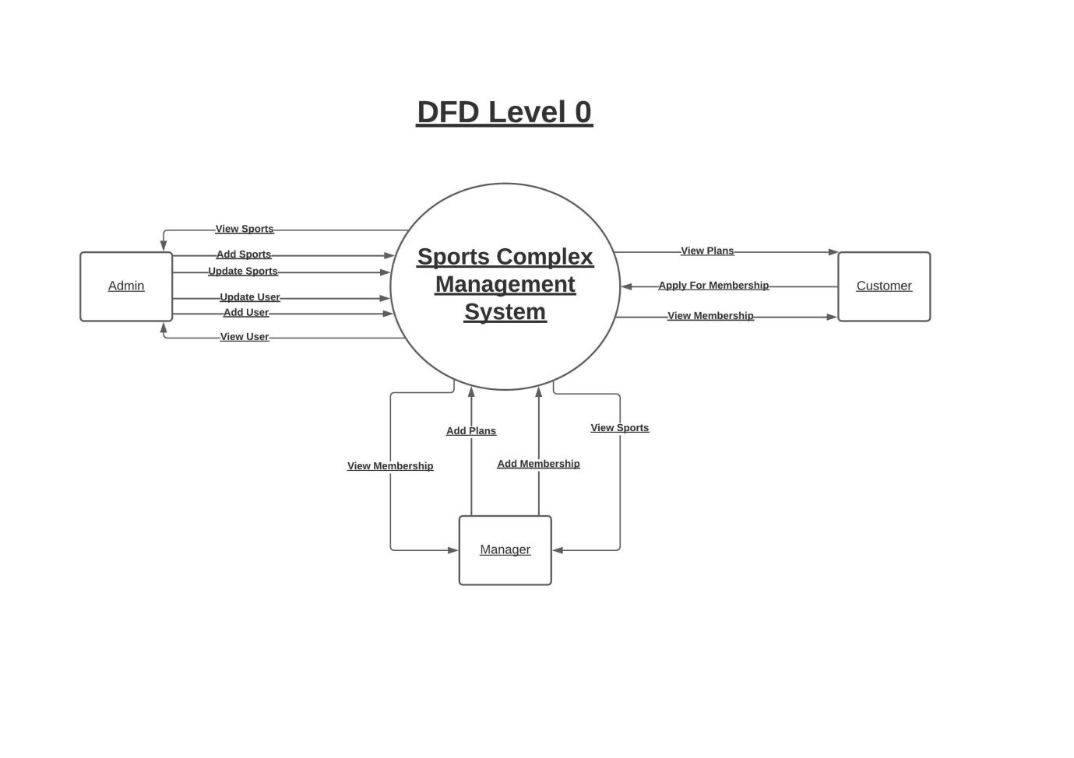

1. **Table Structures:**

**Table Batch:**

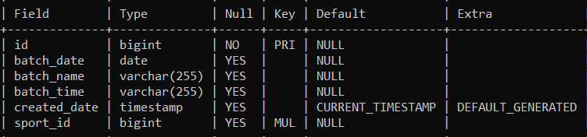

**Table Batch_Member:**

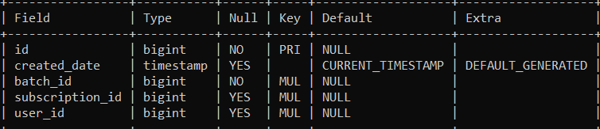

**Table Subscription:**

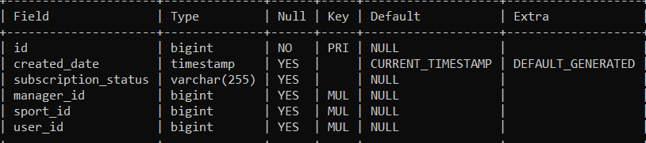

**Table Sport:**

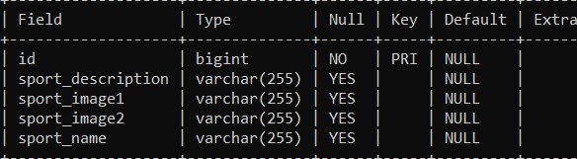

**Table Member:**

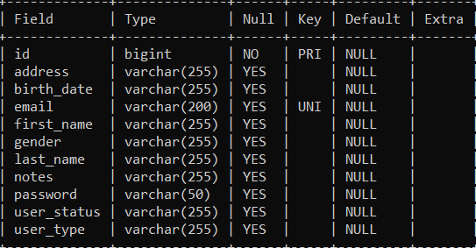

**Table User:**

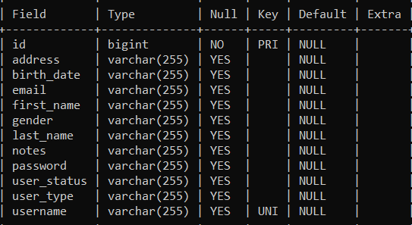

1. **Flow Of Project:**

**This system is being with three-layer management including three major roles for better safety, convenience & speed**

* **User:** after login user will able to see the all sports which are available in club. When user will click on particular sport then he will get the details of that sport like offers, batch timings, fees if user wants to proceed further, he can subscribe to that sport

* **Admin:** Admin can check and verify various member details. He can approve or disapprove the membership.

After user subscribing for particular sport, admin will transfer this to manager. If manager agree and accept then admin can add that user to that sport

* **Manager: he will manage the sport created by admin, e.g., creating new batches, new offers according to season, scheduling sports and launching them...**

**Functionalities provided:**

1) We have given different roles for different tasks using manager, admin, user so each of three will handle tasks individually.

2) we also trying to keep different account logins for this three for security so system could be transparent

3) auto renewal of subscription for user while

4) two factor authentication while login for security purpose

5) personalized suggestion and comments from club for improvement

6) as now we have seen due to pandemic at some extents sport lovers have much restrictions so we are thinking that indoor games to include in this sports club so that there would be safe side for players so we are trying to add online mode

**Thank You!**