Spring 2023: CS5710 – Machine Learning

**In-Class Programming Assignment-3**

**Name - Nikhil Manikya,700734200**

**Github link -** <https://github.com/NikhilManikya123/ML_Inclass-assign-_3>

**Video Link -** <https://drive.google.com/file/d/13Jvl4QZ8LpTKzmqv9xDvqbb9Vu4O2-ai/view?usp=share_link>

# Numpy:

* 1. Using NumPy create random vector of size 15 having only Integers in the range 1-20.
     1. Reshape the array to 3 by 5
     2. Print array shape.
     3. Replace the max in each row by 0

Solution:

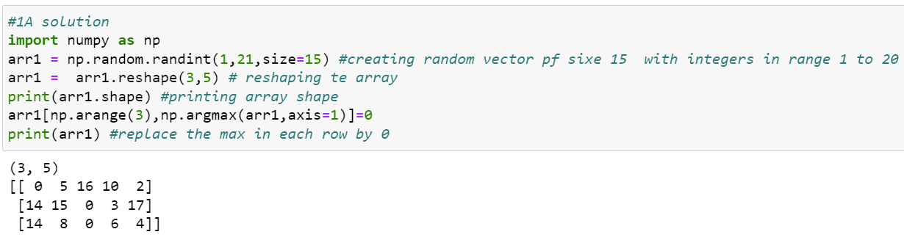

Explanation :

The np.random.randint() function is used to generate a 3x5 NumPy array named arr1 with random integer values between 1 and 20. The.shape attribute of NumPy arrays is then used to print the shape of the array.

The code then uses sophisticated indexing to change the largest value in each row of arr1 with 0. The greatest value in each row is located using the np.argmax() function, and the first axis of arr1 is indexed using an array of row indices created by the np.arange(3) function. In essence, this chooses the highest value in each row.

The chosen elements in arr1 are then given the value 0 by using the = operator. The console displays the output, which is the array arr1.

Create a 2-dimensional array of size 4 x 3 (composed of 4-byte integer elements), also print the shape, type and data type of the array.

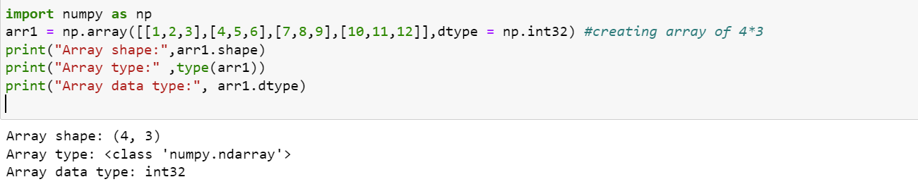

Explanation:

Using the np.array() function, the following code builds a 2D NumPy array named arr1 with the dimensions 4x3 and 4-byte integer elements. The array's elements are explicitly provided as lists of lists with integer values ranging from 1 to 12.

To specify that each element in the array should be represented as a 4-byte integer data type, the dtype parameter is set to np.int32.

The array's form, type, which is numpy.ndarray, and the data type of the array's elements are then printed by the code (which is int32)

* 1. Write a program to compute the eigenvalues and right eigenvectors of a given square array given below: [[ 3 -2]

[ 1 0]]

Solution:

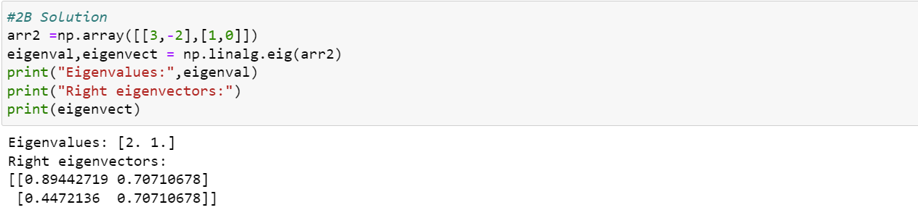

Explanation :

* 1. Compute the sum of the diagonal element of a given array. [[0 1 2]

[3 4 5]]

Solution:

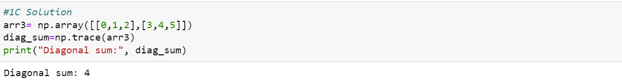

* 1. Write a NumPy program to create a new shape to an array without changing its data. Reshape 3x2:

[[1 2]

[3 4]

[5 6]]

Reshape 2x3:

[[1 2 3]

[4 5 6]]

Solution:

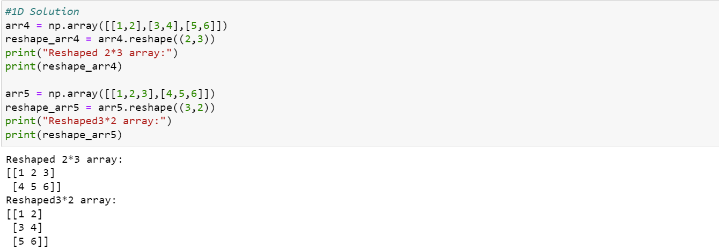

# Matplotlib

1. Write a Python programming to create a below chart of the popularity of programming Languages.
2. Sample data:

Programming languages: Java, Python, PHP, JavaScript, C#, C++ Popularity: 22.2, 17.6, 8.8, 8, 7.7, 6.

Explanation:

The code first defines some example data in the form of two lists, lang and popularity, each of which contains the names of various programming languages and the relative popularity ratings for those languages.

The pie chart is then produced using the plt.pie() function. The labels option is used to supply the names of the programming languages, and the popularity list is passed in as the data to be plotted. The autopct argument specifies that one decimal place should be used to display the percentage values for each piece of the pie.

The pie chart's title is then added using the plt.title() function.

Finally, the pie chart is displayed on the screen by calling the plt.show() function.

Solution:

