# **UNDERWATER CLUSTER BASED NETWORK**

Objective:

The task assigned is to simulate clustering based model in ns2 or ns3 for underwater RF communication.

Approach:

First we considered 500 nodes placed on a grid with length 50m , breadth 10m.The base station is at the centre of the grid at a height of 25 meters.

We implemented 3 algorithms for simulation and calculated the network life of the architecture.

Direct Communication:

All the nodes will directly communicate to base station.

Cluster Head approach:

Nodes are divided into 20 clusters each cluster has 25 nodes in which each cluster has its cluster head at the centre of the cluster. All the nodes will communicate with the cluster head and then cluster head communicates with Base station.

Cluster Head with 2-layers:

In this approach we have two layers in which each layer is of width 25m and height 10m placed one above the other. Each layer has 250 nodes divided into 10 clusters. Each nodes sends data to the cluster head. The cluster head in the bottom layer sends data to the cluster head just above it in the upper layer, then this cluster head in the upper layer sends data to the base station.

Simulation Environment:

**NETWORK SIMULATOR – 2:**

It is a discrete event driven simulator which provides substantial support to simulate bunch of protocols like TCP , FTP , UDP , https. It has a discrete event scheduler which simulates wired and wireless networks and uses TCL as its scripting language which support OOP.

**Parameters Considered:**

(i)Energy of the each Node

(ii)Energy of the cluster head.

(iii)Distance between nodes and cluster head.

(iv)Distance between cluster heads and base station.

(v)No of nodes.

**Parameter values:**

(i)Energy of the each Node = 1 Joule

(ii)Energy of the cluster head = 50 Joules

(iii)Distance between nodes and cluster head = Max:2.8m , Min: 1m

(iv)Distance between cluster heads and base station. = Max:35.7m , Min: 10m

(v)No of nodes. = 500

Simulation Results:

Initial State

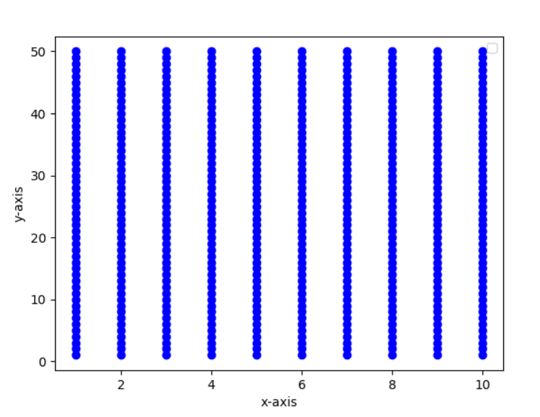

**Direct Communication:**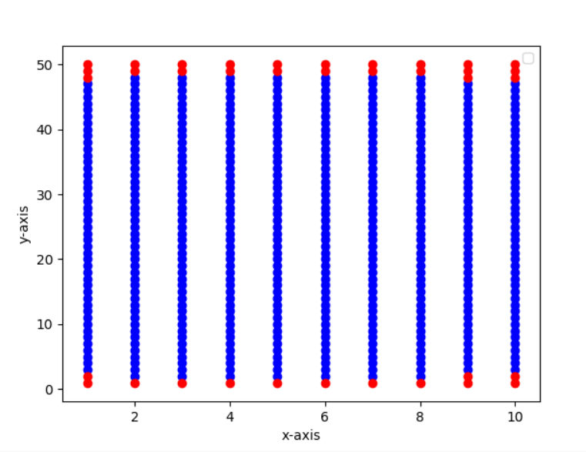

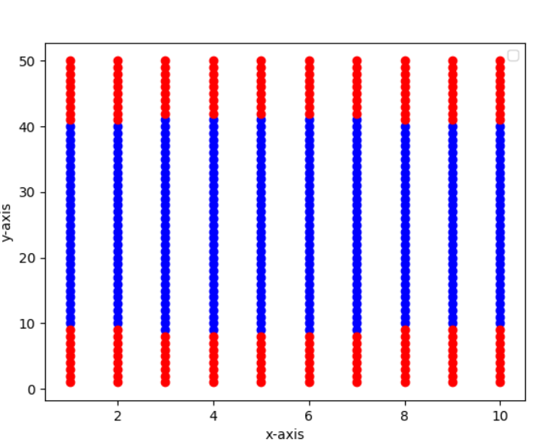

Cluster Head:

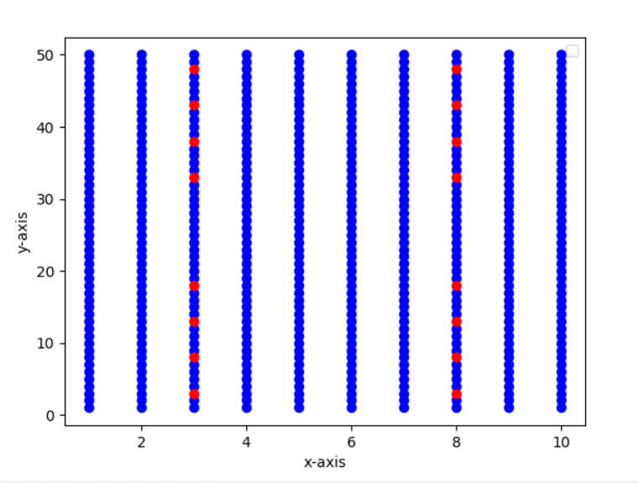

**2-layer Cluster:**

*Initial State:*

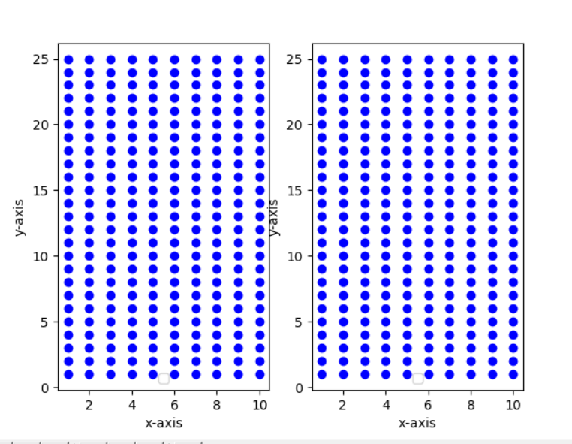

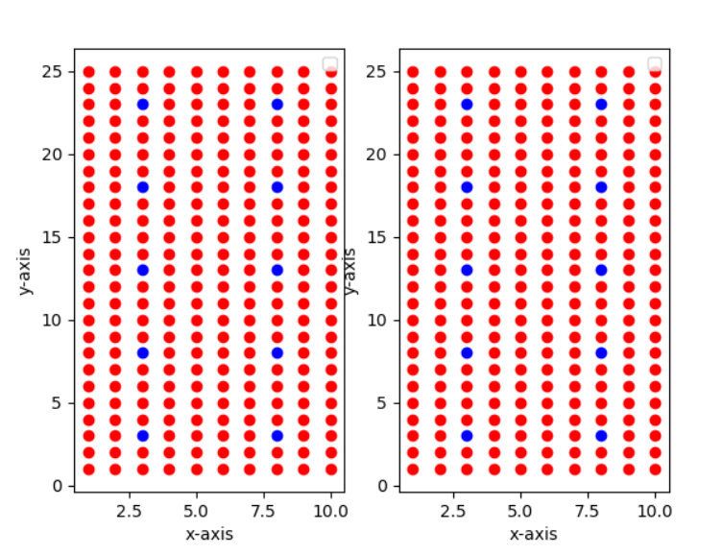

**Comparisons:**

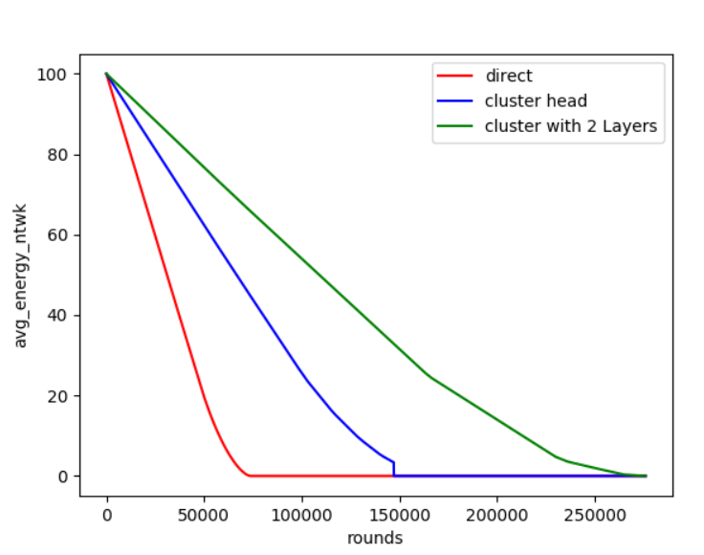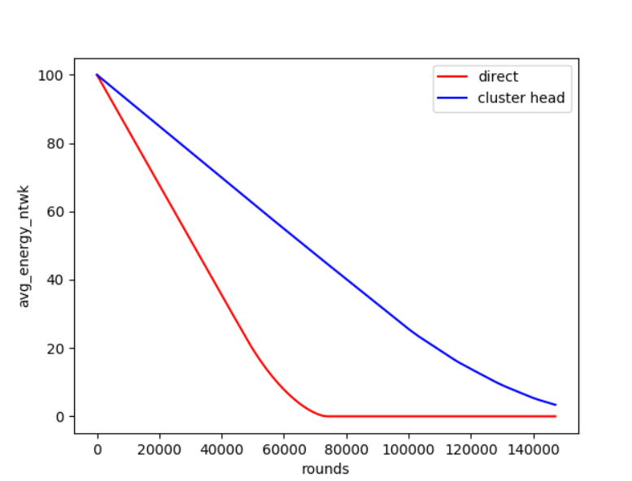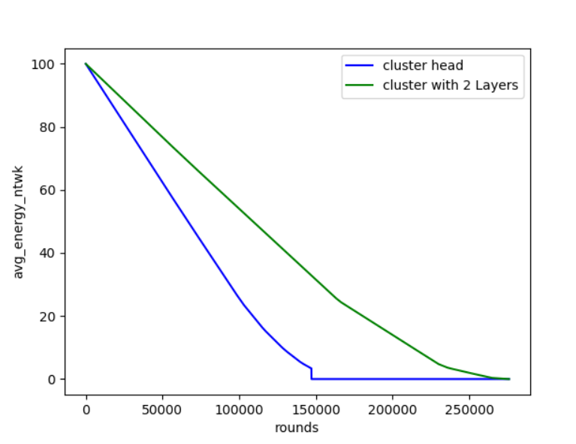

Inferences from Results:

From the above graphs we can see that in **Direct Communication** farther nodes eventually die.It lasts for around **70,000 Rounds** i.e **Network life of 37.1 Seconds** with no delay between each transmission.

In **Cluster Head** approach we can observe that even though we give more energy to cluster head they will die first and when all the cluster heads die the whole network is dead even though other nodes are active. It lasts for **140,000 Rounds** i.e **Network Life of 1929.2 Seconds** with no delay between each transmission.

In **2-layer approach** we can observe that all the nodes will die except the cluster heads in both layers. i.e cluster heads are still active.It last for **250,000 Rounds** .**Network Life of 6614.4 Seconds** with no delay between each transmission.

By comparing all the three approaches we can say that **Clustering with 2-layer approach is the best one.**