**For Running Application:**

For running app the user should have to open the app.

App will have three different screens:

1. Home screen

Normal home screen with an image of PyBot and text in it.

1. Start screen

With the start button.

1. About screen

About screen contains the information about the application.

To start the application the user have to navigate to start screen and have to click on the start button. Then our Python bot will start talking. It will ask the user whether the user want to login or register. In order to use the application services the user must have to register before. To register the user need to know registration password then only the application allows the user to register. Password is 123.

After registration process is done then the user can login and can use the app services. The whole login and registration process is based on face recognition.

For face recognition our application automatically opens camera of the device the user is using and capture the picture for registration and login process. Then application compares both the pictures and tells the result if user is authorized user or not.

Once the user login successfully the user can either use three options provided by application: Send Email, Read Email and Read Sent Email

Python bot will ask user if the user need any help, then is the user said **‘yes’** it asks what the user want to do.

If the user say **‘send email**’ app asks to whom the user want to send email, the user just have to tell the name of the receiver then the app automatically finds the email Id of that receiver.Then user have to tell subject and text inside the body of the email. At last the app confirms the information got from the user and ask whether to send it. After sending, app ask again if the user want to send more mails.

If the user say **‘read email’** app reads all the unseen mails of the user and is there are no unseen mails, app tells the user that there is no new mails for you.

If the user say **‘read sent email’** app reads three recent mails sent by the user with the confirmation of the user to ask next sent mail.

The user can either say **‘yes’** or **‘no’** to the python bot whenever it asks the user questions to help.

**HOME**

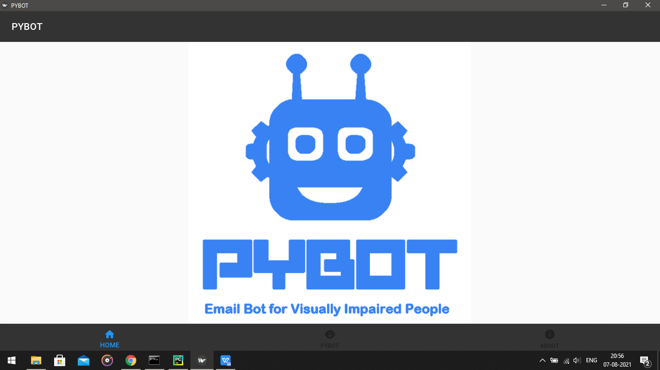

**START**

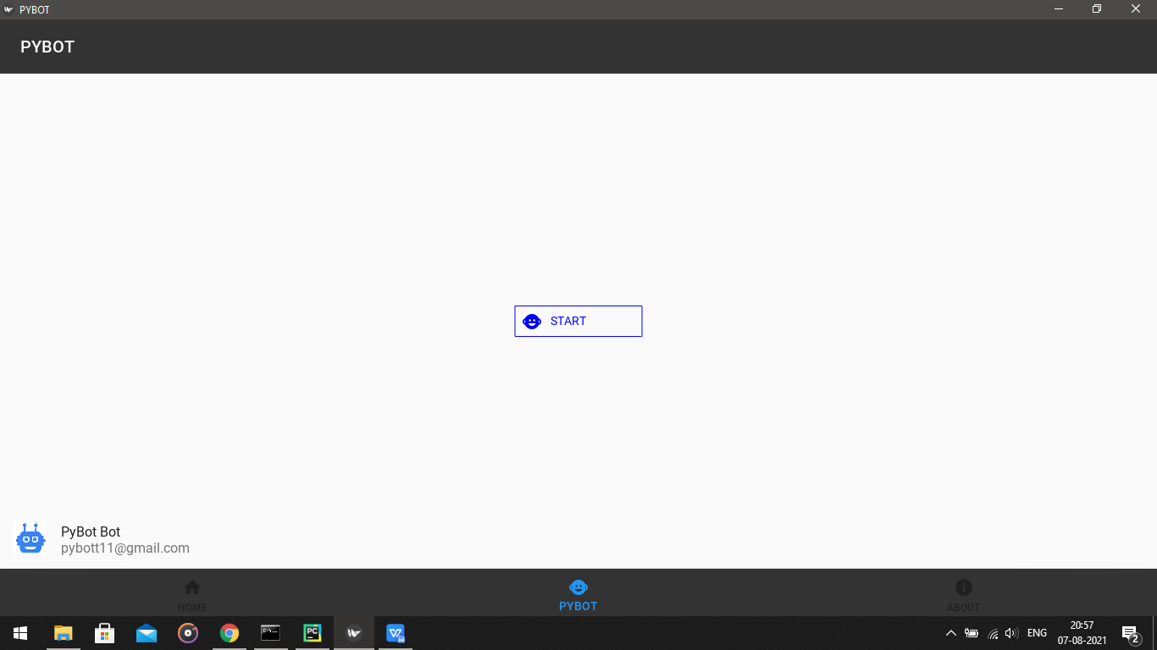

**ABOUT**

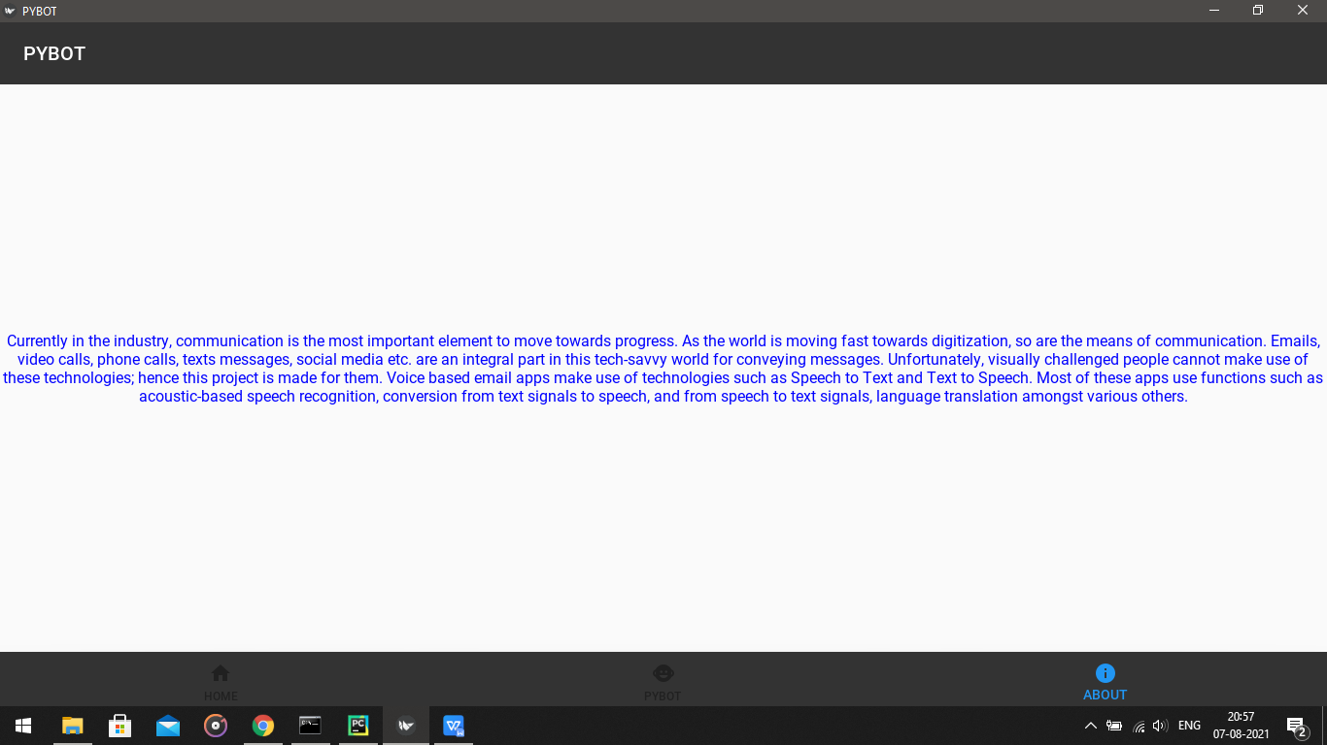

**For Running Web Application:**

For running web app the user should have to open the web application by using the website link.

Web App will have three different screens:

1. Home screen

Normal home screen with an welcoming text in it.

1. Start screen

With the start button.

1. About screen

About screen contains the information about the application.

To start the web application the user have to navigate to start screen and have to click on the start button. Then our Python bot will start talking. It will ask the user whether the user want to login or register. In order to use the web application services the user must have to register before. To register the user need to know registration password then only the web application allows the user to register. Password is 123.

After registration process is done then the user can login and can use the web app services. The whole login and registration process is based on face recognition.

For face recognition our web application automatically opens camera of the device the user is using and capture the picture for registration and login process. Then web application compares both the pictures and tells the result if user is authorized user or not.

Once the user login successfully the user can either use three options provided by web application: Send Email, Read Email and Read Sent Email

Python bot will ask user if the user need any help, then is the user said **‘yes’** it asks what the user want to do.

If the user say **‘send email**’ web app asks to whom the user want to send email, the user just have to tell the name of the receiver then the app automatically finds the email Id of that receiver.Then user have to tell subject and text inside the body of the email. At last the app confirms the information got from the user and ask whether to send it. After sending, web app ask again if the user want to send more mails.

If the user say **‘read email’** web app reads all the unseen mails of the user and if there are no unseen mails , web app tells the user that there is no new mails for you.

If the user say **‘read sent email’ web** app reads three recent mails sent by the user with the confirmation of the user to ask next sent mail.

The user can either say **‘yes’** or **‘no’** to the python bot whenever it asks the user questions to help.

**HOME**

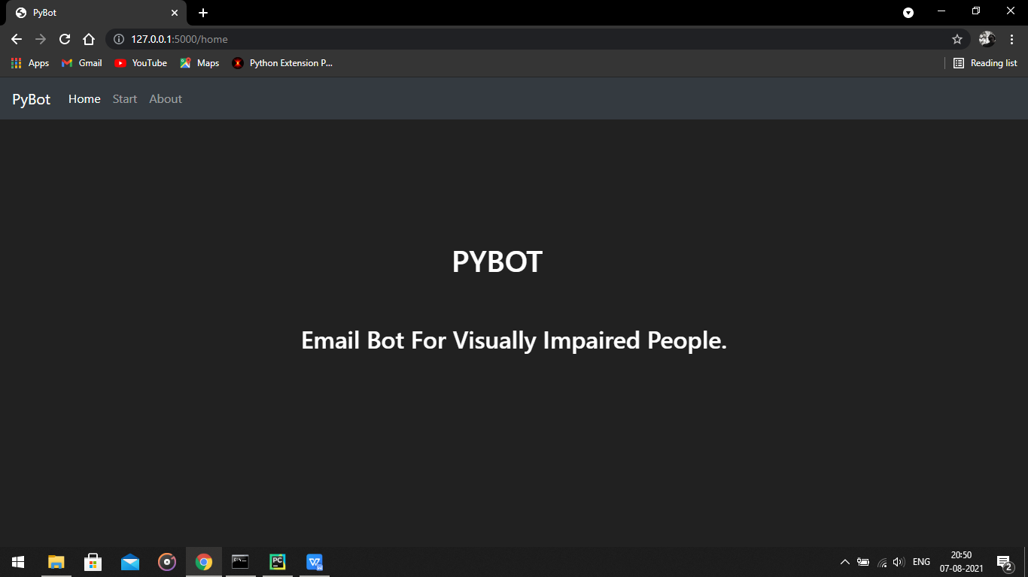

**START**

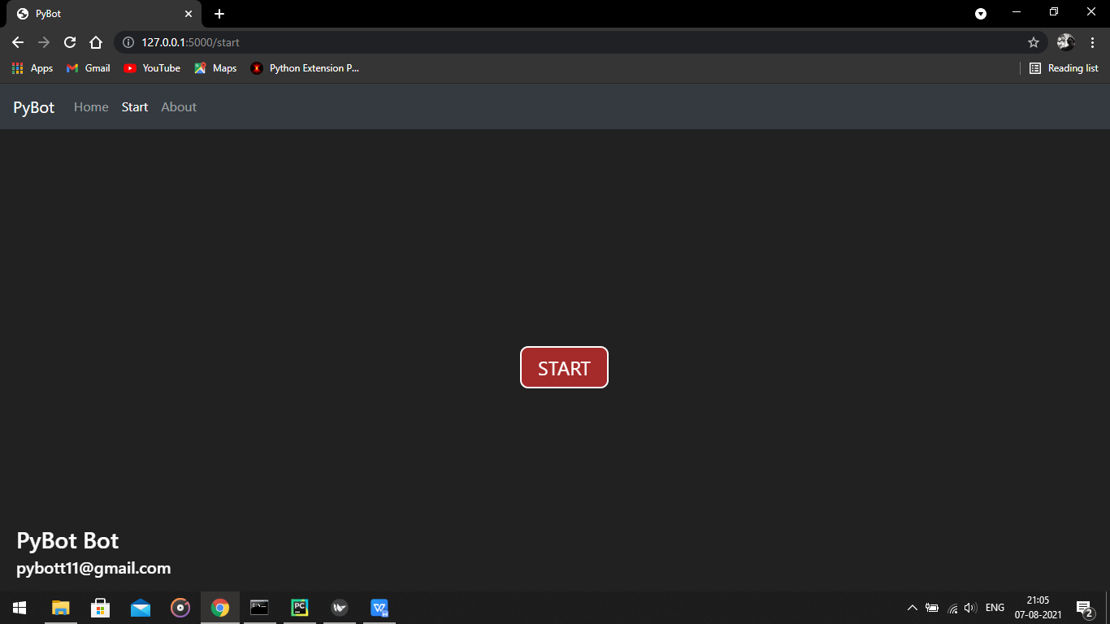

**ABOUT**

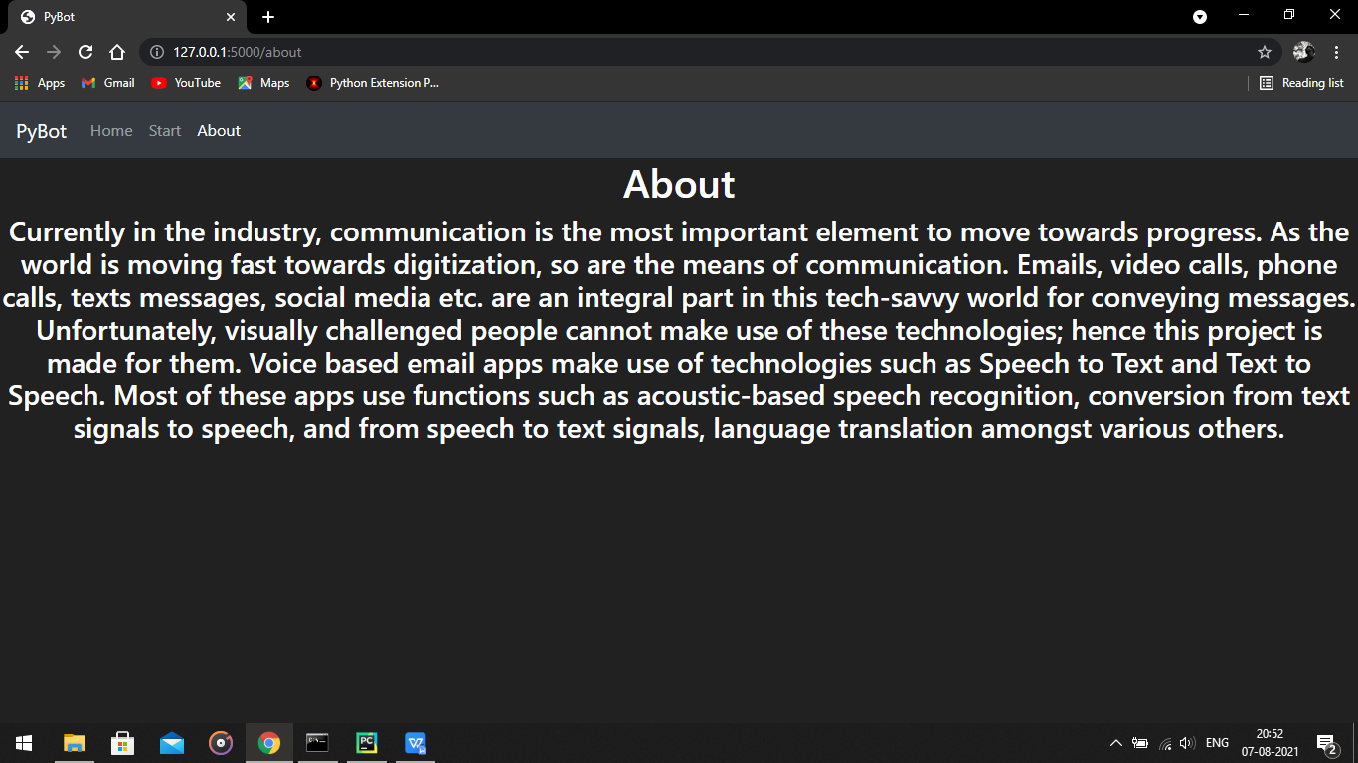

**Packages and Libraries used for building Application:**

1. Kivy
2. Kivymd
3. Widget
4. Boxlayout
5. Sys
6. Open cv python
7. Face_recognition
8. IMAP
9. SMTP
10. Speech_recognition
11. Pyttsx3
12. Email
13. Pyaudio

**Packages and Libraries used for building Web Application:**

1. Flask
2. Sys
3. Open cv python
4. Face_recognition
5. IMAP
6. SMTP
7. Speech_recognition
8. Pyttsx3
9. Email
10. Pyaudio