**Assigment 1**

**Nikhil Paleti  
19803024  
B13**

Q1)

GitHub ID - <https://github.com/NikhilPaleti>

Q2)

Code Uploaded:

//A Very Basic Hello World Program.

#include <conio.h>

*void* main ()

{

    printf("Hello Github");

}

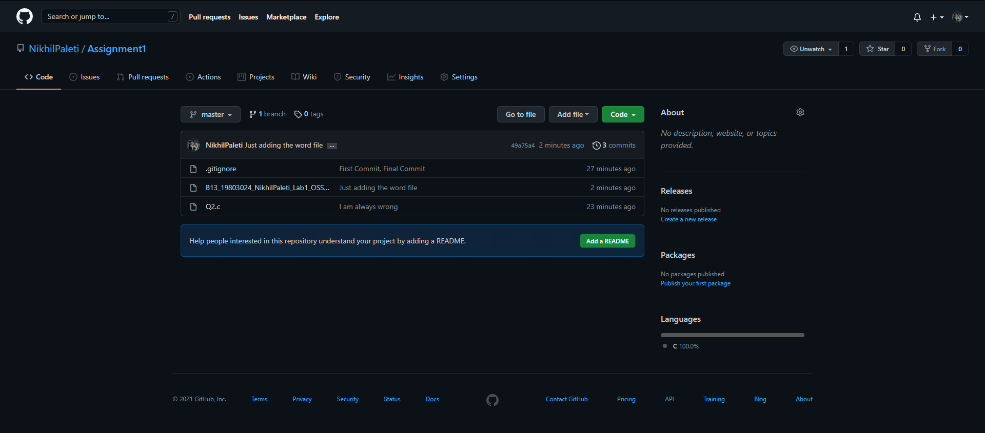

Q3)

Open Source Project Selected: <https://github.com/firstcontributions/first-contributions>

This is a very basic, but important, “mock” repository. It is mostly consisted of “Readme” files, further describing the project and in different Languages. It is managed by a bot and allows all users to contribute to the project.  
This is intended to allow any new user to approach, Fork/Clone the repo, make changes and contribute, hence acclimatizing the users to the standard fork -> clone -> edit -> pull request workflow that they encounter often as a contributor to Open-Source!

This project is intended to serve as a LaunchPad to begin the journey of making contributions to Open Source Projects