MOTIVATION BEHIND THE PROJECT

Our motivation behind the project was as follows:

Image Processing, Data Handling, was of course, a highly exciting prospect to learn the new technologies, since it was uncharted territory for all of us, with none of us having done it before.   
On top, the challenge of trying to “topple” the industry leader (BM3D) was also a very exciting goal to achieve for us.

Furthermore, this also would be helpful for us, since the project domain of Image Processing, Python and Data Handling, would also line-up with our D.E Subjects.

TYPE OF PROJECT – Development-cum-Research Project approach was chosen

CRITICAL ANALYSIS OF RESEARCH PAPER READ AND GAPS IN WORK AND ONE LINE SUMMARY OF EACH PAPER STUDIED

<https://www.uio.no/studier/emner/matnat/ifi/INF2310/v12/undervisningsmateriale/artikler/Huang-etal-median.pdf>

* Given basic idea and implementation of the Sliding Window algorithm within Median Filter

<https://ieeexplore.ieee.org/document/5596999>

* Monetary restricted research paper, but provided mathematical understanding and implementation of PSNR, MSE and also a brief idea of SSIM (Further explored on the web)

[IPOL Journal · An Analysis and Implementation of the BM3D Image Denoising Method](https://www.ipol.im/pub/art/2012/l-bm3d/?utm_source=doi)

* Basic Idea of

OVERALL DESIGN OF PROJECT (DIAGRAM IS WELCOME)

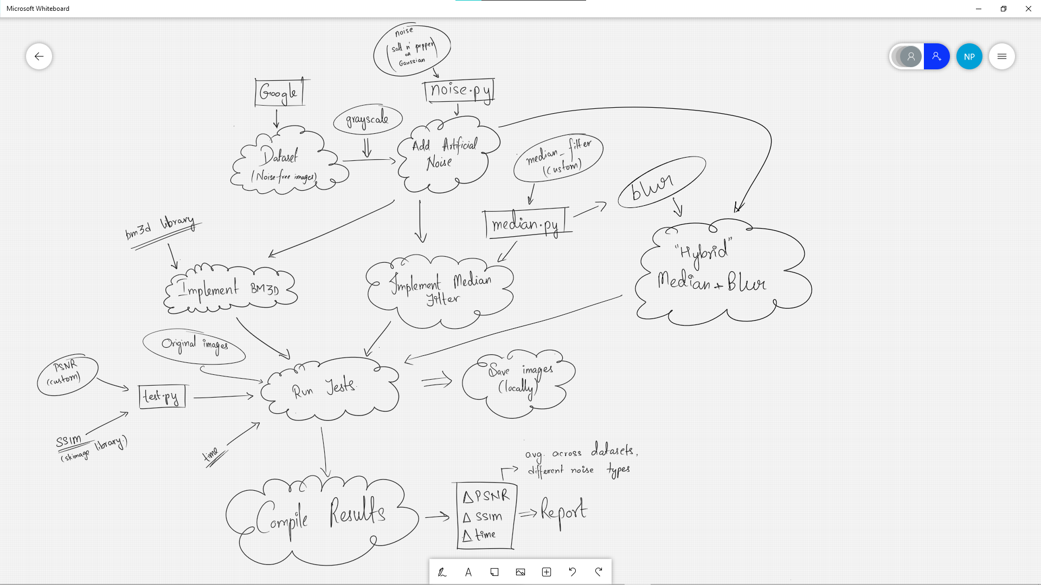

FEATURES BUILD, LANGUAGE USED

Python was the language used for the project. “ipynb” Python Notebook File was used to develop the entire project

Python libraries like numpy, skimage, scipy, bm3d, matplotlib were used for processing the data.

PROPOSED METHODOLOGY  
The process of the project can be broken down into the following steps:

1. Data Processing

* Crop images to 999x999 (or lesser)
* Import images to Python Code, in arrays
* Convert images to grayscale
* Artificially add noise

1. Create Median Filter and Blur function for de-noising evaluation.
2. A BM3D function is also developed for the same purpose.
3. Finally their results are compared using PSNR, SSIM and Time, as reference

ALGORITHM/DESCRIPTION OF THE WORK

Algorithms put to use:

* Median Filter
* Blur
* M.S.E (for PSNR)
* Structural Similarity Index

BM3D was also used, but that was not custom code and that was used just for base-line.

DIVISION OF THE WORK AMONG STUDENTS

The work was predominantly done as a collaborative effort from all 3 team members, with help being lent wherever and whenever required, however, the brief division of work is as follows:

- Nikhil: Result Compilation and Implementation

- Divyanshu: Research and implementation

- Dharmesh: Image Processing Algorithms and Implementation

RESULTS

Given below are a few graphs of the results procured of the

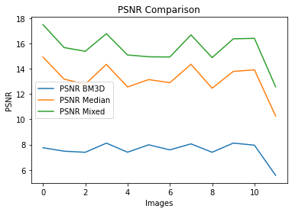 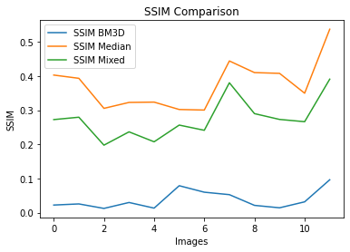

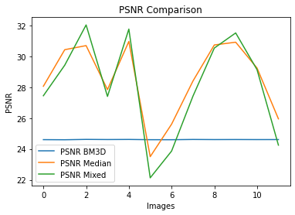 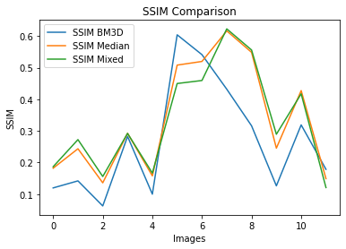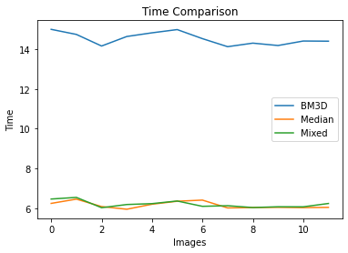

CONCLUSION

A brief of our conclusion is as follows:   
BM3D returned surprisingly underwhelming results in terms of PSNR and SSIM, while also taking up about double (2X) the time, compared to Median Filter, or our Hybrid Algorithm.  
However, BM3D was consistent, and also performed somewhat comparably with Gaussian Noise

The final results to be compared were between our own custom codes, of Median Filter and our “Hybrid” Algorithm. And it was observed as hypothesized, that our Hybrid Algorithm, using a “blur” function, did improve noise, since it acted as a Low-Pass Filter, however, did reduce SSIM, or structural similarity of the image.