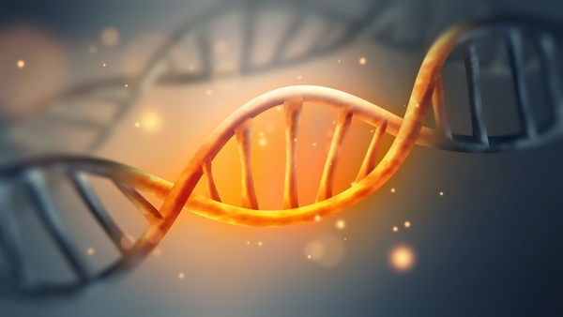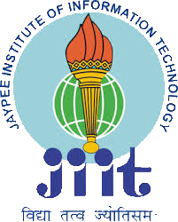

**DEPARTMENT OF BIOTECHNOLOGY,**

**JAYPEE INSTITUTE OF**

**INFORMATION TECHNOLOGY,**

**NOIDA**

**Organizes**

**5th International Conference on Advances in Biosciences and Biotechnology**

**(Theme: Innovations in Life Sciences and Computational Biology)**

**ICABB-2022**

**(20 to 22 Jan 2022)**

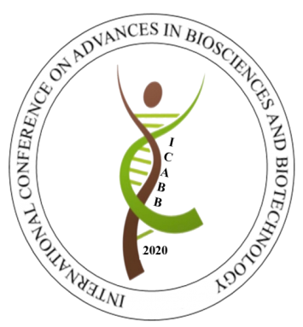

**ABOUT THE INSTITUTE**

Jaypee Institute of Information Technology (JIIT), Noida was established in the year 2001 and has been constantly ranked among the top engineering Institutes in Delhi NCR. JIIT has been accredited and approved by AICTE, NIRF, MHRD and has continued to become a centre of excellence in emerging areas of science and technology.

**ABOUT THE DEPARTMENT**

The Department of Biotechnology at JIIT, NOIDA, established in 2002, remains committed to provide research-informed teaching and learning, and vibrant R&D environment. Faculty with rich research exposure in academia and industry, both in India and abroad, contributes to the department academic core.

**ABOUT THE CONFERENCE**

“5th International Conference on Advances in Biosciences and Biotechnology **(ICABB-2022)”** on Innovations in life sciences and computational biology from 20 to 22 Jan, 2022 will be an amalgamation of multi-disciplinary fields of Biotechnology providing opportunities for exchange of ideas, scientific knowledge and experience amongst researchers, academicians, scientists and students from Biological, Medical, Environmental, Agricultural and Computational fields.

The scientific program will include plenary/ keynote lectures along with oral and poster presentation under 5 major themes focusing on breakthroughs in Biological Sciences, Computational approaches in Biotechnology, Genetics, Environmental, Microbial and Agricultural Biotechnology as well as, other upcoming current technological advancements in the field of Lifesciences.

**BROAD AREAS**

**SESSION I: Computational Biology and Applications**

* Synthetic biology
* Omics
* Molecular Docking
* Molecular Modelling/Simulation
* Chemo informatics
* Drug designing
* Systems Biology
* NGS
* Personalized medicine

**SESSION II: Medical and Microbial Biotechnology**

* Host- pathogen interactions
* Genetic disorders
* Life style disorders
* Diagnostics and treatment
* Stem Cells Therapy
* 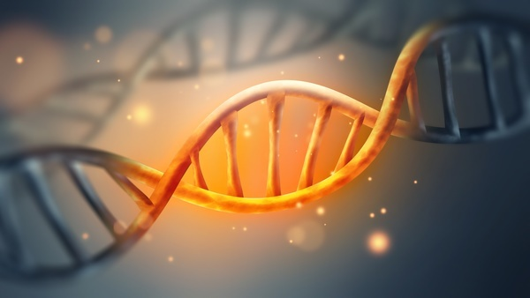Translational Medicine
* Vaccines and Antibiotics

**SESSION III: Food, Agriculture and Natural Products**

* Bio-fertilizers and Bio-pesticides
* Food Biotechnology
* Plant Biotechnology
* Animal husbandry
* Natural products

**SESSION IV: Environmental and Industrial Biotechnology**

* Environmental Biotechnology
* Enzyme Technology
* Bioremediation
* Bio resources
* Bio fuels
* Product development
* Innovative products in

Biotechnology

**SESSION V: Nanotechnology and Drug Delivery**

* Nanomaterials
* Diagnostics
* Biosensors
* Nano-formulations
* Targeted drug delivery
* Nano-remediation

**PATRON**

Prof. S. C. Saxena, Vice Chancellor, JIIT, Noida

**CONFERENCE CHAIR PERSON**

Prof. Pammi Gauba, HOD, Biotechnology Department, JIIT, Noida

**ORGANISING SECRETARY**

Prof. Rachana, Biotechnology Department, JIIT, Noida

Dr. Shazia Haider, Biotechnology Department, JIIT, Noida

**ADVISORY COMMITTEE**

Prof. Hariom Gupta (JIIT, Noida), Prof. D. K. Rai (JIIT, Noida), Prof Jayesh Bellare IIT Bombay, Dr D K Gupta Founder Felix Hospital Noida, Prof S Panda, IIT Kanpur

**TECHNICAL COMMITTEE**

Prof. Neeraj Wadhwa, Prof. Vibha Rani, Dr. Smriti Gaur, Prof. Sujata Mohanty

**ADMINISTRATIVE COMMITTEE**

Prof. Sudha Srivastava, Prof. S Krishna Sundari, Prof. Indira P Sarethy, Dr Garima Mathur, Dr. Vibha Gupta, Dr. Chakresh Kumar Jain, Dr. Manisha Singh, Dr Priyadarshini, Prof. Reema Gabrani, Dr Shalni Mani, Dr. S Bhattacharya, Dr. Shweta Dang, Dr. Sonam Chawla, Dr. Ashwani Mathur, Ms. Ekta Bhatt

**IMPORTANT DATES**

**Last date of Abstract Submission:**

15 December, 2021

**Acceptance notice:**

Within 2 weeks of Submission

**Last date of Registration:**

24 December, 2021

**REGISTRATION FEES:**

Includes admission to all conference sessions, conference kit, lunch, refreshments, conference dinner, and cultural program.

|  |  |  |  |  |
| --- | --- | --- | --- | --- |
|  | **Registration Fee: Indian Participants (INR)** | | **Registration Fee : International Participants (USD)** | |
|  | **Till 24th Dec 2021** | **After 24th Dec 2021** | **Till 24th Dec 2021** | **After 24th Dec 2021** |
| **Industry** | 8,000 | 9,000 | 350 | 400 |
| **Academia** | 6,000 | 6,500 | 250 | 300 |
| **Research Scholar** | 2000 | 2500 | 200 | 250 |
| **Students (UG/ PG)** | 2000 | 2500 | 200 | 250 |
| **Attendee Only** | 500 | 1200 | 100 | 150 |

**FOR REGISTRATION CONTACT**

Prof. Rachana: 09315434437

Dr. Shazia Haider: 09811930241

Email: [icabb2022@gmail.com](mailto:icabb2022@gmail.com), [conference2022@jiiticabb.com](mailto:conference2022@jiiticabb.com)

Website: <http://www.jiiticabb.com/>