The Graphics Processing Unit: Architecture, Parallelism, and the Transformation of Modern Computing

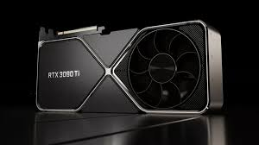

The Graphics Processing Unit (GPU), initially conceived as a specialized circuit for accelerating the rendering of 3D graphics in video games, has undergone a profound architectural and functional transformation. Today, the GPU is recognized as an indispensable, general-purpose parallel processor that forms the computational backbone of modern High-Performance Computing (HPC), scientific simulation, and, most significantly, the global boom in Artificial Intelligence (AI) and deep learning. This evolution is driven by the GPU’s fundamental design difference from the Central Processing Unit (CPU): a dedicated architecture optimized for massive parallel processing, which provides superior efficiency for data-intensive computational tasks.

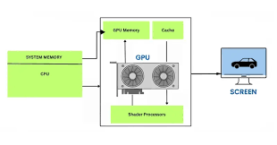

The core strength of the GPU lies in its architecture of massive parallelism. Unlike a CPU, which employs a few powerful cores optimized for sequential task execution and rapid switching between threads (latency-focused), a GPU utilizes thousands of smaller, simpler cores (such as NVIDIA’s CUDA cores or AMD’s stream processors) designed for throughput. This arrangement allows the GPU to process thousands of data streams and execute concurrent threads simultaneously. For tasks that can be broken down into many independent, simultaneous operations—known as "embarrassingly parallel" problems—the GPU’s architecture vastly outperforms the CPU. The ability to perform high-speed matrix multiplications across these numerous cores is the critical factor enabling its dominance in specialized computing fields.
This architectural advantage has made the GPU the workhorse of the AI revolution. Deep learning algorithms, particularly in the training of large neural networks, rely almost entirely on complex linear algebra operations involving vast matrices and tensors. By distributing these computations across thousands of cores, GPUs dramatically reduce the time required to train models like those used for natural language processing (NLP), computer vision, and autonomous systems. Modern GPUs further specialize this capability with dedicated hardware, such as Tensor Cores, which are optimized specifically for the low-precision matrix operations vital to deep learning training and inference. The combination of high core density and high-bandwidth memory (VRAM), such as HBM (High Bandwidth Memory), ensures that the compute units are continuously supplied with the massive datasets required for rapid iteration and model optimization.
Beyond machine learning, GPUs have cemented their role in High-Performance Computing and scientific research. The General-Purpose computing on Graphics Processing Units (GPGPU) movement, facilitated by programming models like NVIDIA’s CUDA and the open standard OpenCL, unlocked the GPU’s power for simulations. Researchers now employ GPU clusters to model phenomena ranging from molecular dynamics, astrophysics, and weather forecasting to complex financial risk analysis. These simulations involve billions of calculations, and the parallel architecture allows for model scales and resolution that were previously unattainable using only CPU resources. The GPU accelerates time-to-discovery, making complex computational science faster, more accessible, and more energy-efficient relative to the performance delivered.
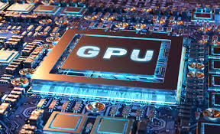

In conclusion, the Graphics Processing Unit has successfully transitioned from a specialized rendering tool to the engine of modern data processing. Its inherent design for massive parallelism provides the computational horsepower necessary to sustain the rapidly escalating demands of deep learning, large-scale scientific modeling, and HPC clusters. As AI models continue to grow in size and complexity, and as the need for real-time data processing increases, the GPU’s specialized architecture will remain a central, indispensable component, driving the next wave of technological innovation across both the commercial and scientific domains.

