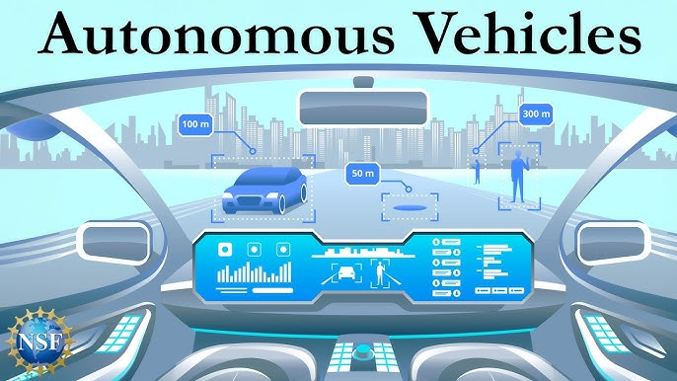

The Road to Autonomy: Technical and Ethical Challenges in Autonomous Vehicle Development
Autonomous vehicles (AVs) represent a disruptive technology poised to redefine transportation, promising a future of reduced traffic congestion, optimized fuel efficiency, and, most crucially, a dramatic decrease in accident rates attributed to human error. However, the path to achieving widespread, fully autonomous, and safe driving capability (Level 5 autonomy) is fraught with significant technical, legal, and ethical hurdles. Developing a machine capable of navigating the unpredictable complexity of the real world—a domain governed by social cues, ambiguous situations, and environmental variance—requires overcoming challenges that extend far beyond simple engineering.

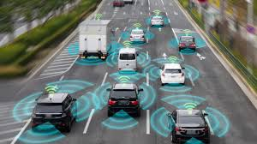

The Challenge of Sensor Fusion and Perception
The foundation of any self-driving system is its ability to accurately perceive its environment, a function executed through a suite of advanced sensors, including LiDAR, radar, and high-resolution cameras. While each sensor provides unique data—LiDAR for precise 3D mapping, radar for velocity and distance, and cameras for classification and color detail—no single sensor is infallible. Rain, fog, or snow can blind cameras; bright sunlight can degrade LiDAR performance; and radar lacks the resolution for detailed object classification. The primary technical challenge lies in sensor fusion: merging these disparate data streams in real-time to create a consistent, reliable, and holistic environmental model.
